DESK-TOP REVIEW OF INDIGENOUS ENGAGEMENT IN THE NATIONAL ENVIRONMENTAL SCIENCE PROGRAM (NESP)
PART 1
Final Report |  | Prepared for
juLY 2020 |  | Department of Agriculture, Water and the Environment



Front Cover Photo:
NT Rangers NT Ranger Forum discussing the Our Knowledge Our Way Guidelines. Photo by Patch Clapp.
Rear Cover Photo:
Stephanie Beaupark, Ngugi woman teaching Indigenous weaving techniques using Spiny-headed Mat-rush (Lomandra longifolia). Stephanie completed research for the CAUL Hub on air quality and Indigenous seasons and engaged with attendees through her practice. Photo by Sarah Fisher.

Citation:
Wensing, E. and Callinan, T. (2020) Desk-Top Review of Indigenous Engagement in the National Environmental Science Program (NESP). SGS Economics and Planning for the Department of Agriculture, Water and the Environment, Canberra. https://www.sgsep.com.au/projects/desk-top-review-of-indigenous-engagement-in-the-national-environmental-science-program

© SGS Economics and Planning Pty Ltd 2020
This report has been prepared for the Department of Agriculture, Water and the Environment. SGS Economics and Planning has taken all due care in the preparation of this report. However, SGS and its associated consultants are not liable to any person or entity for any damage or loss that has occurred, or may occur, in relation to that person or entity taking or not taking action in respect of any representation, statement, opinion or advice referred to herein.
The Report’s authors are:
- Dr Ed Wensing (Life Member) MPIA, FHEA, Special Adviser and Associate
- Tara Callinan, Senior Consultant
SGS Economics and Planning Pty Ltd
ACN 007 437 729
www.sgsep.com.au
Offices in Canberra, Hobart, Melbourne, Sydney

Acknowledgement of Country

SGS Economics and Planning acknowledges the Traditional Owners on whose Country we live and work.
SGS Economics and Planning acknowledges that the Indigenous peoples of Australia are the oldest living culture on Earth, have the oldest continuing land tenure system in the World, and have the oldest continuing land use planning and management system in the World.
We acknowledge that the you have suffered the indignity of having your land taken from you without your consent, without a treaty, without compensation. We acknowledge these matters are yet to be justly resolved.
Dr Ed Wensing
Tara Callinan

TABLE OF CONTENTS
Acknowledgement of Country iii
Abbreviations x
EXECUTIVE SUMMARY xv
RECOMMENDATIONS xix
1. About this report 1
1.1 The Client 1
1.2 NESP2 Announcement by the Minister for the Environment 1
1.3 The Brief for a review of Indigenous engagement in NESP 3
1.4 Report Structure 4
1.5 Additional Outputs 5
1.6 Acknowledgements 5
1.7 Caveats and Limitations 6
1.8 Notes on Concepts and Terms used in this Report 7
1.9 Disclaimer 9
2. Background to the NESP and Indigenous engagement 10
2.1 Introduction 10
2.2 The National Environmental Science Program (NESP) 10
2.3 Indigenous Engagement in the NESP 12
2.4 Performance Indicators for Indigenous engagement in the NESP 14
2.5 Mid-Term Evaluation of the NESP 15
2.6 NESP Research Priorities from 2017 16
2.7 NESP Indigenous Gathering – February 2018 17
2.8 Survey about the NESP – June 2019 19
2.9 Summary Details about the NESP Hubs 20
2.10 Findings and Conclusions 24
3. Indigenous Engagement by the NESP Hubs 25
3.1 Introduction and Approach 25
3.2 NESP Hubs’ commitment to Indigenous Engagement 26
3.3 NESP Hubs’ Indigenous Engagement and Participation Strategies 28
3.4 NESP Hubs’ Approaches to Indigenous Engagement 34
3.5 NESP Hubs’ Key Performance Indicators for Indigenous Engagement 38
3.6 NESP Hubs’ Cross-Hub Activities 41
3.7 NESP Hubs’ Synthesis or Ground-Breaking Activities 42
3.8 NESP Hubs’ Research and Indigenous Engagement Activities 43
3.9 Findings and Conclusions 54
4. Commonwealth Agencies, NESP Research and Indigenous Research Themes / Questions 61
4.1 Introduction and Approach 61
4.2 Commonwealth Agencies and Departments, Indigenous Engagement and Research Priorities 61
4.3 NESP Hub Collaboration with Commonwealth Agencies and Departments 81
4.4 Findings and Conclusions 84
5. NESP Hub Indigenous Research Projects – location and regional gaps 88
5.1 Introduction and Approach 88
5.2 Spatial Mapping of Indigenous NESP Hub Research Projects: 88
5.3 Findings and Conclusions 102
6. Indigenous Protected Area (IPA) management Plans and Indigenous research Themes / Questions 105
6.1 Introduction and Approach 105
6.2 Indigenous Protected Areas (IPAs) 105
6.3 Establishing an IPA 106
6.4 Benefits of IPAs 107
6.5 New IPA’s in the planning stage 108
6.6 NESP research on IPAs 108
6.7 IPA Management Plans 110
6.8 Analysis of IPA Management Plans 111
6.9 Indigenous Ecological Knowledge (IEK) and research methods 116
6.10 Indigenous research themes and questions arising from IPA Management Plans 119
6.11 Findings and Conclusions 120
7. Resources Supporting Indigenous Engagement 123
7.1 Introduction 123
7.2 Indigenous Engagement Resources 123
7.3 Defining ‘engagement’ and ‘effective engagement’ 133
7.4 Opportunities for integrating IK and Western Science 135
7.5 NESP Hub Research Agreements and/or Protocols 137
7.6 The AIATSIS GERAIS is to become a Code of Ethics 139
7.7 Protecting Indigenous Knowledge and Data Sovereignty 141
7.8 Reflections on Indigenous peoples’ experiences in Land and Water Research 147
7.9 Findings and Conclusions 152
8. Conclusions and Recommendations 154
8.1 Introduction 154
8.2 Task 1: Scoping Indigenous environmental and climate science research themes and questions 154
8.3 Task 2: Indigenous Research gap analysis 165
8.4 Task 3: Resources supporting Indigenous engagement 166
8.5 Task 4: NESP Hub Performance and Consultation Outcomes 170
References 174
Legal Authorities 174
Legislation 174
Books, Book Chapters, Journal Articles, Reports, etc. 174

PART TWO: APPENDICES A to I
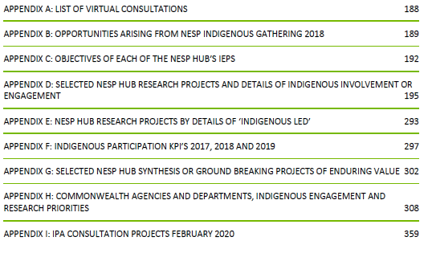
PART THREE: APPENDICES J to M
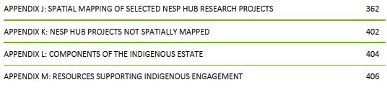

Table of FIGURES
Figure 1.1: NESP 2 Research Hubs and Focus of Research Missions 3
Figure 2.1: Survey Respondents views about Indigenous inclusion in the NESP/Future Program 19
Figure 3.1: CAUL Hub IEPS Key Activities 56
Figure 3.2: National Indigenous Dialogue on Climate Change 2018 - Statement on Indigenous people and climate change 57
Figure 3.3: MB Hub selected Research projects 2016-2019 59
Figure 4.1: Savanna Burning for reduced carbon emissions (left). Applied research supporting Indigenous heritage management (right) 72
Figure 4.2: Integrated Marine and Coastal Regionalisation of Australia (IMCRA v4.0) 73
Figure 4.3: Australian Marine Parks 74
Figure 4.4: Interim Biogeographic Regionalisation of Australia, Version 7 75
Figure 4.5: Indigenous Protected Areas and Consultation Projects – February 2020 76
Figure 4.6: National Landcare Program 2018 Regional Land Partnership Management Units 78
Figure 4.7: The Indigenous Forest Estate by land ownership and management category 80
Figure 5.1: Selected NESP Indigenous research projects by Hub and Jurisdiction as at March 2020 89
Figure 5.2: Selected MB Hub Indigenous research project locations by IMCRA Bio Regions 90
Figure 5.3: Selected NESP Hub Indigenous research projects by NRS and NRSMPA 91
Figure 5.4: Selected NESP Hub Indigenous research projects by National Reserve System (NRS) 92
Figure 5.5: Selected NESP Hub Indigenous research projects by Indigenous Protected Areas (IPAs) 93
Figure 5.6: Selected NESP Hub Indigenous research projects by National Landcare Program Management Units 94
Figure 5.7: The Indigenous estate under three land titles (as at 2013) 95
Figure 5.8: Vegetation condition (2006) and exclusive possession native title or Indigenous lands (2013) 96
Figure 5.9: Threatened species count (2008) and exclusive possession native title or Indigenous lands (2013) 97
Figure 5.10: Disturbance of riparian zones (2008) and exclusive possession native title or Indigenous lands (2013) 98
Figure 5.11: The Indigenous estate and national conservation lands 99
Figure 5.12: Indigenous and other components of the terrestrial conservation estate 100
Figure 5.13: Selected NESP Hub Indigenous research projects by Indigenous Land Categories 101
Figure 6.1: Indigenous Protected Areas and Consultation Projects – February 2020 106
Figure 6.2: Purpose and Background to Our Country Our Way Guidelines 111
Figure 7.1: How the complementary products of the Kimberley Indigenous Saltwater Science Project relate to one another 130
Figure 7.2: How ICIP is affected by more than IP laws 144
Figure 7.3: True Tracks Principles Diagram 145
Figure 7.4: True Tracks Principles and Framework 146
Figure 7.5: Word Cloud for Aboriginal Research Teams On-Country 148
Figure 7.6: Word Cloud for Aboriginal Academics 149
Figure 7.7: Word Cloud for Non-Aboriginal Scholars 149
Figure 7.8: Word Cloud for all Participants Combined 150
Figure 7.9: Exploring views related to traditional custodial identity 151
Figure 8.1: The principle of Free, Prior and Informed Consent 168

Table of TABLES
Table 2.1: New Indigenous Research Priorities from 2017 17
Table 2.2: NESP Hub Details as at May 2020 21
Table 3.1: NESP Hubs and Indigenous Engagement (as at December 2019) 27
Table 3.2: NESP Hub IEPS by Date and Version 29
Table 3.3: NESP Hub Indigenous Engagement and Participation Strategy Objectives 31
Table 3.4: Summary of Indigenous engagement KPIs as reported in NESP Hubs’ Annual Progress Reports 2017 - 2019 40
Table 3.5: NESP Hub Research activities involving Indigenous partners – Definitions 44
Table 6.1: IPA and Other Management Plans and timeframes of when they were prepared 112
Table 6.2: IPA Management Plans, Indigenous specific research priorities and alignment with NESP2 Hubs 114
Table 6.3: Non-IPA Management Plans, Indigenous specific research priorities and alignment with NESP2 Hubs 115
Table 6.4: Subjects relevant to NESP2 Resilient Landscapes Research 119
Table 6.5: Subjects Relevant to NESP2 Marine and Coastal Research Hub 120
Table 6.6: Subjects Relevant to NESP2 Climate Systems Research Hub 120
Table 7.1: Resources supporting Indigenous engagement and their applicability to NESP research activities 124
Table 7.2: Analysis of manifestations of IEK and Western science integration according to governance types 137

Abbreviations
ABARES Australian Bureau of Agricultural and Resource Economics and Sciences
ACA Australia Council for the Arts
ACCSP Australian Climate Change Science Program
ACL Australian Consumer Law
ACoG Agency driven co-governance
AFMA Australian Fisheries Management Authority
AyG Agency governance
AG Australian Government
AHC Australian Heritage Council
AHRC Australian Human Rights Commission
AIATSIS Australian Institute of Aboriginal and Torres Strait Islander Studies
AIFS Australian Institute of Family Studies
AIHW Australian Institute of Health and Welfare
AIMS Australian Institute of Marine Science
ALRC Australian Law Reform Commission
AMOS Australian Meteorological and Oceanographic Society
AMP Australian Marine Park
AMSA Australian Marine Science Association
ANAO Australian National Audit Office
ANU The Australian National University
APY Anangu Pitjantjatjara Yankunytjatjara
ARC Australian Research Council
ASSA Academy of the Social Sciences
ATSI Act Aboriginal and Torres Strait Islander Act 2005 (Cth)
ATSIC Aboriginal and Torres Strait Islander Commission
BoM Bureau of Meteorology
CAEPR Centre for Aboriginal Economic Policy Research
CANZUS Canada, Australia, New Zealand, United States (of America)
CAR Comprehensive. Adequate. Representative
CARE Collective benefit, Authority to control, Responsibility and Ethics
CAUL Clean Air and Urban Landscapes Hub
CBD The Convention on Biological Diversity
CDU Charles Darwin University
CERF Commonwealth Environment Research Facilities
CEWO Commonwealth Environmental Water Office
CLC Central Land Council
CMP Conservation Measures Partnership
COAG Council of Australian Governments
CofA Commonwealth of Australia
COVID-19 The infectious disease caused by the most recently discovered coronavirus.
CoTS Crown of Thorns Starfish
CRC Cooperative Research Centre
CRCAH Cooperative Research Centre for Aboriginal Health
CSIRO Commonwealth Scientific and Industrial Research Organisation
DAWE Department of Agriculture, Water and the Environment
DEE Department of the Environment and Energy
DKCRC Desert Knowledge Co-operative Research Centre
DoE Department of the Environment
DRIP Declaration on the Rights of Indigenous Peoples
ENSO El Niño-Southern Oscillation
EPBC Act Environment Protection and Biodiversity Conservation Act 1999 (Cth)
ESCC Earth Sciences and Climate Change Hub
ESD Ecological Sustainable Development
ESMS Environmental and Social Management System
FaHCSIA Department of Families, Housing, Community Services and Indigenous Affairs
FAIR Findable, Accessible, Interoperable, and Reusable
FAO Food and Agriculture Organisation
FNEWG First Nations Environmental Watering Guidance
FNEWO First Nations Environmental Water Objectives
FPIC Free, Prior and Informed Consent
GA Geoscience Australia
GBR Great Barrier Reef
GBRMPA Great Barrier Reef Marine Park Authority
GBRWHA Great Barrier Reef World Heritage Area
GERAIS Guidelines for Ethical Research in Australian Indigenous Studies
GI Geographical Indicators
GIDA The Global Indigenous Data Alliance
GPS Global positioning system
HCOANZ Heritage Chairs and Officials of Australia and New Zealand
HRBA Human Rights Based Approach
HREC Human Research Ethics Committee
IAC Indigenous Advisory Committee
IBRA Interim Biogeographic Regionalisation for Australia
ICEC International Conference on Engaging Communities
ICIP Indigenous cultural and intellectual property
ICNRM Indigenous cultural and natural resource management
ICoG Indigenous-driven co-governance
IEPS Indigenous Engagement and Participation Strategy
IG Indigenous-governed collaborations
IGA Inter-Governmental Agreement
IGAE Intergovernmental Agreement on the Environment
IGC Intergovernmental Committee
IK Indigenous knowledge(s)
IEIC Indigenous Engagement Implementation Committee
IEK Indigenous ecological knowledge(s)
ILSMPs Indigenous Land and Sea Management Programs
IMCRA Integrated Marine and Coastal Regionalisation of Australia
IP Intellectual Property
IPA Indigenous Protected Area
IPBES Intergovernmental Science-Policy Platform on Biodiversity and Ecosystem Services
IRG Indigenous Reference Group
ISAC Indigenous Strategic Advisory Council
ISE Indigenous Science and Engagement
ITK Indigenous traditional knowledge(s)
ISP Indigenous Science Program
IUCN International Union for the Conservation of Nature
KISSP Kimberley Indigenous Saltwater Science Project
KLC Kimberley Land Council
KLMRP Kimberley Marine Research Program
KPI Key Performance Indicator
LSMU Land and Sea Management Unit
MAC Murujuga Aboriginal Corporation
MB Marine Biodiversity Hub
MDBA Murray Darling Basin Authority
MLDRIN Murray Lower Darling Rivers Indigenous Nations
MNES Matters of National Environmental Significance
MRTCAG Mitchel River Traditional Custodian Advisory Group
NAER Northern Australia Environmental Resources Hub
NAILSMA North Australia Indigenous Land and Sea Management Alliance
NBAN Northern Basin Aboriginal Nations
NCCARF National Climate Change Adaptation Research Facility
NERP National Environmental Research Program
NESP National Environmental Science Program
NGO Non-government organisation
NHMRC National Health and Medical Research Council
NIAA National Indigenous Australians Agency
NLC Northern Land Council
NLP National Landcare Program
NRM Natural Resource Management
NRMMC Natural Resource Management Ministerial Council
NRS National Reserve System
NRSMPA National Representative System of Marine Protected Areas
NSESD National Strategy on Ecological Sustainable Development
PBC Prescribed Body Corporate
PFII Permanent Forum on Indigenous Issues
PGPA Act Public Governance, Performance and Accountability Act 2013 (Cth) (PGPA Act)
PM&C (Department of the) Prime Minister and Cabinet
PNG Papua New Guinea
QPWS Queensland Parks and Wildlife Service
RAP Reconciliation Action Plan
REAC Research Ethics and Access Committee
RNTBC Registered Native Title Body Corporate
RRRC Reef and Rainforest Research Centre
SCFFR Standing Committee of Federal Financial Reforms
SEED Indigenous Youth Climate Network
SGSEP SGS Economics and Planning
SoER State of the Environment Report
SoFR State of the Forests Report
SRoI Social Return on Investment
SRWUIP Sustainable Rural Water Use and Infrastructure Program
STEM Science, Technology, Engineering and Mathematics
S-VAM Shoreline Video Assessment Method
TBA To be advised
TBD To be determined
TCEs/EoF Traditional Cultural Expressions/Expressions of Folklore
TEK Traditional Ecological Knowledge(s)
TOs Traditional Owners
TRaCK Tropical Rivers and Coastal Knowledge research program
TSR Threatened Species Recovery Hub
TSRA Torres Strait Regional Authority
TSSAC Torres Strait Scientific Advisory Committee
TUMRA Traditional Use of Marine Resources Agreement
TWQ Tropical Water Quality Hub
UA Universities Australia
UN United Nations
UNDG United Nations Development Group
UNDRIP United Nations Declaration on the Rights of Indigenous Peoples
UNFCCC United Nations Framework Convention on Climate Change
UNHRBA United Nations Human Rights Based Approach
UNHRC United Nations Human Rights Council
UNPFII United Nations Permanent Forum on Indigenous Issues
UWA University of Western Australia
WALD Centre for Water and Landscape Dynamics
WAMSI Western Australian Maritime Science Institution
WCPA World Commission on Protected Areas
WGIP Working Group on Indigenous Populations
WIPO World Intellectual Property Organisation
WMO World Meteorological Organization
WoC Working on Country
WTMA Wet Tropics Management Authority
WTWHA Wet Tropics World Heritage Area
WWF World Wide Fund for Nature
YYNAC Yorta Yorta Nation Aboriginal Corporation

EXECUTIVE SUMMARY
SGSEP was commissioned by the then Department of the Environment and Energy (DEE) to undertake a desk-top review of Indigenous engagement in the National Environmental Science Program (NESP) to identify Indigenous environmental and climate science research themes and questions, to review existing resources to support Indigenous collaboration and to undertake some virtual consultations with Indigenous research stakeholders. Specifically, the brief required SGSEP to:
- Scope Indigenous environmental and climate science research themes and questions;
- Where documented research themes could not be found online, to consult with relevant Indigenous organisations;
- Collate existing resources to support Indigenous collaboration in environmental and climate science research; and
- Liaise with Indigenous stakeholders about the draft findings via online platforms and phone calls given the constraints on face-to-face meetings due to the COVID-19 pandemic.
This report presents our findings and recommendations. However, as this research was desk-top based and the authors of this report are not Indigenous, our findings and recommendations do not represent the collective views of Indigenous peoples about their environmental and climate science research themes and questions. As we make clear in our recommendations, it will be necessary at the commencement of NESP2 to undertake consultation with Indigenous peoples around Australia to ascertain their environmental and climate science research needs and priorities.

Scoping Indigenous research themes and questions - and NESP Indigenous engagement
Scoping Indigenous environmental or climate science research themes and questions was undertaken by analysis of selected NESP research projects that involved Indigenous people and Country, Indigenous engagement activities undertaken by the NESP Hubs and from various other source documents, including selected Commonwealth agencies and departments and IPA management plans (See Chapters 3, 4, 5, 6 and Appendices C to H and J). Our findings are grouped to align with the four thematic hubs of NESP2: Resilient Landscapes, Marine and Coastal, Sustainable Communities and Waste, and Climate Systems (See Chapter 8).
It was not a requirement of the NESP that Hubs specifically identify Indigenous environmental or climate science research priorities. Most of the NESP Hub research projects that involved Aboriginal and Torres Strait Islander peoples and their Country were not necessarily initiated by Indigenous peoples as a reflection of their needs per se, but rather were initiated by other end-users or the research project arose from NESP Hub or end-user priorities. Only a handful of projects were led by Indigenous people and less than 30 projects were genuinely co-designed and co-produced from start to finish
Research for this brief was largely desk-top based and therefore cannot reflect Aboriginal and Torres Strait Islander peoples’ voices about their environmental and climate science research themes and questions. There are also conceptual matters. For Indigenous people, getting the relationships right is often a higher priority than deciding what the research question(s) may be. The Indigenous peoples of Australia value land and water and all the life systems associated with them as integral to their life and well-being. Indigenous Knowledge (IK) views life holistically and is applied to land management so all life is sustained for present and future generations. Western science tends to compartmentalise knowledge into separate components. Hence, Indigenous peoples’ research themes and priorities may or may not always align with those of Western science, and these differences should not be seen as conflicting priorities, but rather as different world-views worthy of equivalent respect, consistent with relevant Articles of the Convention on Biological Diversity and of the UN Declaration on the Rights of Indigenous Peoples. Indeed, SGSEP found several commitments to those international instruments in NESP Hub and Commonwealth agency and departmental documentation.
SGSEP found that NESP research in environmental and climate science with Indigenous peoples provides many opportunities for cross-cultural integration of Indigenous Knowledge (IK) and Western science, which aligns closely with Indigenous peoples’ philosophy of ‘two-way’ learning between different cultures. We also found that the Caring for Country concept embodies a stewardship approach to land and sea management which is deeply embedded in Aboriginal and Torres Strait Islander culture, because as Traditional Owners or Custodians, they cannot ignore their custodial responsibilities. Importantly, a number of NESP Hub projects enabled cross-cultural integration of IK and western science enhancing existing scientific knowledge. This knowledge co-production is an evolving and exciting sphere of research practice in the NESP.
Our most significant finding is that Aboriginal and Torres Strait Islander peoples are more concerned about getting the processes for research right, rather than agreeing on a list of topics and priorities. Good engagement has to be built on the premise of mutual respect, cultural understanding, continuing trust and honest dialogue and that everyone has a mutual responsibility to engage, consult, achieve and communicate shared outcomes. Hence, issues of research process and approaches to working with Indigenous peoples and accessing their ecological or traditional knowledge are identified as matters of priority when working with Aboriginal and Torres Strait Islander peoples. The research shows that where the process is driven by genuine co-governance arrangements there are better prospects for integration of Indigenous Knowledge (IK) with Western science and better outcomes for the sustainability of social and ecological systems.
Our overall finding about Indigenous engagement by the NESP Hubs is that they embraced the Program's Indigenous engagement directions and research priorities, and many ground-breaking Indigenous engagement products and processes have ensued. Three of the NESP Hubs were able to build on previous long-standing relationships and networks with Indigenous peoples and communities. The other three NESP Hubs started from a different position and with the support of the first three Hubs, were able to build new networks and developed their own engagement policies and practices.
While considerable gains have been made in the level and nature of Indigenous engagement in the NESP compared to its predecessor programs, there is room for further improvement.
- Firstly, by undertaking a series of meaningful conversations with Aboriginal and Torres Strait Islander peoples across Australia about their environmental and climate science research needs and priorities in the early phases of NESP2.
- Secondly, in the transition to NESP2, by valuing the networks of trusted relationships that have been developed and maintained with Aboriginal and Torres Strait Islander peoples under NESP to avoid the loss of trust and good faith. As Martin Parkinson (2017), the former Secretary of the Department of the Prime Minister and Cabinet, has so astutely observed, the culture of constant change in public policy and programs presents opportunity costs, including the risk of collateral damage to relationships of trust and good faith with the Indigenous peoples of Australia, which takes years to build.
- Thirdly, by quarantining a significant proportion of funds within each of the NESP Hubs for Indigenous conceived research projects to be designed, led, implemented and communicated by Indigenous researchers.
- Fourthly, by encouraging Traditional Owner organisations to develop engagement resources similar to those developed by the Kimberley Indigenous Saltwater Science Project (KISSP) under the auspices of Western Australian Maritime Science Institution (WAMSI) and the NAER Hub (discussed below).

Aligning NESP research with spatial information and Indigenous land and sea Country planning
In order to reach our findings in relation to gaps in Indigenous environmental and climate science research themes and questions, it was first necessary to identify where Indigenous environmental and climate science research projects have taken place. SGSEP therefore mapped the selected NESP Hub projects with high levels of Indigenous engagement against a number of thematic environmental databases, including the Integrated Marine and Coastal Regionalisation of Australia (IMCRA), the Interim Biogeographic Regionalisation for Australia (IBRA), the Natural Resource Management regions, the network of IPAs across Australia and the Indigenous estate.
SGSEP found that more Indigenous research projects were undertaken in the north of Australia with less projects in the southern parts of Australia, in both terrestrial and marine contexts. SGSEP also found there are very few NESP Hub Indigenous research projects in many of the bioregions that are under-represented in the NRS. While there is some correlation between the NESP Hubs’ research projects and the IMCRA and IBRA regions, it would be helpful to have a better understanding of Indigenous peoples’ environmental and climate science research needs and particularly how their cultural knowledge may add value to the IMCRA, the IBRA and the National Reserve System (NRS), especially in areas that are not able to be dedicated as IPAs. SGSEP concludes that further investigation is required to ascertain correlations between these and other geospatial layers of information and Indigenous environmental and climate science research needs and priorities that could potentially add value to Australia’s environmental and biodiversity resources.
SGSEP also concludes that given it is now over 25 years since the inception of the IPA program, there would be considerable value in undertaking a meta-analysis of IPAs and their management plans to ascertain a better understanding of their value to the IBRA and IMCRA, the threats they face and the identification of the environmental and climate science research needs of the IPA managers and/or TOs. Our analysis found that many of the IPA management plans were prepared before 2015 and are due for renewal.

Respectful research practice and Indigenous Knowledge
SGSEP identified and assessed over 44 Indigenous engagement resources applicable to environmental research, finding 17 resources of which we categorised as NESP research ‘Must Comply’, 15 as Highly Applicable’, 9 as ‘Moderately Applicable’ and 3 of ‘General Relevance’ to the NESP Hubs’ research engagement with Aboriginal and Torres Strait Islander peoples. SGSEP found that there is a framework for ethical research in Australia, comprising the National Statement by the National Health and Medical Research Council (NHMRC), the Code of Conduct by the Australian Research Council (ARC) and the Guidelines for Ethical Research in Australian Indigenous Studies (GERAIS) by the Australian Institute of Aboriginal and Torres Strait Islander Studies (AIATSIS) that all researchers must conform with when conducting research with Aboriginal and Torres Strait Islander peoples in Australia. While the third element of this framework is still a guideline, it is in the process of being elevated to a mandatory Code of Ethics, which will in due Course replace the GERAIS.
SGSEP found that Indigenous engagement in environmental and climate science research has given increased access to IK and observance of Indigenous cultural practices, and as a consequence, significant contributions have been made to or have enhanced existing scientific knowledge of environmental issues (including but not limited to, threatened species, land and water management, fire management, climate change), and contributed to the development of practical environmental solutions. In part, this can be attributed to the co-design and co-production of research projects by Indigenous peoples. However, co-design and co-production of research projects are not without their challenges, including the need for leadership and trusting relationships; a willingness to share power to reshape accountabilities and align to organisational structures; the need for an organisational culture that supports such ways of working; and better evaluation of what works and what does not work.
Combining IK with Western science can be affected by numerous factors, including the adaptive co-management context, the intrinsic characteristics of the natural resources, and the many different governance and management systems for different environmental components. SGSEP found that research projects with strong co-governance arrangements provides better prospects for integration of IK and western science for the sustainability of social-ecological systems and ultimately for the benefit of all Australians. The integration of IK with Western science also brings into sharp relief the lack of legal protections for accessing and applying IK.
SGSEP found that formal research agreements are rarely used by the NESP Hubs and that locally and regionally developed protocols are the more preferred arrangement. This is consistent with recent research by Janke (2019:328) which found that protocols based on good faith and mutual understanding enable the parties to arrive at an arrangement that respects Indigenous cultural ownership, values and practices as the primary holders, guardians, reproducers and interpreters of the cultures and interactions. However, SGSEP found that most protocols are deficient in relation to adequate protection of ICIP in all its forms, data sovereignty and in dispute resolution mechanisms. SGSEP concludes there is a case for including more specific performance indicators and reporting requirements on the NESP Hubs in relation to the protection of IK and data sovereignty in environmental and climate science research and in relation to the inclusion of dispute resolution mechanisms in all research protocols. SGSEP also concludes that Terri Janke’s True Tracks Principles and Framework provides an excellent framework for the negotiation of research protocols with Indigenous peoples to protect their IK and data sovereignty.
SGSEP found that the Collaborative Science on Kimberley Saltwater Country – A Guide for Researchers produced by the Kimberley Indigenous Saltwater Science Project under the auspices of Western Australian Marine Science Institution (Lincoln et al 2017) and the Our Knowledge Our Way in Caring for Country Best Practice Guidelines produced under the auspices of the Northern Australia Environmental Resources NESP Hub (Woodward et al, 2020) are invaluable because they have been prepared by Indigenous peoples and are specifically about how they want others to work with them in respectfully accessing and sharing their unique knowledges. While these two resources have particular relevance to specific TO groups and their land and sea Country, the authors of the two resources have said that the principles and frameworks embedded in them are replicable by other TO groups and custodians subject to the free, prior and informed consent of the TOs and Custodians that prepared them.

Drawing on the lessons of NESP and aligning Indigenous engagement in NESP 2 with good practice
SGSEP was able to undertake a small number of virtual consultations with key stakeholders, including some members of the Minister’s IAC, on our preliminary findings. Throughout the course of the review, SGSEP also held several consultation meetings with NESP Hub Knowledge brokers, researchers, Commonwealth agency staff and various stakeholders. These consultations yielded valuable information and views about experiences with Indigenous engagement in the NESP. SGSEP was therefore able to reach several conclusions about the design of NESP, measures for improving Indigenous engagement in NESP research and governance, the usefulness of key performance indicators, the need to plan for Indigenous engagement from the outset of research projects, the value of the National Indigenous Gathering in Canberra in 2018 and the value of Indigenous researchers being able to share the results of their research with decision makers in Canberra. SGSEP has therefore identified several elements as a matter of good practice for NESP2.
Our recommendations follow.

RECOMMENDATIONS
The following recommendations are made by SGSEP to help inform the roll-out of the next phase of the program (NESP2) and while not expressly requested by the brief, they emerged as critical from the conclusions of the desk-top analysis and consultations with Indigenous research stakeholders about this review.

Building relationships and identifying Indigenous research needs and questions
- As part of the first phase of research planning for NESP2, a gathering of the proposed Indigenous Facilitation Network for NESP 2 be convened to assist in the identification of Indigenous research needs and interests within and across hubs and their missions, drawing on this report and the engagement resources (see Chapter 7 and Appendix M) as a starting point for meaningful conversations with Aboriginal and Torres Strait Islander peoples and communities across Australia.
- The proposed Indigenous Facilitation Network to be established under NESP2 commence a series of conversations with Aboriginal and Torres Strait Islander peoples around Australia, and that the ESCC Hub’s planned national gathering on climate change, delayed because of COVID-19 in the current NESP, be explored as one important opportunity to commence those conversations.
- Care be taken in the transition to NESP2 to ensure that the long-term relationships and trust that have been established between Aboriginal and Torres Strait Islander peoples and NESP Hub research scientists, are not lost. SGSEP further recommends therefore that opportunities for maintaining long-established regional relationships with Aboriginal and Torres Strait Islander peoples and communities should be documented and valued in the assessment process for the new Hubs.
- A significant proportion of the funds within each NESP Hub be quarantined for Indigenous conceived environmental and climate science research projects, to be designed, led, implemented and outputs communicated by Indigenous researchers. SGSEP suggests a minimum of 10 to 15 per cent of NESP funds over the life of NESP2, that the outcomes of the research assist Indigenous peoples to conserve and sustainably manage areas of high biodiversity and conservation value. SGSEP also suggests that the research from this pool of resources be oversighted by the proposed Indigenous Facilitation Network to be established under NESP2 and be guided and assisted by the relevant NESP Hub.
- NESP2 encourage other TO organisations to develop similar engagement resources for research praxis in their regions, based on the principles and frameworks developed by KISSP/WAMSI for the Collaborative Science on Kimberley Saltwater – A Guide for Researchers and the NAER Hub for the Our Knowledge Our Way in Caring for Country Best Practice Guidelines (see Case Studies 9 and 10).

Aligning NESP research with spatial information and Indigenous land and sea country planning
- Stronger correlations be made between the various geo-spatial thematic layers of information about Australia’s terrestrial and marine environments held by DAWE (such as the IMCRA, the IBRA, the NRS, the IPAs, and the Indigenous estate) with the identification of Indigenous environmental and climate science research needs, as such correlations will provide useful guidance on setting research priorities for NESP2 and beyond.
- Building on Recommendation 6. A meta-analysis of IPAs and their management plans be undertaken to ascertain a better understanding of their value to the IBRA and IMCRA, the threats the IPAs face, and to identify the environmental and climate science research needs of the IPA managers and/or TOs. As part of this analysis, SGSEP also recommends that:
- Efforts to scale up management support be explored, including to undertake regular updates or reviews of IPA management plans;
- Options for scaling up the level of protection for IPAS from external threats be explored;
- Better policy and legal options be explored for enabling native title holders to leverage their native title rights and interests over IPAs to undertake their management activities consistent with, or as part of, their native title rights and interests; and that
- Functional and administrative responsibility for the IPA Program and Indigenous Ranger Program should be returned to DAWE so the Programs can be re-integrated into the Department’s biodiversity conservation and environmental policy and management responsibilities and to improve alignment between NESP research and IPA management.

Respectful Research Practice and Indigenous Knowledge
- The principle of free, prior and informed consent be applied to all research activities by the NESP Hubs that involve Aboriginal and Torres Strait Islander peoples, without exception, and that relevant KPIs be developed that require the NESP Hubs to report regularly on their performance with its application.
- Formal protocols be negotiated between the NESP Hubs, researchers and the Indigenous peoples and communities from the very outset of research engagements involving Indigenous peoples, and that such protocols include sufficient provisions for dispute resolution and alternative dispute resolution, and sufficient provision for the ongoing protection of IK.
- Building on Recommendation 9. The True Tracks Principles and Framework developed by Terri Janke and Company be adopted as the minimum standard for protocols between the NESP Hubs and Indigenous peoples for the protection of IK in all their forms. The protocols must also include dispute resolution processes, including provisions for the appointment of an independent mediator.
- Key performance indictors be developed (in consultation with Terri Janke and Company) for the NESP Hubs on the measures put in place for the ongoing protection and integrity of IK, including the application of the True Tracks Principles and Framework, as part of their annual plan and reporting requirements.
- The NESP Hubs be made aware of Global Indigenous Data Alliance (GIDA) and its objectives with respect to Indigenous data, and the NESP Hubs take account of GIDA’s FAIR and CARE principles relating to Indigenous data, especially in relation to access and use of Indigenous data by non-Indigenous users.

Drawing on the lessons from NESP and aligning Indigenous engagement in NESP2 with good practice
- NESP2 include the following elements as a matter of good practice:
- Greater opportunities for engagement between the NESP Hubs and the Minister’s IAC on identifying Indigenous research themes and priorities; KPIs for monitoring and reporting on Indigenous co-governance, engagement practices, communication and dissemination of research outcomes, and integration of Indigenous knowledge and research outcomes into recovery plans, management plans and environmental impact assessments under the EPBC Act.
- All research involving Aboriginal and Torres Strait Islander peoples must conform with the ethical research framework (The NHMRC National Statement, the ARC Code of Conduct and the AIATSIS Code of Ethics [to be released in September 2020]).
- The Department review its IEPS for the NESP to reflect the recommendations arising from this review, and the Indigenous Engagement resources (see Chapter 7 and Appendix M).
- A clear set of consistent objectives for Indigenous engagement to be developed in consultation with Aboriginal and Torres Strait Islander people. The Hubs be allowed to build on these objectives relevant to their particular field of research, but not detract from the core objectives.
- The KPIs for Indigenous engagement be developed in consultation with Aboriginal and Torres Strait Islander peoples. KPI’s should include both qualitative and quantitative indicators or measures. The Hubs be required to report against the KPIs, year-on-year and to show improvement in performance.
- Allow the Hubs to provide support for Indigenous leadership of research projects, including flexibility to respond to Indigenous research priorities that may emerge during the course of research;
- Allow sufficient time and funds for Indigenous peoples to have input into the research design and the development of appropriate research protocols for each project. The research protocols must include sufficient protections for ICIP and provisions for dispute resolution.
- Include capacity to support the development of Indigenous researchers from high school through to university, in skills transfer and as early career researchers.
- Ensure that cultural capability training for researchers is an essential part of future research programs and where possible, be delivered by local Indigenous groups involved in the research.
- National Indigenous Gatherings be planned early in the life of NESP2, at midterm and again toward the end of NESP2 as a way of enabling information gathering and sharing between Aboriginal and Torres Strait Islander peoples and other stakeholders, including the NESP Hubs and the Department and relevant Commonwealth agencies.
- Canberra briefings be held in line with significant research project outcomes to enable Aboriginal and Torres Strait Islander and other researchers to present and share their findings with key decision-makers.
- The NESP Hub websites include up to date information and better links between research projects and their outputs to make them more accessible.

About this report

The Client
In June 2019, the former Department of the Environment and Energy (DEE) commissioned SGS Economics and Planning to undertake desk-top review of Indigenous engagement in the National Environmental Science program (NESP) to identify Indigenous environmental and climate science research themes and questions and existing resources to support Indigenous collaboration.
Machinery of Government changes came into effect on 1 February 2020, which saw the Environment functions of DEE moved to become part of the Department of Agriculture, Water and the Environment (DAWE). Any references to the former Department of the Environment and Energy (DEE) are correct in relation to events or circumstances prior to the end of January 2020. However, as from 1 February 2020 any references to DEE should be read as references to the Department of Agriculture, Water and the Environment (DAWE). For the purposes of this Report, we use the term ‘Department’ to cover both.

NESP2 Announcement by the Minister for the Environment
In March 2020, the Minister for the Environment announced an investment of $149 million over six years for the second phase of the NESP (Ley, 2020). The second phase of the Program will build on past achievements and will be delivered through four new hubs:
- The Resilient Landscapes hub will focus on increasing the resilience of Australia’s natural landscapes and biodiversity at continental, regional and local scales. The ‘Resilient Landscapes’ Hub will deliver:
- applied research to support management of Australia’s terrestrial and freshwater habitats, including a focus on bushfire recovery, feral animals and invasive species impacts, and accessible science to assist land managers to create and maintain resilient, sustainable and productive landscapes;
- targeted biodiversity and taxonomy products to support efficient system monitoring;
- environmental monitoring systems and decision support tools;
- cross-hub coordination for the ‘threatened and migratory species and ecological communities’ functional mission to support policy development, program management and regulatory processes to protect Australia’s environmental assets in terrestrial, Ramsar and marine environments.

- The Marine and Coastal hub will focus on Australia’s national temperate and tropical marine, coastal and estuarine environments. The ‘Marine and Coastal’ Hub will deliver:
- applied research to support management of Australia’s marine and coastal environments including estuaries, coast, reefs, shelf and deep-water;
- targeted biodiversity and taxonomy products to support efficient system monitoring;
- environmental monitoring systems and decision support tools;
- cross-hub coordination for the ‘protected place management’ functional mission to support the management of our protected places and heritage including the national park estate and Ramsar sites in both marine and terrestrial environments.

- The Sustainable Communities and Waste hub focus on improving the liveability of our urban and rural environments while delivering critical advice on how to reduce the impact of waste, chemicals and air pollution on the environment. The ‘Sustainable Communities and Waste’ Hub will deliver research that supports:
- targeted information and management tools to reduce the impact of plastic and other material on the environment;
- applied scenario modelling to support sustainable people-environment interactions in communities including urban heat island impacts and liveability analysis;
- effective and efficient management options for hazardous waste, substances and pollutants throughout their lifecycle to minimise environmental and human health impacts
- maintained and improved air quality;
- cross-hub coordination for the ‘waste impact management’ functional mission to support decision maker policy development, program management and regulatory processes in both marine and terrestrial environments.

- The Climate Systems hub will focus on climate events such as rainfall and drought, heatwaves, fire weather, storms, flood and cyclones. The ‘Climate Systems’ Hub will:
- maintain our world-class capability in multidisciplinary Earth system science and modelling
- advance understanding of Australia’s climate variability, extremes and associated drivers, including the fundamental drivers of bushfires, drought and rainfall in the Australian region
- develop applied decision-making tools and information to inform policy and programs to prepare Australia to manage emerging risks and opportunities
- cross-hub coordination for the ‘climate adaptation’ functional mission to support climate information to program hubs to drive integrated adaptation research across the program to support evidence-based decision-making and improve Australia’s climate resilience.
Indigenous inclusion will be embedded into each hub at the outset supported by mandated targets and a cross-hub network. Each hub will also include a senior Indigenous facilitator who will sit on all senior hub committees to ensure strong partnerships, collaboration and engagement with Indigenous Australians. The senior Indigenous facilitator will form part of the cross-hub Indigenous Facilitation Network, which will be supported by the Department to drive Indigenous inclusion at the program level (DAWE, 2020).
One of the key changes from the current NESP is that each hub has responsibility for a cross-cutting mission to support an integrated, national approach to complex environmental issues (see Figure 1.1). The Minister’s announcement included the NESP2 Grant Opportunity Guidelines and a call for applications for the four new Hubs from collaborative, multi-disciplinary and multi-institution/organisation consortia or groups (Ley, 2020), to be submitted by 30 June 2020. The information provided by the Department about the research scope for each of the four new Hubs states that:
Applicants for each of the Hubs must be able to demonstrate an ability from the start of the program to establish or maintain long-term, two-way partnerships with traditional owners and Indigenous communities. This means Indigenous knowledge must be treated with respect and reciprocated in culturally appropriate ways in the form of shared practical research outcomes for traditional owners, communities and land managers, and capacity building for Indigenous communities. Each of the Hubs must include mechanisms to nurture the next generation of Indigenous researchers including in remote regions.

NESP 2 RESEARCH HUBS – FOCUS OF RESEARCH MISSIONS
RESILIENT LANDSCAPES HUB | CLIMATE SYSTEMS HUB
Threatened and migratory species and ecological communities Mission  Delivery tools and advice to support the conservation of habitat important for priority threatened species, threatened ecological communities and migratory species;  Updating the National list of threatened ecological communities and species;  Improving detection of cryptic, ‘difficult’ and other data deficient species; and  Monitoring and supporting the management of species /community recovery post extreme events. | Climate adaptation Mission  Support integrated research across the program to improve the evidence base for adaptation decision making for climate resilience;  Marine and coastal ecosystem management for sea-level rise and ocean acidification; and  Building traditional cultural knowledge into climate understanding and working with indigenous communities to help them adapt to the changing climate.
MARINE AND COASTAL HUB | SUSTAINABLE COMMUNITIES AND WASTE HUB
Protected place management Mission  Supporting the management of natural, cultural and Indigenous values in protected places, including Australian Marine Parks, Ramsar sites and World Heritage Areas;  Identifying key drivers of resilient populations and ecosystems across protected areas; and  Supporting the improvement of governance mechanisms for protected places. | Waste impact management Mission  Innovative methods for reuse of materials, including proof of concept demonstration;  Options for improved construction and demolition waste management;  Baseline and ongoing recycling measures in the Australian economy;  Socio-economic analysis to assist with waste reduction and increased use of recycled materials;  Improved material sorting and re-processing; and  Options for the management and quantification of waste stockpiles.
Figure 1.1: NESP 2 Research Hubs and Focus of Research Missions
Source: NESP2 Grant Opportunity Guidelines

The Brief for a review of Indigenous engagement in NESP
The Department of Environment and Energy acknowledged in the Brief for this work that Indigenous Australian’s are key custodians of the environment and vital partners in the Department’s work. As the NESP is scheduled for completion in 2021, the Department wanted to bring together existing work on Indigenous environmental research themes and questions and existing resources to support Indigenous collaboration as a starting point to inform research planning and preparation for the next iteration of the NESP.
The brief issued to SGS Economics and Planning (SGSEP) required us to:
- Scope Indigenous environmental and climate science research themes and questions through a desktop review, collating and synthesizing existing work on identifying themes/questions, and provide guidance on how to interpret the material provided. Sources should include but not be limited to existing NESP research hubs, Caring for Country/Working on Country/Healthy Country Plans, Indigenous Land Councils, Prescribed Body Corporates and Native Title Representative Bodies, CSIRO Indigenous Futures, and the PM&C Regional Network.
- In regions where documented research themes have not been found online, consult with relevant representative and peak bodies to ascertain whether they are aware of any documented sources and how to access them.
- Collate existing resources to support Indigenous collaboration in environmental research, for example template agreements, engagement protocols/principles and case studies. These resources should be drawn from, but not be limited to, existing NESP research hubs, Departmental line areas and other relevant organisations (e.g. AIATSIS).
- Liaise with NESP Indigenous stakeholders about the draft findings using desktop methods, including 3-4 virtual meetings, emails and phone calls to seek feedback and comments. Prepare a consultation summary and list of parties who were consulted for inclusion in the Final Report.

Report Structure
Chapter 1 sets out the parameters of the brief for this desk-top review of Indigenous engagement in the NESP, our acknowledgements of those who contributed their time and effort to this review, caveats and limitations that apply to this review, notes on concepts and terms used in this report and disclaimer.
Chapter 2 sets out the background to the NESP and how Indigenous engagement came to be an important component of the Program, especially from 2017 to the present.
Chapter 3 presents our review of the NESP Hubs’ commitment to Indigenous engagement. The Chapter examines the Indigenous engagement and participation strategies (IEPS) prepared by the Hubs, approaches to Indigenous engagement by the Hubs, the reporting on key performance indicators of Indigenous engagement as required by the Department from 2017, the NESP Hubs Cross-Hub activities, the NESP Hubs’ synthesis and ground-breaking Indigenous-led research activities, an analysis of Indigenous engagement activities in research projects undertaken by the Hubs, and our findings and conclusions about each of the Hubs and their Indigenous engagement.
Chapter 4 presents an overview of selected Commonwealth Agencies and Departments to identify NESP Indigenous research activities and Indigenous research themes and questions. Using publicly available information, SGSEP reviewed the programs and/or research activities, their Indigenous engagement policies and activities, and their interactions with the research activities of the NESP Hubs.
Chapter 5 presents our spatial analysis of the NESP Hub Indigenous research projects against a number of different thematic layers, including by State/Territory, Australia’s Marine BioRegions (MB Hub projects only), Australia’s Terrestrial BioRegions, Natural Resource Management (NRM) Regions. Indigenous Protected Areas (IPAs), and the Indigenous estate and discusses the correlation between these underlying geospatial themes or elements and their relationship to Indigenous environmental and climate science research themes and questions.
Chapter 6 presents our analysis of the management plans of the Indigenous Protected Areas (IPAs) in Australia. IPAs are prepared by the Traditional Owners and therefore carry a high degree of authenticity in terms of the identified threats and management actions and any research themes or questions they may have identified as necessary to support their management actions. With the Department’s assistance we located Management Plans for 49 of the current 76 declared IPAs and seven Healthy Country management plans for other localities. We examined these plans to ascertain the extent to which they identify environmental and climate science research themes and questions.
Chapter 7 presents our findings in relation to resources supporting Indigenous engagement in environmental and climate science research. The Chapter reviews over 44 engagement resources from a wide range of sources and grades their applicability to NESP Hub research activities, a discussion of the definitions of ‘engagement’ and ‘effective engagement’, the opportunities for integration of Indigenous knowledge and Western science that collaborative engagement in environmental and climate science research presents, a discussion of the agreements and protocols that the NESP Hubs currently deploy to manage their Indigenous engagements, the upgrade of the AIATSIS Guidelines for Ethical Research in Australian Indigenous Studies to a Code of Ethics (AIATSIS, 2012, 2020), and protections for Indigenous cultural and intellectual property (ICIP) and data sovereignty.
Chapter 8 presents our findings and conclusions with recommendations for the next iteration of the NESP. The structure of the Chapter reflects the four tasks in the brief: scoping Indigenous environmental and climate science research themes and questions; spatial gap analysis; resources supporting Indigenous engagement, and consultation outcomes.
Appendices A to M. provide supporting information and analysis.

Additional Outputs
In order to satisfy the terms of the Brief, SGSEP also produced several other outputs, including:
- An Overview of each of the six NESP Hubs’ scope of research, Indigenous engagement policies and resources and summaries of selected projects.
- An excel spreadsheet of the 108 NESP Hub research projects that SGSEP was guided to by the Hubs or that SGSEP selected on the basis of having a high level of Indigenous engagement.
- An overview of nine (9) selected Commonwealth Agencies and Departments. Using publicly available information, SGSEP reviewed the programs and/or research activities, their Indigenous engagement policies and activities, and their interactions with the research activities of the NESP Hubs.
- An excel spreadsheet analysing 46 IPA management plans and 7 other Health Country management plans for non-IPA areas.
All of these documents have been provided to the Department separately to this Final Report.

Acknowledgements
SGSEP is grateful to the Knowledge Brokers in each of the six NESP Hubs who gave generously of their time and effort to locate documents, provide information and review draft documents. We thank them sincerely. We also want to acknowledge the contributions of the many Hub Steering Committee members, Indigenous Advisory Group members and Indigenous researchers who also gave freely of their time to have discussions with us via various electronic platforms following the restrictions on face-to-face meetings that were introduced following the emergence of the COVID-19 pandemic.
SGSEP also appreciates the time given by many other people who agreed to be interviewed and participate in discussions along the way, especially many Aboriginal and Torres Strait Islander people and organisations around the country.
SGSEP also wishes to thank Ms Hmalan Hunter-Xenie, an Aboriginal woman who was born on Larrakia Country in the NT, for permission to cite her ANU Honours research on Aboriginal peoples’ experiences in land and water research in the Northern Territory.
SGSEP would also like to acknowledge our appreciation of the time, insights and assistance provided by the Science Partnerships Section and other officers within the Department of Agriculture, Water and the Environment (DAWE) and other Commonwealth agencies. Their assistance in providing information, locating documents and recalling the history around policies, programs and events was very helpful and greatly appreciated.
We trust we have reflected your views fairly and constructively in this report.

Caveats and Limitations
SGSEP prepared separate overviews of Indigenous Engagement on each the NESP Hubs’ activities. The Overviews were initially based on each Hub’s Annual Research Plan V5 and whatever information was publicly available on the respective Hub’s websites. Part way through this review, Annual Research Plan V6 was approved by the Minister. This meant that our initial draft Overviews had to be updated to ensure they contained the latest information available.
In order to ascertain an understanding of the nature of Indigenous engagement in each of the NESP Hubs’ research activities, SGSEP undertook a closer examination of a selection of research projects from each of the Hubs. The timeframe and budget for this review did not allow for an analysis of all of the research projects across the life of the NESP. The analysis of Indigenous engagement in NESP Hub research projects is therefore based on 108 projects that SGSEP was guided to by the Hubs or that SGSEP selected on the basis of having a high level of Indigenous engagement (see Appendix D for details of the selected projects).
Project descriptions of the selected projects in the NESP Hub Overviews are based on the specific Project Plans prepared by the Hubs at the outset of the respective projects. In many cases, the original intent may have been exceeded as opportunities arose during the project. Where possible, some of these outcomes or achievements are reflected in the detailed information on the level of Indigenous engagement by each of the Hubs and in the Excel spreadsheet that accompanies this Report.
SGSEP also reviewed the programs and research activities of selected Commonwealth Agencies and Departments to ascertain to the extent to which they interact with the NESP Hubs’ research activities and outputs as end users, and engage with Indigenous peoples about their environmental and climate science research themes and questions. Those reviews commenced before the machinery of government changes that abolished the Department of the Environment and Energy and created the Department of Agriculture, Water and the Environment came into effect on 1 February 2020, but were updated after that date to take account of those changes.
The information contained in this Report and in the Overviews prepared by SGSEP are based on a desktop assessment of publicly available online materials and annual plans and reports provided by the NESP Hubs, their host organisations and the relevant Commonwealth agencies and departments. We sincerely thank them for their cooperation in providing information, reviewing drafts and providing comments or corrections.
Just as SGSEP was beginning to undertake a wider search for information and consultations with various stakeholders outside of the NESP Hubs and Commonwealth departments and agencies, COVID-19 emerged. The subsequent restrictions and lockdown of work places had a significant impact on our ability to communicate with many Aboriginal and Torres Strait Islander organisations as many of them closed their offices, removed information from their websites and cancelled all existing permits unless they were for the provision of essential services as a way of protecting their communities from unnecessary visitors. Many of the Land Councils in particular replaced their access and engagement pages with information about the closure of their communities and comprehensive information about personal hygiene practices and avoiding the spread of COVID-19.
It is also necessary to state that the authors of this report are not Indigenous and do not claim to represent the views of Indigenous Australians. We were approached directly by the Department to undertake this review because of our knowledge and understanding of the rights and interests of the Aboriginal and Torres Strait Islander peoples as the original custodians of this land and waters and our knowledge and experience in academic scientific research and public policy. On accepting the Department’s brief, we noted the task was to undertake a desk-top review of the NESP and that face-to-face consultations with Indigenous peoples was not included in the scope of work. To the Department’s credit, they listened to our advice that some face-to-face consultations should be included, and with the emergence of COVID-19 and the imposition of social distancing, it became possible to hold video meetings via many different electronic platforms. In April 2020, the Department therefore extended the brief to enable us to hold electronic meetings with several Aboriginal and Torres Strait Islander stakeholders, including members of the Minister for the Environment’s Indigenous Advisory Committee. The timing coincided with the completion of our preliminary findings and enabled us to circulate the document to key stakeholders for review and comment. We would like to thank those people that gave generously of their time to read draft documents and for meeting with us electronically to provide their feedback. These consultations provided invaluable feedback and insights and we are very grateful for the time and effort people made to connect with us. It was an enriching experience.
However, that is not to say that this report represents the collective views of Indigenous peoples about their environmental and climate science research themes and questions. It does not. As we make clear in our recommendations, it will be necessary at the commencement of NESP2 to undertake such consultation with Indigenous peoples around Australia to ascertain what their environmental and climate science research themes, questions, needs and priorities are, as we recommend above and in Chapter 8.

Notes on Concepts and Terms used in this Report
The term ‘Indigenous’ has evolved through international law and acknowledges a particular relationship of Aboriginal people to the territory from which they originate. The Convention on Biological Diversity (1992) uses the term ‘Indigenous and local communities’ in recognition of communities that have a long association with the lands and waters that they have traditionally live on or used (UN PFII, 2004). The term ‘Indigenous peoples’ has been the subject of considerable discussion and study and there is no universal, standard definition thereof (WIPO, 2019a). Generally, the term ‘Indigenous peoples’ refers to the diverse international community of Indigenous Peoples, whose distinct identity and rights are recognised in international law (i.e. the United Nations Declaration on the Rights of Indigenous Peoples (UN, 2007)), unless otherwise specified.
Throughout this report we use the terms ‘Indigenous’, ‘Aboriginal’ and/or ‘Torres Strait Islander’ peoples, capitalised to refer to the huge number of individuals, family groups, clans, language groups and others, who are descendants of Australia’s first peoples, the Aboriginal and Torres Strait Islanders Peoples. We use the plural because we respect the fact that in 1788 there were over 500 Aboriginal and Torres Strait Islander nations scattered about the Australian continent, each with their own distinct laws and customs, land tenure systems (Wallace-Bruce 1989: 97) and land use planning and management systems (Wensing, 2019). Indigenous people and Aboriginal and Torres Strait Islander people refers to individuals.
Many Aboriginal and Torres Strait Islander people prefer to identify with their language group/s and traditional land/s from where they trace their ancestry. We use those more localised or regional terms when referring to a particular group or groups of people. For example, the Bardi and Jawi People to refer to the peoples whose country is at the northern tip of the Dampier Peninsula in Western Australia, or the Malgana Aboriginal Corporation and Malgana Rangers for the people whose country takes in Shark Bay in the World Heritage Listed Shark Bay in WA.
The term ‘Traditional Owner’ came into common usage in the mid-1970s following the passage of the Aboriginal Land Rights (Northern Territory) Act 1976 (Cth), which established mechanisms through which Aboriginal people could claim unalientated Crown Land in the Northern Territory on the basis that they are the ‘traditional Aboriginal owners’ of the land. The term ‘traditional owners of indigenous people’s land’ is defined in s.368(4)(a) of the Environment Protection and Biodiversity Conservation Act 1999 (Cth) and in s.4 of the Aboriginal and Torres Strait Islander Act 2005 (Cth). The term has also been replicated, in full or in part, in other statutes in some of the other jurisdictions around Australia. While the term ‘Traditional Owner’ holds particular meaning in some legal contexts, it is used in this Report to recognise the connections to Country and culture of the First Nations Peoples of this land and waters that pre-date the colonisation of Australia from 1788.
The term ‘Country’ refers to ‘the collective identity shared by a group of people, their land (and sea)’ (Palmer, 2001) and includes all the ‘values, places, resources, stories, and cultural obligations’ (Smyth, 1994) associated with Aboriginal and Torres Strait Islander peoples’ ancestral lands and waters. D.B. Rose (1996:10) in her ground-breaking work for the former Australian Heritage Commission, also found that ‘Country’ ‘is synonymous with life’ and that ‘life for Aboriginal people needs no justification’. That Aboriginal peoples’ conception of country is ‘multi-dimensional’ consisting of ‘all people, animals, plants, Dreamings, underground, earth, soils, minerals and waters, surface water, and air; that it has origins and a future; and that it exists both in and through time’. All of these are identified by Aboriginal people as being integral parts of their particular country, and each country is surrounded by other unique and inviolable whole countries, ensuring that no country is isolated and ‘together they make up some larger whole’, each not knowing the full extent because ‘knowledge is, of necessity, local’ (D.B. Rose, 1996:9, 12, 13). Healthy country is ‘one in which all the elements do their work’, nourishing each other (D.B. Rose, 1996:10). There is no site for self-interest because ‘the interest of all of the other living components of country, cannot exist independently of each other in the long term.’ (D.B. Rose, 1996:10, emphasis in original). ‘Each country is understood by its people to be a unique and inviolable whole’ and ‘the interdependence of all life within country constitutes a hard but essential lesson – those who destroy their country ultimately destroy themselves’ (D.B. Rose, 1996:10). Gammage (2011:139) sums it up more succinctly: ‘Songlines distributed land spiritually; ‘Country’ distributed it geographically’. Therefore, the term ‘Country’ is upper case throughout this report when it refers to the traditional land and sea territories of Australia’s Aboriginal and Torres Strait Islander Peoples, except where it occurs within a direct quote.
Cultural Knowledge is a term used by the courts in Western Australia v Ward (2002) 213 CLR 1 and the Australian Law Reform Commission (ALRC) review of the Native Title Act 1993 (Cth), Connection to Country (ALRC, 2015). While the High Court of Australia in Western Australia v Ward noted that there is a lack of precision in what encompasses ‘cultural knowledge’ but recognised that it includes such knowledge as ‘secret ceremonies, artworks, song cycles and sacred narratives’, the Australian Law Reform Commission in its review of the Native Title Act 1993 (Cth), adopted a wider view, as follows:
Cultural knowledge is a core aspect of the law and custom of Aboriginal and Torres Strait Islander communities. The term ‘cultural knowledge’ signifies an intense affiliation with land and waters, where ‘places are discursively acknowledged as being essentially and primarily particular things in place, things that are resonances and signs of the ancestral past’. (Langton 2010)-:87) It can encompass particular forms of expression of the knowledge of places—such as dance, art, stories and ceremonies, to knowledge of the medicinal properties of plants and genetic resources. It includes knowledge that is not to be openly-shared, but which is transmitted through particular genealogically and spatially referenced processes. Cultural heritage is a cognate term also adopted to describe this knowledge, as well as physical expressions of culture, such as paintings (ALRC 2015:262).
Indigenous Cultural and Intellectual Property or ‘ICIP’ is widely used in Australia following the report Our Culture: Our Future (Janke, 1999). It follows the terminology used in the Draft United Nations Declaration on the Rights of Indigenous Peoples in the mid-1990s and used in the pivotal international study conducted by Madam Erica-Irene Daes (Daes, 1993). While the scope of ICIP is constantly evolving (Terri Janke and Company, 2018:3), at a minimum it includes free, prior and informed consent, integrity, attribution and benefit sharing (Janke, 2019:v). Janke (2019:v) also asserts that the appropriation of ICIP without the free, prior and informed consent is not only demeaning, but is also steals economic opportunities from Indigenous peoples. ICIP also includes intangible and tangible aspects of cultural heritage from cultural property, cultural sites to languages, human remains and documentation of Indigenous peoples.
The terms Indigenous Ecological Knowledge (IEK), ‘Indigenous Traditional Knowledge’ (ITK) and ‘Traditional Ecological Knowledge’ (TEK) are used Interchangeably) in this report, recognising that Indigenous societies are the holders of IEK or ITK or TEK (Fordham et al, 2010). IEK is defined by Berkes et al (2000:1252) as ‘a cumulative body of knowledge, practice, and belief, evolving by adaptive processes and handed down through generations by cultural transmission, about the relationship of living beings (including humans) with one another and with their environment’ and that it is ‘attribute of societies with historical continuity in resource use practice’ Jackson and Douglas (2015) also recognise that ‘IEK forms part of governance and cultural systems that encompass language, naming and classification systems, resource use practices, rituals, spirituality and worldviews.’ IEK is in a continual state of change ‘as it acquires deeper and more extensive understandings of the local environment and adapts to environmental changes and intercultural interaction.’ (Fordham et al, 2010:4).
Consistent with Austin et al (2018), we have also adopted the term Indigenous Knowledge (IK) to refer to ‘all of the knowledge practices-beliefs held by Indigenous people today that have both been passed on from generation to generation and continue to developed within the Indigenous domain’ (emphasis in original).
When quoting from other sources or referencing published works, the original usage of these terms in the source is retained.

Disclaimer
The views expressed in this report are those of the authors and do not necessarily reflect those of the Minister for the Environment, the Australian Government, the Department of Agriculture, Water and the Environment or the NESP Hubs. Any errors of fact or oversights remain with SGSEP and the authors.
While all reasonable efforts have been made to ensure the contents of this Report are factually correct, SGSEP and the Commonwealth do not accept responsibility for the accuracy or completeness of the contents, and shall not be liable for any loss or damage that may be occasioned directly or indirectly through the use of, or reliance on, the contents of this report or supporting documentation.

Background to the NESP and Indigenous engagement

Introduction
This Chapter examines the history of the current NESP and the iterative requirements to lift the level of Indigenous engagement in the Program. The assessment was carried out by reviewing the published program information and official records held by the Department and other stakeholders, as well as interviews with Departmental officials and the knowledge brokers in each of the NESP Hubs.

The National Environmental Science Program (NESP)
The National Environmental Science Program (NESP) is the Australian Government’s long-term commitment to support environmental and climate science research in Australia. The Program funded for 6 years from 2015 to 2021, builds on its predecessors – the National Environmental Research Program (NERP) and the Australian Climate Change Science Program (ACCSP) – in securing for decision makers the best available information to support understanding, managing and conserving Australia’s environment.
The key objective of the NESP is to improve the understanding of Australia’s environment through collaborative research that delivers accessible results and informs decision making. The NESP seeks to achieve its objective by supporting research that:
- Is practical and applied and informs on-ground action;
- Addresses the needs of the Australian Government and other stakeholders by supporting and informing evidence-based policy and improving management of the Australian environment;
- As innovative and internationally recognised;
- Enhances Australia’s environmental research capacity;
- Is collaborative and builds critical mass by drawing on multiple disciplines, research institutions and organisations to address challenging research questions;
- Produces meaningful results accessible to government, industry and the community;
- Includes synthesis and analysis of existing knowledge; and
- Builds relationships between scientists and policy-makers to encourage collaborative problem solving on environmental issues.
The NESP therefore has a very strong focus on the applied environmental and climate science needs of end-users to inform on-ground action and yield measurable improvements to the environment. The end-users include a broad range of stakeholders, including the Australian Government, state and local governments, industry, business and community groups, the Indigenous peoples of Australia and landholders, whose decisions impact on the environment.
The NESP is delivered through multi-disciplinary research Hubs or consortia, hosted by Australian research institutions. NESP funding of $145 million over the six years from 2015 to 2021 supports six themed research hubs, along with projects to address emerging environmental and climate science research needs. The six Hubs are as follows:
- The Clean Air and Urban Landscapes (CAUL) Hub’s research is taking a comprehensive view of the sustainability and liveability of urban environments ($8.88M).
- The Earth Systems and Climate Change (ESCC) Hub’s research is ensuring Australia’s policies and management decisions are informed by the latest earth systems and climate change science, now and into the future ($23.9M).
- The Marine Biodiversity (MB) Hub's research is providing nationally consistent scientific information to support evidence-based decision making about marine species, marine protected areas, and pressures on the marine environment ($24M).
- The Northern Australia Environmental Resources (NAER) Hub’s research is delivering new knowledge, practical tools and partnerships to support the sustainable development of the region’s natural and cultural environments ($23.88M).
- The Threatened Species Recovery (TSR) Hub’s research is informing on-ground responses to reduce threats and promote recovery of threatened species; and build a better understanding of their status, threats and management options ($29.98 million, plus up to $2 million additional funding in 2020 for bushfire recovery science).
- The Tropical Water Quality (TWQ) Hub’s research is providing innovative research for practical solutions to maintain and improve tropical water quality from catchment to coast ($31.98M).
It is necessary for the purposes of understanding the analysis in this review, to appreciate that three of the Hubs are constrained by the geographic scope of their respective briefs.
- The NAER Hub is constrained to operate only in northern Australia, the area to the north of the Tropic of Capricorn.
- The TWQ Hub is constrained to operate only in the Great Barrier Reef and other tropical waters in northern Australia.
- The CAUL hub describes its mission as taking a holistic view on the sustainability and liveability of urban environments and helping to deliver better cities. The bulk of CAUL’s work has therefore been in our major cities and some regional centres.
The research undertaken by the six thematic Hubs under the NESP is intended to be influential in informing those who make decisions that may impact on the environment. The NESP therefore has a substantial communications and knowledge brokering dimension (CharterPoint, 2018:2)
The Department’s website states that Indigenous research partnerships are a highly valued part of the program and the NESP recognises there is much to learn from Indigenous knowledges and peoples. The Department’s website also acknowledges that the advice of the Minister for the Environment’s Indigenous Advisory Committee (IAC) has been provided at key points of the program.
The Department’s Guidelines for the NESP state that:
The Department recognises and values the experiences, perspectives and cultures of Indigenous Australians and supports Indigenous aspirations to maintain, protect and manage their culture, language, land and sea country and heritage. Indigenous considerations are an important aspect of the Department’s natural resource management and heritage protection responsibilities. Aboriginal and Torres Strait Islander peoples play a key role in protecting and managing their heritage and in this regard are important partners in the Department’s business.
Successful hubs will be expected to engage and consult appropriately with Aboriginal and Torres Strait Islander peoples who have an active interest in the areas where research projects occur, and develop an Indigenous Engagement Strategy to outline opportunities for Indigenous employment, skills transfer, knowledge sharing, and increase cultural awareness among all parties. (AG, 2014)
Each NESP Hub has a set of NESP research priorities, approved by the Minister, to guide disciplinary research development. A number of priorities are specific to outcomes for, or make reference to, research activities of importance for Indigenous people. These are applied across five Hubs and were most significant for the NAER Hub.
The design of the NESP implemented many of the recommended improvements from predecessor programs. Including but not limited to:
- Broadening the focus of research applicability from departmental and predominantly EPBC Act–focussed to all Australian environmental decision makers (to include Indigenous people and groups, amongst other target audiences); and
- Incorporating measures aimed at maximising Indigenous engagement and participation in the program’s design so that genuine opportunities for improved research and Indigenous outcomes under a national environmental program can be realised (DoE, 2015b:13).

Indigenous Engagement in the NESP
In April 2015, the Department of the Environment released the NESP Indigenous Engagement and Participation Strategy Guidelines (the IEPS Guidelines) (DoE, 2015a). The IEPS Guidelines were prepared in consultation with the IAC, to provide direction on the Department’s expectations and to ensure effective integration of Indigenous aspirations and outcomes in the NESP. The IEPS Guidelines state that:
All research that is undertaken, irrespective of its nature, will have some sort of impact on Indigenous Australians. Indigenous engagement and participation is identified as a cross-cutting theme for all NESP hubs in the development of research priorities.
And that:
The Indigenous engagement and participation strategies (to be developed by the NESP Hubs), are expected to be realised in hub research plans and the broader reach of research activities across the life of NESP. Outcomes for Indigenous Australians form a key assessment component of the NESP Monitoring and Evaluation Strategy.
And that:
Meaningful, thoughtful and appropriately resourced engagement with Aboriginal and Torres Strait Islander peoples will result in benefits to Indigenous Australians and to Australian society. Genuine engagement, participation and communication strategies that are relevant to the culture and views of Indigenous Australians are essential to build strong, effective and mutually respectful relationships.
The Department recognises and values the experiences, perspectives and cultures of Indigenous Australians and supports Indigenous aspirations to maintain, protect and manage their culture, language, land and sea country and heritage. Engagement is an integral component of the service design and delivery processes and good engagement, is an ongoing process based on cultural understanding, relationships of trust and continuing, honest dialogue.
Everyone has a mutual responsibility to engage, consult, achieve and communicate shared outcomes. (DoE 2015a:1)
The IEPS Guidelines identify several international and national instruments and initiatives that direct engagement with Indigenous communities, underpin Indigenous engagement and participation activity across the public and private sectors, and provide a sound basis and source of information for the NESP Hubs in the development of their Indigenous Engagement and Participation Strategies (IEPS).
The international instruments that were relevant at the time, and still are, include:
- The UN Convention on Biological Diversity (The Secretariat of the Convention on Biological Diversity, 1992). In particular, Article 8(j) which commits Convention Parties to respect, preserve, maintain and promote the wider use of traditional knowledge with the approval and involvement of the users of such knowledge.
- The UN Declaration on the Rights of Indigenous Peoples (UN, 2007). In particular, Articles 11, 18, 19, 23, 24, 25, 26, 29, 31 and 32.
Australia is a party to both of these international instruments and they both have ongoing relevance to Indigenous engagement in the NESP. These instruments are referred to in several places in this report, but they are particularly pertinent to the discussion in Chapters 7 and 8.
The specific national instruments and initiatives that were mentioned in the Department’s Guidelines and were deemed relevant at the time include:
- Closing the Gap in Indigenous Disadvantage (COAG, 2008; SCFFR, 2008: D-66). In 2008, the Council of Australian Governments (COAG) agreed to six targets to address disadvantage faced by Indigenous Australians in life expectancy, child mortality, education and employment.
- Indigenous Advancement Strategy. In July 2014, the Australian Government commenced the Strategy to focus on several key priority areas in Indigenous Affairs, including: Jobs, Land and Economy; Children and Schooling; Safety and Wellbeing; Culture and Capability; and Remote Australia Strategies.
- Whole of Government Indigenous Service Delivery Arrangements (ANAO, 2007). All Commonwealth agencies are to cater for and respond to the needs of Indigenous people, and consistent with their broader responsibilities, reform their programs and operations to maximise effort in achieving the Government priorities in Indigenous Affairs – getting children to school, adults into work, making communities safer, achieving the Closing the Gap targets and the Government’s new engagement with Indigenous Australians.
- Australia’s Biodiversity Conservation Strategy 2010-2030 (NRMMC, 2010). Arising from the UN Convention on Biological Diversity (CBD), the Strategy commits Australia to increased Indigenous engagement in biodiversity conservation and respecting the culture, values, innovations, practices and knowledge of Indigenous peoples.
- The Environment Protection and Biodiversity Conservation Act 1999 (EPBC Act). Three objectives of the EPBC provide the rationale for the inclusion and involvement of Indigenous peoples in all aspects of research and works undertaken to conserve Australia’s biodiversity, including the protection of the traditional use of lands and waters by Indigenous peoples, the protection of Indigenous heritage and in providing for Indigenous involvement in the management of Commonwealth reserves (DoE, 2015b:17). The EPBC Act also establishes the Indigenous Advisory Committee (IAC). The IAC advises the Minister for the Environment (the Minister) on the operation of the EPBC Act, taking into account the significance of Indigenous peoples' knowledge of the management of land and the conservation and sustainable use of biodiversity.
- The Guidelines for Ethical Research in Australian Indigenous Studies (GERAIS) published by the Australian Institute of Aboriginal and Torres Strait Islander Studies (AIATSIS, 2012). The AIATSIS Guidelines guides research ethics, embodies the best standards of ethical research and human rights and provides principles on respect for the rights of Indigenous Australians, including their right to full and fair participation in any processes, projects and activities that impact on them. The Australian Government required the NESP Hubs to apply the AIATSIS Guidelines to ensure that the research undertaken by the NESP Hubs is undertaken to the highest ethical standards with respect for Indigenous priorities and values.
The aim of requiring the Hubs to develop Indigenous Engagement and Participation Strategies (IEPS) as a component of their Knowledge Brokering and Communications Strategy was to maximise the level of Indigenous engagement and participation in the Program. However, the Department’s IEPS Guidelines were not released till well after the NESP Guidelines were published in 2014. Feedback from Indigenous people as the NESP was implemented revealed that the timing of these guidance and establishment arrangements meant it was difficult to achieve meaningful Indigenous partnerships from the outset.
There are many other factors that have also influenced the direction of the NESP and Indigenous engagement. These include, but are not limited to, the National Heritage Listing of places of cultural significance to Aboriginal and Torres Strait Islander peoples, the processes of identifying new Indigenous Protected Areas and their assessment, preparation of the Reef Plan 2050 Investment Framework and Traditional Owner priorities, and National Landcare program funding for Aboriginal and Torres Strait Islander involvement in natural resource management.
How these various factors have impacted on the Hubs’ Indigenous engagement strategies and activities is explored in later Chapters of this Report.

Performance Indicators for Indigenous engagement in the NESP
The NESP IEPS Guidelines included some broad performance indicators for meaningful and measurable Indigenous engagement and participation in NESP research and required the NESP Hubs to include robust and quantifiable indicators in their Indigenous engagement strategies. The IEPS Guidelines stated that appropriate performance indicators could include information on which Indigenous groups or individuals were consulted including details on the mechanism for engagement; how their views and knowledge have been incorporated in research; identifying the co-benefit of that knowledge exchange; what employment opportunities have been realised and how research outcomes will benefit Indigenous people and communities (DoE, 2015a:4).
In 2015, the Australian Government responded to the evaluation of the National Environmental Research Program (NERP) by developing the Monitoring and Evaluation Plan for the NESP (DoE, 2015b). The Monitoring and Evaluation Plan included a range of Key Performance Indicators (KPIs) for the Hubs to report against in relation to their Indigenous engagement and participation. The KPIs were developed with the assistance of Waratah Partners Aboriginal Corporation and in consultation with stakeholders. The rationale for the KPIs is set out in the Monitoring and Evaluation Plan for the NESP (DoE, 2015b), and that includes their connection to the national priorities discussed earlier, including:
- the objects of the Environment Protection and Biodiversity Conservation Act 1999 (Cth);
- Closing the Gap in Indigenous Disadvantage;
- the National Landcare Program;
- Indigenous Land Corporation;
- Indigenous Protected Areas (including Sea Country Indigenous Protected Areas, co-management and conservation agreements, and the National Reserve System including Marine Parks and Reserves) (DoE, 2015b:46-50).
The KPIs were initially set as follows (where relevant):
- The extent to which Indigenous engagement has contributed positively to NESP research activity.
- The extent to which NESP supported Indigenous communities to work on, and care for, Country.
- The extent to which Indigenous people have derived professional development and knowledge sharing from engagement and participation in NESP.
- The extent to which NESP has delivered outcomes that supports Indigenous land and sea managers/owners to care for Country.
- The extent to which hub Knowledge and Communication Broker Strategies effectively address Indigenous knowledge sharing and communication needs.
- The extent to which understanding of Australia’s environment has been improved through a collaborative approach that delivers accessible results and informs decisions.
- The extent to which hubs and Indigenous communities have developed partnerships to undertake NESP research. (DoE, 2015b:48-49)
The KPIs have been progressively updated over the life of the NESP. Since 2017, the Hubs have been required in their Annual Reports to report against the following KPIs in relation to Indigenous engagement and participation:
- Number of Indigenous people employed in a project.
- FTE of Indigenous people employed in a project.
- Number of Indigenous researchers/graduates/post-graduate/PhD/Post Doc Positions in project.
- Number of Indigenous people trained in the use of environmental management tools and techniques.
- The number of management tools for Indigenous waters and land that benefitted from NESP research and outcomes.
- Number and type of communication products that have been used to communicate research with Indigenous people.
- Number of research, knowledge sharing and communication events held with Indigenous communities.
- Number of public events, conference presentations, jointly authored/published papers with Indigenous participants/contributors.
- ADDITIONAL REPORTING: Number of Indigenous communities and organisations engaged to develop, refine or inform NESP research.
The NESP Hubs’ performance against these KPIs is discussed in Chapter 3.

Mid-Term Evaluation of the NESP
In 2017, the Department of the Environment and Energy commissioned a mid-term evaluation of NESP to assist the Department with understanding whether the NESP is achieving its objectives and to identify opportunities for implementable improvements to the NESP. At the time of the mid-term review, the NESP was approaching the halfway point in its current funding to 2021. The high-level focus of the evaluation was to determine whether the NESP was flexible enough to accommodate changing research needs as well as meeting current expectations.
The fourth term of reference for the Mid-Term Evaluation is pertinent to this review of Indigenous engagement in the NESP. The fourth term of reference required the consultant to evaluate:
The extent to which the NESP and Indigenous communities have co-benefitted from Indigenous engagement and participation, including development of successful partnerships, level of Indigenous community participation in research, and response of the NESP to relevant findings of the National Environmental Research Program (NERP) evaluation. (Charterpoint, 2018:71)
The 2014 review of the NERP indicated that future programs should be clear about expectations and scope of stakeholder engagement – especially with Indigenous communities, finding that:
NERP research has assisted the department and its portfolio agencies to better design investment programs intended to protect biodiversity—particularly in terms of developing the science underpinning the program logic for Reef Rescue. At the same time NERP researchers have introduced engagement protocols with indigenous land owners in Northern Australia and assisted program managers in the application, selection and evaluation processes used in public environmental funding programs such as Caring for Our Country and the Biodiversity Fund. However, this assistance has not been extensive and there are substantial opportunities for the Environment portfolio to improve the design and delivery of new programs so that they can utilise the best available science and the skills of NERP Hub participants in the future. Respondents to the evaluation survey and those researchers and Hub leaders interviewed during the evaluation highlighted a wide range of areas where Commonwealth and state agencies had not sufficiently drawn on the available science and where the Environment portfolio and other agencies (Commonwealth and state) could further draw on the expertise of Hubs in the future. (Cited in Charterpoint, 2018:72)
In response to the fourth term of reference for the Mid-Term Evaluation of NESP, Charterpoint concluded that:
Each hub has a comprehensive Indigenous Engagement Strategy. There are many excellent examples of proactive engagement of Indigenous people and organisations at the hub and research project level. It was obvious to the review that meaningful engagement is the product of hub leadership, planning and persistent execution over time.
Some hubs are more advanced than others, and further work and resources are required to ensure that this expectation is delivered, to the explicit and properly measured satisfaction of the communities and individuals engaged. (Charterpoint 2018:3 and 42)
The Mid-Term Evaluation also found that the Hubs are ‘certainly engaging effectively in relation to the quantity of [Indigenous] engagement’, and that ‘the qualitative reports of activities underway demonstrate that the program is delivering positive impacts for Indigenous people’ (Chaterpoint, 2018:45).
However, the Mid-Term Evaluation concluded that ‘the NESP would benefit from greater engagement with the Minister’s Indigenous Advisory Committee for additional guidance and monitoring’ (Charterpoint 2018:47).

NESP Research Priorities from 2017
In 2017, new Research Priorities for the NESP were issued following a process of consultation across the Hubs, the Department and other stakeholders. The 2017 Priorities built on previous iterations (2015 and 2016), with amendments to clarify and emphasise new initiatives and management challenges, and removal of previous priorities that are no longer a focus. Some changes were made to Indigenous specific priorities for five of the Hubs, and these and their justifications are set out in Table 2.1.
Where a research priority is shown in bold, these were regarded by the Department as a ‘focus priority’ for Research Plan version 4, based on stakeholder feedback that these are particularly important to their existing and future decision-making needs. Each NESP Hub was expected to work with stakeholders to understand the nature and extent of effort required under Research Plan Version 4 to respond to the set of priorities, taking into consideration research projects which are already underway.
Also, from 2017 the Department required the NESP Hubs to include impact stories as part of their annual reports. These are included as attachments to the 2018 and 2019 Annual Reports from the Hubs. A selection of these are included as case studies in Chapter 3 of this report.

Table 2.1: New Indigenous Research Priorities from 2017
NESP Hub | New Indigenous priority from 2017 | Justification
CAUL | No change.
ESCC | Engage with stakeholders to ensure that the information is being provided in a manner which supports decision-making and is meeting the needs of end users including business, government and Indigenous people. This includes contributing Australian and Southern Hemisphere climate information, analysis and expertise to global initiatives such as the Intergovernmental Panel on Climate Change and climate modelling projects (e.g. Coupled Model Inter-comparison Project) to ensure that Australia benefits from the international analysis efforts that shape global discussions on climate change (a2). | This amendment reflects that climate science is an international, collaborative effort and Australia plays a key role in furthering Southern Hemisphere Earth Systems and Climate Science research. The benefits of Australia engaging in international activities flow directly back to us in terms of strengthening the representation of the Southern Hemisphere in global climate models and assessments, improving the evidence base for global and local decision-making in the face of future environmental change. This amendment reflects changes proposed by the Hub.  There was a high interest across the Department in this priority, including from the Land Branch of Domestic Emissions Reduction Division, Australian Antarctic Division, International Climate Change, Energy and Innovation Division. The amendment also clarifies the range of end-users to which this priority relates, to further reiterate that certain outputs need to be directed towards particular end-users outside of academic circles.
MB | Identify key opportunities to collaborate and build Indigenous participation and knowledge into the management and protection of marine species (3.5).
NAER | Identify lessons learned from the incorporation of Top End Indigenous fire knowledge into fire management, to inform the incorporation of Indigenous knowledge in fire management and carbon abatement planning nationally (A1). | Moved from a focus priority. This priority is being addressed as part of a Research Plan (version 1) project. It is not anticipated that further work beyond ongoing sharing of Hub research outcomes is required, unless stakeholder engagement as part of Research Plan Version 4 development suggests otherwise.
NAER | The development and direct trial of practical techniques that underpin on-ground management for the recovery of identified threatened species, including Kakadu National Park and adjacent Indigenous Protected Areas (A3).
NAER | Participation of Indigenous people in environmental management across northern Australia, including Indigenous Protected Areas (C2).* | Moved to a focus priority. This priority aligns closely with the whole of government Closing the Gap agenda and is strongly supported by the Minister’s Indigenous Advisory Committee.
TSR | Collaborations with, and participation of, Indigenous people in threatened species research and management (D3.4).
TWQ | Explore the opportunities for citizen science and Indigenous participation to improve tropical water quality awareness and outcomes (3.6).
Source: DEE 2017
*This priority was identified as a ‘focus priority’ to reflect a greater emphasis for the Hub in the upcoming Research Plan v4.

NESP Indigenous Gathering – February 2018
In February 2018, the NESP held an Indigenous Gathering at the Australian National University, ‘A shared vision for Indigenous collaboration’ (Department of the Environment and Energy, 2018), which was designed to:
- Celebrate achievements of collaborative Indigenous research under NESP.
- Reflect on the successes and challenges of collaborative Indigenous research under NESP.
- Develop a shared understanding about how we can work together to improve collaborative Indigenous research under NESP.
- Look to the future for Indigenous environmental research.
The CAUL and NAER Hubs were the primary organisers of the NESP Indigenous Gathering, with the agenda being guided by an advisory group and all sessions were led by an Indigenous person. Participants included Hub researchers involved in Indigenous research, governance or engagement, Indigenous Advisory group and Steering Committee members, Hub and project leaders, Knowledge Brokers, and liaison staff, as well as members of the Minister’s Indigenous Advisory Committee.
The Gathering provided the opportunity for NESP Indigenous members to come together, share information, provide feedback on collaboration and generate ideas. The key highlights of the Gathering include:
- The positive trajectory of Indigenous participation from CERF to TRACK, NERP to NESP and since the commencement of NESP, is recognised and valued. There is still a long way to go, but progress has been made.
- Retrofitting Indigenous engagement into projects is challenging and poor practice.
- The different cultural competency of the NESP Hubs was recognised and strong cultural capability was seen as key to good research outcomes.
- The legacy of research needs to be considered beyond the life of projects in order for relationships and trust to be sustained with Indigenous peoples and communities.
- Indigenous-led research is seen as best practice and what the Hubs should be aiming for.
- Co-design or engaging with Indigenous people in the research design phase is best practice.
- Ethical practices need to be adopted when engaging with Indigenous people.
- Reciprocity must be recognised and realised – realising benefit to communities through research and closing the feedback loop to inform collaborating communities on the use of their contributions.
- The concept of an Indigenous “hub” or collaboration was discussed as a way of supporting best practice Indigenous inclusion and an effective way of realising the benefits of Indigenous inclusion in future environmental research programs (NESP 2.0). This would not be a “hub” in the same sense as the current research hubs, but a governance model that works across all Hubs to guide and support Indigenous engagement and participation.
- The legacy of research needs to be considered beyond the life of projects in order for relationships and trust to be sustained with Indigenous communities.
Participants were supportive of Indigenous people forming a governance model that could work as a conduit across all hubs to guide and support Indigenous-led research in applicable projects and Indigenous engagement and participation in other projects in a future research program.
The Gathering provided for three important opportunities to progress Indigenous engagement and participation in the NESP as starting points for discussion and refinement. The opportunities identified by the Gathering include the following:
- To promote the positive achievements of NESP in relation to Indigenous collaboration through a range of actions.
- To support a higher level of Indigenous collaboration within NESP (and more broadly).
- To inform the design of NESP 2 in a way that will strengthen Indigenous collaboration.
The Gathering also identified a number of outputs and actions against each of these opportunities that they wanted to see achieved before the end of the current iteration of the NESP and feed into NESP2. These are shown in full in Appendix B and are revisited in Chapter 8.

Survey about the NESP – June 2019
As part of the planning for a future research program to succeed the NESP, Science Partnerships conducted an online survey in June 2019 (DoEE 2019). The survey was targeted at known opportunities for improvement and the feedback has been used to inform the design and administration of a future program. A total of 239 respondents participated in the survey, representing the environmental research community and current and potential users of NESP research. The survey covered:
- NESP engagement – researchers, research user and program manager interactions before and during research projects, from understanding needs, scoping and design, to research activities and delivering outcomes.
- Big picture research – multiple disciplines working together to inform environmental management challenges.
- Indigenous inclusion – NESP activities and other ideas for improving Indigenous inclusion in environmental research.
One of the key issues raised by respondents about facilitating transdisciplinary and broad scope environmental research is the need for ‘explicit mechanisms to overcome cultural and institutional barriers to collaboration’.
On Indigenous inclusion, many survey respondents expressed support for targeted activities and program administrative arrangements to strengthen collaborative research with Indigenous communities in a future program (see Figure 2.1 below).
- There needs to be time allowed to develop meaningful relationships. This is generally not feasible or constructive on a project-by-project basis.
- Lack of budget to do preliminary engagement and budget/time/resources to build the required relationship.
- Programs to support young people to become leaders – scholarships, mentoring, work experience programs – to highlight opportunities.
- I think it would be good for NESP hubs to have an imperative to support relevant training of potential Indigenous researchers at all levels from high school to university.
- Well done to NESP – it’s a great start on this road to better integration and genuine involvement of Indigenous communities in environmental research – but there’s a long way to go.
- Principle of Free Prior Informed Consent is critical. Researchers [must] have the Cultural Authority to do work on country or [be there] with TO knowledge.
- We can't continue to expect First Nations people to give us permission to access their lands or cultural heritage, or to contribute to our research, [while others] control the agenda and the rights to the data.
Figure 2.1: Survey Respondents views about Indigenous inclusion in the NESP/Future Program
Source: DEE
Respondents made the following observations and suggestions for improvement:
- The NESP has included researchers with considerable experience working with Traditional Owners, others have begun to develop cultural capacity, and some projects have suffered from inadequate resourcing and planning for Indigenous inclusion.
- Building trusted relationships, with dedicated resourcing, is critical to Indigenous inclusion in environmental research.
- There is a need to build capacity for Indigenous research by investing in transfer of skills, Indigenous students and early career researchers.
- The structure of an environmental research program needs to incorporate explicit ethical and intellectual property arrangements.

Summary Details about the NESP Hubs
Table 2.2 summarises the details about each of the NESP Hubs as the basis for the Review that follows. The details include:
- The NESP Hub’s core research focus;
- NESP Funding;
- Host organisation;
- Hub Leader;
- Hub Partners;
- Hub Website;
- Research priorities set by the Department’s NES Program Manager; and
- Indigenous research priorities set by the Department’s NES Program Manager in 2017.

Table 2.2: NESP Hub Details as at May 2020
NESP Hub | CAUL Hub | ESCC Hub | MB Hub | NAER Hub | TSR Hub | TWQ Hub
Core Focus | Research to support environmental quality in urban areas. | Research to understand and manage Australia’s changing and variable climate. | Research for understanding and managing Australian oceans and temperate marine environments. | Research to support the sustainable development of Australia’s northern environments | Bringing together leading ecological experts to deliver research to improve the management Australia’s threatened species and ecological communities | Research to support the management of the Great Barrier Reef and other coastal tropical waters
NESP Funding | $8.88 million | $23.9 million | $23.88 million | $23.88 million | $29.98 million, plus up to $2 million additional funding in 2020 for bushfire recovery science | $31.98 million
Host | University of Melbourne | CSIRO | University of Tasmania | Charles Darwin University | University of Queensland | Reef and Rainforest Research Centre Inc.
Hub Leader | Dr Kirsten Parris | Professor David Karoly​ | Associate Professor Alan Jordan | Professor Michael Douglas | Professor Brendan Wintle | Professor Damien Burrows
Hub Partners | RMIT University, University of Wollongong and University of Western Australia | Bureau of Meteorology, University of New South Wales, Australian National University, Monash University, University of Melbourne and University of Tasmania | Geoscience Australia, NSW Department of Primary Industries, NSW Office of Environment and Heritage, Charles Darwin University, Australian Institute of Marine Science, CSIRO, Museum Victoria, University of Western Australia | Northern Territory Department of Environment and Natural Resources, North Australian Indigenous Land and Sea Management Alliance Ltd, Griffith University, CSIRO, Queensland Department of Environment and Science, James Cook University, University of Western Australia, Queensland Department of Agriculture and Fisheries, and the Western Australian Department of Biodiversity, Conservation and Attractions | The Australian National University, University of Sydney, University of New South Wales, Charles Darwin University, University of Tasmania, RMIT University, Monash University, University of Melbourne, University of Western Australia, and Australian Wildlife Conservancy. | Australian Institute of Marine Science, Central Queensland University, CSIRO, Griffith University, James Cook University, University of Queensland.
Hub website | www.nespurban.edu.au | http://nespclimate.com.au/ | http://www.nespmarine.edu.au/ | www.nespnorthern.edu.au | www.nespthreatenedspecies.edu.au/ | www.nesptropical.edu.au
Research Priorities set by Program Manager | Group A: Increasing our understanding of the environmental and social impacts of air pollution in urban and peri-urban areas to inform management actions.  Group B: Quantifying the benefits of urban greening for humans and other species in cities to inform Australian Government policy and programs, and management actions by all levels of government, the community and industry. | a) Building the utility of Earth systems and climate change information.  b) Improving our understanding of how the climate system may change in the future.  c) Improving our observations and understanding of past and current climate. | Theme A: Threatened and migratory species.  Theme B: Supporting management decision making.  Theme C: Understanding pressures on the marine environment.  Theme D: Biophysical, economic and social assessments.  Theme E: Science for a sustainable Australia. | A. Effective management of northern Australia's environmental resources.  B. Understanding the pressures and impacts on environmental resources in northern Australia.  C. Understanding and measuring the condition and trends of environmental, social and economic resources in northern Australia. | D1. Effective on-ground responses to reduce threats and promote recovery of threatened species.  D2. Better understanding, measuring and reporting on the condition and trend of threatened species.  D3. Using social and economic opportunities for threatened species recovery. | Theme 1: Improved understanding of the impacts, including cumulative impacts, and pressures on priority freshwater, coastal and marine ecosystems and species.  Theme 2: Maximise the resilience of vulnerable species to the impacts of climate change and climate variability by reducing other pressures, including poor water quality.  Theme 3: Natural resource management improvements based on sound understanding of the status and long-term trends of priority species and systems.
Indigenous Research Priorities set by Program Manager in 2017 | Nil | Engage with stakeholders to ensure that the information is being provided in a manner which supports decision-making and is meeting the needs of end users including business, government and Indigenous people. This includes contributing Australian and Southern Hemisphere climate information, analysis and expertise to global initiatives such as the Intergovernmental Panel on Climate Change and climate modelling projects (e.g. Coupled Model Intercomparison Project) to ensure that Australia benefits from the international analysis efforts that shape global discussions on climate change (a2). | Identify key opportunities to collaborate and build Indigenous participation and knowledge into the management and protection of marine species (3.5). | A1. Identify lessons learned from the incorporation of Top End Indigenous fire knowledge into fire management, to inform the incorporation of Indigenous knowledge in fire management and carbon abatement planning nationally.  A3. The development and direct trial of practical techniques that underpin on-ground management for the recovery of identified threatened species, including Kakadu National Park and adjacent Indigenous Protected Areas.  C2. Participation of Indigenous people in environmental management across northern Australia, including Indigenous Protected Areas. | Collaborations with, and participation of, Indigenous people in threatened species research and management (D3.4). | Explore the opportunities for citizen science and Indigenous participation to improve tropical water quality awareness and outcomes (3.6).

Findings and Conclusions
This Chapter explored:
- The objectives of NESP, the program’s Guidelines, the establishment of the six themed Hubs and how the design of NESP was intended to implement many of the recommended improvements from predecessor programs;
- The Department’s NESP Indigenous Engagement and Participation Strategy Guidelines (the IEPS Guidelines) and the specific national instruments and initiatives that were deemed relevant at the time;
- The Performance Indicators for Indigenous engagement in the NESP issued in 2017;
- The mid-term evaluation of the NESP undertaken by Charterpoint in 2017;
- The Indigenous-specific key performance indicators or KPIs;
- The 2017 Research Priorities for the NESP that were issued following consultation across the Hubs, the Department and other stakeholders;
- The NESP Indigenous Gathering in Canberra in February 2018; and
- The results of the online survey that was undertaken in 2019.
Through each of these actions, the Department endeavoured to provide guidance to the Hubs to ensure integration of Indigenous aspirations and outcomes were embedded in the NESP.
The most pertinent finding is that the combination of these initiatives ensured that Indigenous engagement was a cross-cutting theme in the NESP and provided the impetus for a number of innovative collaborations between Indigenous stakeholders and researchers. These initiatives also precipitated several exciting developments, including Indigenous led research, the co-design of research projects, the development of various practical tools and guide documents that will have enduring value and legacy for the next iteration of the NESP. SGSEP notes that this is a significant advance in overall Indigenous engagement when compared to its predecessor programs and provides a very solid basis on which to make further progress.
Feedback from the survey and from discussions with each of the Hubs and other stakeholders consulted as part of this review, concluded that the IEPS Guidelines should have been available well ahead of research planning and this impacted on how some of the Hubs progressed their Indigenous engagement strategies. SGSEP concludes therefore, that there is room for significant improvement in terms of providing more information and guidance to the Hubs about Indigenous Engagement from the outset of the next phase of the program.
The next Chapter discusses how the NESP Hubs have taken up the challenges and implemented the Department’s objectives with respect to Indigenous engagement.

Indigenous Engagement by the NESP Hubs

Introduction and Approach
This Chapter examines how the six thematic Hubs under the NESP have performed in relation to improving the overall levels of Indigenous engagement in the NESP. This assessment was carried out in several stages.
- Firstly, SGSEP prepared an overview of each Hub’s Indigenous engagement activities based on what was available on the public record via the Hub’s websites, annual reports and annual research plans to the Department and other publicly available documents (i.e. technical reports, final reports, fact sheets, brochures, videos and journal articles). These Overviews record significant information about:
  - the Hubs’ purpose and scope;
  - research priorities/themes;
  - commitment to Indigenous Engagement;
  - Indigenous Engagement and Participation Strategies (IEPS);
  - a tabular analysis of a selection of the Hub’s projects detailing the nature of Indigenous engagement in each of those projects;
  - selected project summaries,
  - information about the extent of cross-Hub collaboration and with relevant Commonwealth agencies.
- Secondly, a dialogue with each of the Hubs about the information gleaned from public records and what was included in the Overviews of their Hub’s Indigenous engagement activities (see first point above), with ample opportunities for the Hubs to view drafts and provide additional information and/or corrections.
- Thirdly, analysis of the information gathered/provided, the development of a spreadsheet for comparative analysis of a selection of projects. (A summary of the spreadsheet is included with this report as Appendix D).
- Fourthly, the preparation of SGSEP’s Preliminary Findings followed by one-on-one interviews with each of the Hubs’ key Knowledge Brokers and/or Indigenous members of their Steering Committees and Indigenous Advisory or Reference groups (where they have been established and where they made themselves available).
- Finally, consultation on Preliminary Findings with the NESP Hubs and with other Indigenous research stakeholders, including the IAC (for the full list see Appendix A).
The NESP Hub Overviews are a comprehensive resource, documenting each of the Hubs’ commitment to, and extent of, Indigenous engagement in their governance and research activities and should be read alongside the analysis in this Chapter. Due to their electronic size, the overviews are provided as separate documents. {SEPARATE DOCUMENTS}
In reading the analysis that follows, it is important to bear the following points in mind:
- It was not a requirement of NESP that the Hubs specifically identify Indigenous environmental or climate science research priorities. Our observations about what the Indigenous environmental and climate science research priorities may be have been drawn out on the basis of our analysis of the research projects and other activities undertaken by the NESP Hubs.
- The Department’s expectations with respect to ensuring effective integration of Indigenous aspirations and outcomes in the NESP were clearly set out in the NESP Indigenous Engagement and Participation Strategy Guidelines because the Department believes all research undertaken, irrespective of its nature, will have some sort of impact on Indigenous Australians (DoE 2015a). The Department identified Indigenous engagement and participation in the NESP as a cross-cutting theme for all the Hubs in the development of their research priorities. Our analysis therefore examined the full scope of NESP Hub activities, including their governance arrangements, their annual plans and annual reports, selected research projects and engagement practices across the board.
- Most of the NESP Hub research projects were not necessarily initiated by Indigenous peoples as a reflection of their priorities per se. In most cases Indigenous stakeholders were approached by researchers and the Indigenous stakeholders were reacting to the science needs of other end users or the research project arose from Hub priorities. Some of the specific projects that were initiated by Indigenous peoples per se or had a very high level of Indigenous engagement are discussed in more detail in Parts 3.7 and 3.8 of this Chapter and in Appendix E. However, some of the Indigenous stakeholders SGSEP consulted made the point that it would be nice to see Indigenous peoples driving some of the research priorities. We return to this point later in this report.

NESP Hubs’ commitment to Indigenous Engagement
SGSEP collected and collated information and resources from the NESP Hubs and other sources in relation to their commitment and actions in relation to Indigenous engagement across the full scope of their roles and activities.
As the Overviews of the NESP Hubs shows, all of the Hubs have taken the responsibility of lifting the level of Indigenous engagement in their activities very seriously.
Table 3.1 shows the nature of Indigenous involvement in the governance of the NESP Hubs and the nature of Indigenous engagement by the NESP Hubs at an aggregated scale.
The various initiatives aimed at lifting the level of Indigenous engagement in the overall governance and business of the Hubs can be summarised as follows:
- Each of the Hubs has an Indigenous engagement strategy (as required under the NESP Guidelines and the Department’s IEP Strategy and discussed in the next part of this Chapter).
- Two of the Hubs have established an Indigenous Advisory or Reference Group (CAUL, TSR). The CAUL Hub’s Indigenous Advisory Committee is co-chaired by a male and female chair to reflect and respect gender diversity.
- All of the Hubs have at least one Indigenous member on their Steering Committee or governing body.
- Four of the Hubs have an Indigenous Research Executive Member or Indigenous Research Leader (CAUL, ESCC, NAER, TWQ).
- Four of the Hubs employ Indigenous facilitators (ESCC, NAER, TSR, TWQ).
- All of the Hubs employ several Indigenous Researchers.
- All of the Hubs make use of Indigenous liaison, science advisers and coordinators.
- Five of the Hubs are applying the 3-Category Approach to Indigenous Engagement. The other Hub applies the Department’s 5-Pillar approach to Indigenous Engagement (ESCC).
These achievements are indicative of a growing commitment to Indigenous engagement by the NESP Hubs.

Table 3.1: NESP Hubs and Indigenous Engagement (as at December 2019)
Indigenous Engagement | NESP Hub (Numbers reflect persons in those roles)
Indigenous Engagement | CAUL | ESCC | MB | NAER | TSR | TWQ
Indigenous Engagement & Participation Strategy | Yes | Yes | Yes | Yes | Yes | Yes
Indigenous Advisory/Reference Group | Yes | No | No | No | Yes | No
Indigenous membership of Hub Steering Committee | Yes (2) | Yes (1) | Yes (1) | Yes (2) | Yes (1) | Yes (1)
Research Executive member of Research Leader | Yes (1) | Yes (2) | No | Yes (1) | No | Yes (1)
Indigenous Facilitator | No | Yes | No | Yes | Yes | Yes
Indigenous Researchers | Yes | Yes | Yes | Yes | Yes | Yes
Indigenous liaisons, science advisers and coordinators | Yes (a) | Yes | Yes | Yes | Yes (a) | Yes
Applies 3-Category Approach | Yes | No | Yes | Yes | Yes | Yes
Applies DEE 5-Pillar Approach | No | Yes | No | No | No | No
- Some of the Indigenous Liaisons in the CAUL and TSR Hubs are also members of their respective Hub’s Indigenous Advisory/Reference Group.
Sources: DEE/DAWE and NESP Hub websites.

However, care needs to be taken to not read too much into some of these statistics. For example, while only two of the Hubs have established an overarching Indigenous advisory or reference group, the Hubs were not required to do so, and other governance models, like regional Indigenous facilitation, have proved to be an effective engagement mechanism for the NAER Hub. While it was not a requirement to establish an Indigenous advisory or reference group, the CAUL and TSR Hubs were motivated to do so because they both felt their respective Steering Committees could benefit from advice provided by such a group with respect to Indigenous engagement and participation on a range of matters relating to the Hubs’ research, communication and knowledge-brokering activities. For both of those Hubs, their Indigenous advisory groups play active roles in advising the Hubs about the appropriate level of Indigenous engagement in all of their respective research projects. For example, since establishing its Indigenous Advisory Committee in 2016, the CAUL Hub has required all of its project proposals to be submitted to the Committee for consideration and advice on Indigenous engagement. This has led to increased communication, collaboration and co-design with Aboriginal and Torres Strait Islander peoples and organisations in all of the CAUL Hub’s projects with more projects having a much higher level of Indigenous engagement than would otherwise have been the case.
With significant prior experience under the predecessor programs, including CERF, TRaCK, NERP, the NAER, TWQ and the TSR Hubs have built deep and trusting relationships with Indigenous peoples and organisations in the regions where they are carrying out research. The CAUL, ESCC and MB Hubs started from a lower base and have progressively built their relationships and developed partnerships with the Indigenous peoples and organisations relevant to their respective fields of research and involving Indigenous peoples in their research activities. These matters are discussed in more detail later in this Chapter.
When compared to the NERP, considerable gains have been made. All six of the NESP Hubs have successfully lifted the level of Indigenous engagement in the overall governance of the program, as well as in relation to research and communication activities, and the program learning is continuing.
It is also clear that through Indigenous engagement, access to Indigenous traditional knowledge and observance of Indigenous cultural practices have made significant contributions to, or enhanced existing scientific knowledge of, environmental issues (including but not limited to, threatened species, land and water management, fire management and climate change) and contributed to the development of practical environmental solutions. This is discussed in more detail in Chapter 7.

NESP Hubs’ Indigenous Engagement and Participation Strategies
The Department’s IEPS Guidelines issued in April 2015 included five considerations for the development of an IEPS by the NESP Hubs, including:
- Performance indicators for, but not limited to, engagement; views and knowledge; co-benefits; employment; and research outcomes.
- Respectful relationships to achieve successful outcomes and understanding and actioning Indigenous cultural protocols.
- Consultation with Indigenous people and communities in order to inform research at appropriate phases, enhance ownership of the research outcomes and support increased on-ground adoption of research results.
- Deeper engagement and participation activities which help embed cultural perspectives, build Indigenous capacity and establish partnerships between researchers and Indigenous communities.
- Adoption of Indigenous knowledge, intellectual property rights and closing the loop in relation to communicating the outcomes and research results to participating Indigenous peoples and communities.
- Research outcomes benefiting Indigenous Australians.
The Department’s IEPS Guidelines also stipulated that in developing their IEPS, the Hubs must ensure that:
- The contribution of resources, knowledge and access to other information made by Indigenous peoples is acknowledged by way of rights in the research outputs and/or access to research results.
- Research outcomes are made available to the Indigenous persons or community in a form that is useful and understandable.
- Indigenous co-researchers are recognised in publications to which their knowledge and endeavours have contributed.
- Researchers are aware of and commit to the equitable sharing of the benefits derived from the utilisation of Indigenous knowledge.
As per the Department’s IEPS Guidelines, each of the Hubs has prepared and adopted an Indigenous Engagement and Participation Strategy (IEPS). The Indigenous engagement and participation strategies identified at the inception of the NESP were expected to be realised in Hub research plans and the broader reach of research activities across the life of the program. One way of achieving this requirement is to keep the Hub’s IEPS under regular review.
Table 3.2 shows the NESP Hub IEPS by date and version number that was inspected for this review. The ESCC Hub maintains that its IEPS complements the Hub’s annual Research Plan and is updated annually with each annual Research Plan approval. Similarly, the MB Hub’s IEPS states that the annual Research Plan progress reports provide an important trigger for periodic review of the IEPS. Apart from the ESCC and MB Hubs, it is not clear from the publicly available versions of the IEPSs as to whether they were in fact reviewed annually and whether any changes were made. If engagement and participation strategies are to be seen as living documents, then the annual research plans and reports need to show how the strategies are being applied and reviewed annually.
Table 3.2: NESP Hub IEPS by Date and Version
NESP Hub | Date | Version
CAUL Hub | May 2015 | V1
ESSC Hub | February 2017 | V3.1
MB Hub | November 2015 | V1.1
NAER Hub | August 2016
TSR Hub | November 2015 | V1.1
TWQ Hub | July 2015 | V0.4

The objectives of each of Hub’s IEPS are listed in Appendix C. These are summarised and compared in Table 3.3, which shows:
- Only one objective is common to all of the hubs: A commitment to conducting research to the highest ethical standards.
- Three objectives are common to most of the Hubs, including undertaking research that is relevant and beneficial to Indigenous Australians (except ESCC Hub); communicating research results and sharing knowledge with Indigenous Australians (except ESCC Hub) and having meaningful Indigenous participation in Hub governance (except TSR Hub).
- Opportunities for Indigenous employment, training or skills transfer is common to four of the Hubs (CAUL, MB, NAER, TWQ Hubs).
- Shaping research so that Indigenous Cultural and Intellectual Property is respected is common to three of the Hubs (MB, NAER, TSR Hubs), while the TWQ hub includes research which respects Indigenous priorities and values.
- Increasing cultural awareness within the Hub is common to three of the Hubs (ESCC, MB, NAER Hubs).
- Building relationships with Indigenous peoples/groups is common to two of the Hubs (ESCC, MB Hubs).
- Five objectives relate to matters which only a single Hub has identified. Interestingly, these relate to matters such as:
  - Working collaboratively with other institutions/research partners (CAUL Hub);
  - Engaging with other NESP Hubs (ESCC Hub);
  - Developing and delivering case studies that address engagement/collaboration goals (ESCC Hub);
  - Nurturing effective involvement of Indigenous peoples to address on-ground needs (TSR Hub); and
  - Transitioning from engagement to collaboration (NAER Hub).
Four of the five objectives discussed in the last dot point above, could also have applied to the other Hubs.
Several Indigenous stakeholders commented that the Department’s IEPS (DoE, 2015a) did not include a set of clear objectives for Indigenous engagement in the NESP. It would have helped the NESP Hubs if there had been one set of objectives the NESP Hubs could add to, but not divert from, in developing their own IEPS. Stakeholders also commented that Aboriginal and Torres Strait Islander people should be consulted on the development of the engagement objectives and their agreement sought before the objectives are adopted by the Department.

Table 3.3: NESP Hub Indigenous Engagement and Participation Strategy Objectives
NESP Hub IEPS Objectives | CAUL | ESCC | MB | NAER | TSR | TWQ
Research relevant and beneficial to Indigenous Australians | Y |  | Y | Y | Y | Y
Research respects Indigenous priorities and values |  |  |  |  |  | Y
Shape the research so that Indigenous Cultural and Intellectual Property (ICIP) are respected |  |  | Y | Y | Y
Research conducted to the highest ethical standards | Y | Y | Y | Y | Y | Y
Effectively communicate research results and share knowledge with Indigenous Australians | Y |  | Y | Y | Y | Y
Meaningful Indigenous participation in Hub governance | Y | Y | Y | Y |  | Y
Opportunities for Indigenous employment, training, skills transfer | Y |  | Y | Y |  | Y
Building relationships with Indigenous peoples/groups |  | Y | Y
Increase cultural awareness within the Hub |  | Y | Y | Y
Work collaboratively with other institutions/research partners to promote Indigenous perspectives | Y
Engage with other NESP Hubs |  | Y
Develop and deliver case studies that address engagement/collaboration goals |  | Y
Nurture effective involvement of Indigenous peoples to address on-ground needs |  |  |  |  | Y
Transition from engagement to collaboration |  |  |  | Y
Sources: NESP Hub Indigenous Engagement and Participation Strategies

The following extracts of policy statements by each of the NESP Hubs are drawn from various sources, including the Hub’s websites, the Hub’s Indigenous Engagement and Participation Strategy or the Hub’s Annual Research Plans, and are indicative of the way they have viewed the commitment to Indigenous engagement.

3.3.1 CAUL Hub
The CAUL Hub is committed to meaningful Indigenous engagement and collaboration during all phases of the delivery of the NESP. Where relevant, due consideration will be given to actively involving key Indigenous stakeholders in research prioritisation, research delivery and, especially, the communication of research output. …
CAUL Hub’s IEPS aims for greater impact in our cities as project teams learn more about Indigenous ways of understanding urban environments and start focusing on Indigenous led or co-designed research. …
A major opportunity for the CAUL Hub lies in its highly interdisciplinary nature. Integrating an Indigenous Australian perspective across these different disciplinary areas is a continuing focus of the IEP Strategy in 2020. The CAUL Hub will focus on maximising participation activities that best align with CAUL Hub's strategic research plan and are achievable with available resources, specifically:
- identifying key Indigenous organisations and people in the cities where our research is focused, or whose expertise covers our research project areas;
- personal contact and workshops with Indigenous stakeholders allowing iterative refinement of research projects in a respectful and collaborative manner.

3.3.2 ESCC Hub
The ESCC Hub engages in a mutually beneficial two-way dialogue with Indigenous stakeholders to explore ways traditional knowledge can inform Hub research and determine what climate change information Indigenous communities need. …
The ESCC Hub is committed to meaningful Indigenous engagement and collaboration during all phases of the delivery of the NESP. Where relevant, due consideration is given to actively involving key Indigenous stakeholders in research prioritisation, research delivery and, especially, the communication of research output. …
The ESCC Hub’s research and engagement activities aim to ensure that as a result of our science:
- established ongoing relationships between the Indigenous communities and the Australian climate change science community and NESP. [sic]
- Traditional and western science knowledge is combined to understand the climate risks relevant to Indigenous communities.
- Indigenous researchers and stakeholders are empowered to lead research and knowledge exchange activities and case studies relevant to their communities.
- Indigenous communities use tailored climate change information to train and inform their own communities about the changing climate and the potential impacts to their country and people.
- the Australian climate change science community values and incorporates traditional knowledge in climate change information and research.

3.3.3 MB Hub
The MB Hub regards Indigenous engagement and participation in its research program to be important for outcomes in research effectiveness, respecting Indigenous culture and promoting Indigenous aspirations. The MB Hub recognises the role of Indigenous peoples in the conservation and ecologically sustainable use of Australia’s biodiversity and promote the use of traditional knowledge. The MB Hub is committed to improving Indigenous Australian peoples’ engagement in coastal and marine research through partnerships based on respect, trust, reflection and knowledge sharing. …
The MB Hub has led four national Indigenous workshops to identify needs and opportunities for increased collaboration and partnership with the MB Hub and marine researchers nationally. These activities have contributed to an increased level of awareness in the marine science research community to consider the involvement of Indigenous people in their research.

3.3.4 NAER Hub
The NAER Hub is committed to meaningful Indigenous engagement and collaboration during all phases of its delivery. Where relevant, the NAER Hub will actively involve key indigenous stakeholders in research prioritisation, research delivery and, especially, the communication of research outputs. …
The NAER Hub partners have an outstanding record of appropriate Indigenous collaboration in large research programs in northern Australia as demonstrated through NERP and TRaCK. The NAER Hub will continue to work with Traditional Owner partners at a number of scales (pan-north Australia, regional and local) reflecting the diversity in roles and functions. Traditional Owner partners are involved in setting the research direction, undertaking research, and two-way knowledge sharing ensuring that research goals reflect the priorities of Indigenous land and sea managers. …
Opportunities for Indigenous engagement are available at all levels of NAER Hub governance and include membership of the NAER Hub Steering Committee. Wherever possible existing Indigenous governance structures, such as local steering groups or committees are engaged to provide guidance to Northern Hub project activities.

3.3.5 TSR Hub
The Threatened Species Recovery Hub is committed to meaningful Indigenous engagement and collaboration during all phases of the delivery of the NESP. Where relevant, due consideration will be given to actively involving key indigenous stakeholders in research prioritisation, research delivery and, especially, the communication of research output. …
The Hub has actively sought to engage and collaborate with Indigenous groups in the prioritisation and implementation of its research, and to produce findings that are both useful and accessible to Indigenous researchers and practitioners. The Hub seeks to put forward projects that are codesigned or Indigenous initiated.

3.3.6 TWQ Hub
The TWQ Hub aims to provide innovative research for practical solutions to maintain and improve tropical water quality from catchment to coast with a focus on the Great Barrier Reef, Torres Strait and other tropical waters. These geographical areas are strongly connected to the region’s Aboriginal and Torres Strait Islander peoples. The geographical region of the TWQ Hub includes:
- Approximately 70 Traditional Owner clan groups whose land and sea country include the Great Barrier Reef Marine Park and coastal ecosystems.
- 20 Traditional Owner groups in the Torres Strait (19 Torres Strait Islander Corporations and one Aboriginal Native Title Corporation).
- Eight land and sea Indigenous Protected Areas (IPAs); and
- Seven Traditional Use of Marine Resource Areas (TUMRA).
All activity in the Torres Strait is therefore planned with the Traditional Owners, the Chairpersons of the Registered Native Title Bodies Corporate and The Torres Strait Regional Authority.
Indigenous ecological knowledge is a fundamental pillar for the sustainable environmental management of the natural resources of north Queensland. The TWQ Hub recognises the importance of Indigenous engagement in the understanding and management of north Queensland’s land and sea country. …
The TWQ Hub and the Hub Host strongly promote with project leaders and researchers that all projects must endeavour to engage with Indigenous groups in the geographical area of their research. The communication of research results to Traditional Owners is strongly encouraged.
These statements reflect the commitment by the Hubs to Indigenous engagement across the full scope of their work.

NESP Hubs’ Approaches to Indigenous Engagement

3.4.1 The Department’s Indigenous Engagement Guidelines
The Department’s IEPS for the NESP (DoE, 2015a) refers to the Department’s Indigenous Engagement Guidelines which provides advice on how to build strong, effective relationships with Aboriginal and Torres Strait Islander peoples and their communities (DoE, 2015c). The commitment to Indigenous engagement as being central to the design and delivery of all government programs and services can be sourced back to the Council of Australian Government’s (COAG) and the National Indigenous Reform Agreement in 2008 (COAG, 2008; SCFFR, 2008: D-66).
The Department’s Indigenous Engagement Guidelines (DoE 2015c) are underpinned by five pillars, or principles, that are critical to successful Indigenous engagement. The Department’s five pillars are about building relationships with Indigenous peoples based on trust, respect and upholding their unique rights and interests through understanding and partnership.
The five pillars are summarised as follows:
- Pillar 1: Building trust. Trust is an essential element of building and maintaining strong relationships.
- Pillar 2: Respectful interactions. Respecting and valuing the experiences, perspectives and cultures of Aboriginal and Torres Strait Islander peoples is fundamental to building a diverse business and workplace culture. Respectful relationships between Indigenous and non-Indigenous Australians enable the Department, staff and stakeholders to achieve good business outcomes and to fulfil cultural aspirations by working together with a positive shared purpose.
- Pillar 3: Upholding rights. The United Nations Declaration on the Rights of Indigenous Peoples (UN 2007), which Australia has supported since April 2009, reinforces Indigenous peoples’ right to self-determination. Articles 18 and 19 of the Declaration are cited as being particularly relevant to respecting and protecting Indigenous rights.
- Pillar 4: Mutual Understanding. Understanding Indigenous cultures and worldviews, languages, communication preferences, cultural protocols and the history of relationships with governments is a critical step in meaningful engagement.
- Pillar 5: Enduring Partnerships. Strong and resilient relationships enable the Department and Indigenous people, communities and organisations to work toward achieving common goals. Building trust, ensuring respectful interactions, upholding rights and fostering mutual understanding are the foundations to building enduring partnerships. Engagement should empower communities and build capacity. This means involving communities throughout each stage of the process to ensure there is a common understanding of the issue or issues at hand and that community views are heard and taken into account. By involving communities in this way, a true collaborative partnership may be achieved and communities will be able to give more to the engagement process.
The Department’s IEPS for the NESP also states that Indigenous engagement is viewed as an integral component of the service design and delivery processes. Good engagement is an ongoing process based on cultural understanding, relationships of trust and continuing, honest dialogue, and that everyone involved in the NESP has a mutual responsibility to engage, consult, achieve and communicate shared outcomes (DoE, 2015a). Genuine engagement, participation and communication strategies that are relevant to the culture and views of Indigenous Australians are essential to building strong, effective and mutually respectful relationships (DoE, 2015a).

3.4.2 The Three Category Approach to Indigenous Engagement
In developing their Indigenous engagement and participation strategy, the TWQ Hub drew on their experience with developing the Indigenous Engagement Strategy that was prepared for the Tropical Ecosystems Hub (RRRC, 2013) under the former NERP and reflected on how Indigenous engagement could be better measured. The TWQ Hub undertook an analysis of the Department’s requirements for Indigenous engagement under NESP and the KPIs and deliverables that the Hubs were expected to achieve.
The TWQ Hub decided to revise and update the Three Category approach that had been developed in conjunction with Torres Strait Islander researcher, scientist and consultant, Stan Lui, by the Tropical Ecosystems Hub under NERP. The revised Three-category approach was applied and tested within the TWQ Hub before it was presented to the IAC and refined and adopted by the TWQ Hub by inclusion in their Annual Research Plan No. 2 in 2016. Since that time, the TWQ Hub has been requiring each project schedule to apply the Three Category Approach and include Indigenous engagement deliverables within each project’s milestone tables. The Three Category Approach was designed to build on the Department’s Five Pillars approach discussed above, by adding another layer which is aimed at getting researchers to engage with Indigenous peoples about their research and to incorporate their involvement in the research (where practical and appropriate) from the outset and before a research proposal reaches the approval stage. This is consistent with best practice emerging in other areas of research involving Indigenous peoples in Australia and elsewhere around the World, as discussed later in this Report.
The definitions of the three Indigenous engagement categories as revised by the TWQ Hub are as follows (TWQ Hub, 2016):
Category One:
The definition of a Category One project, is a research project that is anticipated to be undertaken with direct collaboration with an Indigenous community, organisation, group or individual. As per the objectives of the IEPS, a Category One project will be expected to:
- Clearly identify how the research will be relevant, co-managed and of benefit to Indigenous communities and/or organisations.
- Provide opportunities for Indigenous engagement, employment or skills transfer, and the sharing of knowledge and the increase of cultural awareness amongst all parties.
- Ensure the research is conducted according to the highest ethical standards and respects Indigenous priorities and values.
- Develop a co-managed process for the generated knowledge, data and research results to be effectively shared, presented and communicated between Indigenous peoples, communities and organisations.
Category Two:
The definition of a Category Two project, is a research project that has a field component within the project, but does not have direct collaboration with an Indigenous community, organisation, group or individual. As per the objectives of the IEPS, a Category Two project will be expected to:
- Clearly identify how the research will be relevant and of benefit to Indigenous communities and/or organisations and if not why.
- Ensure the research is conducted according to the highest ethical standards and respects Indigenous priorities and values.
- Explore opportunities for Indigenous engagement, employment, skills transfer, sharing of knowledge and the increase of cultural awareness amongst all parties.
- Develop a process for the generated knowledge, data and research results to be effectively shared and communicated between Indigenous peoples, communities and organisations.
Category Three:
The definition of a Category Three project, is a research project that is laboratory or desktop based and does not have direct collaboration with an Indigenous community, organisation, group or individual. As per the objectives of the IEPS, a Category Three project will be expected to:
- Develop a process for the generated knowledge, data and research results to be effectively shared and communicated between Indigenous peoples, communities and organisations.
SGSEP understands that the primary object behind developing the Three Category Approach was to make researchers think about the need for Indigenous engagement and how that engagement needs to occur before researchers embark on developing their research proposal and submitting it for approval. Based on past experiences, many scientific research projects have been conceived and executed without first considering Indigenous peoples’ connections to and responsibilities for Country and what that means in terms of engaging with Indigenous peoples’ about accessing their Country or utilising their ecological or traditional knowledges. In such circumstances Indigenous engagement has to be retrofitted to a project, often after its initial approval, which is not easy to do.
Following the TWQ Hub’s adoption of the Three Category Approach in its Annual Research Plan 2 in 2016, four other NESP Hubs also adopted the Three Category Approach (CAUL, MB, NAER, TSR) and they have continued to apply the Three Category Approach as the basis for assessing the level of Indigenous engagement for all their research projects since that time (Research Plan 3 in 2017).
In developing the Three Category Approach Workbook (see Case Study 1), the CAUL Hub has re-worked the three categories to lift the level of engagement to a higher level. For example:
- Category One projects are co-designed with Indigenous people and work towards an application of Caring for Country in an urban context. To complete a Category One project, a researcher or practitioner will co-design the project, plus collaborate on the work, plus communicate the outcomes with the relevant Indigenous people involved in each part.
- Category Two projects take place on Country, with research that has a fieldwork component. To complete a Category Two project, a researcher or practitioner will collaborate on the work, plus communicate the outcomes with relevant Indigenous organisations.
- Category Three projects do not directly engage with or benefit from Indigenous knowledge. They can often be laboratory or desktop based. To complete a Category Three project, a researcher or practitioner will communicate the outcomes and share results with relevant Indigenous organisations.

Case Study 1: The CAUL Hub and the Three Category Approach Toolkit and Workbook

CAUL Hub Three Category Toolkit and Workbook
The CAUL Hub has taken the Three Category Approach into the urban research arena. As the CAUL Hub’s website states, embedding Indigenous knowledge systems and applying cross-cultural work and two-way sharing of knowledge in an urban context has not been a normal part of research practice aimed at improving the quality of life in cities for people and for biodiversity. The CAUL Hub engaged Kalinya Communications to work with Stan Lui to develop the Three-Category Approach into a toolkit and workbook. The Workbook and associated workshop are aimed at guiding non-Indigenous researchers and practitioners in supporting Indigenous-led research and creating space for the co-design of urban projects. The Workbook discusses Indigenous engagement in research in three categories – Communicate, Collaborate and Codesign – and guides users through each category, with suggested actions and prompts to reflect on their work and approaches to research.
Under the CAUL Hub IEPS, individual project leaders have responsibility for obtaining necessary training in cultural competency, especially where Category 1 or 2 activities are planned, ensuring researchers follow appropriate Indigenous Engagement protocols and maintaining relationships with Indigenous Communities through the life of the project. Project leaders are also responsible for ensuring knowledge of current best practice with regards to intellectual property, is maintained, communicated and honoured and that decisions relating to IP are made on a project-by-project basis with the Indigenous community or individuals involved.
The Three Category Workbook and associated workshop developed by the CAUL Hub is a valuable resource to enable researchers to undertake a self-assessment of the requirement to engage with and involve Indigenous peoples in their research and working out what that engagement might look like.
The first two workshops were held in Melbourne and Canberra in December 2019 and were very successful. The main attendees have been landscape architects, urban planners, state government agency staff, local government officers working in urban planning and design. The Canberra workshop included representatives from the Department of Agriculture, Water and the Environment. There is strong interest in the workshops from practitioners in state and local government. The CAUL Hub has been approached by the City of Melbourne and had pre-booked a workshop for its design team, however the restrictions arising from COVID-19 have resulted in it being postponed, and SGSEP understands the CAUL Hub is considering the development of an online format.
Source: https://nespurban.edu.au/3-category-workbook/

A number of significant resource documents have been produced by the Hubs, led by or developed in collaboration with Indigenous researchers, to document this evolution in practice. These include:
- the NAER Hub’s Our Knowledge Our Way Guidelines (Woodward, 2020);
- the TSR Hub’s Indigenous Engagement Protocols for Threatened Species Researchers (TSR Hub 2020);
- the MB Hub’s Promoting partnerships for Sea Country Research and Monitoring in Western Australia: A snapshot of Indigenous, science and management agency partners (Lincoln and Hedge 2019);
- the ESCC Hub’s Co-design, Cross cultural Communication and Climate Change considerations for Engaging with First Nations People (Morgan, 2019).

There are also a number of noteworthy engagement initiatives including:
- the NAER Hub’s employment of three Regional Research Coordinators across northern Australia (see Case Study 5 later in this Chapter).
- the TWQ Hub’s work with young Indigenous people to build their awareness and provide training to build capabilities to manage their sea Country.

3.4.3 Application of the Three Category Approach by the Hubs
To get a sense of how the Hubs are applying the Three Category Approach to their research projects, SGSEP examined 108 NESP Hub research projects that we were guided to by the Hubs or that we selected on the basis of having a high level of Indigenous engagement. A precis of the 108 projects is provided in Appendix D. A more detailed analysis was also prepared in an Excel spreadsheet (provided to the Department separate from this Report).
The definition of Category 1 is a research project that is anticipated to be co-designed and undertaken in collaboration with an Indigenous partner (a community, organisation, group or individuals). That is, the highest level of Indigenous engagement.
Of the 108 projects we examined, 34 of them were classified by the respective NESP Hubs as being Category 1 projects against the Three Category Approach. SGSEP then went a step further and examined 31 of those projects because they were identified as being co-designed or ‘Indigenous-led’. A list of the projects so identified and with a brief description of the nature and level of Indigenous engagement is provided in Appendix E.
On closer inspection of the documentation publicly available or provided by the NESP Hubs, there are some projects that are still based on non-Indigenous people designing the research and then seeking Indigenous input about pre-determined questions, frameworks or methods and pre-determined outcomes. On the basis of our further analysis, only about 20 to 23 of those projects can be identified as being genuinely Indigenous-led from start to finish. That is, Indigenous people driving the project’s conception, preparing the research proposal, designing the research method(s), executing the research, producing the outcomes and outputs, and communicating the results to their own audiences and to wider public audiences, and benefiting from the research. While this is a significant achievement in and of itself, this is a very small number of projects given the overall number of projects funded under the life of the NESP, especially given the growing number of IPAs across Australia and the ever-increasing size of the Indigenous estate (discussed in Chapters 4 and 6).

NESP Hubs’ Key Performance Indicators for Indigenous Engagement
As discussed in Chapter 2, since 2017 the NESP Hubs are required to report progress against the following KPIs in their Annual Reports in April each year:
- Number of Indigenous people employed in a project.
- FTE of Indigenous people employed in a project.
- Number of Indigenous researchers/graduates/post-graduate/PhD/Post Doc Positions in project.
- Number of Indigenous people trained in the use of environmental management tools and techniques.
- The number of management tools for Indigenous waters and land that benefitted from NESP research and outcomes.
- Number and type of communication products that have been used to communicate research with Indigenous people.
- Number of research, knowledge sharing and communication events held with Indigenous communities.
- Number of public events, conference presentations, jointly authored/published papers with Indigenous participants/contributors.
- ADDITIONAL REPORTING: Number of Indigenous communities and organisations engaged to develop, refine or inform NESP research.
Appendix F includes summaries of the Indigenous participation KPIs from the 2017, 2018 and 2019 NESP Hubs’ Annual Reports. These Summaries are prepared by the Science Partnerships Section of the Department of Agriculture, Water and the Environment.
Table 3.4 shows the how the Hubs have performed against each of the Indigenous Engagement KPIs over the three years 2017 to 2019 inclusive.
It is important to note that most of the data in Table 3.4 and in Appendix F is heavily qualified with additional details in Endnotes about the nature of Indigenous engagement that contributes to that particular data set. The Endnotes in the Tables provided by the Department of Agriculture, Water and the Environment are also indicative of the challenges presented by KPI’s that attempt to capture often complex information about people in the form of single numbers. Reading the qualifying Endnotes against each of the data sets in Appendix F (held by the Department) shows that there are many variables at play which affect the level and nature of that engagement. For example:
- The Hubs do not ask their researchers to identify as Indigenous. The information gathered is therefore based on information that is provided voluntarily.
- The numbers of Indigenous people employed in a project may include permanent, casual and one-off engagements.
- A particular project may not yet be at the stage of engagement with Indigenous stakeholders where management tools can be developed. This may be due to the nature of the research project and may not necessarily translate into tools.
- Capacity building projects will be various in nature, duration and scope, and therefore Indigenous engagement may not be for the full duration of a particular project.
- A particular project is working towards development of an Indigenous-led and designed framework for future research, which will build management tools for use in particular environmental contexts.
- A particular project only has progress reports available so far, and final management plans and reports will become available through the final stages of the project and reported in the final year.
The statistics relating to each of the KPIs between 2017 and 2019 are indicative of a significant increase in the quantity of Indigenous engagement, acknowledging that they are not to be interpreted as absolutes. Reducing human interactions and beneficial outcomes to numbers is not necessarily the full picture, but it is just one way of measuring progress.
Table 3.4 is a compilation of the data collected on the NESP Hubs’ KPIs from the 2017, 2018 and 2019 Annual Reports. It is clear from the data in Table 3.4 and in Appendix F that the Hubs have invested considerable effort in lifting the level of Indigenous engagement and building cultural competencies across their research activities. It can be concluded from Table 3.4 that from 2017 to the end of 2019:
- 319 Indigenous people have been employed in NESP research projects;
- 34.9 FTE of Indigenous people employed in a project;
- 44 Indigenous researchers/graduates/post-graduate/PhD/Post Doc Positions have been engaged in NESP research projects;
- 1,050 Indigenous people have been trained in the use of environmental management tools and techniques;
- 52 management tools for Indigenous waters and land have benefitted from NESP research and outcomes;
- 375 communication products have been used to communicate research with Indigenous people;
- 493 research, knowledge sharing and communication events have been held with Indigenous communities;
- 316 public events, conference presentations, jointly authored/published papers have occurred with Indigenous participants/contributors.
Table 3.4: Summary of Indigenous engagement KPIs as reported in NESP Hubs’ Annual Progress Reports 2017 - 2019
Indigenous Engagement KPI | CAUL Hub | ESCC Hub | MB Hub | NAER Hub | TSR Hub | TWQ Hub | Total
Number of Indigenous people employed in a project | 6 | 3 | 10 | 231 | 32 | 37 | 319
FTE of Indigenous people employed in a project | 1.85 | 0.7 | 0.6 | 21.92 | 1.65 | 8.15 | 34.87
Number of Indigenous researchers/graduates/post-graduate/PhD/Post Doc Positions in project | 11 | 5 | 6 | 8 | 6 | 8 | 44
Number of Indigenous people trained in the use of environmental management tools and techniques | 25 | 10 | 28 | 611 | 116 | 260 | 1,050
The number of management tools for Indigenous waters and land that benefitted from NESP research and outcomes** | 2 | 2 | 4 | 17 | 6 | 21 | 52
Number and type of communication products that have been used to communicate research with Indigenous people | 64 | 6 | 22 | 155 | 71 | 57 | 375
Number of research, knowledge sharing and communication events held with Indigenous communities | 57 | 24 | 95 | 165 | 39 | 113 | 493
Number of public events, conference presentations, jointly authored/published papers with Indigenous participants/contributors | 163 | 7 | 11 | 48 | 58 | 29 | 316
ADDITIONAL REPORTING: Number of Indigenous communities and organisations engaged to develop, refine or inform NESP research |  |  | 19+ |  |  |  | 19+
Source: NESP Hub Annual Progress Reports 2017- 2019

While these statistics should not be read as absolutes, SGSEP has some concerns with the first two KPIs. Our concern relates to the correlation between the number of Indigenous people employed in a project and the number of FTE Indigenous people employed in a project. In response to these particular KPIs, some of the Hubs provided a break down between full time and casual staff and some did not, and then not consistently across the three annual reports. A simple correlation between the two figures suggests that of the 319 Indigenous people employed in a NESP project, this only equates to less than 35 full time positions across the six Hubs over the three years from 2019 to 2019. What this suggests is that most of those people are only employed as casuals and/or for very short periods of time. While that may be the case, this simple correlation raises some questions about the reasons for collecting this data without further clarification and follow-up. One Hub also pointed out that there is not a KPI for contracting or engaging Indigenous owned businesses, as that Hub has engaged with several Indigenous owned businesses as a matter of good policy. This could be overcome by the inclusion of requirements of the NESP Hubs to seek out Indigenous owned businesses before going to the open market.
Questions were also raised by several stakeholders as to whether these KPIs are sufficiently appropriate as measures of Indigenous engagement across the full suite of NESP governance and research activities. Discussions with Indigenous stakeholders about the KPIs raised some concerns about the need for stronger benchmarking of performance on a much wider range of indicators of the breadth of Indigenous engagement practices by the NESP Hubs. There was acknowledgement that the statistics in Table 3.4 show some remarkable and worthy achievements by the NESP when compared the Program’s predecessors, but there is no accountability for how the NESP Hubs perform against the KPIs to sustain their performance or to keep making improvements year-on-year. There are a range of other practical measures that could be designed into the program to improve performance and the level of accountability for achieving better outcomes in relation to Indigenous engagement. For example, it was suggested that targets be negotiated with the Hubs from the outset of NESP2 and that additional incentives be offered for reaching the agreed targets to ensure they can go further the following year.

NESP Hubs’ Cross-Hub Activities
SGSEP found that all of the Hubs have collaborated in various cross-Hubs projects. The following are just a few examples:
- The development of an Indigenous Community of Practice in 2017 across the six NESP Hubs, led by the NAER Hub, to collaborate and share information and resources and draw from the experiences and history of Indigenous collaboration, partnership and engagement in the north. Practice materials were prepared by the NAER Hub leader and CAUL’s Knowledge Broker to kick-start the process.
- The development of the Hubs’ respective Indigenous communication and engagement strategies, informed by the positive trajectory of Indigenous engagement from predecessor programs, including CERF, TRaCK, NERP, and best practice approaches across the Hubs since the commencement of NESP in 2015.
- As discussed earlier in this report, the TWQ Hub shared the Three Category Approach to Indigenous engagement with the other NESP Hubs for adaptation and implementation.
- The Indigenous gathering in Canberra, held in early 2018, to directly inform and improve Indigenous engagement and participation in the NESP (discussed in Part 2.7 above and see Appendix B). Importantly this event was led by Indigenous peoples involved in the NESP. Outputs included a cross-Hub document that consolidated the considered and direct input from Indigenous leaders involved in the NESP to inform the roll out of the Program and the scope of Indigenous engagement in research activities.
- The preparation of the Indigenous Engagement all-hubs brochure published by the DoEE in 2019 (AG, 2019).
- The NAER, TWQ and MB Hubs collaboration with Traditional Owners of the land and sea Country in the Gulf of Carpentaria in assessing the extent of mangrove dieback in the Gulf (TWQ Hub Project 4.13). The project was jointly funded by the three Hubs.
- The MB Hub sending a Malgana delegation (Shark Bay) to the National Indigenous Dialogue on Climate Change convened by the ESCC Hub on Yorta Yorta County in 2018.
- The MB Hub co-investing and participating in an ESCC Hub led project on Climate Risk perceptions of Indigenous communities and linking this to the MB Hub’s project on assisting restoration of ecosystems in the Shark Bay World Heritage Site.
- The CAUL Hub hosting the Indigenous Science Conversations at Questacon in Canberra as part of National Science Week in August 2018.
- The TWQ Hub participating in the National Science Week 2018, Indigenous Science Conversations in Canberra in August 2018 acknowledging the contribution of First Nation Peoples’ knowledge and practice to the environmental research program.
For the NAER Hub, several projects capturing environmental research themes of interest to TOs and Indigenous land managers in the north are entering into their final phases, the focus of activity has shifted to research synthesis. In 2019, the NAER Hub commenced a research synthesis process with the specific aims of synthesising project findings across topics and focus regions, the transferability of project outputs to other regions, and developing web-based products and tools for management. The projects of relevance and interest to TOs and Indigenous land managers include Savana burning and Biodiversity; IPA's and Biodiversity; Kakadu Cultural Connections; Gamba Web Resource Project; Mitchell River Catchment Story; Kakadu Floodplain Synthesis; and a project on the suitability of Integrated Environmental Assessment to inform environmental decisions which is being led by the TSR Hub and to which all of the NESP Hubs are contributing.
These examples show that each of the NESP Hubs have developed a rapport around a commitment to cross-Hub Indigenous engagement.

NESP Hubs’ Synthesis or Ground-Breaking Activities
The NESP Hubs have also been involved in what can be described as synthesis or ground-breaking research projects and activities. Several projects stand out for particular mention, including:
- The CAUL Hub’s research project on Indigenous contributions to the framing of research and working out better models for enabling Indigenous people and communities to define and direct research that is of importance and value to them (CAUL Hub Project 4.7).
- The ESCC Hub’s facilitation of the Climate Change Dialogues on Yorta Yorta Country in 2018 enabling TOs from around the Country to converse on climate change, sharing their observations, talking about their priorities and exploring opportunities to improve knowledge of climate change and its risks for people and Country. The National Dialogue has also highlighted the importance of an ongoing dialogue and made clear that First Peoples want to set their own agenda on climate knowledge and action (ESSC Hub Project 3.2).
- The MB Hub’s partnership with the Australia Marine Sciences Association (AMSA) designed to promote Indigenous engagement and participation in Australia’s marine research by convening a series of annual Indigenous engagement workshops, and the MB Hub’s 2017 baseline survey from which to measure progress in future surveys and to understand changes in motivations, perceptions and practices with respect to Indigenous engagement by marine scientists. MB Hub’s approach to developing a partnership with a peak professional association has considerable merit as a way of raising awareness, understanding and acceptance of the need to better engage with Indigenous peoples about research on their traditional land and sea Country (MB Hub AMSA Partnership and Baseline Survey).
- The NAER Hub’s research on Indigenous land and sea management programs (ILSMPs) provides quantifiable and comparable information about multiple, local to national scale socio-economic and wellbeing benefits associated with ILSMPs and how it contributes to northern development, promotes Indigenous business development and economic independence, Indigenous wellbeing, knowledge exchange, and helps Indigenous communities meet their wider aspirations (NAER Hub Project 5.3).
- The NAER Hub’s research on Knowledge brokering for Indigenous land management led to the development of the ‘Our Knowledge Our Way in Caring for Country’ guidelines for strengthening Indigenous knowledge in land and sea management, a document that will have significant and lasting value for some time to come (NAER Hub Project 5.4).
- The TSR Hub’s research co-directed with the Martu Kanyirninpa Jukurrpa Rangers on developing a threatened species monitoring program tailored to the requirements of Indigenous land holders allowing them to assess trends and make decisions to implement management on their lands, is a case study of good practice in integrating Indigenous ecological values and knowledge with Western science approaches to quantitative analyses (TSR Hub Project 3.2.2.2).
- The TWQ Hub’s research with the TOs of the Great Barrier Reef led to the development of a coordinated Indigenous framework for sea Country management of the Reef and shows how Indigenous participation in sea Country management can be effectively increased (TWQ Hub Project 3.9).
More details on these projects can be found in Appendix G.
SGSEP believes the projects and activities cited above demonstrate that the NESP Hubs saw past the need for Indigenous engagement at the individual project level and also focussed on synthesising the research outcomes of several projects so they would have greater long-term value for a larger number of end-users. The projects cited above also demonstrate a commitment by the Hubs to breaking new ground in relation to Indigenous engagement in environmental and climate science research.
The projects cited in Parts 3.6 and 3.7 above are truly remarkable outputs and outcomes that will have enduring value well beyond the life of NESP and provide a very solid basis for NESP2 to continue building upon.

NESP Hubs’ Research and Indigenous Engagement Activities
In order to ascertain an understanding of the nature of Indigenous engagement in NESP Hub research activities, SGSEP undertook a closer examination of a selection of research projects from each of the Hubs. The timeframe and budget for this review did not allow for an analysis of all of the research projects across the life of the NESP, so the following analysis is therefore based on 108 projects that we were guided to by the NESP Hubs or that we selected on the basis of having a high level of Indigenous engagement. A precis of the 108 projects is provided in Appendix D and a more detailed analysis was also prepared in an Excel spreadsheet (provided to the Department separate from this Report).
The analysis focuses on the different types of research activities where Indigenous people were engaged, including: planning, engagement, fieldwork, management, training or communications. These terms were already being used by the TSR Hub to describe how their Indigenous partners were engaged in the TSR Hub’s research activities. For consistency, SGSEP requested the other Hubs to provide similar details of the level of Indigenous engagement in their identified projects. SGSEP generally adopted the dictionary meaning of these terms with some variation, as shown in Table 3.5.
It is not possible to interpret the information gathered numerically, as only a selection of projects carried out by the NESP Hubs were examined. An entry against any one of these activities does not necessarily constitute a discreet or single activity, because it invariably encompasses a number of similar types of activities against a particular project. Care must be taken in reducing human interactions and beneficial outcomes to numbers, as this does not necessarily portray the full picture. The intention behind collating information about the different types of activities was to get a sense of the nature of Indigenous engagement across a wide selection of projects from all of the Hubs.

Table 3.5: NESP Hub Research activities involving Indigenous partners – Definitions
Activity | Definition
Planning | To form a scheme of action, procedure, arrangement or project for a definite purpose.
Engagement | To obtain the attention or efforts of a person/organisation; to become involved.
Fieldwork | To devote a period of time to outdoor activities to accomplish set objectives or outcomes.
Management | To bring about; to take charge or care of; to handle or control; handling, direction or control.
Training | To give or attend lessons or instructions in some skills, knowledge, discipline or profession or for a particular kind of work.
Communication | To give, impart, pass, share (information) with others, and listening to others.
Source: The Macquarie Dictionary
Several other factors also make comparative analysis difficult. The nature of each research project is different depending on the purpose, scope and desired outcomes of the research. For example, research being undertaken on a particular species in a particular location, is very different from research on the Indigenous perspectives about the impacts of a particular phenomenon such as changes in climate systems on their traditional land or sea Country and its environmental values. The level of engagement with and/or the nature of involvement of the relevant indigenous peoples in a particular research project is also driven by a number of factors, including their level of interest and availability, relevance to their priorities, as well as the likely benefits to the Indigenous peoples concerned.
Notwithstanding these factors, the following general observations can be made about the different ways Indigenous peoples were engaged in NESP Hub research projects. A case study is included with each category of activity.

3.8.1 Planning
The term ‘plan’ means to form a scheme or set of ideas for acting, or to design or develop a pattern of arrangements to achieve particular outcomes or outputs. ‘Planning’ therefore constitutes the ‘doing’ of these things in order to achieve a set of desired outcomes or outputs. Projects with identified planning activities have generally included meetings or workshops to plan for certain outcomes or to plan for specific activities, as listed below. Case Study 2 is an example of Indigenous engagement in planning a NESP Hub research project.
- Meetings with Indigenous peoples, Traditional Owners (TOs), Prescribed Bodies Corporate (PBCs) and/or other Indigenous organisations as potential partners to:
  - discuss project proposals, including the development of shared objectives, clarifying cultural objectives, planning for access to sites and identifying training opportunities;
  - seek Indigenous perspectives about the scope and usefulness of a research idea/proposal;
  - seek guidance from TOs for a particular research proposal in a particular locality;
  - ascertain Indigenous research priorities and how the research may benefit them;
  - conceive and co-design a research proposal and Indigenous involvement;
  - discuss participation in planning the research approach, how they wish to be involved and how they wish to contribute toward outputs;
  - co-design of monitoring activities;
  - design and participate in a community survey about a particular matter;
  - understand cultural importance of particular species of sea snakes and other protected marine species and interest in participating in the research;
  - undertake project planning and discuss interest in undertaking a survey of Indigenous interests and priorities for research on threatened and migratory marine species in northern Australia;
  - ascertain interest in participating in field work and training to deploy scientific equipment;
  - develop agreements about engagement and employment of Indigenous advisers and rangers;
  - develop a conference program and call for abstracts from possible presenters;
  - establish a project steering committee to prioritise Indigenous research priorities and/or to oversight a project as it progresses;
  - plan projects, set management objectives, set targets, and decide what Rangers can do to protect certain species;
  - decide on site locations for fieldwork;
  - complete a questionnaire to assist Rangers with thinking through management priorities for their land or sea Country;
  - explain research activities (on-site), seek permission to access sites and who will need to accompany the researchers;
  - make arrangements for employment of Indigenous project officer;
  - make arrangements for on-going consultation, communication, outputs and training opportunities;
  - obtain relevant approvals, settle research agreements prior to commencing fieldwork and data collection; or
  - obtain required permits to conduct surveys and mapping and sample testing on site.
- Workshops with Indigenous peoples, Traditional Owners and/or Prescribed Bodies Corporate (PBCs) and other Indigenous organisations to:
  - design cross-cultural decision-support mechanisms;
  - ascertain Indigenous input into research design and involvement in executing the research;
  - develop research agreements, decide representation on project steering committee and how logistical support will be provided for fieldwork components;
  - develop appropriate research protocols, obtain ethics clearances and settle collaborative research agreements;
  - identify priority actions to care for a particular plant species and surrounding habitat;
  - undertake tailored cultural competency training.
- Working with TOs and/or Rangers in planning specific activities, such as:
  - Collation of information on IK and cultural values of particular marine species;
  - setting out field trials;
  - species control activities;
  - helping the researchers to locate the mangrove dieback;
  - species restoration activities;
  - methods of repairing wetland systems on their Country;
  - seagrass monitoring workshop;
  - on-ground monitoring activity;
  - locations for stinger monitoring and collection on Country;
  - identifying areas requiring management to improve water quality entering the GBR;
  - project management from identification of erosion mangroves, fieldwork to be undertaken, vessel usage and maintenance, workshops with stakeholders and community members;
  - finalising report recommendations.
This analysis shows that in the planning phase, the focus is on seeking Indigenous input in relation to research priorities and project co-design, developing appropriate protocols for communication and participation, workshopping to clarify particular matters and/or details, settling research agreements and scoping specific research activities.

Case Study 2: ESCC Hub’s National Indigenous Dialogues on Climate Change

ESCC Hub Project 3.2: Meeting Indigenous priorities for climate change information, capacity building and engagement
The first Indigenous Dialogue on Climate Change at the Dharnya Cultural Centre Barmah, Victoria, in November 2018 was planned with assistance from an Indigenous-led Steering Committee including the co-hosts the Yorta Yorta Nation Aboriginal Corporation (YYNAC), Kimberley Land Council, and SEED (Indigenous Youth Climate Network).
The ESCC Hub supported more than 50 Traditional Owners from across Australia met to converse on climate change sharing their observations, talking about their priorities and exploring opportunities to improve knowledge of climate change and its risks for people and Country.
Importantly, the two-way dialogue between researchers and Traditional Owners working on climate change helped improve the understanding of mutual goals and potential benefits from working together to support the community’s climate information needs. This dialogue has been recorded in a co-authored report from the workshop.
An Indigenous Steering Committee is planning the second Indigenous Dialogue on Climate Change, originally planned for 2020 but now more likely to be held in early 2021.
Source: http://nespclimate.com.au/supporting-a-national-dialogue-on-the-climate-change-science-needs-of-indigenous-communities/ (See also Appendix G)

What is also clear from the information provided by the NESP Hubs and from discussions with the Hubs and Indigenous and other stakeholders, is that for planning projects covering large geographical areas, considerable up-front work is required to undertake deliberations with Traditional Owners and their PBCs/RNTBCs about securing their engagement and maximising participation and input. This takes time and resources for it to be successful.

3.8.2 Engagement
The term ‘engagement’ means to obtain the attention or efforts of a person/organisation to become involved in a particular activity. Engagement in the context of this analysis therefore encompasses the extent to which the attention and efforts of Indigenous people has been secured to become involved in a particular project. Projects with identified engagement activities can be grouped under various sub-headings including meetings, workshops, building relationships, knowledge sharing, the conduct of fieldwork and other engagement tasks. Case Study 3 is an example of Indigenous engagement in a NESP Hub research project .
- Meetings or workshops with Indigenous research partners (which may include Traditional Owners and/or Prescribed Bodies Corporate (PBCs) and other Indigenous organisations) to:
  - identify Indigenous aspirations and collaborative opportunities and advice about working in partnership;
  - co-develop terms of reference for steering committee;
  - complete consent forms;
  - develop workshop program and content;
  - discuss cultural protocols, research agreement, case studies, involvement in production of information products for an Indigenous audience and other end-users;
  - determine cultural heritage values and science required to commence an adaptation planning process with the host community;
  - attend and participate regular project management meetings, research-user and stakeholder meetings;
  - review desktop findings and finalise research priorities.
- Workshops involving:
  - Cross-cultural workshop at Australian Meteorological and Oceanographic Society (AMOS) conference to discuss research protocols and understanding of working with Indigenous peoples.
  - Cultural workshops led by Indigenous researchers;
  - Multi-stakeholder workshops with participatory scenario planning sessions followed familiar workshop methods, such as the delivery of material to the whole group, smaller focus group discussions and the comparison of points emerging from each group. This included the engagement of interpreters to discuss underlying concepts and to culturally translate the materials of two workshops, and for separate workshops with TOs and multi-stakeholders.
- Building relationships:
  - one-on-one phone conversations with TO groups, plus information sharing via email. TO groups also providing input on project design. Further engagement via email updates and workshops.
  - building relationships and using different constructs to co-create new ways of understanding cultural differences about climate and the environment.
  - Indigenous partners signing an engagement plan with the view to one of the three restoration field sites being selected to occur in traditional fishing grounds.
- Knowledge sharing:
  - via one-on-one meetings and workshops for presentation of project material and seeking guidance;
  - exploring different ways of collecting and sharing cultural knowledge and expertise and more flexible ways of expressing the cultural components.
- Conduct of Fieldwork:
  - planning the conduct of field research to capture, tag and release protected species.
  - for each of the prioritised Australian Marine Parks (AMPs), the survey leaders engaged with relevant TO groups and Indigenous land councils to discuss the proposed survey and understand Indigenous interests in the survey area, or adjacent areas.
  - on-Country fieldwork arranged and conducted in partnership with Rangers from relevant TO groups.
  - consultation with National Park staff and TOs to identify monitoring sites across major ecosystems in the Park that build on previous long-term monitoring.
- Engagement tasks, including:
  - interviews or yarning circles with local Indigenous people about their local knowledge;
  - collaboration with Land and Sea Management Rangers and peak bodies such as NAILSMA, MRTCAG;
  - working with TOs, rangers and pastoralists to monitor particular threatened species, refine survey methods, undertake threat management and help build local capacity in these areas;
  - interviews and workshops held with key Indigenous fire managers and partners (TOs, NGOs, scientists and government agencies) across northern Australia who are actively participating in, or are interested in participating in, fire management projects;
  - action-learning process of adaptive co-management; Employment as co-researchers;
  - co-developed participatory methods, workshops, project updates, co-communication of the findings to DAWE, communication of final reports;
  - rangers and Traditional Owners co-presenting with researchers at relevant conferences.

Case Study 3: MB Hub and the Malgana community restoring sea grasses in Shark Bay

MB Hub Project E6: Assisting restoration of seagrasses in the Shark Bay World Heritage Area
The Malgana Aboriginal Corporation and Malgana Rangers have been involved in planning the research, including development of shared understanding about science objectives, cultural objectives, access to sites and training opportunities, for the natural recovery of sea grasses in the World Heritage listed Shark Bay in WA.
The Shark Bay World Heritage Site (WHS) is unique globally for its natural values, including stromatolites, seagrass meadows and marine megafauna including dugongs, sharks, turtles, and dolphins. The immediate goal is to scale up the existing restoration research to assist recovery of the dominant seagrasses, Amphibolis antarctica and Posidonia australis following the 2011 marine heat wave.
This project is a collaboration between scientists and the Shark Bay Malgana Indigenous community into jointly developed seeding and shoot planting methods to assist natural recovery of seagrasses in preparation for future devastating impacts of climate change. The Indigenous participants identified restoration sites and provided directions on access to sites (where to go and not to go); ensured that training was part of the research agreement (benefits of project for Indigenous communities) and with a focus on understanding mutual benefits from the research.
Source: https://www.nespmarine.edu.au/project/project-e6-%E2%80%93-assisting-restoration-seagrasses-shark-bay

3.8.3 Fieldwork
The term ‘fieldwork’ means to devote a period of time to outdoor activities to accomplish a set objectives or outcomes and in a particular contextual setting away from one’s usual place of work. Not all projects examined included a fieldwork component, but projects with identified fieldwork activities included the following activities, many of which included details that are more relevant to the particular project, but not included here.
- Co-designing field work and undertaking the monitoring;
- Data collection, including field surveys by air, river and by sea for various purposes, including for example to understand whether protected areas adjacent to heavily fished grounds provide refuge for culturally important and conservation priority marine species;
- Capturing, tagging and releasing and monitoring of protected species;
- Relocation of threatened species;
- Scientists and rangers working together to collect seagrass seeds, seedlings and samples and engage in training activities for restoring seagrass habitat;
- Fish biodiversity sampling, water quality sampling, bund wall removal;
- Mapping for quantification of diversity and extent of mangrove dieback damage throughout a particular the region.
Most of the Hubs said that they have developed long-term relationships with TO groups and discrete Indigenous communities and stressed that Indigenous people are always involved in all project fieldwork activities, including in paid positions as co-researchers or on a fee-for-service basis. Case Study 4 is an example of fieldwork in a NESP Hub research project.

Case Study 4: TSR Hub and Martu people monitoring the Mankarr (Bilby)

TSR Hub Project 3.2.2.2: Monitoring threatened species in the IPAs: Bilbies in the Martu Determination
The TSR Hub recognises that outcomes for threatened species will be improved by increasing Indigenous involvement in their management. Martu people are traditional owners of over 14 million hectares of the Western Desert - one of the last strongholds of the Greater bilby. Martu have extensive knowledge of the occurrence and ecology of Mankarr (bilby) on their Country and their Ranger teams have been surveying for bilbies for the past 10 years and have detected bilbies at multiple locations.
Martu rangers monitor bilbies by searching for signs of their presence in the form of tracks, scats, diggings and burrows and are keen to work with the TSR ecologists to ensure their future. A co-developed bilby field monitoring program is helping Martu rangers to determine bilby population trends and assess whether current management practices (feral herbivore and predator removal, fire management) are helpful to conserve bilbies on Martu lands.
This program helps Rangers decide on which parts of their vast desert Country to focus their monitoring efforts, the best data to collect in the field, and how to interpret the data to understand how bilby populations may be changing. This ‘best-practice’ monitoring program capitalises on the unique skills of the Martu people and allow for the challenges of working in remote and often difficult conditions, allowing their management to be adapted to suit the species over time.
Source: https://www.nespthreatenedspecies.edu.au/publications-tools/factsheet-monitoring-threatened-species-on-indigenous-lands-bilbies-in-the-martu-determination (See also Appendix G)

3.8.4 Management
The term ‘management’ means to bring about; to take charge or care of; to handle, direct or control. Of the 108 projects that we examined across all of the Hubs, this is where there were the least number of entries, as well as some confusion over what the activity applied to. For example, against several projects it was stated that TOs or IPA Management bodies are responsible for on-ground land and sea management activities, which is as you would expect it to be. However, this category of activity was not intended to capture what land or sea management activities Indigenous people are responsible for. Rather, the type of activity that was meant to be captured by this category is where Indigenous people have played an active role in bringing about a project or taking charge of or directing the project. Case Study 5 is an example of Indigenous engagement in management of a NESP Hub’s research activities. Of the small number of projects that provided the appropriate information, the management activities included:
- An Indigenous-led Steering Committee was established to run the 2018 national Indigenous dialogue on climate change.
- A refreshed Indigenous-led steering committee has been established to co-develop and co-design the next national Indigenous dialogue on climate change.
The NESP Hubs have indicated to SGSEP that there are many projects where researchers have been directed by Indigenous partners, particularly in relation to a range of specific matters, including but not limited to:
- Cultural matters;
- Advice on which sites to include/not include;
- Access to cultural knowledges;
- Access to significant sites;
- Protocols to be followed when liaising with TOs on the ground and on-site meetings;
- Practices in relation to working with threatened or significant species for the purposes of catching, tagging and releasing for monitoring purposes; and
- The scope of projects;
- Artwork and the design of signs to draw attention to protection measures for threatened and migratory species;
- Managing engagement with the local primary school.
And there are also several projects that were led and staffed by Indigenous researchers, which are not captured in this analysis.
The NESP Hubs have also advised that there are several projects where Indigenous engagement, traditional knowledge and cultural practices have significantly contributed to or enhanced existing scientific knowledge of environmental issues (including but not limited to, threatened species, land and water management, fire management, climate change) and contributed to the development of environmental solutions, but these were not captured in this category of engagement. This knowledge co-production is an evolving and exciting sphere of research practice in the NESP. The integration of Indigenous knowledge and Western science through co-design and co-production of research projects is explored in more detail in Chapter 7.

Case Study 5: NAER Hub’s employment of Regional Research Coordinators

NAER Hub’s Regional Research Coordinators
Since 2017 the NAER Hub has employed three Regional Research Coordinators to support project activity in three regions across the north of Australia: one in the Kimberley in WA, one in Jabiru in the NT to support projects in Kakadu National Park, and one in far north Queensland through JCU to support projects in Cape York and the Gulf of Carpentaria.
The Regional Research Coordinators are involved in research coordination, communication with stakeholders, and promotion of Hub outputs to partners and research users, and ensuring relevant Traditional Owners are included and involved in NESP research activities relevant to them. The positions facilitate discussions between Indigenous partners and Land Management groups (such as rangers), local land managers and researchers to understand local capabilities and potential benefits of local involvement in research activities, and identify opportunities for researchers to incorporate capacity building activities into research plans.
The role of the Regional Research Coordinators is to ensure that all regional voices are heard in the process of selecting and designing environmental and climate science research projects. The model also recognises that Indigenous peoples have their own priorities and the Regional Research Coordinators can liaise with them to better understand their priorities and capacities in relation to research opportunities as they arise.
Source: Information supplied by NAER Hub and DAWE.

3.8.5 Training
The term ‘training’ means to give or attend lessons or instructions in some skills, knowledge, discipline or profession or for a particular kind of work. SGSEP found that many projects include the development of training materials and the delivery of training activities as an integral part of a project. Case Study 6 is an example of Indigenous engagement in NESP Hub training activities. Where specific training activities have been identified, they include the following:
- Two-way knowledge exchange as an integral part of working with Indigenous partners and in shaping the design of projects, fieldwork and outputs, including through workshops and digital networking activities. Two-way knowledge exchange often involves TOs or Indigenous rangers contributing their knowledge, and research scientists providing Indigenous people with training in specific techniques and Western science knowledge and interpretations. Two-way knowledge exchange also includes TOs helping to target data collection and rangers learning to collect scientific data about culturally important species.
- Training for TOs, Rangers and Indigenous partners in a wide range of specific skills, including:
  - the practice of kelp cultivation for either commercial purposes or to advance with kelp restoration;
  - shorebird counting techniques, water sampling and other research activities;
  - sampling sharks at the Garig Gunak Barlu Cobourg Marine Park;
  - fish surgery techniques and acoustic telemetry;
  - field guide to assessing mangrove health;
  - an eDNA sample collection manual and eDNA collection kits;
  - use of drones, time lapse cameras and participatory videos at case study sites;
  - in-field methods of data recording;
  - COTS control, diving and vessel operations;
  - stinger drags and jellyfish identification on Country.
  - use of environmental management tools and techniques for reef leadership, coral restoration and identification of coral diseases;
  - aerial survey techniques;
  - capability development to enhance understanding and application/use of climate systems and change data, and information in World Heritage management
  - use of software required to explore digital maps and the ability to update the maps at a later date;
  - salinity data entry and monitoring;
  - dugong and turtle capture and transmitter and tag deployment;
  - shoreline monitoring data acquisition using the Shoreline Video Assessment Method (S-VAM) and mangrove identification using cameras, GPS equipment and boat handling and formal achievement certificates and skills recognition on completion.
- Conference attendance and participation. All of the NESP Hubs have provided support for TOs, Rangers and Indigenous partners involved in NESP research activities to attend and participate in various scientific research or native title conferences. These activities are generally counted as outputs against particular projects.
- Academic achievements. The NESP Hubs have also supported Indigenous researchers to complete tertiary studies in their chosen fields of endeavour at various universities around Australia. The data is included in the analysis of KPIs in Part 3.5 of this report.
- The NESP Hubs have also been able to employ Indigenous researchers to undertake research on Hub projects and training was offered where Aboriginal staff were employed to assist with field work. The NAER Hub reports that for Project 5.3 Multiple Benefits of Indigenous Land and Sea Management Program, two young local Indigenous people were employed for two periods of the survey process for the project. In interviews at the completion of the first stage of the project, these two spoke in detail about the benefits that they derived from the project. In particular the opportunity to speak to their family and ‘countrymen’ in a way that was impactful to both. The insights that they got from the process about local priorities were also notable. Their delivery of the project findings to government representatives in Canberra was hugely successful with strong feedback received on the impact that they made on the bureaucrats.
Our review of the selected projects shows that the delivery of training activities often involves the researcher/s making visits to the TO groups, ensuring the groups are small, and the information delivery is tailored at an appropriate level for each group. Some projects, depending on the circumstances, location and experience of Indigenous partners will also include follow up with the Indigenous Ranger groups to ascertain how they are going with newly acquired skills, how they fit with local priorities and management options in looking after their land and sea Country and whether any follow up training may be required. Several projects also flagged that training activities are to be conducted in the final year of NESP1.

Case Study 6: TWQ Hub’s training in Crown of Thorns Starfish (CoTS) control

TWQ Hub Project 5.1: Matching the Crown-of-Thorns Starfish Integrated Pest Management to the scale of new Control Program
The highly invasive Crown-of-Thorns (CoTS) Starfish are a major threat to the health of the northern Great Barrier Reef, reproducing in great numbers and feeding on live coral. An outbreak of the starfish can strip a reef bare in weeks or even days. Researchers in the TWQ Hub have brought together scientists, Commonwealth and state government reef managers and tourism stakeholders to develop a ground-breaking Integrated Pest Management strategy focused on tactical control.
Part of CoTS control program has included training young people in a six-month dive training and CoTS Control program. Trainees received a Certificate III’s in Tourism and Occupational Diving while at the same time culling the coral eating Starfish. Over 50% of the trainees have been Indigenous, and more than 85% of the 230 young trainees (to date) are now in full time employment, most in marine and tourism industries. This is building training capacity in the region to manage the outbreaks and the TWQ Hub is assessing the training, employment and social development outcomes of these traineeships, and the role of the training program in the expanded CoTS Control Program and other reef programs.
Source: https://nesptropical.edu.au/index.php/round-5-projects/project-5-1/

The more significant finding in this category is that there is a strong commitment to two-way knowledge exchange and learning in several projects. It is indeed a sign of significant progress in building relationships between Indigenous Australians and the environmental and climate science fraternity, when there is a clear commitment to two-way learning and knowledge exchange on matters relating to the management of land and sea Country and generally on equal terms. This knowledge exchange and Country partnerships in NESP is enabling the production of practical management and training tools for Indigenous land and sea Country managers and their communities.

3.8.6 Communication
The term ‘communication’ means to give, impart, pass or share (information) with others, and listening to others. SGSEP found that most of the projects includes communication activities with their Indigenous partners throughout the life of their research projects, encompassing the early establishment phase of a research project, at critical points during a project, at the completion of a project, in the production of final communication products (i.e. reports, factsheets, journal articles, etc.) and after completion through conference presentations and sometimes media coverage of final project reports. Where specific communication activities have been identified, they include the following:
- Communication with Indigenous partners at the start-up stages of a project. This includes the preparation of fact sheets or star-up sheets, meetings to establish relationships, establishing the ground work for developing formal research agreements, using community contacts to advise of survey dates and times, and provision of schedules about fieldwork visits to arrange suitable times/sites.
- Communication with Indigenous partners during research projects. This covers a range of activities, such as:
  - regular in-person meetings with the relevant TO group or management committees during fieldwork visits;
  - regular communications via phone calls and/or email exchanges;
  - regular updates via intranet websites or enewsletters;
  - in the Torres Strait through Torres News and local ABC Radio
  - workshops on specific topics, such as setting management objectives, setting targets
  - participation in surveys/questionnaires.
- Communication of research results to Indigenous partners, including for example:
  - cross-cultural communication products (videos, signage and handling protocols) with Indigenous collaboration in the design, production and distribution of these products;
  - on-site meetings in person to share and discuss research results, including implications of the results and follow-up meetings for opportunities to provide further feedback;
  - articles and/or paid advertorials in relevant newspapers such as The Koorie Mail;
  - presentations at key gatherings of TOs on Country or as part of other forums (i.e. Northern Australian Savanna Fire Forum, CDU, Darwin Feb 2020);
  - providing summaries of research results with outline of key messages, a focus on key lessons learned and protocols for effective and appropriate ways to incorporate IK into management goals and practices;
  - use of oral, written and visual communications (particularly on-Country site inspections and discussions/workshops/roadshows) to communicate and share research results with Indigenous peoples.
- Communication of research results directed toward non-Indigenous researchers and practitioners to build capacity within settler institutions and alleviate the burden on Indigenous communities through various means. Including for example:
- visits by TOs to DAWE and other key agencies and institutions in Canberra (and State capitals) prior to completion of the project to share findings and understandings;
- producing summaries of research findings for government agencies outlining key messages, key lessons learned from the research and how the results may be applied elsewhere in similar contexts; and
- through stakeholder workshops and community events following the completion of projects.
- Communication products, including for example, final reports, technical reports, booklets, other media resources such as videos, podcasts, films, PPT presentations, posters, information sheets for policy makers, investor friendly products, guidelines for adapting existing metrics and reporting, co-authored articles in academic journals, scientific publications and academic texts, brochures and fact sheets. Noting that these products are:
  - often co-produced with TOs and Indigenous partner organisations and with their prior approval/consent, including the use of photos and videos and Indigenous people story telling;
  - disseminated through individual contacts, local and regional community networks, representative bodies, peak bodies;
  - hosting on various websites and social media forums.
- Presentations of research results at conferences etc by Indigenous partners. Several projects made explicit provisions for the presentation of research results at various national and sometimes international conferences of relevance to the research theme, including for example, the National Native Title Conference in Broome, Queensland Indigenous Ranger Conference in Cairns; Torres Strait Treaty Environmental Management Committee; and meetings with DAWE in Canberra.
Other observations to emerge from this analysis of communication activities, include the fact that the NESP Hubs invest a considerable amount of time and energy in:
- Developing their communication techniques and tailoring products for use with their Indigenous research partners;
- Communicating the results of their research back to their Indigenous host research partners;
- Ensuring there is a genuinely shared understanding of the research results and benefits;
- Obtaining approval of final reports and other products before they are publicly released;
- Obtaining the necessary consents from Indigenous people before publicly acknowledging their contributions;
- Developing practical guidelines that enable Indigenous land managers to apply the research in their everyday activities; and
- Developing on-going engagement and communications with Indigenous partners about the ongoing benefits of their research outcomes.

Case Study 7: NAER Hub’s Highlighting people, science and impact in Northern Australia

NAER Hub: Communicating the science of Northern Australia
The Northern Hub is using proven science communication techniques alongside innovative approaches to most effectively deliver research findings including factsheets, diagrams, animations, storymaps and symbols to tell the stories of research in northern Australia.
This transdisciplinary approach has led to uptake by research users, in some cases even before the research is completed. Recently at the Australian Science Communicators Conference, the Hub’s transdisciplinary research approach was presented. This approach brings together knowledge for research users – federal and state government departments, Traditional Owners and land managers – to showcase research results in ways and at times that are most relevant to them.
One area that received great attention was the development of symbols to assist in the knowledge exchange with Traditional Owners.
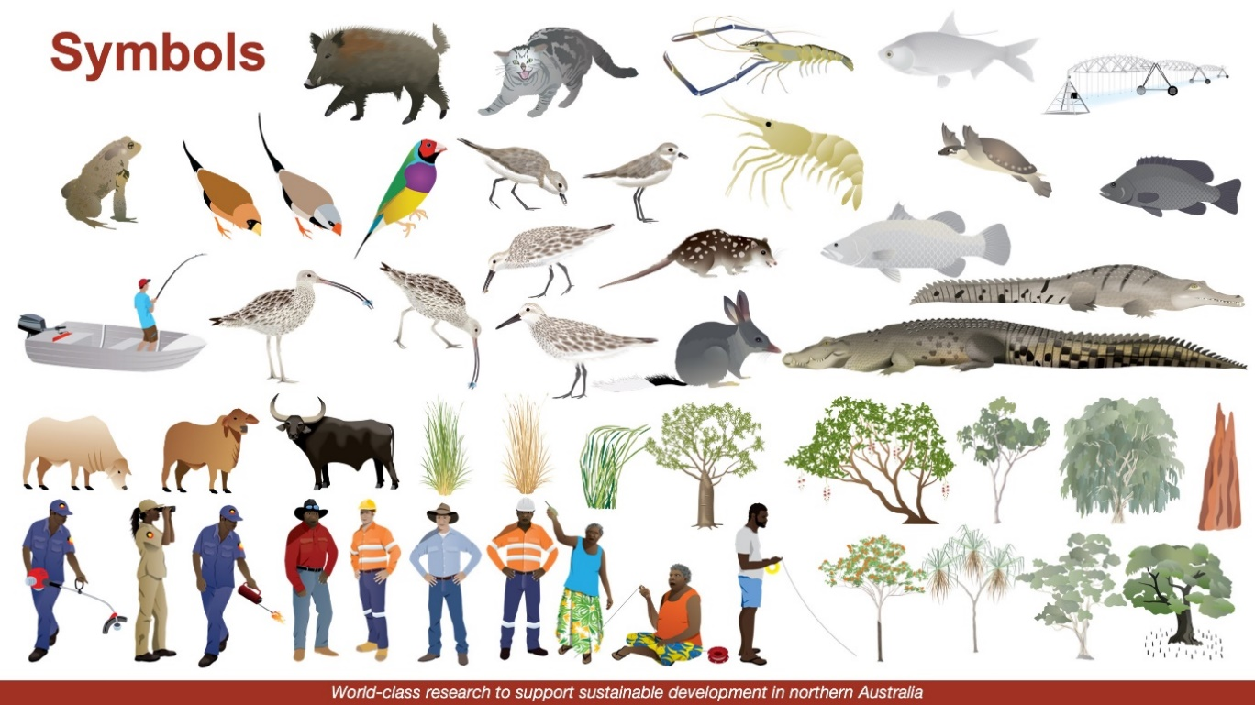
Source: https://www.nespnorthern.edu.au/2020/03/17/highlighting-people-science-and-impact-in-northern-australian-landscapes/

Findings and Conclusions
SGSEP draws the following findings and conclusions about each of the NESP Hubs and their commitment to Indigenous engagement in environmental and climate science research.

3.9.1 CAUL Hub
The CAUL Hub is one of two Hubs that has established an Indigenous Advisory Group. The Advisory Group’s role is to oversee the development and implementation of Indigenous engagement, collaboration and participation by the CAUL Hub, endorse the evaluation requirements with respect to the IEPS in overall CAUL Hub Reporting; and encourage alignment and coordination of the Hub’s IEPS with other initiatives including those led by other NESP Hubs, government, community, industry and the broader scientific community.
As Jason Barrow, one of the Co-Chairs of the CAUL Hub’s Indigenous Advisory Committee states:
‘The purpose of the Indigenous Advisory Group is to work with our various research teams across the Hub and to seek to embed aboriginal perspectives right across their research works. It could range from translating research into usable materials by community, by people, to help people succeed and to build cases within their communities, right through to employment, through to research careers for aboriginal people and indeed Aboriginal people leading and developing their own research pathways into the future.’
Under the guidance of its Indigenous Advisory Group and a wide network of Indigenous contributors, the CAUL Hub has worked hard to develop a cross-cultural and cross discipline approach to Caring for Country in cities. In developing its research plans, CAUL Hub is asking the question:
- Given thousands of years of Caring for Country in places we now call cities, how can city decisions better include Traditional Custodians, Indigenous knowledge and cultures in future city planning?
The Caring for Country concept embodies a stewardship approach to land and sea management which is deeply embedded in Aboriginal and Torres Strait Islander culture. The CAUL Hub has applied this concept in an urban context as a new and innovative way of interacting with nature and managing its resources for economic, social and cultural prosperity. The CAUL Hub’s research has resulted in a synthesis of Indigenous perspectives about urban planning and urban greening. In particular, introducing greater levels of Indigenous input and active engagement in managing urban public green and blue spaces in urban environments, reversing the trend of species loss, restoring ecological function and ecosystem services and reconnecting people with traditional Aboriginal knowledge in urban environments.
The CAUL Hub’s research has also focussed on how Indigenous values, perspectives and methodologies are able to drive environmental and climate science research in both urban and non-urban settings. The research found that urban practitioners and researchers need to better understand and engage in meaningful dialogue on the expectations, rights and aspirations of Indigenous communities in urban areas. Moving beyond a model of ‘inclusion’ of Indigenous people in research and teaching, especially within an urban context, toward genuine involvement in decision making about urban environments. The research has also identified that further work is required on developing better models for enabling Indigenous communities to define and direct research that is of importance and value to them.
The CAUL Hub’s Indigenous Advisory Group has played an active role in leading some of the CAUL Hub’s activities (such as the Indigenous Science Conversations in National Science Week 2018), as well as oversighting all of the CAUL Hub’s project proposals which has led to increased communication, collaboration and co-design with Aboriginal and Torres Strait Islander people and organisations in all of the CAUL Hub’s projects than would otherwise have been the case.
Figure 3.1 summarises the key activities completed and planned under the CAUL Hub IEPS from 2015 to 2020, and shows the progression of Indigenous engagement across the Hub’s activities.
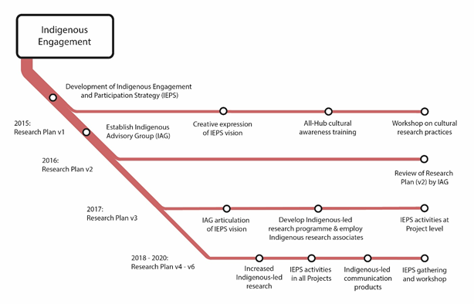
Figure 3.1: CAUL Hub IEPS Key Activities
Source: CAUL Hub Research Plan V6, page 21.

3.9.2 ESCC Hub
The ESCC Hub came from a position of minimal direct engagement with Indigenous peoples when it was first established. The ESCC hub has sought to develop a strong commitment to meaningful Indigenous engagement and collaboration. Where relevant, due consideration has been given by the ESCC Hub to actively involving key Indigenous stakeholders in research prioritisation, research delivery and communication of research output. The ESCC Hub has also sought to engage in mutually beneficial two-way dialogues with Indigenous stakeholders to explore ways traditional knowledge can inform Hub research and determine what climate change information Indigenous communities need.
The ESCC Hub was aware of the forum on climate change that had been hosted by Monash University under the National Climate Change Adaptation Research Facility (NCCARF) in 2012-13 (Griggs, et al 2013) that was run by Monash University and the Yorta Yorta Nation Aboriginal Corporation (YYNAC). Through a series of connections, the ESCC developed a relationship with the Yorta Yorta people who were keen to build on that initial gathering back in 2013. In the interests of building on the NCCARF gathering in 2013, the ESCC worked with the Yorta Yorta people to develop the National Indigenous Dialogue on Climate Change that was again hosted by Yorta Yorta on their ancestral Country in November 2018. While it took two years to organise the 2018 National Dialogue, it was led by an Indigenous steering committee from the outset. While invitations were issued to all of the Hubs, only the MB Hub accepted the invitation and sent representatives to attend and participate. The key outcome of the 2018 Dialogue was a statement from Traditional Owners (Figure 3.2) calling on the Australian Government to understand how Indigenous peoples have always understood the changing climate in Australia and the significance of Indigenous culture and its enduring nature.
The 2018 National Dialogue was one of the most significant national gatherings of Indigenous peoples on climate science research priorities. The National Dialogue identified several research priorities, including bio cultural renewal; monitoring of seasonal indicators; impact on water cycles/flows; water rights and access; impacts of resource extraction; governance and institutional responses; cumulative impacts and many others. The ESCC Hub reports that the 2018 National Dialogue generated a strong response among Aboriginal people and communities from across Australia and a growing interest in being involved in the next national dialogue and translating the outcomes into policies and actions. The ESCC Hub had commenced planning for the next national dialogue to be held in 2020, but at the time of writing it was seeking the agreement of the Department to postpone it to 2021 given the impact of the COVID-19 pandemic.
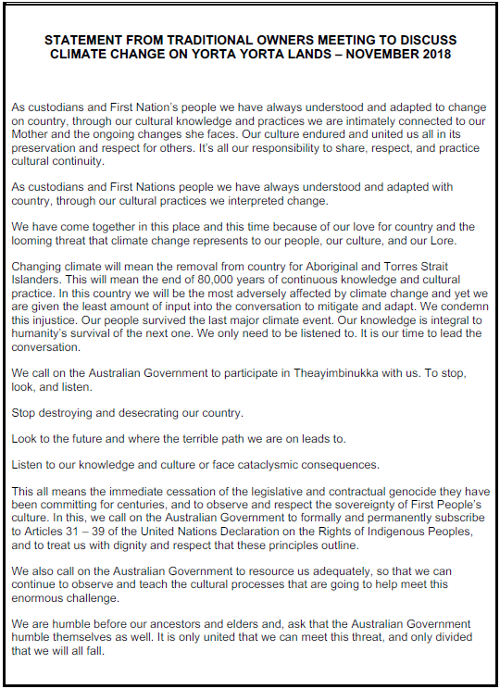
Figure 3.2: National Indigenous Dialogue on Climate Change 2018 - Statement on Indigenous people and climate change
Source: Morgan et al, 2018:7.
In 2019, the ESCC Hub continued to strengthened relationships started through the National Indigenous Dialogue on Climate Change by developing new networks in central Australia and working with these communities to provide climate information to inform housing developments. The ESCC has also commenced three significant projects in 2019 that are specifically aimed at raising the profile of Indigenous climate science research needs (Supporting Indigenous participation at the Australian Meteorological and Oceanographic Society 2020 Conference); improving the participation and inclusion of Indigenous peoples in understanding and using climate information for the management and protection of their traditional lands and seas under changing climatic conditions (Indigenous perspectives of climate risk); and supporting World Heritage Managers to identify climate change variables and benchmark the use of climate change information in the management of World Heritage Properties (Adapting to climate change and building resilience in Australian World Heritage properties: Using climate change science information to inform risk & vulnerability assessments and adaptation planning).

3.9.3 MB Hub
The MB Hub has also come from a position of minimal direct engagement with Indigenous peoples when it was first established. From the outset, the MB Hub sought to promote Indigenous engagement and participation in marine science research by convening a series of Indigenous engagement workshops at the Australian Marine Sciences Association’s (AMSA) annual conferences over the last four years, as discussed in Part 3.6 above. As stated earlier, an important part of this approach was to promote engagement and participation in both northern and southern Australia, given historical research efforts appear to have strongly favoured engagement with the former. These series of workshops have resulted in an increased and increasing level of awareness about engagement with Indigenous people in marine science research and resulting in genuine engagement.
The MB Hub has also focussed its efforts on EPBC Act Matters of National Environmental Significance (i.e. listed species, communities and world heritage areas) and protected places (Australian Marine Parks), and is finding that many of the listed species and communities accorded this formal significance are also of great importance to Indigenous people. Although the motivations and criteria for assigning significance may be different, there is a strongly shared commitment to ensuring that the Indigenous peoples will continue defining Australian seascapes and their spiritual and instrumental value as also being of value to Australian society. The marine research interests identified by Indigenous people reflect the powerful obligations they accept as custodians of sea Country and the lifeforms and ancestors depending on their management of sea Country. Research is continuing with a number of specific species and communities of interest to Indigenous peoples and in more recent years the Hub has extended its partnership approaches from northern to western and southern Australia. The MB Hub provided the details in Figure 3.3 to show the nature of their Indigenous engagement with Indigenous peoples and the species that are the subject of their research projects.
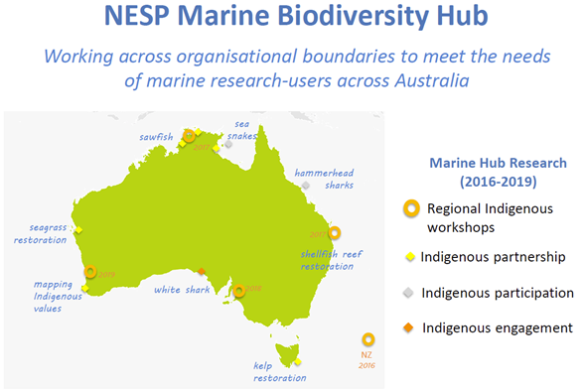
Figure 3.3: MB Hub selected Research projects 2016-2019
Source: Marine Biodiversity Hub

3.9.4 NAER Hub
The NAER Hub partners have a long track record of engaging with Indigenous peoples in large research programs in northern Australia as demonstrated through their involvement in the NERP and the TRaCK research program (Jackson and Douglas, 2015). The NAER has sought to build on these long-term relationships and has done so very effectively. Where relevant, the NAER Hub has actively sought to involve key indigenous stakeholders in research prioritisation, research delivery and the communication of research outputs.
Given the geospatial scope of the NAER Hub, it has been able to collaborate with Indigenous peoples on a very diverse range of matters, including environmental and Indigenous cultural water needs; environmental and economic accounting for river waters, the links between Gulf rivers, coastal environments and food for migratory birds; managing savanna riparian zones; assessing mangrove die-back in the Gulf; fish movement and sensitivity to contaminated mine water; waste and marine debris management; lessons from Top-End fire management; defining metrics for feral animal management; obnoxious and invasive weed management; prioritising threatened species management; monitoring, mapping and safeguarding threatened species; developing eDNA methods for detecting Top-End animals; and the development of Healthy Country indicators.
The NAER Hub has also been able to focus its efforts in collaborating with Indigenous peoples across northern Australia on enabling several cross-thematic projects of particular importance to Indigenous peoples and land managers, including:
- The Indigenous led Our Knowledge. Our Way in Caring for Country best practice guidelines;
- The Country: multiple values, multiple benefits into the future research priorities for IPAs across northern Australia, and the Economic values of Indigenous Protected Areas across Northern Australia; and
- The Report on the National Indigenous Fire Knowledge and Fire Management Forum – Building Protocols from Practical Experiences.
These and several other projects initiated by the NAER Hub have generated valuable lessons and resources for future research and the next iteration of the NESP.

3.9.5 TSR Hub
In mid-2017, the TSR Hub decided that it needed an Indigenous Reference Group (IRG) to assist the TSR Hub to improve Indigenous engagement and participation in the Hub’s activities and research projects. Members are appointed on the basis of their capacity to understand research, community, government and threatened species, along with the aim of having a gender balance and geographical balance. The IRG’s role is to assist the Hub with better aligning its research with Indigenous Australians’ strategic needs, identify activities within the Hub which could advance Indigenous Australians’ involvement in threatened species recovery and management, advice on how to value-add to projects by addressing Indigenous research needs, and advice on culturally appropriate formats for research outputs for Indigenous end-users and stakeholders. The IRG has a standing item on its agenda to scrutinise at least 2-4 projects at each meeting to track the level of Indigenous engagement and their progress. The IRG is also currently leading a project that aims to articulate Indigenous interests and management aspirations for culturally important species and overseeing the development of Cultural Engagement Guidelines for Threatened Species Researchers.
The TSR Hub has been able to collaborate with Indigenous peoples on a wide range of matters. Including mitigating feral animal impacts on native animals; saving endangered species; contrasting outcomes of contemporary and traditional fire management approaches in different environments; improving conservation measures for threatened species; long-term monitoring of threatened species to try and unravel causes of decline and extinctions of threatened species; developing coordinated monitoring programs; optimising the design of a network of havens for vulnerable species; key factors for effective partner integration and governance for threatened species and developing national monitoring priorities for threatened species.
The TSR Hub has also played a key role in assisting DAWE with identifying the threatened ecological communities following the 2019-20 bushfire season, including the appointment of leading researchers involved in the TSR Hub to the Minister’s Wildlife and threatened species bushfire recovery Expert Panel.

3.9.6 TWQ Hub
The TWQ Hub has also been building on its long-standing collaborations with Indigenous peoples, particularly in Qld along the Great Barrier Reef and other parts of Northern Australia. The development and application of the 3-Category Approach by the TWQ Hub has played a significant role and the majority of scientists involved through the TWQ Hub are quite comfortable with its application.
The TWQ’s research on TOs and Sea Country in the Southern Great Barrier Reef was used to further define Indigenous aspirations in the Reef 2050 Plan, and the research on Ecosystem Services in the Eastern cape York Peninsula is proving invaluable in terms of holistic approaches to environmental management in tropical waters.
Thematically, the research priorities that the TWQ Hub has been able to collaborate with Indigenous peoples on, includes further research on the crown of thorns invasive species; best practice approaches to restoration of the Reef; improving coral conditions in the Reef through better resilience-based management practices; better management of estuarine environments flowing into the Reef; assessment of key Turtle and Dugong seagrass resources in the northern Torres Strait; water quality and ecosystem health threats in the Torres Strait; and capacity building and increased participation in sea Country management.

Commonwealth Agencies, NESP Research and Indigenous Research Themes / Questions

Introduction and Approach
For comparative and overlap purposes, SGSEP also undertook a review of the environmental and climate science research priorities and activities of several Commonwealth agencies and departments, as well as their Indigenous engagement policies and activities and any connections the agencies or departments have with NESP Hub research projects. This Chapter presents the results of our review.
The agencies and departments SGSEP reviewed include the following:
- Australian Institute of Marine Science (AIMS)
- Bureau of Meteorology (BoM)
- Commonwealth Scientific and Industrial Research Organisation (CSIRO
- Geoscience Australia (GA)
- Great Barrier Reef Marine Park Authority (GBRMPA)
- Murray Darling Basin Authority (MDBA)
- Torres Strait Regional Authority (TSRA)
- Department of Prime Minister and Cabinet (PM&C) and the National Indigenous Australians Agency (NIAA), and the
- Department of Agriculture, Water and the Environment (DAWE).
As agencies or departments of the Commonwealth, these institutions are actively involved in policy development and program implementation or research in their respective areas of interest or specialised fields. These agencies and departments are also significant initiators and/or end-users of NESP research activities and outputs.
This assessment was carried out by examining the publicly available information about environmental and climate science functions, programs and/or research activities of each of the Agencies and the two Departments, where the Agency or Department has any connection with NESP Hub research activities and, where possible, whether any Indigenous research themes and questions are identified. The assessment was current for most of the Agencies and the two Departments as at January and March 2020. The Machinery of Government changes that were announced in December 2019 and came into effect from 1 February 2020 were taken into account in this assessment.
SGSEP prepared separate overviews of each agency’s activities, their Indigenous engagement policies and approaches and research activities. These overviews were shared with the respective agency for accuracy and have been provided to the Department as separate documents. Our analysis is included as Appendix H to this Report.

Commonwealth Agencies and Departments, Indigenous Engagement and Research Priorities
The following provides a brief snapshot of each Agency’s or Department’s research priorities and Indigenous engagement and how they may relate to Indigenous environmental and climate science research themes and questions. The following should be read in conjunction with the more detailed analysis provided in Appendix H.

Australian Institute of Marine Science (AIMS)
AIMS’ primary research focus is to support a resilient Great Barrier Reef, sustainable coastal ecosystems and industries across northern Australia, including environmentally sustainable offshore oil and gas development on Australia’s North-West Shelf. AIMS’ current research priorities include:
- Cumulative impacts and ecosystem resilience. Understanding the cumulative impacts of global and local pressures on tropical marine ecosystems.
- Marine and coastal industries. Supporting the sustainable development of Australia’s marine and coastal industries through partnership and innovation.
- Measuring change. Supporting conservation and sustainable use in tropical marine environments.
- Reef recovery, adaptation and restoration. Enhancing the evolutionary potential and climate resilience of coral reefs for conservation and management.
- Species at risk. Identifying important habitats and threats to iconic marine species.
- Technology development and innovation. Information, monitoring and decision-making tools to help managers meet the challenges of sustainable ocean use.
AIMS’ current research programs include:
- A healthy and resilient Great Barrier Reef program to conduct interdisciplinary research to provide managers and policymakers with a better understanding of the Reef’s vulnerability to climate change and ocean acidification, and its interactions with local and regional environmental stressors.
- Sustainable coastal ecosystems and industries in tropical Australia to deliver science relating to the critical issue of cumulative stressors in a broad range of tropical marine habitats arising from coastal and catchment development, in the context of shelf-scale ecosystem drivers.
- Sustainable use of north-west marine ecosystems to focus on the sustainable development of marine resources in north-west Australia.
- Data and technology innovation to provide the interface between science and infrastructure management, and in some cases science and users.
AIMS’ National Marine Science Research Plan 2015-2025 (2015) acknowledges that Indigenous Australians can play an increasing role in marine research and monitoring; recognises the Indigenous peoples’ cultural connection with the oceans around Australia; and increasing opportunities for collaboration between Indigenous and Western knowledge systems. AIMS’ Strategy 2025 also commits the agency to building its internal cultural competence and meaningful partnerships with Traditional Owners of sea country in northern Australia to deliver impactful research for both Indigenous and non-Indigenous Australians, and focussing on bringing together Indigenous knowledge with other areas of science to create new insights into Australia’s marine systems, as conditions and circumstances allow, as well as sharing the results of its work to help improve the impact of its research.

Bureau of Meteorology (BoM)
BoM has meaningful engagement with Aboriginal and Torres Strait Islander people both as users of Bureau products and services, and as contributors to or sharing knowledge with the Bureau. BoM strives to understand, harness and celebrate the unique skills and perspectives of Aboriginal and Torres Strait Islander people. For example, through the Indigenous Weather Knowledge website BoM is working with communities that wish to record and share valuable seasonal and environmental information and traditional knowledge.
BoM has also developed a website devoted to Indigenous Language, Culture and Environmental Knowledge, to aid learning about the history of Indigenous weather, season and environment knowledge across Australia. The webpage includes links to 16 different cultural groups and their annual climate cycles.

Commonwealth Scientific and Industrial Research Organisation (CSIRO)
CSIRO recently completed its second Reconciliation Action Plan (RAP), which aims to strengthen its approach to driving reconciliation through its business activities, services and programs, and develop mutually beneficial relationships with Aboriginal and Torres Strait Islander stakeholders and commits CSIRO to continue fostering a culture of inclusion and cultural awareness (CSIRO, 2018). CSIRO's RAP:
- Affirms CSIRO’s commitment to reconciliation with Aboriginal and Torres Strait Islander peoples, the oldest living culture in the world;
- Recognises Aboriginal and Torres Strait Islander peoples as the first inhabitants of Australia and respects their enduring connection to lands, skies, waters, plants and animals;
- Commits to enabling Aboriginal and Torres Strait Islander peoples to contribute to and benefit from education, science, innovation and research;
- Demonstrates CSIRO's commitment to fostering a culture of inclusion and cultural awareness;
- Demonstrates that CSIRO is contributing towards the Commonwealth Government's target of three per cent of all purchases being made through Aboriginal and Torres Strait Islander owned businesses;
- Commits to the Commonwealth Government’s target of three per cent Aboriginal and Torres Strait Islander employment and outlines a new Aboriginal and Torres Strait Islander Employment Strategy to help CSIRO achieve this;
- Commits to celebrating the successes of Aboriginal and Torres Strait Islander peoples and the sharing of their customs, cultures, knowledge and languages to improve CSIRO’s work for the benefit of the Australian community.
A key science related action within the CSIRO RAP is:
- Action 5 – Opportunities: Increase Indigenous-led, driven and/or co-developed research activities in areas that address aspirations, opportunities and challenges prioritised by Aboriginal and Torres Strait Islander people, communities and organisations (CSIRO, 2018).
CSIRO engages Indigenous people in the co-design, implementation and translation of outcomes of research projects through diverse range of approaches, including participatory action research, weaving Indigenous, scientific and local knowledge, photovoice, collaborative film production, participatory mapping, matrices and guides that identify cultural law risks, and the “Walking-Together” Indigenist research approach: research as a respectful, reciprocal exchange between Indigenous peoples involving five steps.
CSIRO is also developing an Indigenous Cultural and Intellectual Property (ICIP) policy and protocols to guide organisational responses in operating at the cultural interface between IP and ICIP.
CSIRO is engaged in substantial research aimed at the development of new Indigenous enterprises and economies based on land, water and sea that have a sustainable social and environmental bottom line/benefit. Key application domains include:
- Fire management for carbon and protocols for Indigenous fire partnerships;
- Environmental and ecosystem services;
- Biosecurity and feral animals;
- Ecotourism;
- Blue economy;
- Bush food development;
- Pastoral improvement/transition;
- Evaluating investment in in Indigenous cultural and natural resource management (ICNRM) to identify multiple co-benefits, enhance new income streams, help close the gap, and generate pathways to economic independence; and
- Understanding non-government investment in ICNRM enterprises, including philanthropic and impact investors.
While CSIRO hosts the Earth Sciences and Climate Change (ESCC) Hub funded under NESP, many of CSIRO’s scientists are also engaged in several research projects initiated by the other NESP Hubs. The following are just a very small selection of NESP Hub projects where CSIRO scientists have played active and key roles.
- Bininj/Mungguy indicators for healthy country Project. Through the NAER Hub, CSIRO was involved in the developing and trialling an adaptive approach to co-management using Bininj/Mungguy indicators to monitor and evaluate the health of important values on Country. (NAER Hub Project No. 5.5 Phase 2)
- Protocols for Indigenous fire-management. Through the NAER Hub, CSIRO was involved in the development of a series of protocols to guide Indigenous fire management partners delivering environmental and cultural management programs. (NAER Hub Project 5.2)
- Managing threatened species and their habitats. Through the TSR Hub CSIRO collaborated with Indigenous people to support on-Country opportunities for protecting and recovering Australia's threatened species and their habitats. (TSR Hub Project No. 6.2)
- Research priorities for Indigenous Protected Areas (IPAs). Through the NAER Hub, CSIRO collaborated in an assessment of the research priorities for IPAs in northern Australia and identifying the environmental, social, economic and cultural benefits associated with IPAs. (NAER Hub Project No. 5.1)
- Investing in Indigenous cultural & natural resource managers. Through the NAER Hub, using Indigenous led and co-developed participatory methods, focused on three key investor types – Indigenous corporations and communities, shareholder corporations, and philanthropic investors – to help investment in the ICNRM sector continue to expand and diversify into the future. (NAER Hub project No. 5.6)

Geoscience Australia (GA)
GA’s work aligns with the national science and research priorities and supports global and domestic government initiatives, and impacts six key areas of society:
- Maximising the value from our abundant mineral and energy resources;
- Strengthening our resilience to the impact of hazards;
- Optimising and sustaining our water use;
- Supporting the sustainable use of our marine environment;
- Using digital mapping for faster and smarter decision making; and
- Equipping government, industry and the community with geoscience data, and information to make informed decisions.
GA’s Strategic Plan 2028, commits GA to delivering data and advice that helps government, industry and the community to address challenges and enhance opportunities facing Australia now and into the future. In doing so, GA also commits to respect and collaborate with the First Peoples—Australia’s original mappers, miners and navigators (GA, 2019).
The current level of engagement between GA and stakeholders depends on the type of activity being undertaken, the degree to which the land would be disturbed and the type of stakeholder involved. GA uses four levels of engagement: notify, consult, involve and collaborate. For example, an aerial survey with no ground disturbance requires notification only to the affected stakeholders. However, stakeholders are encouraged to express concerns and ask questions. Additional consultation is undertaken on a case-by-case basis and tailored to specific needs. GA’s Strategic Plan notes that it will maintain a focus on the needs of its stakeholders, including respectfully engaging and collaborating with Aboriginal and Torres Strait Islander peoples.
In 2020, GA adopted a new Land and Marine Access (LAMA) Strategy which provides for an Indigenous Stakeholder Engagement Strategy (GA, 2020). The LAMA Indigenous Engagement Strategy 2020 sets out to develop trusted, mutually beneficial relationships and collaborations with Indigenous stakeholders through the application of best-practice engagement protocols. The UN Declaration on the Rights of Indigenous Peoples (UN, 2007) and the UN 2030 Agenda for Sustainable Development (UN, 2015) are used to inform the LAMA Indigenous Engagement Strategy. The LAMA Indigenous Engagement Strategy aims to continue to build and strengthen relationships with Aboriginal and Torres Strait Islander groups and communities, develop trusted relationships with mutual benefit, and includes several objectives and short and long-term indicators for measuring its success. The LAMA Indigenous Engagement Strategy also includes a commitment to collaborating with other federal and state agencies by sharing knowledge and resources which are likely to lead to more integrated outcomes and mitigate the risk of ‘engagement fatigue’ that might result amongst GA’s key Indigenous stakeholders.
GA has identified two issues in relation to its efforts to meaningfully engage with Aboriginal and Torres Strait Islander communities and TOs, and they are: obtaining true consent to access land and assets; and data access disadvantage. Aboriginal and Torres Strait Islander peoples have expressed much frustration over these matters to GA, and GA has acknowledged their concerns (Mouthaan et al, 2020).
Given the concerns expressed by Aboriginal and Torres Strait Islander peoples, GA is in the process of placing much greater effort in moving to a more formal approach to managing marine and land access. GA has therefore committed to ensuring meaningful engagement with Aboriginal and Torres Strait Islander stakeholders through free, prior and informed consent. In working towards these goals, GA is striving to engage early with traditional owners of land where surveys are being conducted, allowing sufficient time for relationships of trust to be developed.

Great Barrier Reef Marine Park Authority (GBRMPA)
Aboriginal and Torres Strait Islander people are the Traditional Owners (TOs) of the GBR region, with evidence of their sea Country connections dating back over 60,000 years. The sea Country of approximately 70 Traditional Owner clan groups includes the GBR Marine Park.
GBRMPA works with Aboriginal and Torres Strait Islander TOs and acknowledges their continuing social, cultural, economic and spiritual connections to the GBR region, and recognises that establishing effective and meaningful partnerships with TOs is essential to protecting cultural and heritage values, conserving biodiversity and enhancing the resilience of the GBR. GBRMPA collaborates with TO groups to develop a suite of sea Country management arrangements including Traditional Use of Marine Resources Agreements (TUMRAs) and Marine Park Indigenous Land Use Agreements (ILUAs) covering approximately 46,808 square kilometres of the GBR Region.
In 2016, the Department commissioned the Gidarjil Development Corporation to consult with Traditional Owners and develop a Reef 2050 Indigenous Implementation Plan (Gidarjil Development Corporation, 2016). The Gidarjil Development Corporation found that the capacity of TOs is variable across the region; continued support for existing efforts is important; most of the Indigenous actions in the Reef 2050 Plan are closely linked; Further consultations need to be undertaken to inform monitoring and reporting; and Implementation should focus on coordination, cultural heritage and business capacity. The Report also identified coordination; cultural heritage; and business capacity as key priority areas for implementation.
In 2017 the Australian Government commissioned a consortium of Indigenous and research organisations, led by the Reef and Rainforest Research Centre (RRRC), to engage with GBR TOs to better understand and reflect their aspirations for the GBR and deliver on existing commitments. The consortium’s report (CoA, 2018), provides advice from GBR TOs about their aspirations for involvement in the management, governance and protection of the GBR. The Report notes that while significant progress has been made with respect to land and sea rights across much of the GBR (catchment and marine) and the emergence of some outstanding examples of TOs, government agencies and researchers working together in productive partnerships, there is no lasting, continuously improving GBR-wide approach to empowering TOs in the governance of the GBR. The Report also states that with the future health of the GBR under serious threat from climate change and other stresses, it is now critical to harness the capacity of TOs and their sea Country institutions for a new generation of reef protection and management into the future. The Report recommends the establishment of a GBR-wide Sea Country Traditional Owner Alliance; resourcing the GBR’s leading research institutions to jointly collaborate with TOs to negotiate a long-term strategy for supporting TO knowledge and research needs (e.g. data sharing agreements, etc.); and TOs be embedded in all aspects of GBR monitoring and evaluation using culturally appropriate approaches (e.g. Strong Country – Strong People Framework).
The GBRMPA is responsible for the preparation of several primary documents, including the Great Barrier Reef Blueprint for Resilience (GBRMPA, 2017), the Reef 2050 Long-Term Sustainability Plan (AG, 2018), and the GBR Outlook Report 2019 (GBRMPA, 2019), all of which contain considerable information and guidance about how the reef needs to be managed, including working with the TO groups of the region and identifying research priorities.
The GBR Outlook Report 2019 examines the GBR’s health, pressures, and likely future, and aims to provide a regular and reliable means of assessing reef health and management in an accountable and transparent way. The Report also identifies that the GBR Region still faces significant pressures ranging in scale from local to global, and that the greatest threat to the Reef is still climate change:
A comprehensive risk assessment of 45 threats to the Region’s ecosystem and heritage values considered the residual risk, after taking into account the current management regime. The 10 threats identified in 2014 as presenting a very high risk to the Region’s ecosystem and heritage values are again the highest ranked in 2019. Of the very high-risk threats, most relate to climate change or land-based run-off (water quality) affecting values on a Region-wide scale. Given the current state of the Region’s values, actions to reduce the highest risks have never been more time-critical. …. Without additional local, national and global action on the greatest threats, the overall outlook for the Great Barrier Reef’s ecosystem will remain very poor, with continuing consequences for its heritage values also. The window of opportunity to improve the Reef’s long-term future is now. Strong and effective management actions are urgent at global, regional and local scales (GBRMPA, 2019:vi).
In relation to research activities, the GBR Outlook Report 2019 states:
Inclusion of Traditional Owners in research within their sea country is limited and research results are often not disseminated to Traditional Owners. However, examples of collaboration are increasing. These include: a protocol between the Wuthathi Aboriginal Corporation and Queensland Parks and Wildlife Service to manage permits for research in the Shelburne Bay area in Cape York; new guidelines for Woppaburra Traditional Owner Heritage Assessments in the Keppel islands region; and involvement of Traditional Owners in the development and implementation of research, monitoring and beach restoration at Raine Island (GBRMPA, 2019:205).
Multiple managing agencies continue to have representation on major committees relating to research on the Reef. Many of these are coordinated through the overarching Reef 2050 Plan. However, a number of researchers noted decreased engagement from the Marine Park Authority’s staff on research priorities, which they attributed to a loss of key staff members at the authority over the past few years. The reduced engagement may also be a consequence of diversified sources of funding for research in the Region, with significant research funds being managed through the Commonwealth Department of the Environment and Energy (GBRMPA, 2019:206).

Murray Darling Basin Authority (MDBA)
The MDBA has developed partnership agreements with the Northern Basin Aboriginal Nations (NBAN) and the Murray Lower Darling Rivers Indigenous Nations (MLDRIN), and works with them and a wide range of other community organisations to help raise public awareness about Aboriginal interests and concerns relating to water and invests considerable effort into collecting and sharing Aboriginal information across the Basin.
The MDBA is committed to working with NBAN and MLDRIN to develop and incorporate Basin Nation’s environmental watering objectives into environmental water planning and management, including through the First Nations Environmental Water Guidance (FNEWG) Project and the National Cultural Flows Research Project. The MDBA has also actively engaged with Indigenous peoples across the Basin on several other research projects, including water resource planning; reporting on Aboriginal participation in water for the environment; the Living Murray (TLM) Indigenous Partnerships Program; the Aboriginal Weather Watchers Project; the Aboriginal Water Entitlements Program; and Ranger groups and interest in expansion to water.
It is noted however, that no environmental or climate science research has been undertaken by the NESP Hubs in the Murray Darling Basin with the MDBA, MLDRIN or NBAN, other than the ESCC’s Hubs work with the Yorta Yorta Nation Aboriginal Corporation to host the National Indigenous Dialogues on Climate Change.

Torres Strait Regional Authority (TSRA)
The TSRA provides regional coordination of policies and programs of benefit to Torres Strait Islander and Aboriginal people living in the region. The TSRA consists of an elected arm and an administrative arm, and is the only such regional Indigenous body in Australia, delivering services to all communities in the Torres Strait and to Bamaga and Seisia on Cape York.
The Torres Strait region stretches 150 km from Cape York Peninsula to 3.73 km off the south-west coast of Papua New Guinea, covering an area of approximately 48,000 km2. The region straddles the Australia – Papua New Guinea international border and contains the Torres Strait Protected Zone, established under the Torres Strait Treaty between the two countries to acknowledge and protect the traditional way of life and livelihood of their Indigenous inhabitants.
The region is identified by the Australian Bureau of Statistics as the Torres Strait Indigenous Region. The majority of the region’s population is Indigenous, comprising two distinct Indigenous races – Torres Strait Islander and Aboriginal peoples. The population is located on eighteen island communities in the Torres Strait and five Torres Strait Islander and Aboriginal communities on the Northern Peninsula Area of Cape York (Seisa, Bamaga, Umagico, Injinoo, New Mapoon).
The TSRA has been actively involved in several environmental and climate science research projects in in the region, including the Traditional Ecological Knowledge (TEK) Project (TSRA, 2016) and the Torres Strait Climate Change Strategy 2014-2018 (TSRA, 2014).
The Traditional Ecological Knowledge (TEK) Project (TSRA, 2016) is a database system managed by the Torres Strait Regional Authority (TSRA) Land and Sea Management Unit (LSMU). The TEK Project Review included several key recommendations for improvements to the system, including improving community access to TEK systems through investigation of offline data upload; focusing on key TEK communities in order to acquire a baseline level of ecological data in these; increase staffing levels for TEK Project to adequately support TEK Systems; investigating the incorporation of TEK data sets into land and sea planning; and continuing to train rangers and LSMU staff on the importance of incorporating TEK into LSMU activities and recording methods.
The revised Torres Strait Climate Change Strategy 2014-2018 (TSRA, 2014) highlights current climate trends and recent updates to climate change predictions for the region, and identifies the need for further research that targets species vulnerable to climate change (e.g. corals, fishes, crayfish, marine turtles, dugongs, seagrasses, pelagic foragers) to optimise the effectiveness of resilience-based management. Several knowledge gaps have also been identified, including lack of high-quality data; El Niño-Southern Oscillation (ENSO) and the Indian Ocean Dipole; tropical cyclones in the region; Climate Change Projections from Global Climate Models; and high-resolution regional climate models. (Suppiah et al, 2010:54).
TSRA is currently participating in two NESP research projects being undertaken by the TWQ Hub: Identifying the water quality and ecosystem health threats to the Torres Strait from the Fly River runoff, and Improving historical estimates of abundance and distribution of dugongs and large green turtles in western and central Torres Strait.

Department of Prime Minister and Cabinet (PM&C) and the National Indigenous Australians Agency (NIAA)
On 12 June 2019 the Prime Minister announced the transition of the Indigenous Affairs Group within PM&C to become the National Indigenous Australians Agency (NIAA). The new NIAA began operations on 1 July 2019. The two key programs of relevance to this report are the Indigenous Protected Area (IPA) Program and the Indigenous Rangers Program (formerly Working on Country).
The IPA program has been helping Indigenous communities voluntarily dedicate their land or sea Country as IPAs since 1997 and has achieved some remarkable successes, as demonstrated by the following statistics:
- The first IPA, Nantawarrina, celebrated its 20th anniversary on 27 August 2018.
- There are 76 IPAs that make up almost 44 per cent of Australia’s National Reserve System, managed for the benefit of all Australians.
- Over 60 per cent of IPAs are managed by Australian Government funded Indigenous ranger groups.
- 839 Aboriginal and Torres Strait Islander people are employed in full-time, part-time and casual jobs under the IPA Program.
Indigenous ranger projects were first funded in 2007 through the former Working on Country (WoC) Program to create meaningful employment, training and career pathways for Aboriginal and Torres Strait Islander people working in land and sea management. Indigenous ranger projects support Indigenous people to combine traditional knowledge with conservation training to protect and manage their land, sea and culture. Indigenous ranger groups also develop partnerships with research, education, philanthropic and commercial organisations to share skills and knowledge, engage with schools, and generate additional income and jobs in the environmental, biosecurity, heritage and other sectors.
By achieving employment and environmental outcomes, alongside wider social, cultural and economic benefits, the work of Indigenous rangers is valued by Indigenous communities across Australia. Independent evaluations of the Indigenous Rangers and IPA programs in 2006 (Gilligan, 2006) and in 2016 (SVA Consulting, 2016) found that rangers had experienced increased confidence and skills through their training and work on Country. Rangers reported they felt more pride, self-worth, health and wellbeing, with closer connections to family, culture and Country. Ranger groups also reported a wide range of community benefits as a result of the programs, including safer communities, strengthened language and culture, an ability to find meaningful employment, increased respect for women, and more role models for younger people.
Indeed, the 2016 Social Return on Investment study of the IPA and Working on Country (WoC) programs (SVA Consulting, 2016) found that:
- Engaging Indigenous Australians in meaningful employment to achieve large scale conservation outcomes.
- Facilitating reconnection with Country, culture and language to achieve exceptional levels of engagement among Indigenous Australians which is driving positive social, economic, cultural and environmental outcomes.
- Helping to catalyse the development of an Indigenous land and sea-based economy, empowering Indigenous landowners to manage their Country in accordance with their priorities.
- This report synthesises findings from across the analyses, exploring the relevant drivers of value and alignment of program outcomes with PM&C's Strategic Priorities.
SVA Consulting (2016) concluded that over the period between the 2009 and 2015 financial years, an investment of $35.2m from Government and a range of third-party investors has generated social, economic, cultural and environmental outcomes with an adjusted value of $96.5m.
However, since the Machinery of Government changes in 2013 that created the Indigenous Advancement Strategy, the administration of the IPA Program has been awkwardly split between two different Departments. Under current Administrative Arrangements, the NIAA is responsible for the ongoing funding to IPAs through the Indigenous Ranger Program and the Department of Agriculture, Water and the Environment retains responsibility for the selection of new IPAs. Among the feedback from consultations with various Indigenous stakeholders, serious concerns were expressed about the artificial disconnect of the ongoing upkeep of IPAS and the Indigenous Ranger Program from Aboriginal and Torres Strait Islander peoples’ holistic view of looking after Country generating numerous other benefits.
As is also discussed in Chapter 6, it is well established over more than a decade of empirical research that IPAs deliver more than environmental benefits because the Indigenous managers are ‘caring for their Country’ (Garnett and Sithole, 2007; Ganesharajah, 2009; Burgess et al, 2009; Zander and Garnett, 2011; Larson et al, 2020). Indigenous communities managing the IPAs are able to protect the values of their Country for future generations and achieve significant health, education, economic, social and cultural benefits, not only for their peoples, but also for Australia more generally. These benefits are well beyond any doubt (SVA Consulting, 2016). It was expressed to SGSEP in no uncertain terms that the disconnect between the IPA Program and the Indigenous Ranger Program from the overall management of Australia’s conservation estate risks placing the deeper benefits of the programs in much greater jeopardy.

Department of Agriculture, Water and the Environment (DAWE)
The Department of Agriculture, Water and the Environment (DAWE) was established on 1 February 2020. The Department is responsible for the administration of over 125 statutes and regulations relating to agriculture, water and the environment (CofA, 2019). DAWE’s functions also include responsibility for environmental information and research, environment protection and biodiversity conservation, natural built and cultural heritage, and coordination of climate change/systems science research activities, among many other matters relating to other parts of the portfolio. DAWE and its agencies are the biggest end-users of NESP research outputs.
The overview that follows focusses on the matters most pertinent to the scope of this review of Indigenous engagement in the NESP and in particular to Indigenous environmental and climate science research themes and questions, and is a snapshot of the details provided in Appendix H.

The Environment Protection and Biodiversity Act 1999 (Cth) (EPBC Act)
The EPBC Act is Australia’s central piece of environmental legislation which provides a framework to protect and manage nationally and internationally important flora, fauna, ecological communities and heritage places - defined under the EPBC Act as Matters of National Environmental Significance (MNES).
The EPBC Act provides for the recovery plans for threatened species, setting out what must be done to protect and restore important populations of threatened species and habitat, as well as how to manage and reduce threatening processes. Recovery plans achieve this aim by providing a planned and logical framework for key interest groups and responsible government agencies to coordinate their work to improve the plight of threatened species and/or ecological communities. In many cases, the recovery plans rest heavily on research undertaken under the auspices of the NESP, and in turn on partnerships with Indigenous people in order to access and utilise their IK, as the following case study demonstrates.
Case Study 8 is an example of the kind of partnerships with Indigenous peoples and other partners that can be developed around threatened species and their recovery.

Case Study 8: Psephotus chrysopterygius — Golden-shouldered Parrot, Alwal

National recovery plan for the Golden-shouldered Parrot (Psephotus chrysopterygius) 2003-2007
The golden-shouldered parrot is one of 20 birds that the Australian Government has prioritised resource allocation to support the species recovery effort. This species is a priority for investment primarily because of the support afforded to actions to recover it through community partnerships. Priority actions needed to recover this species include protecting termite mounds and associated foraging habitat, controlling feral pigs and feral cats and implementing suitable burning regimes.
The golden-shouldered parrot, or alwal, is a significant cultural species for the Olkola people of Cape York. This brilliantly coloured little parrot lives in tropical savanna woodland, spending much of its time on the ground feeding on grass seeds. Alwal have the unusual habit of nesting in old termite mounds which makes them vulnerable to feral pigs and cats.
The Olkola Aboriginal Corporation, Bush Heritage and landholders are working together with Queensland Parks and Wildlife Service to implement actions from the recovery plan.
The preface of the new draft Recovery Plan states:
‘Traditional Owner groups participating in the golden-shouldered parrot Recovery Team welcome the opportunity to work with partners who can help to meet the objectives of the Recovery Plan. All requests to work in partnership with the Recovery Team and participating Traditional Owner groups should be directed to the Recovery Team secretariat at recoveryteam@olkola.com.au. Potential partners will be requested to complete an Expression of Interest form to identify the purpose of their proposed work and whether there is a good alignment of purpose with the Recovery Plan objectives. This process is necessary to protect Indigenous interests in golden-shouldered parrot recovery as outlined in Specific Objective 1.1 of the recovery program.’
Sources:
https://www.environment.gov.au/biodiversity/threatened/recovery-plans/recovery-plan-golden-shouldered-parrot-psephotus-chrysopterygius-2003-2007
https://www.environment.gov.au/system/files/resources/f2ba8fe9-2091-4e37-84ac-dc1ee04c5179/files/p-chrysopterygius.pdf
http://www.environment.gov.au/cgi-bin/sprat/public/publicspecies.pl?taxon_id=720
https://www.bushheritage.org.au/newsletters/2016/summer/bring-alwal-home

An independent review of the EPBC Act is currently underway and is due to report later in 2020. In a Discussion Paper (Samuel, 2019), the Review panel notes that respect for and appreciation of Aboriginal and Torres Strait Islander peoples and their cultures has deepened since the introduction of the Act, and that Aboriginal and Torres Strait Islander peoples’ roles could be strengthened by placing an emphasis on early and genuine engagement with them, and updating the objects of the Act to provide more emphasis and clarity on the involvement and interests of Indigenous Australians. SGSEP agrees, including in relation to the connections between Indigenous-driven environmental and climate science research outcomes and recovery plans prepared under the EPBC Act.
The EPBC Act also establishes the Indigenous Advisory Committee (the Committee) as a statutory committee to advise the Minister on the operation of the EPBC Act and on other relevant matters as requested by the Minister, taking into account the significance of Indigenous peoples' knowledge of the management of land and the conservation and sustainable use of biodiversity. The IAC meets about once or twice per year and Bulletins from each meeting are placed on the web. An examination of the Bulletins shows that over the last five years the IAC has provided regular input into the NESP, providing valuable insights and feedback on current program delivery, ensuring greater transparency in how local research priorities are considered, the need to identify best practice approaches and seek more consistency in Indigenous engagement across the Hubs.

The State of the Environment (SoE) Report
Every five years, the Australian Government commissions an independent review of the state of the environment (SoE) to provide all Australians with authoritative information on the state of the environment that sustains our economy and wellbeing, an assessment of how effectively the Australian environment is being managed and what the key national environmental issues are. While the most recent SoE Report (2016) does not necessarily single out Indigenous issues as a theme, it does highlight Indigenous peoples’ concerns and inputs across a number of themes, including heritage, land and water, pressures affecting the environment, the marine environment and other matters. For example, there is discussion of the use of land and vegetation for carbon sequestration by Indigenous land owners (Figure 4.1 left) and the development and take up of innovative scientific tools by Indigenous Rangers for harvesting biodiversity observations and monitoring long term change in our environment (Figure 4.1, right) (Jackson et al, 2017:32, 34,76-77).
For the 2021 Report, the SoE Taskforce is designing a culturally appropriate process to ensure authoritative Indigenous voices and cultural perspectives about environmental condition and change underpin the 2021 National Report. Drawing on the advice of the IAC, the 2021 report will bring together a mix of traditional, scientific and regional knowledge to inform decision making for better environmental outcomes, including Indigenous knowledge about caring for Country. The use of storytelling using culturally appropriate communication mediums like videos, will ensure the report can be communicated back to Indigenous audiences.

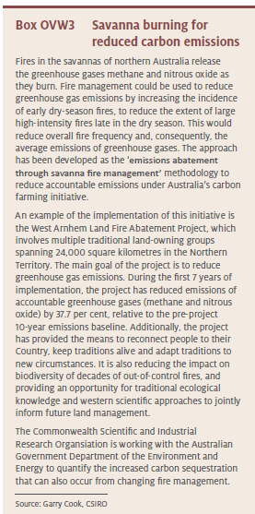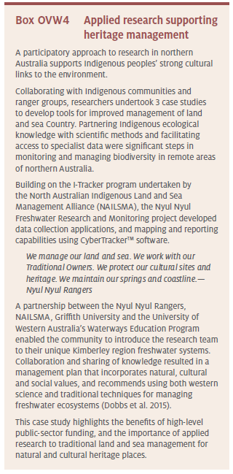
Figure 4.1: Savanna Burning for reduced carbon emissions (left). Applied research supporting Indigenous heritage management (right)
Source: Jackson et al 2017:34, 77)

Australia’s Marine Bioregions, National Representative System of Marine Protected Areas (NRSMPA) and Australia’s Marine Parks
The Integrated Marine and Coastal Regionalisation of Australia (IMCRA v4.0) (Figure 4.2) is a spatial framework for classifying Australia's marine environment into bioregions that make sense ecologically and are at a scale useful for regional planning. These bioregions are the basis for the development of a National Representative System of Marine Protected Areas (NRSMPA). The NRSMPA aims to establish and manage a comprehensive, adequate and representative system of marine protected areas to contribute to the long-term ecological viability of marine and estuarine systems, to maintain ecological processes and systems, and to protect Australia’s biological diversity at all levels.
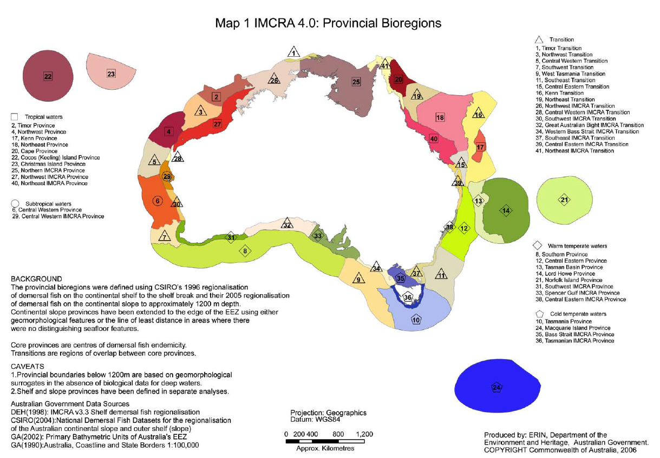
Figure 4.2: Integrated Marine and Coastal Regionalisation of Australia (IMCRA v4.0)
Source: DAWE
Australian Marine Parks (Commonwealth reserves) are proclaimed under the EPBC Act and are located in Commonwealth waters that start at the outer edge of state and territory waters, generally three nautical miles (approximately 5.5 km) from the shore, and extend to the outer boundary of Australia’s exclusive economic zone, 200 nautical miles (approximately 370 km) from the shore. Marine parks have also been established by state and territory governments in their respective waters under the NRSMPA.
Combined, these cover about 3.3 million square kilometres or 36 per cent of our oceans, as shown in Figure 4.3, effectively fulfilling the Australian Government’s commitment to establishing the NRSMPA.
The Commonwealth, through the Director of National Parks, manages the 58 Australian Marine Parks located within Commonwealth waters – those over 5.5 kilometres from the coast - with management plans for each of the six regions setting out how Australia’s Marine Parks are managed.
The Director of National Parks has developed partnerships with various stakeholders, including with Aboriginal Corporations representing the TOs to support collaborations and engagement in accordance with a set of Indigenous engagement principles (see Figure G.13 in Appendix H). These principles inform the approach to implementing the Management Plans, as well as the development and implementation of actions in each marine park.

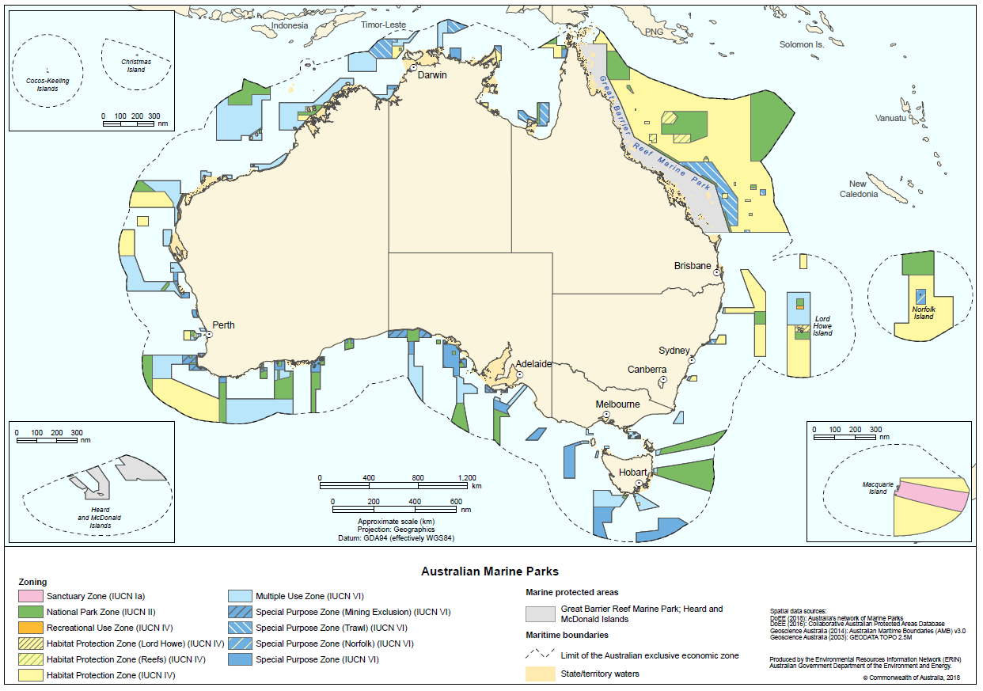
Figure 4.3: Australian Marine Parks
Source: DAWE
An Indigenous engagement program enables the Director of National Parks to work with Indigenous organisations, land councils and Indigenous ranger groups to establish collaborative projects for marine parks and to protect cultural values. The program outcomes include social, cultural and economic benefits for traditional owners, and partnerships with traditional owners and Indigenous groups to manage sea Country in marine parks.

Australia’s Terrestrial Bioregions, Ecoregions, National Reserve System (NRS) and Indigenous Protected Areas (IPAs)
The Interim Biogeographic Regionalisation for Australia (IBRA) is a spatial framework for the systematic development of a comprehensive, adequate and representative (CAR) National Reserve System (NRS) in Australia. The current version of IBRA classifies Australia's landscapes into 89 large geographically distinct bioregions based on common climate, geology, landform, native vegetation and species information. For example, the Australian Alps, the Nullabor Plain and the Wet Tropics are distinct bioregions (Figure 4.4). The NRS is Australia's network of protected areas, conserving examples of our natural landscapes and native plants and animals for future generations.
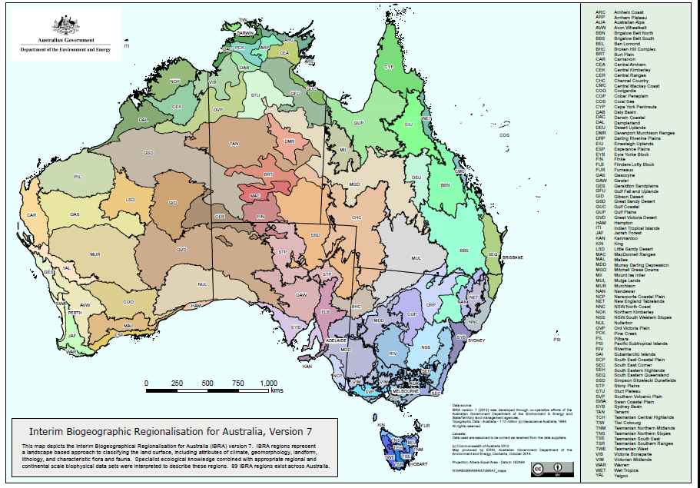
Figure 4.4: Interim Biogeographic Regionalisation of Australia, Version 7
Source: DAWE
Under the UN Convention on Biological Diversity (Secretariat of the Convention on Biological Diversity, 1992), Australia has worked towards a target of 17 per cent of the Australian continent to be protected as part of the National Reserve System. In building the National Reserve System, priority is given to under-represented bioregions that have less than 10 per cent of their remaining area protected in reserves. Other priorities include: key habitats for nationally listed threatened species or migratory species and/or Ramsar sites or wetlands of national importance; and areas that contribute to whole-of-landscape conservation outcomes, such as places that offer refuge and/or contribute to connectivity and the adaptation of biodiversity to changing climate.
The NRS includes more than 10,500 protected areas covering 19.63 per cent of the Country – over 150 million hectares. It comprises Commonwealth, state and territory reserves, Indigenous lands and protected areas run by non-profit conservation organisations, through to ecosystems protected by farmers on their private working properties. While governance and institutional arrangements vary between jurisdictions, four types of protected areas are recognised in the NRS includes public reserves (or government-owned), IPAs, private protected areas, and shared management reserves.
The next 20 years will be a critical period for biodiversity conservation in Australia, and the National Reserve System Strategy 2009-2030 (NRMMC, 2010) is an important step towards long-term protection of Australia's biodiversity. The Strategy states that the foundation of the NRS must be based on strong partnerships between the Australian Government and the various state, territory and local governments, with a commitment to ongoing collaboration and sharing of information and resources. The NRS cannot be built solely on public lands and there is a significant role for Indigenous groups, local communities, private landholders and non-government organisations to play in establishing and managing protected areas to ensure the success of the NRS. The Strategy includes the following three targets:
- To expand the area that is protected within the National Reserve System to at least 125 million hectares (a 25 per cent increase), with priority to be given to increasing the area that is protected in under-represented bioregions.
- To expand the contribution of Indigenous Protected Areas (IPAs) to the National Reserve System by between eight and 16 million hectares (an increase of at least 40 per cent).
- To complete management plans for 100 per cent of Australian Government-funded protected areas under the National Reserve System within two years of the formation of agreements relating to these areas.
Currently, IPAs account for more than 45 per cent of the total area of the NRS. There are currently 76 dedicated IPAs comprising approximately 67 million hectares (Figure 4.5), plus 12 more sites currently under consultation (See Appendix I for details), which when dedicated will add almost 30 million hectares and increase the size of the NRS by almost 30 per cent.
As well as protecting biodiversity, IPAs deliver cost-effective environmental, cultural, social, health and wellbeing and economic benefits to Indigenous communities. IPAs also protect cultural heritage into the future, and provide employment, education and training opportunities for Indigenous people in remote areas. The formation of IPAs, the benefits of IPAs, IPA Management Plans and their role in environmental and climate science research are discussed in more detail in Chapter 6.
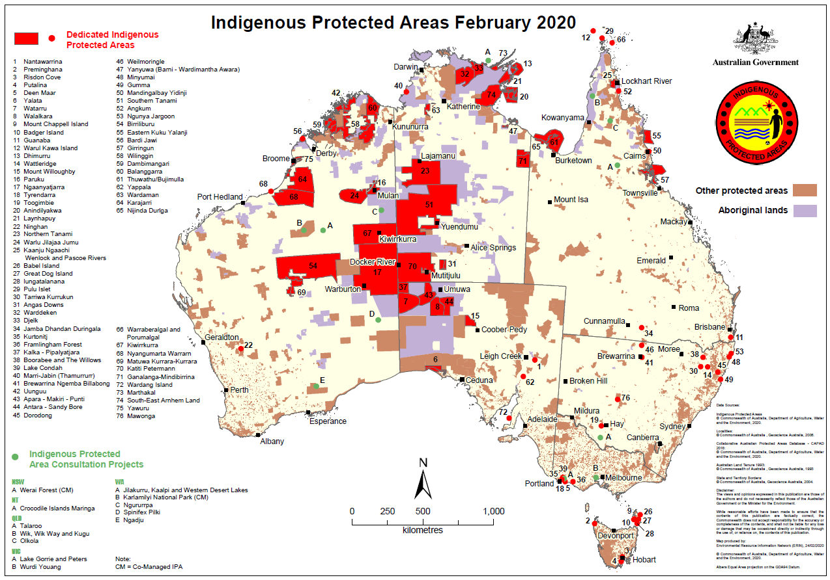
Figure 4.5: Indigenous Protected Areas and Consultation Projects – February 2020
Source: DAWE, 2020
The Australian Government manages three terrestrial National Parks jointly managed with Aboriginal people, the Booderee National Park in NSW and the Kakadu National Park and Uluru-Kata Tjuta National Park in the Northern Territory.

Indigenous heritage
While Australia's state and territory governments have broad responsibilities for recognising and protecting Australia's Indigenous heritage, the Commonwealth plays a role through the Aboriginal and Torres Strait Islander Heritage Protection Act 1984 (Cth) and the EPBC Act.
The Aboriginal and Torres Strait Islander Heritage Protection Act 1984 (Cth) enables the Australian Government to respond to requests to protect important Indigenous areas and objects that are under threat, if it appears that state or territory laws have not provided effective protection.
The EPBC Act protects Australia’s World heritage properties listed for outstanding cultural and natural values (Kakadu National Park in the NT) and establishes the National Heritage List, which includes natural, Indigenous and historic places that are of outstanding heritage value to the nation. A place may be added to the National Heritage List if the place has outstanding heritage value to the nation because of the place’s importance as part of Indigenous tradition. The Act also establishes the Commonwealth Heritage List, which comprises natural, Indigenous and historic places on Commonwealth lands and waters or under Australian Government control, and identified by the Minister for the Environment (the Minister) as having Commonwealth Heritage values (i.e. the Uluru-Kata Tjuta National Park in the NT). ‘Indigenous tradition’ means the body of traditions, observances, customs and beliefs of indigenous persons generally or of a particular group of indigenous persons (s.201(4) of the EPBC Act).
Regulations under the EPBC Act include the requirement for management plans for World, National and Commonwealth heritage places and the application of a set of management principles. Including that the management of these places should make timely and appropriate provision for community involvement, especially by people who have a particular interest in, or associations with, the place, and may be affected by the management of the place.
Under the EPBC Act, the Minister must table a report in the Parliament at least once in every five years on the National Heritage List and the Commonwealth Heritage List (S.324ZC and s.341ZH respectively). The most recent report on the heritage lists covers the five years from 1 July 2013 until 30 June 2018 (DEE, 2019). In relation to Indigenous heritage, the Report makes the following points:
- The Australian Heritage Council’s preferred approach to National Heritage nominations of Indigenous heritage is that they be led by the relevant Indigenous communities with the support of the relevant State or Territory government. This approach of strong partnerships with Indigenous communities ensures obligations around free, prior and informed consent are met. This enables Indigenous people to take leadership in identifying Indigenous heritage places for potential recognition in the National and World Heritage lists.
- In May 2018, Chairs and senior officials from Aboriginal and Torres Strait Islander heritage organisations and agencies joined the annual meeting of the Heritage Chairs and Officials of Australia and New Zealand (HCOANZ) for the first time and were invited to become permanent members of HCOANZ. The HCOANZ forum, led by the Chair of the Australian Heritage Council and the forum host, the chair of the Northern Territory Heritage Council, issued the Darwin Statement. The statement affirms the need to include, engage and collaborate with Aboriginal and Torres Strait Islander people and share their cultural heritage stories.

National Landcare Program
The National Landcare Program (NLP) invests in projects that build on partnerships with Indigenous people and communities which also enable them to have the opportunity to fully participate in land and sea management and draw on their significant and unique knowledge, skills and responsibilities.
The National Landcare Program includes a Regional Land Partnerships component which provides many of the 56 regional NRM organisations around Australia with resources to work with local Indigenous people and communities. Figure 4.6 shows the 49 management units across Australia that were funded under the Regional Land Partnerships component of the National Landcare Program to support the delivery of 195 projects that aim to contribute to vital on-ground environment and agricultural projects across the country. many of these management units are part of the network of regional NRM organisations across Australia.
Indigenous peoples are involved in NLP projects in several different ways, including:
- on-ground natural resource management (NRM) activities (e.g. fire, rehabilitation, weed or pest management);
- the recording and continued use, support and reinvigoration of IK to underpin biodiversity conservation and the sustainable use of natural resources, such as savannah and traditional cool burns;
- employment and capacity building, including access to appropriate training, education, land and sea management planning, management activities and enterprise development;
- clear articulation of Indigenous land and sea aspirations in regional NRM plans and the development and implementation of regional NRM Indigenous participation strategies;
- development of land and sea management plans; and
- Indigenous Participation Strategies that provide a framework and practical guide for regional NRM organisations to partner with and include Indigenous people in the planning, consultation and implementation of NRM investment.
These activities contribute to wider social and economic benefits, such as Indigenous employment, training and enterprise development.
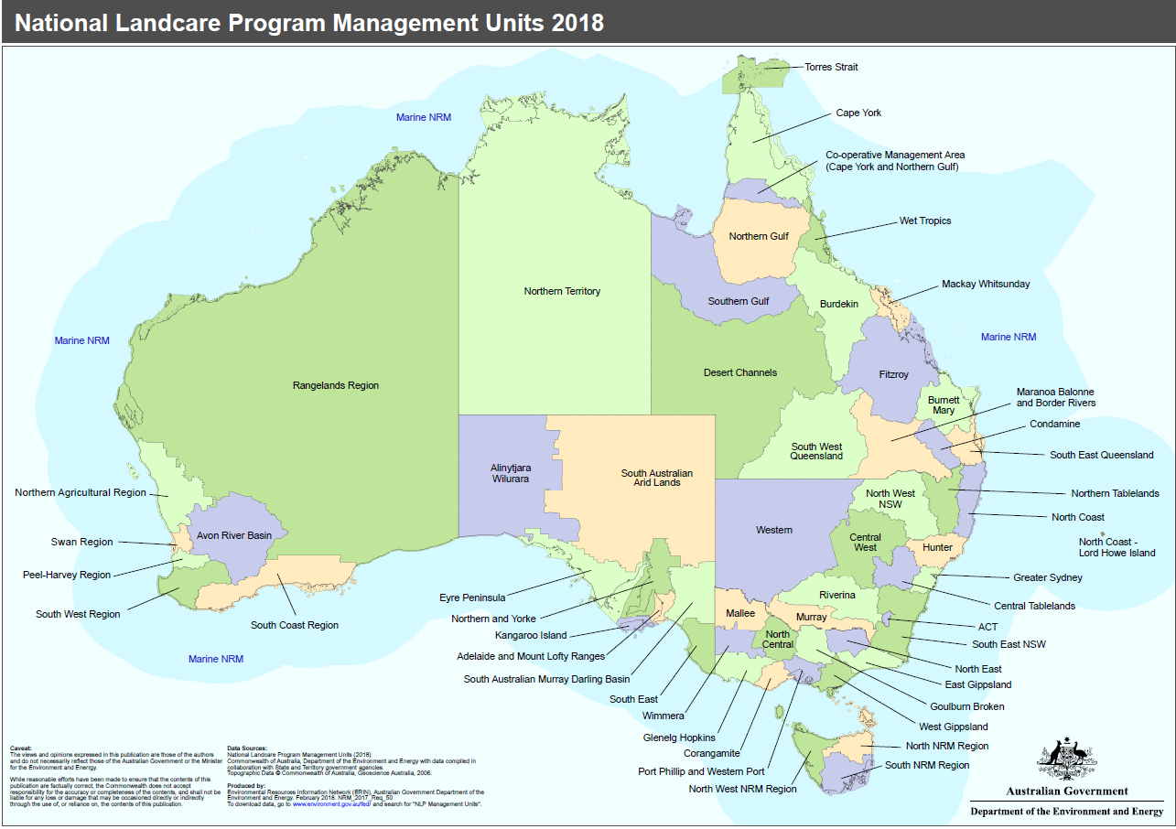
Figure 4.6: National Landcare Program 2018 Regional Land Partnership Management Units
Source: DAWE http://www.nrm.gov.au/system/files/resources/83b10aba-cd7a-4068-bccb-c41b0cc7d5c1/files/national-landcare-program-management-units-2018-map.pdf

National Waste Strategy
DAWE is responsible for implementation of the National Waste Policy (AG, 2018b), in collaboration with state, territory and local Governments, business and industry. Importantly for Indigenous communities, the Policy encourages governments, businesses and industries to implement tailored solutions in response to local and regional circumstances and acknowledges better waste management also helps reduce health and environmental problems and prevents pollution of our land and oceans. The Policy contains strategies that target the waste minimisation and recovery needs of Indigenous communities. Strategy 6 is about 'Improving access' by identifying and improving regional, remote and Indigenous communities’ ability to access, influence and participate in a circular economy. Strategy 10 is about 'Plastics and packaging' to reduce the impacts of plastic and packaging on the environment and oceans, reduce plastic pollution, and maximise benefit to the economy and society.

Commonwealth Environmental Water Office (CEWO)
The role of the Commonwealth Environmental Water Holder was established under the Water Act 2007 (Cth) to manage water acquired by the Australian Government as part of a suite of national water reforms, including the Murray-Darling Basin Plan. The Commonwealth Environmental Water Holder’s plans take into account annual priorities and longer-term targets set within the Murray-Darling Basin Plan by the MDBA, and the CEWO is co-funding the First Nations Environmental Water Guidance (FNEWG) Project with the MDBA to develop a defined and transparent methodology for First Nations’ environmental watering objectives to be incorporated in environmental water planning.

Australian Bureau of Agricultural and Resource Economics and Sciences and the inventory of Indigenous owned, managed or co-managed lands
ABARES is now part of the DAWE portfolio. Among its many functions, ABARES produces a periodic State of the Forests Report (SoFR) to meet certain reporting requirements of the Commonwealth Regional Forest Agreements Act 2002 (Cth). Indicator 6.4a in the SoFR is about the area of forest to which Indigenous people have use and rights that protect their special values which are recognised through formal and informal management regimes. This indicator monitors the degree to which land is placed under appropriate tenure classifications or management regimes to protect Indigenous peoples’ values in forests. An acceptable level of accountability for the protection of Indigenous peoples’ cultural, religious, social and spiritual needs and values is an essential part of forest management.
The relevance of the SoFR to this review of Indigenous engagement in the NESP is because in order to report against Indicator 6.4a, the SoFR includes a national data set of four Indigenous land ownership and management categories. For reporting purposes, the information collected on Indigenous land is grouped into four categories (Dillon et al. 2015):
- Indigenous owned and managed: freehold lands that are both owned and managed by Indigenous communities.
- Indigenous managed: lands that are managed but not owned by Indigenous communities (e.g. Crown reserves and leases); and lands that are owned by Indigenous people, but have formal shared management agreements with Australian and state and territory government agencies (e.g. leased-back nature conservation reserves).
- Indigenous co-managed: lands that are owned and managed by other parties, but have formal, legally binding agreements in place to include input from Indigenous people in the process of developing and implementing a management plan (e.g. nature conservation reserve memoranda of understanding).
- Other special rights: lands subject to native title determinations, registered Indigenous Land Use Agreements and legislated special cultural use provisions. These are independent of tenure and, in most cases, do not grant ownership or management rights of land to Indigenous communities. They can provide for the right to access areas of cultural significance or the use of areas for cultural purposes (e.g. within protected water supply catchment areas), or can provide a legal requirement for consultation with the local Indigenous community before any major development activities take place.
A land parcel may be subject to more than one type of management. For this indicator in the SoFR, land is classified into the highest-ranked Indigenous land ownership and management category that is applicable (Dillon et al, 2015). For example, a land parcel that is subject to a native title determination, but that is also Indigenous owned and managed as a declared Indigenous Protected Area, is reported here as Indigenous owned and managed.
In 2016, the national Indigenous estate contained 438 million hectares of land, of which 69.5 million hectares was forested. This is 52% of Australia’s total forest area. Of the 69.5 million hectares of forested land in the Indigenous estate, 47.8 million hectares (69%) is in Queensland and the Northern Territory. The proportion of forested land that is in an Indigenous land category varies from 15% in New South Wales, to 79% in the Northern Territory.
The 69.5 million hectares of Indigenous forested land comprises 18.0 million hectares of forested land that is Indigenous owned and managed, 4.9 million hectares of forested land that is Indigenous managed, 5.7 million hectares of forested land that has Indigenous co-management arrangements in place with government agencies, and 40.9 million hectares of forested land over which Other special rights apply (including native title determinations and Indigenous Land Use Agreements). Figure 4.7 shows the geographic distribution of the Indigenous forest estate across Australia by land ownership and management category.
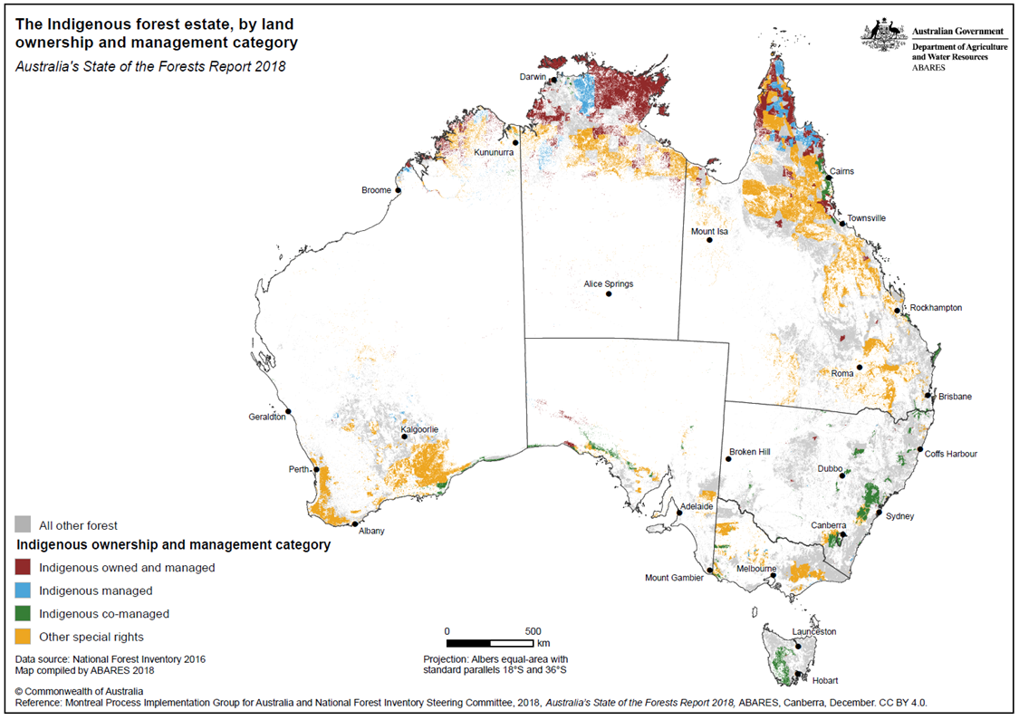
Figure 4.7: The Indigenous Forest Estate by land ownership and management category
Source: ABARES 2018:403
The State of the Forests Report notes that while the level of Indigenous participation in forest management through various mechanisms may be difficult to measure, Indigenous people provide critical knowledge that contributes to the protection and maintenance of forest values independently of any legal right to the land. The Report also notes that the joint management arrangements applied in Kakadu and Uluru-Kata-Tjuta National Parks are a blueprint for joint management arrangements more broadly, not just in Australia, but also internationally (ABARES, 2018:423).
We return to the ABARES’ Indigenous land data set in Chapter 5.

NESP Hub Collaboration with Commonwealth Agencies and Departments
SGSEP also requested the NESP Hubs to identify their collaborations with the selected Commonwealth Agencies and Departments or any others, in order to understand the connections between the Hubs’ research activities and uptake by end users. The following information is indicative of the scope of interactions between the NESP Hubs and various Commonwealth agencies and Departments. What follows is by no means an exhaustive account of those interactions and the way NESP Hub research outcomes are used or applied by those agencies or departments.

4.3.1 CAUL Hub
The CAUL Hub links with DAWE in a number of ways, including the following:
- DAWE (and its stakeholders) are collaborators and are working directly with the CAUL Hub on co-creating practitioner- and industry-appropriate training and engagement such as the Three-Category Approach toolkit.
- DAWE’s policymakers have undertaken training on the Three-Category Approach to inform their own practice and perspectives (this has the potential for broader reach to other departments).
- DAWE’s policymakers have been informed by the CAUL Hub’s work highlighting Indigenous knowledge and perspectives on air quality, urban greening, biodiversity, people, nature and liveability through cities as Indigenous places.
- DAWE’s policymakers have developed new conceptual frameworks for perceiving engagement through the CAUL Hub’s highly regarded Flipping the Table report and its promotion of cities as Indigenous places.
- DAWE has drawn upon CAUL-Hub research expertise, including in the development of National Performance Framework data and State of the Environment reporting through multiple themes.
- DAWE participates in the CAUL Hub’s bi-annual Steering Committee Meetings with the Indigenous Advisory Group co-Chairs.

4.3.2 ESCC Hub
The ESCC Hub links with many Commonwealth agencies in several ways, including the following:
- The ESCC Hub has collaborated with the Commonwealth and State Governments agencies through World Heritage Properties, Science teams and International Heritage Teams. CSIRO and BOM are partners in the Hub, but the ESCC Hub also uses capability from other areas of these organisations, including the Diversity and Inclusion team in BoM and Land & Water in CSIRO. ESCC Hub has held workshops that have had included collaboration with the TSRA and, to a lesser extent, the Great Barrier Reef Fund.
- ESCC Hub has collaborated with DAWE on a number of projects, including:
  - Meeting Indigenous priorities for climate change information, capacity building and engagement (Project 3.2).
  - Climate change impacts on inshore aquatic ecosystems and coastal communities in the Torres Strait (Project 3.3).
  - Adapting to climate change and building resilience in Australian World Heritage properties: Using climate change science information to inform risk & vulnerability assessments and adaptation planning.

4.3.3 MB Hub
The MB Hub links with many Commonwealth agencies in several ways, including the following:
- DAWE is the primary research-user of the MB Hub’s research. Many of the MB Hub’s research outputs are designed to inform decision making for the protection of threatened and migratory species, management of Australian Marine Parks, assessment of proposed activities and State of the Environment reporting. Three DAWE senior executives sit on the MB Hub’s Steering Committee.
- AFMA, the Australia’s Fisheries Management Authority is an important research user of the MB Hub’s research, they also collaborate with the MB Hub by sharing data on commercial fisheries. In more recent times AFMA has sought advice from the MB Hub about approaches to Indigenous engagement and participation. One AFMA officer sat on the MB Hub’s Research-user Committee, which has since been replaced by direct meetings with research-users and a primary contact officer in AFMA.
- GBRMPA – An important research-user of the MB Hub’s research and has benefitted from advice and tools developed to establish integrated monitoring and cumulative impact assessment.
- TSRA – Stan Lui from TSRA sits on the MB Hub’s Steering Committee. Stan Lui is the Program Manager – Environment Management, Land and Sea Management Unit, Torres Strait Regional Authority.
- The MB Hub has collaborated with DAWE on a number of projects, including:
  - Northern Australian hotspots for the recovery of threatened euryhaline species (Project A1).
  - Australia’s Northern Seascape: assessing status of threatened and migratory marine species Project A12).
  - Underpinning the repair and conservation of Australia’s threatened coastal- marine habitats (Project B4).
  - National data collation, synthesis and visualisation to support sustainable use, management and monitoring of marine assets (Project D1).
  - Implementing monitoring of Australia’s Marine Parks and the status of marine biodiversity assets on the continental shelf (Project D3).
  - Assisting restoration of ecosystem engineers through seed-based and shoot-based programs in the Shark Bay World Heritage Site (Project E6).
  - Assessing the feasibility of restoring giant kelp beds in eastern Tasmania (Project E7).

4.3.4 NAER Hub
The NAER Hub links with many Commonwealth agencies in several ways, including the following:
- DAWE are the primary research user for the Hub’s research outputs and projects have been co-designed with DAWE to deliver targeted research products to address their needs. Two Senior DAWE staff sit on the Hub Steering Committee.
- CSIRO are a founding partner in the Hub and a CSIRO senior staff member sits on the Hub’s research Executive Committee. CSIRO have led major projects in the Hub and have collaborated on others. These projects have employed Indigenous people, provided support for Indigenous people in areas of water planning and catchment management and have involved a number of Indigenous-led projects including the production of the Our Knowledge, Our Way guidelines.
- The Hub has undertaken a number of projects specifically focussed on supporting policy development for IPAs including a review of research needs on IPAs and an assessment of the benefits of Indigenous land management on IPAs.
- The Hub has worked closely with the National Indigenous Australians Agency in the Department of Prime Minister and Cabinet. A senior staff member sits on the Hub’s Steering Committee and several projects were developed specifically to respond to their research needs.
- The Hub has worked very closely with Parks Australia and the Director of National Parks on research in Kakadu National Park. This included six projects with significant Indigenous involvement including the development of Indigenous Research Priorities, the establishment and support for the Kakadu Indigenous Research Committee and Indigenous-led projects on Healthy Country Indicators.
- The NAER Hub has collaborated with DAWE on a number of projects, including:
  - Environmental Water Needs of the Mitchell River, and 4.6: Environmental Economic Accounting for the Mitchell River (Project 1.3.1)
  - Environmental Water needs for the Fitzroy River (Project 1.3.3).
  - Indigenous Water Needs for the Fitzroy River (Project 1.5).
  - Defining Metrics of Success for Feral Animal Management in Northern Australia (Project 2.5).
  - Prioritising Threatened Species in Northern Australia (Project 3.3).
  - Kakadu National Park’s Threatened Species (Project 3.4).
  - Monitoring, Mapping and Safeguarding Kimberly Bilbies (Project 3.5).
  - Developing eDNA methods for tropical waters and 4.5: Developing eDNA methods to detect Top End animals (Project 4.3).
  - Assessing Mangrove Dieback in the Gulf (Project 4.4).
  - Research Priorities for Indigenous Protected Areas Across Northern Australia (Project 5.1).
  - Lessons from Top End Indigenous Fire Management (Project 5.2).
  - Multiple Benefits of Indigenous Land and Sea Management Programs (Project 5.3).
  - Knowledge Brokering for Indigenous Land Management (Project 5.4).
  - Phase 1: Bininj/Mungguy Natural resource management research priorities for Kakadu National Park, and 5.5: Phase 2: Bininj/Mungguy Healthy Country Indicators (Project 5.5).
  - Investing in Indigenous cultural and natural resource managers (Project 5.6).
  - Cultural Connections (Project 6.3.3).

4.3.5 TSR Hub
The TSR Hub links with many Commonwealth agencies in several ways, including the following:
- Collaborating with Parks Australia Division in DAWE on projects at Booderee and Kakadu that had high levels of Indigenous engagement and provided paid work to traditional owners/Indigenous rangers.
- Facilitating connections between the Office of the Threatened Species Commissioner in DAWE and Indigenous groups, including facilitating meetings. Also, promoting some of the Commissioner’s Indigenous engagement activities through the TSR Hub’s communications.
- Undertaking two-way research projects in collaboration with TOs and land managers to support improved monitoring and land management strategies on a number of IPA.
- Working with CSIRO to deliver Indigenous led projects that had high levels of Indigenous engagement.
- The TSR Hub has collaborated with DAWE on a number of projects, including:
  - Saving an endangered bettong with fire – a controlled fire and predator experiment in the Wet Tropics (Project 1.3.3).
  - Monitoring threatened species in IPAs: Bilbies in the Martu Native Title Determination (Project 3.2.2.2).
  - Strategic planning for the Eastern Curlew (Project 5.1.1).
  - Collaborating with Indigenous people in threatened species research and management (Project 6.2).
  - Conserving Alwal, the golden-shouldered parrot (Project 6.2b).
  - National monitoring priorities, process and prospectus for threatened species (Project 7.5).

4.3.6 TWQ Hub
The TWQ Hub links with many Commonwealth agencies in several ways, including the following:
- The TWQ Hub continues to work with the TSRA and the Prescribed Bodies Corporates to understand the community’s concerns on the water quality and the ecosystem health threats to the Torres Strait from the Fly river run-off.
- Duane Fraser, Acting Chair of the Indigenous Advisory Committee to the Minister for the Environment is a member of the TWQ Hub Steering Committee.
- The TWQ Hub responds to requests from DAWE for case studies on Indigenous Engagement within the Hub.
- The TWQ Hub supports Traditional Owners in their aspirations for co-governance and co-management of the Great Barrier Reef and has collaborated with GBRMPA on several projects as noted earlier in this Chapter.
- The TWQ responds to requests for advice on Indigenous matters from NAILSMA and other Land Councils or TO organisations if and when required.
- The TWQ Hub has collaborated with DAWE on the following projects:
  - Implementation of the crown of thorns starfish research strategy: regional strategies (Project 3.1.1), and Crown-of-thorns starfish: surveillance and life history (Project 4.1), and Matching the Crown-of-Thorns Starfish Integrated Pest Management to the scale of the new Control Program (Project 5.1), and Innovations in COTS control on the GBR (Project 6.1).
  - Reducing sediment loads to the Great Barrier Reef: developing optimal approaches for treating alluvial gully erosion (Project 3.1.7).
  - Best practice coral restoration for the Great Barrier Reef, and 6.5: Improving coral condition through better informed resilience-based management (Project 4.3).
  - Identifying the water quality and ecosystem health threats to the high diversity Torres Strait and far northern GBR from runoff from the Fly River (Project 2.2.1)
  - Science evaluation of coastal wetland systems repair projects across GBR catchments (Project 3.3.2).
  - Assessing the Gulf of Carpentaria mangrove dieback (Project 4.13).
  - Restoring ecosystems from catchment to reef (Project 6.2).
  - Reducing end-of-catchment fine sediment loads and ecosystem impacts (Project 6.4).
  - Learnings from applied environmental research programs: Elements for success (Project 6.7).
  - Integrated Environmental Assessment to inform Environmental decisions (Project 6.8).

Findings and Conclusions
This Chapter reviewed the programs and research activities of selected Commonwealth Agencies and Departments relating to environmental and climate science research activities to examine their engagement with Indigenous Australians, to ascertain to the extent to which the agencies and departments interact with the NESP Hubs’ research activities and outputs as contributors and/or end users and, where possible, to identify key research themes and questions regarding Indigenous environmental and climate science research themes and questions.
As agencies or departments of the Commonwealth with a wide range of responsibilities in relation to the environment more broadly, their engagement with Indigenous peoples arises from the Australian Government’s commitment to engagement with Indigenous peoples, as reflected for example, in the earlier COAG agreements dating back to 2008 (cited earlier) and more recently the formal Partnership Agreement between COAG and the National Coalition of Aboriginal and Torres Strait Islander Peak Organisations which came into effect in March 2019 (COAG, 2019).
The commitment to working closely with Indigenous Australians on environmental matters also arises from the fact that Australia is a signatory to the UN Convention on Biological Diversity (CBD) (The Secretariat of the CBD, 1992) and the UN Declaration on the Rights of Indigenous Peoples (DRIP) (UN, 2007), which several of the agencies and departments refer to on their websites and in their documentation relating to Indigenous engagement. These international instruments are also identified in DAWE’s IEPS for the NESP as being among the key drivers for Indigenous engagement. Interestingly, many of the agencies make explicit reference to Article 19 in the UN DRIP relating to the principle of free, prior and informed consent when it comes to working with Indigenous peoples’ ecological knowledge and cultural and intellectual property. The agencies acknowledge that the principle of free, prior and informed consent is seen as the benchmark for working with Indigenous peoples. This principle is discussed in more detail in Chapter 8.
SGSEP draws the following observations about the Commonwealth agencies and departments and their Indigenous engagement and research activities, however, with the caveat that these matters need to be verified with Aboriginal and Torres Strait Islander peoples from around Australia in the very early stages of NESP2.
This review of Commonwealth agencies and departments with environmental responsibilities shows there is an increasing recognition and acceptance by Commonwealth agencies and departments of the value of engaging with Indigenous peoples about environmental and climate science matters because of their intricate cultural knowledge about the natural environment and the Indigenous peoples’ resilience in the face of increasing pressures.
Most of the agencies have adopted Indigenous engagement strategies and have developed partnerships or other collaborative working arrangements that enable the agencies and departments to work together with Indigenous peoples on matters of mutual concern or interest. Some of the agencies have an Indigenous advisory structure in place to provide specialist advice or input to research topics and research design, to act as a sounding board for new ideas or approaches, to monitor performance against agreed targets or outcomes, and to reach out to a wider audience of Indigenous peoples as potential end-users of the research the agencies undertake.
In the case of the Great Barrier Reef and the Torres Strait regions, AIMS, GBRMPA and TSRA must work with Indigenous peoples because the Aboriginal and Torres Strait Islander peoples are the TOs of the Reef and the Torres Strait with evidence of their sea Country connections dating back many thousands of years. However, while significant progress has been made with respect to some matters (catchment and marine land and sea rights and some outstanding examples of productive partnerships), there is no lasting, continuously improving GBR-wide approach to empowering TOs in the governance of the GBR. With the future health of the GBR under serious threat from climate change and other stresses, it is now critical to harness the capacity of TOs and their Sea Country institutions for a new generation of reef protection and management arrangements into the future (CofA, 2018).
In many respects the same can be said of the Murray Darling Basin, except that the extent of dispossession and dislocation of the Aboriginal peoples from their ancestral lands was far more extensive and prolonged. This history manifests in differences in focus on livelihoods and wellbeing between the TOs of the lands and waters that comprise the Murray Darling Basin and the non-Indigenous interests in the Basin, especially over the health of the Basin and access to water and its use. This presents the MDBA with a different set of challenges when compared to GBRMPA and TSRA. For example, the MDBA has had to invest considerable effort in developing partnership agreements with both NBAN and MLDRIN to collect and share information across the Basin’s Aboriginal communities and to help raise public awareness about Aboriginal interests and concerns relating to water. While these arrangements appear to be working to some degree, the river system is at breaking point because in the view of the Aboriginal elders, the river system is not being managed for the health of the river (Simons, 2020).
This review also finds there are considerable interactions between the Commonwealth Agencies and Departments and the NESP Hubs and on many levels and in a number of different ways, as documented in Part 4.3 above. For example, agency and departmental senior officials sitting on Hub Steering Committees or on specific project reference groups are seen as being very supportive, relevant and constructive. Senior officials participating directly in significant events involving Indigenous peoples is also always seen as constructive and providing opportunities for two-way learning. Some of the agencies play an active role in several NESP Hub projects through being on a project’s steering committee or through direct involvement, especially in terms of ensuring the outcomes of the research will aid the agency’s management responsibilities for a particular asset. However, all of the interactions are important and valuable because in most cases they facilitate regular contact and information exchange between researcher and end user during the life of a project and in communicating the research outcomes and benefits.
Two events stand out for special mention because they were also mentioned by many of the Aboriginal and Torres Strait Islander stakeholders that SGSEP was able to interview. The two events are:
- The National Indigenous Gathering in February 2018 enabled Indigenous peoples from across the country to come together to discuss research themes and priorities for the NESP. The event brought together NESP Hub researchers involved in Indigenous research, governance or engagement, Indigenous Advisory group and Steering Committee members, NESP Hub and project leaders, Knowledge Brokers, and liaison staff, as well as members of the Minister’s Indigenous Advisory Committee. The event provided a significant impetus for Indigenous engagement and capacity building, networking and sharing information. The only downside of this event, was that it was held in the third year of the NESP and the consensus among stakeholders is that this event needs to happen much earlier in the next iteration of the NESP.
- The opportunity for Indigenous people to be able to come to Canberra to brief Departmental and agency officials in their offices and to brief politicians at Parliament House on the outcomes of their research was mentioned by several stakeholders as very valuable because it enabled them to share their knowledge and understanding about their Country and how the investment in environmental and climate science research is beneficial, not only to them but also for all Australians. The significance of being able to come to Canberra or the agency/department’s head office and to the federal politicians as projects are nearing completion and give a presentation about the research outcomes, should not be under-estimated.
For some agencies, the challenges include employment opportunities and career pathways into research institutions as the numbers of Indigenous peoples holding senior leadership positions in environmental and climate science research institutions is very small. Some agencies have included specific employment targets in their RAPs as a way of way of addressing these shortcomings.
In relation to Indigenous environmental and climate science research themes and questions, several recurring themes can be distilled from a review of the agencies and departments’ activities. These include for example:
- Mapping of Indigenous weather, season and environmental knowledge.
- Governance of social-ecological systems for sustainable ecosystem stewardship.
- Cumulative impacts on marine and coastal ecosystems and their resilience to recovery under climate change.
- Impacts of climate systems/change on the environment, industries and communities in the Murray Darling Basin with a focus on four key actions to respond to the risks and prepare for impacts.
- Knowledge brokering for managing landscapes in a time of climate change, including the need for interdisciplinary science to address the extreme events, such as severe cyclones and harsh heat-waves.
- Water resource planning and cultural flows.
- Water quality and ecosystem health threats to the Torres Strait from Fly River runoff.
- Improving estimates of abundance and distribution of turtle and dugong in the Torres Strait.
- Documenting and quantifying Indigenous social and economic values of aquatic resources.
- Fire management: cultural fire management versus adverse fire events.
- Managing threatened species and their habitats.
- Managing feral animal problems to reduce impacts in protected areas and to protect important cultural sites.
- Collecting and collating baseline level of ecological data.
- Data and technology for monitoring of ecosystems and threatened species.
- Improving the recording and application of TEK for land and sea management.
- Improving regional, remote and Indigenous communities’ ability to access, influence and participate in a circular economy.
- Reducing the impacts of plastic and packaging on the environment and oceans, reduce plastic pollution, and maximise benefit to the economy and society.
SGSEP also notes that DAWE interacts with Indigenous peoples on many issues across the full suite of the Department’s environmental functions, including through providing secretariat support for and liaising with the Minister’s IAC, the administration of various parts of the EPBC Act, input into the periodic SoE Reports, the management of Australia’s marine parks, the management of NRS and IPAs, the selection of new IPAs, Indigenous heritage matters to with listing, management and protection of significant sites, joint management of three Commonwealth National Parks, direct involvement in the NLP, engagement with the CEWO on water allocations, and engagement with ABARES in the preparation of the periodic SoF Reports. And while the NIAA engages with Indigenous peoples across a very wide portfolio of policies and programs, in relation to this review of Indigenous engagement in the NESP, we only examined the IPA and Indigenous Ranger programs. The conclusion we draw from this review is that the level of engagement between Indigenous peoples and the two Departments on environmental and climate science related matters is daunting in its enormity. However, we draw attention to the fact that the division of responsibility for the management of the IPA program and Indigenous Ranger Program away from the environment and water functions of DAWE is seen as a retrograde step and not endearing toward closer links between research and practice in managing Australia’s environmental resources.
In our discussions with various Indigenous stakeholders across the NESP Hubs and other stakeholders, concerns were expressed about the sum of all the parts of different engagements and the overall level of expectations and commitments being placed on Aboriginal and Torres Strait Islander people, organisations and communities to engage in environmental and climate science related matters. Several Indigenous stakeholders universally expressed concerns about the level of demands or expectations being placed upon them. The abolition of the former Aboriginal and Torres Strait Islander Commission and the constant changes in public sector policy, program and funding arrangements leaves a deep void in the capacity of Aboriginal and Torres Strait Islander people and communities to meet the demands being placed upon them by governments and research institutions and agencies. Without adequate support and funding for engagement activities above and beyond where people are paid as employees, there is a risk that the expectations for Indigenous engagement will fall short of the desired outcomes. Resources supporting Indigenous engagement are discussed in more detail in Chapter 7.
Another issue that was raised by Indigenous stakeholders was the apparent lack of clear linkages between the research outcomes and official plans and statutory documents that are intended to provide a framework for better environmental governance. For example, it is not always clear that research outcomes on threatened species and habitat protection are taken into consideration in developing threat abatement or recovery plans or whether the research outcomes are used in impact assessment decision making under the referrals and assessment processes under the EPBC Act. A matter the ANAO has also recently drawn attention to (ANAO, 2020:9).

NESP Hub Indigenous Research Projects – location and regional gaps

Introduction and Approach
This Chapter examines the geo-spatial location of the selected Indigenous research projects of each of the NESP Hubs against a number of different thematic layers of geo-spatial information.
The brief required SGSEP to identify regions where Indigenous research themes and questions have not been found online. To perform this task we needed to map the geo-spatial location of the selected Indigenous research projects of each of the NESP Hubs to ascertain where Indigenous environmental and climate science research has taken place and where there may be geographic gaps in Indigenous research.
In approaching this task, SGSEP also decided that there would be some added value by mapping the selected Indigenous research projects against a number of different thematic layers of geo-spatial information. Using the projects that SGSEP selected or were guided to by the Hubs on the basis of having a high level of Indigenous engagement, we were able to map them against the following thematic layers of geo-spatial information:
- State/Territory;
- Australia’s Marine BioRegions (MB Hub projects only);
- Australia’s Terrestrial BioRegions;
- NRM Regions;
- Indigenous Protected Areas;
- The Indigenous estate.
The selected thematic layers of geo-spatial information depended on the availability and compatibility of the relevant geo-spatial data.
From this analysis, we are able to make some observations about the connections, or lack thereof, between the Indigenous environmental and climate science research projects undertaken by the NESP Hubs and the various layers of geo-spatial information. We conclude there is considerable value in developing stronger correlations between the environmental and climate science research and the other thematic layers of information about Australia’s environment and land matters that will provide some useful guidance on research priorities for the next iteration of the Program.

Spatial Mapping of Indigenous NESP Hub Research Projects:
As discussed in Chapter 3, in order to ascertain an understanding of the nature of Indigenous engagement in NESP Hub research activities, SGSEP undertook a closer examination of a selection of 108 research projects that we were guided to by the Hubs or that we selected on the basis of having a high level of Indigenous engagement. Figure 5.1 shows the selected Indigenous NESP projects by Hub that we were able to map against a particular locality. It shows that the majority of projects are located predominantly in northern Australia. The projects included in our analysis but not included in the spatial mapping in this Chapter are listed in Appendix I.
The maps in this Chapter show the location of the selected NESP Hub projects by various environmental or other significant layers to ascertain an understanding of the relationship between the NESP Indigenous research activities and the other layers of geospatial information or theme. It is important to note that the maps in this Chapter do not reflect all of the NESP Hub Indigenous research projects. However, the maps can be read as generally indicative in terms of their relationship between the selected NESP Hub Indigenous research projects and a particular layer of information.
It is also important to note that three of the Hubs have responsibilities for a particular geographic area:
- The geographic scope of the NAER Hub’s research is on Northern Australia only.
- The geographic scope of the TWQ Hub’s research is focussed on the Great Barrier Reef, the Torres Strait and other tropical waters.
- The geographic scope of the CAUL Hub is on urban environments in our major cities and regional centres.
These geographic factors therefore skew the results predominantly toward northern Australia.
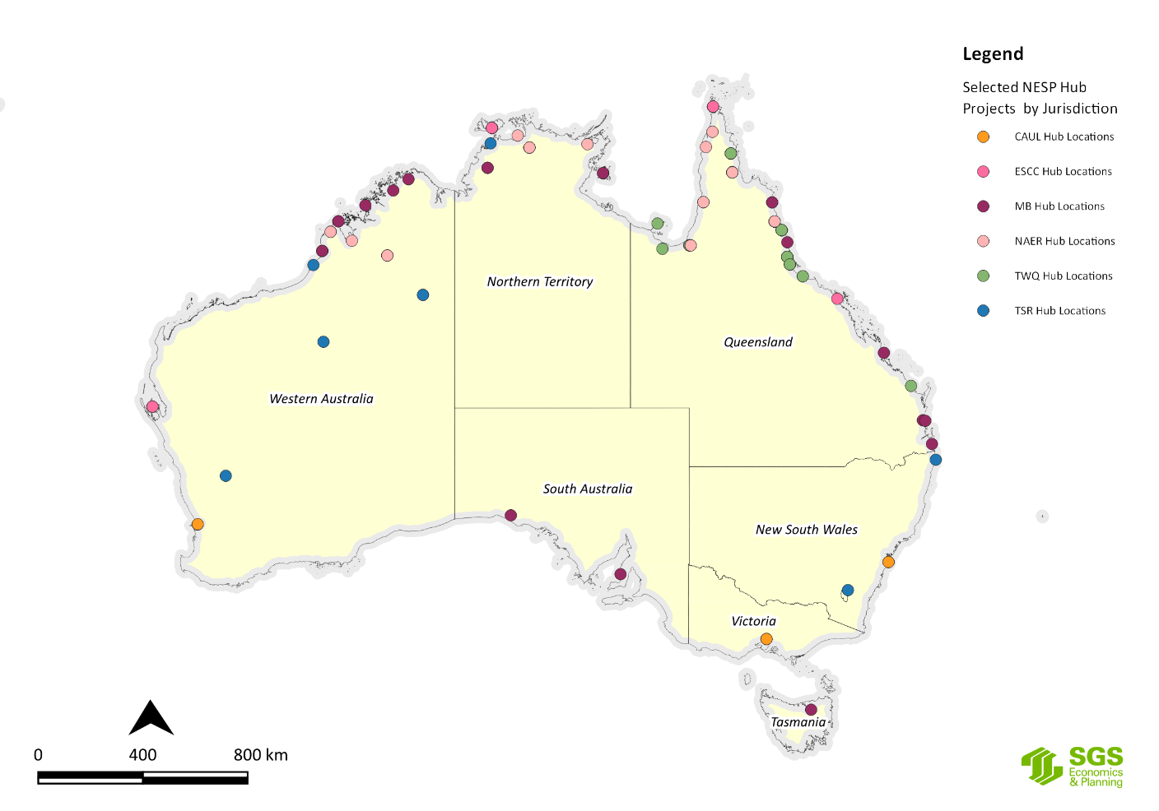
Figure 5.1: Selected NESP Indigenous research projects by Hub and Jurisdiction as at March 2020
Source: SGS Economics and Planning using NESP Hub Data, 2020

5.2.1 State/Territory
Figure 5.1 also shows that the jurisdictions with the least number of Indigenous NESP Hub research projects are the Australian Capital Territory, South Australia, Tasmania, New South Wales and Victoria. More detailed maps of the selected NESP Hub projects by jurisdiction are in Appendix J.

5.2.2 Australia’s Marine BioRegions
The framework for Australia’s Marine Bioregions, the National Representative System of Marine Protected Areas (NRSMPA) and Australia’s Marine Parks (AMP) was discussed in part 4.2 of Chapter 4 (and Appendix H). The Integrated Marine and Coastal Regionalisation of Australia (IMCRA v4.0) (Figure 4.2) is a spatial framework for classifying Australia's marine environment into bioregions which form the basis for the development of a National Representative System of Marine Protected Areas (NRSMPA).
Using Figure 4.2 in Chapter 4, Figure 5.2 maps the Marine Biodiversity Hub’s selected Indigenous research projects against the IMCRA Bioregions. Figure 5.2 shows that most of the MB Hubs projects are concentrated in the tropical waters and transition areas with fewer projects in the subtropical waters and cold temperate waters, reflecting the Australian Government’s general policy interest in developing the north, as well as the marine areas under the greatest pressures and the areas of strong interest by TOs.
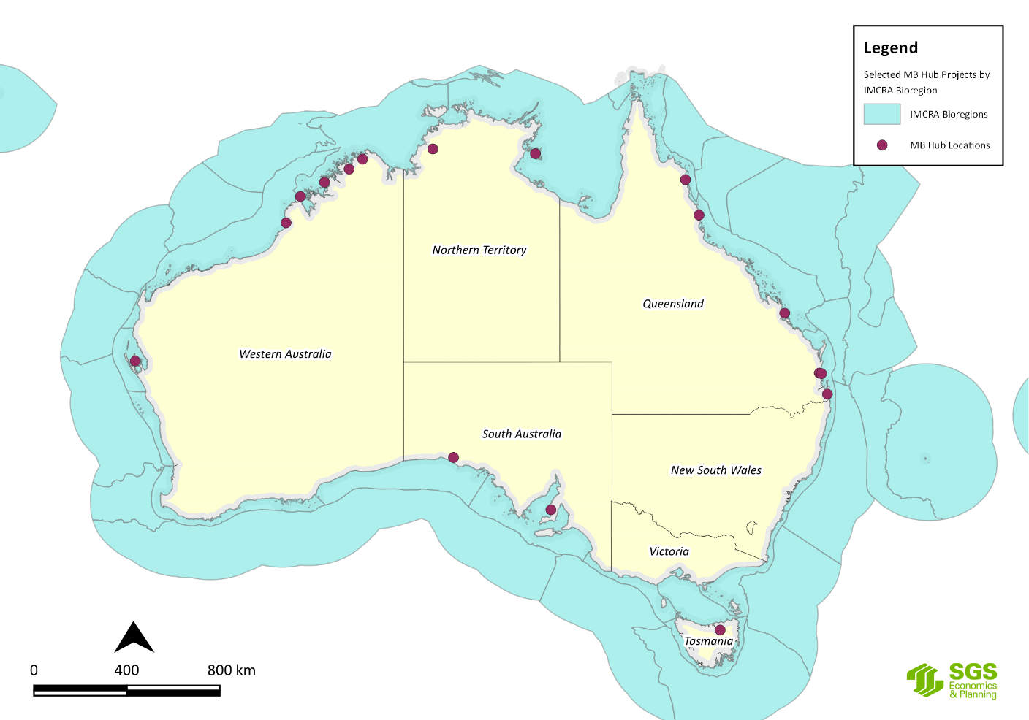
Figure 5.2: Selected MB Hub Indigenous research project locations by IMCRA Bio Regions
Source: MB Hub and SGS Economics and Planning and DAWE data, 2020.
Using Figure 4.3 in Chapter 4 and Figure H17 in Appendix H, Figure 5.2 maps the location of all the selected NESP MB Hub Indigenous research projects against Australia National Reserve System and National Representative System for Marine Protected Areas. Figure 5.2 shows that the MB Hub’s projects are spread across most of the Marine Park areas in the northern and western areas of Australia in the waters around Tasmania, but none or very few in the waters around South Australia, Victoria and New South Wales.

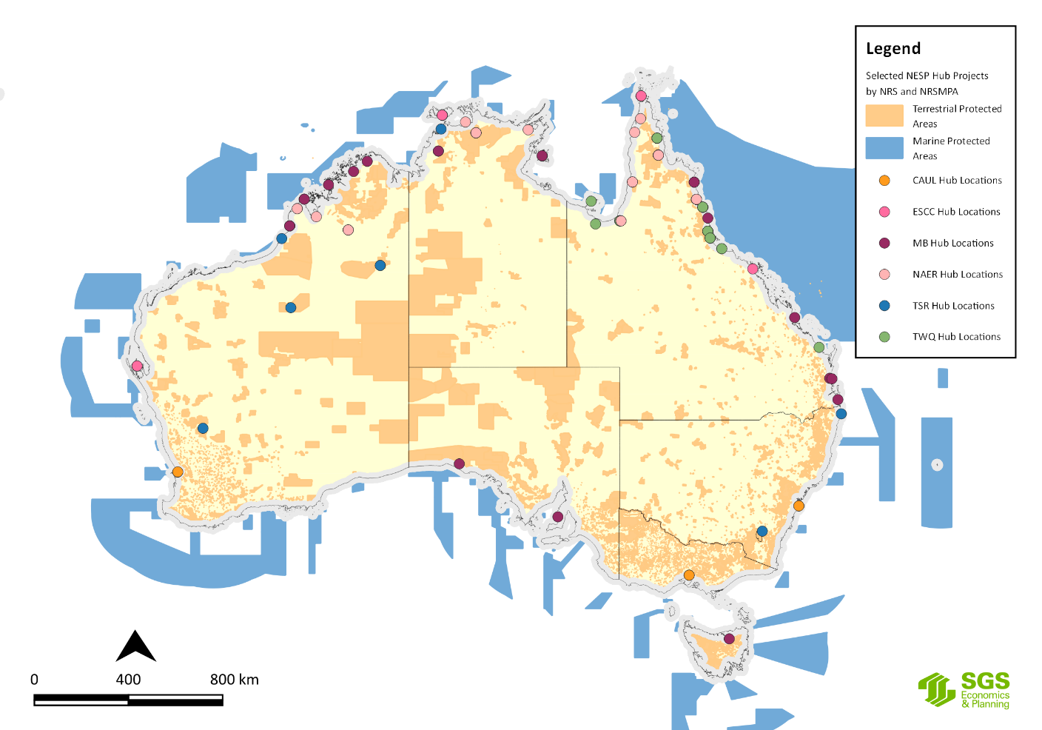
Figure 5.3: Selected NESP Hub Indigenous research projects by NRS and NRSMPA
Source: SGS Economics and Planning utilising NESP Hub data, 2020.

5.2.3 Australia’s Terrestrial BioRegions;
The framework for Australia’s Bioregions and NRS was discussed in Chapter 4. The Interim Biogeographic Regionalisation for Australia (IBRA) (Figure 4.4) and Terrestrial Ecoregions of Australia (Figure 4.5) are a spatial framework for the systematic development of a comprehensive, adequate and representative NRS in Australia. The IBRA classifies Australia's landscapes into 89 large geographically distinct bioregions based on common climate, geology, landform, native vegetation and species information.
Using Figure 4.4 in Chapter 4 and Figure H16 in Appendix H, Figure 5.4 shows the selected NESP Hub Indigenous research project locations by IBRA regions. A closer inspection of the data behind these maps shows that some of the NAER Hub and TWQ Hub projects are in areas that are under-represented in the NRS, especially in Queensland and the Northern Territory and we are informed by the Hubs that the research outcomes are adding valuable knowledge and understanding about various environmental matters in these areas.

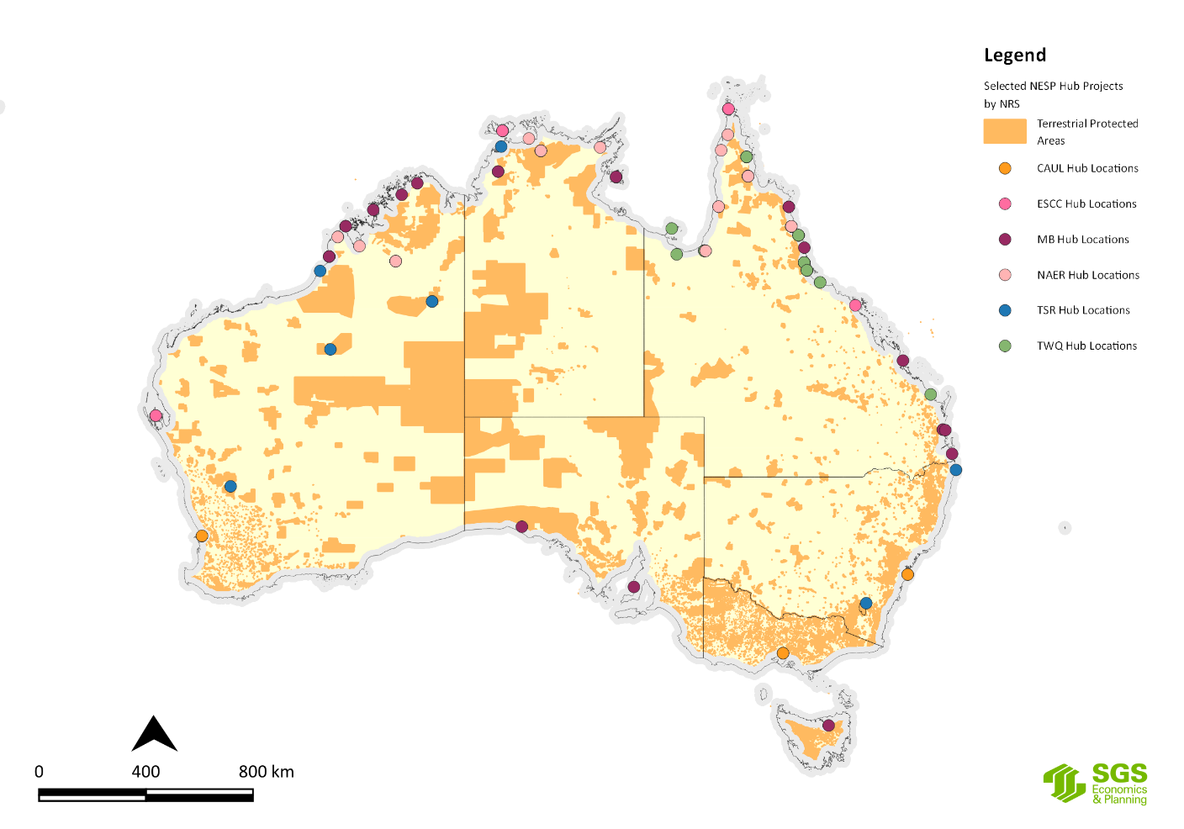
Figure 5.4: Selected NESP Hub Indigenous research projects by National Reserve System (NRS)
Source: SGS Economics and Planning utilising NESP Hub data, 2020

5.2.4 Indigenous Protected Areas
As discussed in Chapter 4, there are 76 dedicated IPAs in Australia, covering approximately 67 million hectares and accounting for more than 45 per cent of the National Reserve System's total area (Figure 4.4). There are also 12 more sites currently under consultation (Appendix H).
Using Figure 4.4 in Chapter 4, Figure 5.5 shows the selected NESP Hub projects against a map of the 76 IPAs and 12 IPA sites under consultation. Figure 5.5 shows that for some Hubs there are a large number of projects involving several IPAs. For example, the NAER, ESCC and TSR Hubs undertook several research projects that had a national focus and therefore related to more than one IPA.
IPAs are important to Indigenous Australians because the declaration of an IPA is undertaken in consultation with the relevant TOs and a management plan has to be prepared by the entity that will be appointed to manage the IPA before the declaration is finalised. This means that an IPA Management Plan carries a considerable degree of authenticity about what the TOs see as threats to the place and its values and how a place should be managed. IPA Management plans may also identify matters where research is required either to better understand the nature of threats or how to improve monitoring and management techniques to ensure the place continues to protect the values for which the place was dedicated as an IPA. For these reasons we examine the IPA Management Plans in more detail in Chapter 6.

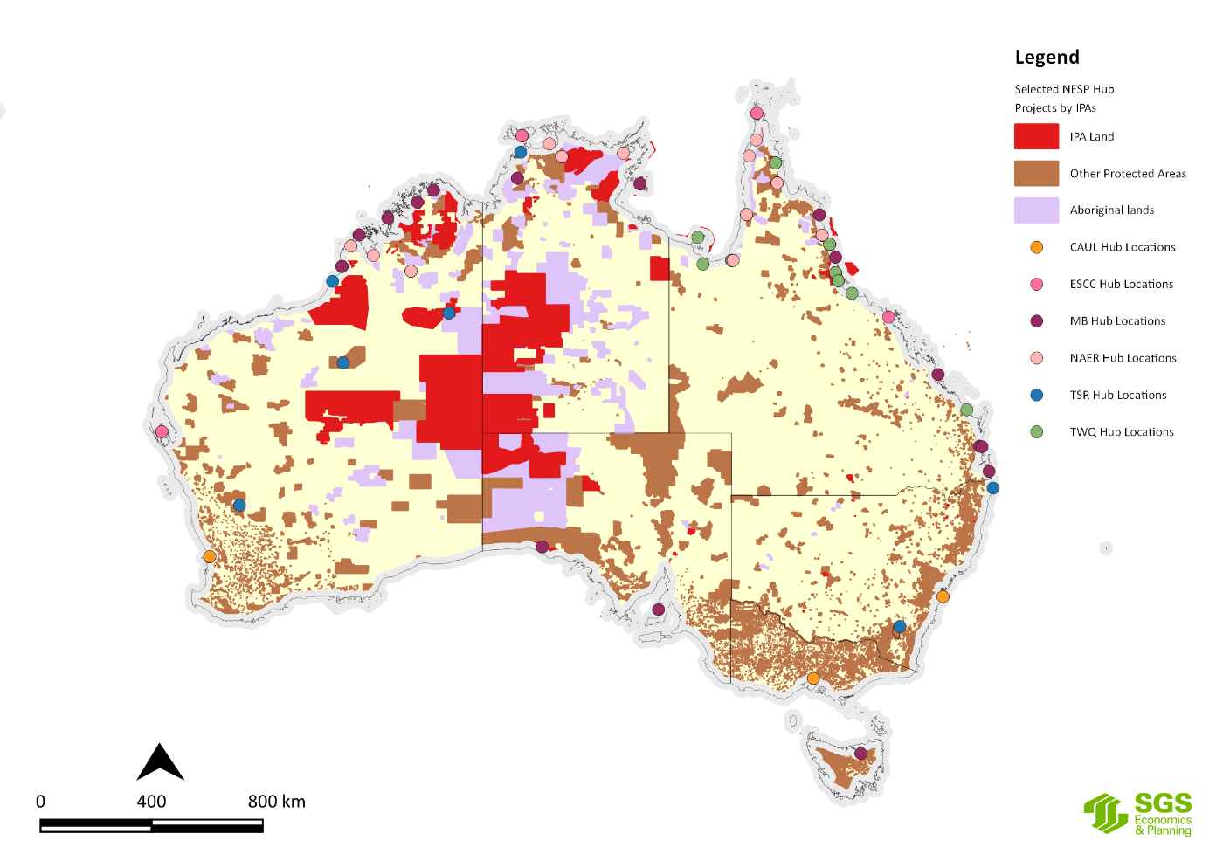
Figure 5.5: Selected NESP Hub Indigenous research projects by Indigenous Protected Areas (IPAs)
Source: SGS Economics and Planning utilising NESP Hub data

5.2.5 The NLP and NRM Regions
As discussed in Part 4.2 of Chapter 4, the Regional Land Partnerships component of the National Landcare Program provides funding for 49 management units across Australia (Figure 4.6) to deliver particular outcomes, including engagement with Indigenous peoples and the utilisation of their IK for the achievement of environmental and agricultural outcomes.
Utilising the interactive map of the 56 regional NRM organisations and Figure 4.6 in Chapter 4, Figure 5.6 shows that many of the NRM Regions have a very low number of Indigenous NESP Hub research projects in their respective areas of interest. What this suggests is that there is little or no correlation between Indigenous NESP Hub research activities and Indigenous NRM projects funded under the National Landcare Program. A closer examination of NESP and NLP projects is required to verify the extent of any correlation, especially in terms of the NLP as an end user of NESP research outcomes.
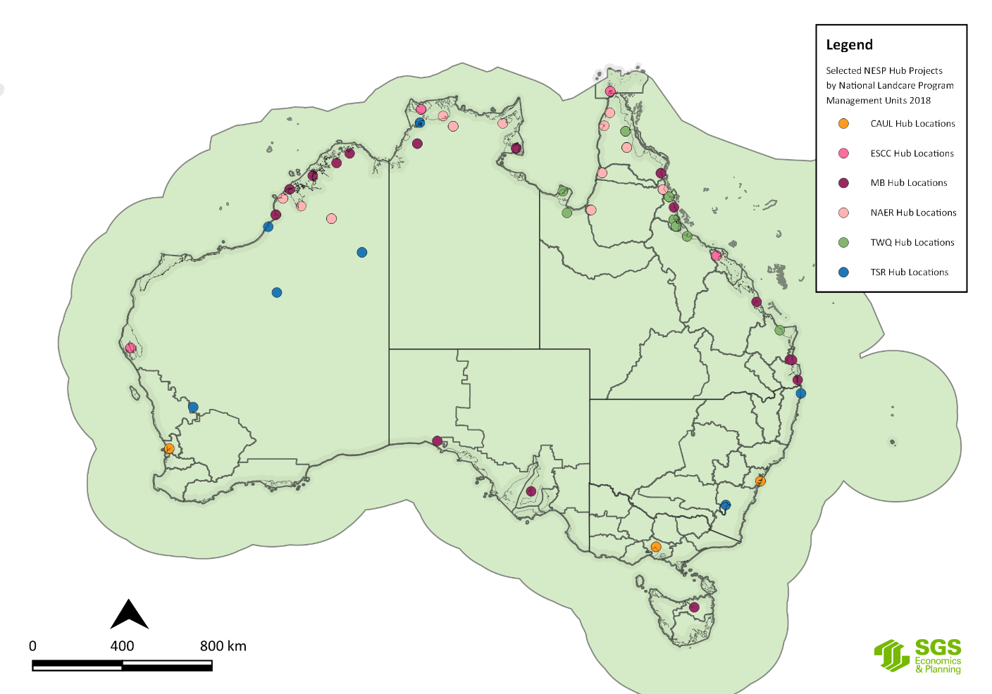
Figure 5.6: Selected NESP Hub Indigenous research projects by National Landcare Program Management Units
Source: SGS Economics and Planning utilising NESP Hub data, 2020

5.2.6 The Indigenous Estate
Recent research has shown that the extent of land owned, managed or controlled by Aboriginal and Torres Strait Islander peoples is increasing over time. This is referred to as the ‘Indigenous estate’ by several academics (Altman and Kerins, 2012; Wensing, 2016) and the Indigenous Property Rights Network (AHRC, 2016). The Indigenous Estate is defined by the Indigenous Property Rights Network as encompassing ‘the lands, seas, waters and resources of Aboriginal and Torres Strait Islander peoples’ (AHRC, 2016:1). The different components of the Indigenous Estate are listed in Appendix L.
Altman’s (2014) research reveals that the extent of the Indigenous estate is around 2.5 million square kilometres, or roughly 33 per cent of terrestrial Australia. Figure 5.7 shows the extent of the Indigenous estate under the following three tenure types:
- Land claimed or automatically scheduled under statutory land rights schemes (an estimated 969,000 sq kms as at 2013);
- Native title determinations of exclusive possession (92 determinations totalling 752,000 sq kms); and
- Native title determinations of non-exclusive possession (142 determinations totalling 825,000 sq kms).
Altman (2014:5) notes that the last category often provides a weak form of property right that needs to be shared with other interests, most commonly commercial rangeland pastoralism. The data used to compile this map was current as at 31 December 2013 and only relates to the terrestrial estate, and does not include the marine estate.
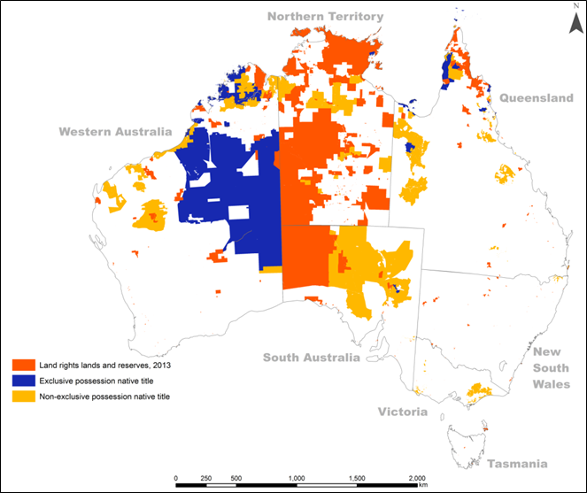
Figure 5.7: The Indigenous estate under three land titles (as at 2013)
Source: Altman 2014:6
Altman’s (2014) research also highlights the relationship between three different environmental values overlaying a template of lands of exclusive land rights and native title possession over Australia.
Figure 5.8 shows a marked contrast between exclusive possession native title and Indigenous lands and vegetation condition.
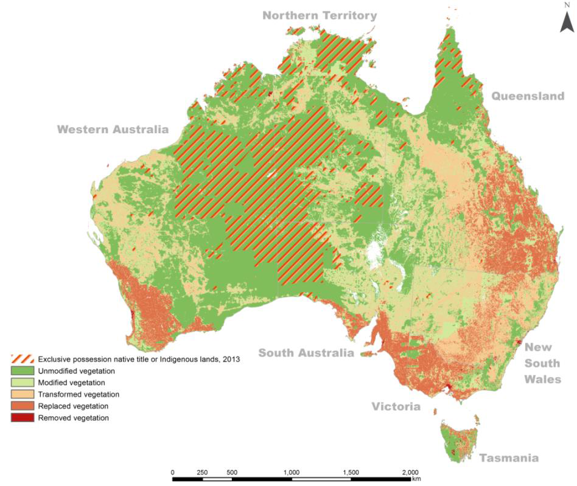
Figure 5.8: Vegetation condition (2006) and exclusive possession native title or Indigenous lands (2013)
Source: Altman 2014:10

Figure 5.9 also shows a marked contrast between exclusive possession native title and Indigenous lands and official threatened species counts, particularly in the more densely settled areas in the east, south east and south west of the continent.
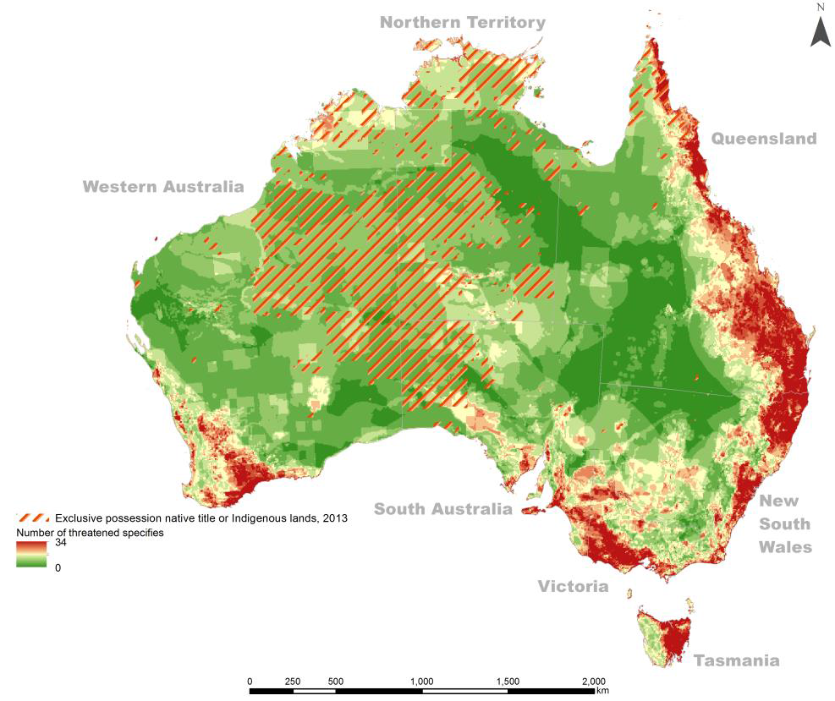
Figure 5.9: Threatened species count (2008) and exclusive possession native title or Indigenous lands (2013)
Source: Altman 2014:10

Figure 5.10 shows the relationship between exclusive possession native title and Indigenous lands and the riparian zones of rivers, so crucial to biodiversity and water quality. Figure 5.10 shows a high river disturbance indicator in the south east and south west of the continent, especially along the Murray Darling system. Altman (2014:9) notes that while there has been low disturbance in the remote tropical savannah, this does not necessarily suggest these areas are threat free.
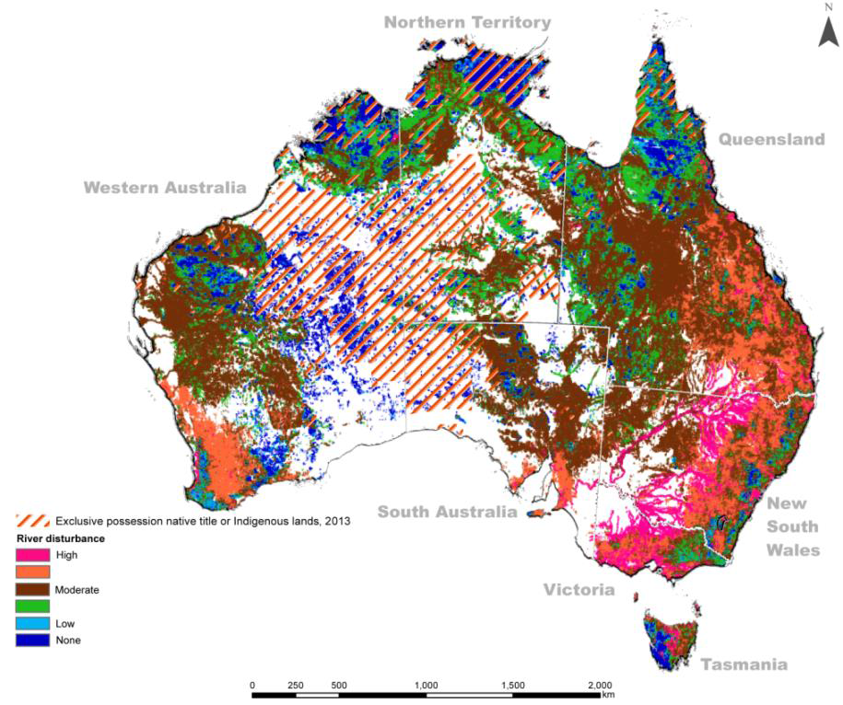
Figure 5.10: Disturbance of riparian zones (2008) and exclusive possession native title or Indigenous lands (2013)
Source: Altman 2014:11
Altman notes that because much of the Indigenous estate has high environmental values, it is resulting in more of this land being incorporated into the conservation estate, especially since the mid-1990s when the NRS was created (as discussed in Part 4.2 of Chapter 4 and in Chapter 6). Figure 5.11 shows the extent of the Indigenous estate and national conservation lands in about 2012 when there were only 60 IPAs.
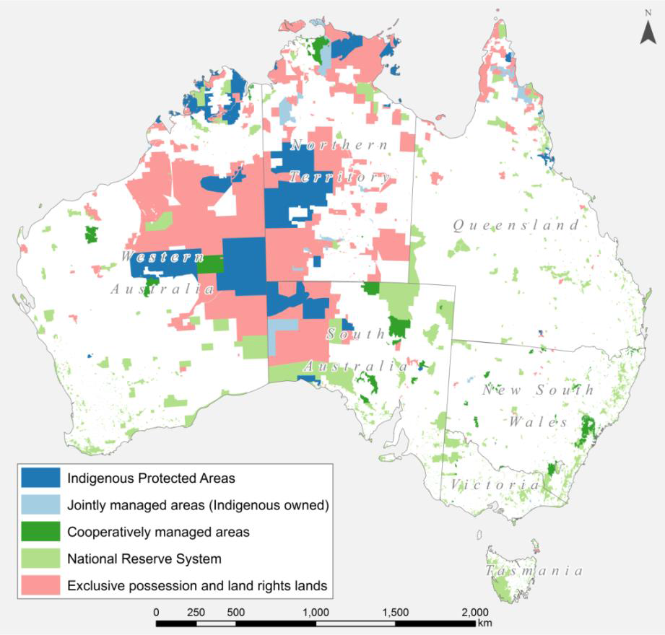
Figure 5.11: The Indigenous estate and national conservation lands
Source: Altman 2014:12
This situation is shown diagrammatically in Figure 5.12. The data used to compile Figure 5.12 was current at 31 December 2013. As discussed in Chapter 4, the NRS and the number of IPAs have increased significantly since then, and there is potential for more to be added, if traditional owners so wish (Altman, 2014:13).
The purpose of Altman’s analysis was to show the correlation between the growing size of the Indigenous estate and its environmental values. Altman’s (2014:1) analysis focuses on the tension between national growth (as measured by gross domestic product dependent on industrial extraction of minerals and commodity exports) and local and regional development for Indigenous landowners. Altman (2014) argues that while the tension is based on a different focus on livelihoods and wellbeing, there is potential for the commodification of the provision of environmental and other ecosystem services on the Indigenous estate.
Furthermore, the Intergovernmental Science-Policy Platform on Biodiversity and Ecosystem Services (IPBES, 2019:14) in its Global Assessment of Biodiversity and Ecosystem Services notes that at least a quarter of the global land area is traditionally owned, managed, used or occupied by Indigenous peoples, and that nature and ecosystems managed by Indigenous peoples and local communities is coming under increasing pressure. The IPBES (2019:14) also reports that among the indicators used by Indigenous peoples and local communities, 72 per cent are showing negative trends that underpin local livelihoods and wellbeing, and that the impacts of climate change are also adversely affecting the ability of Indigenous peoples and local communities to conserve and sustainably manage the areas of high biodiversity and conservation value that are also of value to broader society.
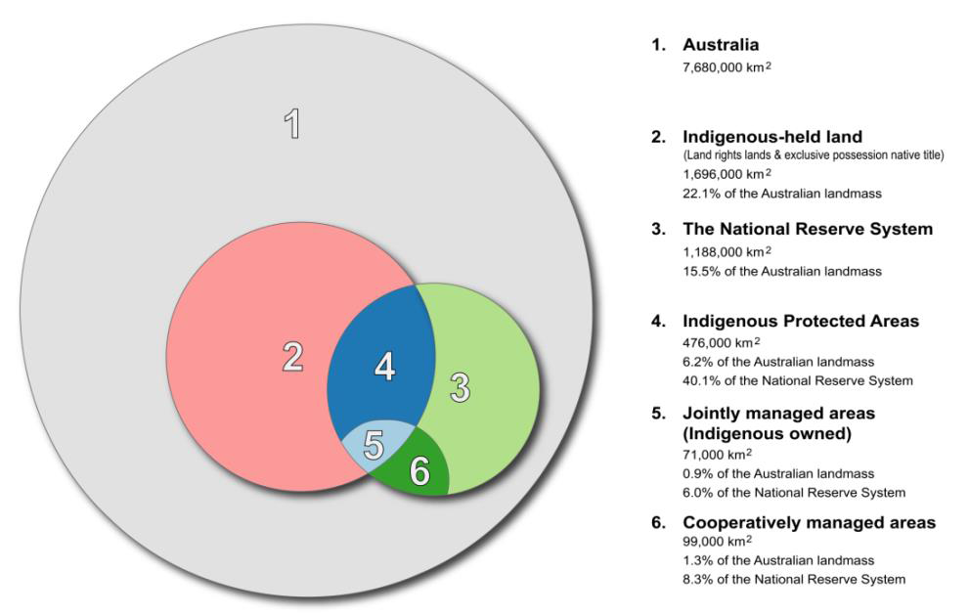
Figure 5.12: Indigenous and other components of the terrestrial conservation estate
Source: Altman 2014:13
As discussed in Chapter 4, ABARES prepares a periodic State of the Forests Report (SoFR) which includes as a key indicator (Indicator 6.4a) the area of forest to which Indigenous people have use and rights that protect their special values and which are recognised through formal and informal management regimes (ABARES, 2018:397). ABARES believes that an essential part of forest management is an acceptable level of accountability for the protection of Indigenous peoples’ cultural, religious, social and spiritual needs and values.
In order to report against this indicator, ABARES collates information on land under Indigenous ownership, management or control and groups this information into the following four categories (Dillon et al, 2015):
- Indigenous owned and managed: freehold land that is both owned and managed by Indigenous persons, entities or organisations.
- Indigenous managed: land that is managed but not owned by Indigenous people, entities or organisations (e.g. Crown reserves and leases); and lands that are owned by Indigenous people, but have formal shared management agreements with Australian and state and territory government agencies (e.g. leased-back nature conservation reserves).
- Indigenous co-managed: land that is owned and managed by other parties, but have formal, legally binding agreements in place to include input from Indigenous people in the process of developing and implementing a management plan (e.g. nature conservation reserve memoranda of understanding).
- Other special rights: land subject to native title determinations (exclusive possession or non-exclusive possession), registered Indigenous Land Use Agreements and legislated special cultural use provisions. These are independent of tenure and, in most cases, do not grant ownership or management rights of land to Indigenous communities. They can provide for the right to access areas of cultural significance or the use of areas for cultural purposes (e.g. within protected water supply catchment areas), or can provide a legal requirement for consultation with the local Indigenous community before any major development or other activities can take place (ABARES, 2018:398).
SGSEP was able to access the ABARES database on the Indigenous estate and has mapped the selected Indigenous NESP Hub research project locations against each of these four categories of Indigenous land ownership, management or control. Figure 5.13 shows the composite result of the selected NESP Hub research projects against the four Indigenous land ownership, management or control categories. The full suite of maps of each NESP Hub’s selected research projects and the four categories of Indigenous land ownership, management or control are shown in Appendix J.

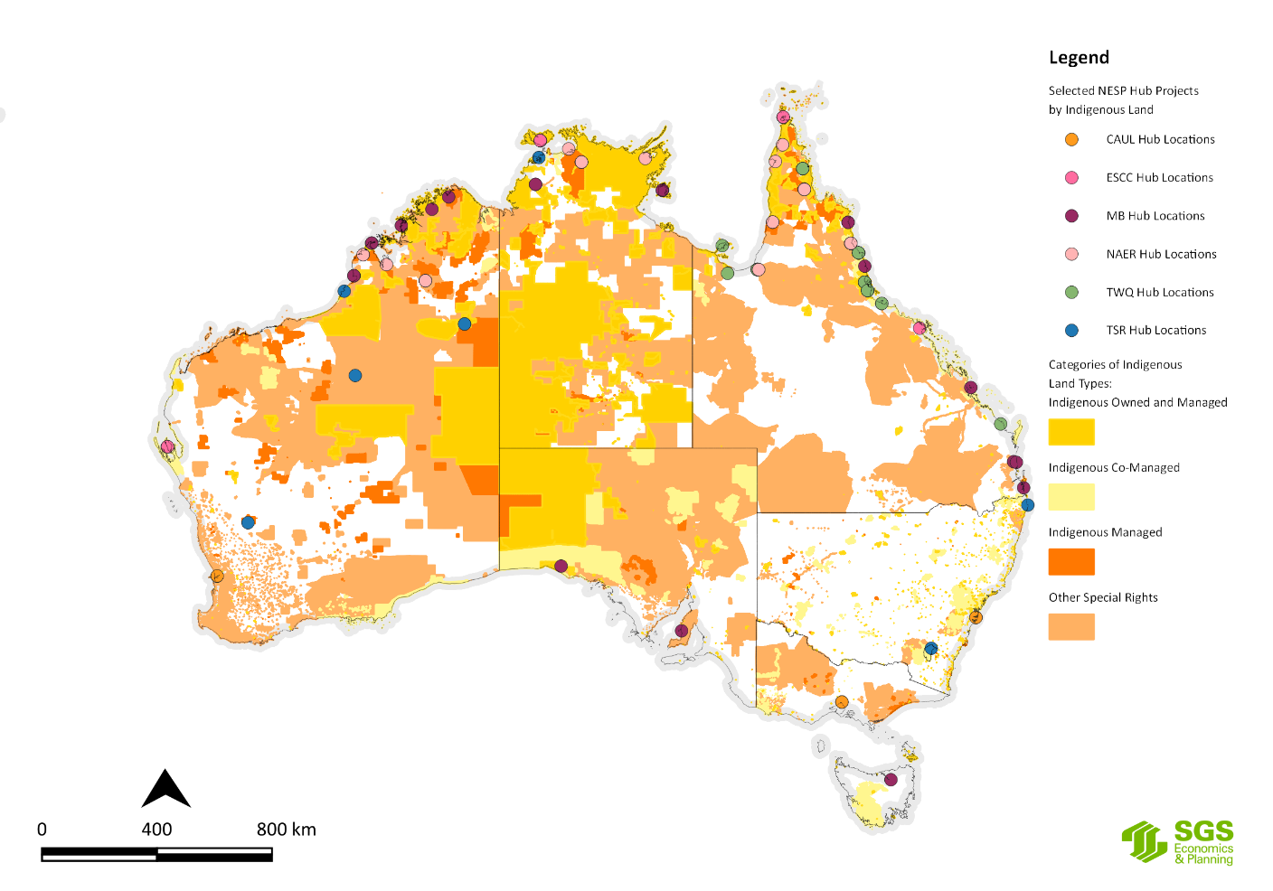
Figure 5.13: Selected NESP Hub Indigenous research projects by Indigenous Land Categories
Source: SGS Economics and Planning utilising NESP Hub data and ABARES Indigenous land data with permission, 2020.
By necessity, the maps focus on the macroscopic and continental scale and are not intended to focus on the local scale. Nevertheless, it is possible to make the observation that there is a reasonable correlation between the location of NESP Hub projects and Indigenous owned and/or managed lands of one kind or another. But having drawn that general observation, SGSEP hastens to add that this is an area where further investigation is required in consultation with the Indigenous people and entities that have interests in land to ascertain with greater clarity what their environmental and climate science research themes and questions may be.
Figure 5.13 shows that several Indigenous research projects are located on or near parts of the Indigenous estate. However, the extent to which the Indigenous land owners or managers are utilising the results of NESP Hub research that has taken place on or near their lands remains to be ascertained with any degree of certainty. One factor that is abundantly clear, is that following a positive native title determination, the exercise of native title rights and interests to undertake land management activities are not always included in the determination. This can significantly impair native title holders from leveraging their native title rights to undertake land management activities that would ordinarily also benefit Australia more generally (Grace, 2018). Research undertaken by the NAER Hub in the Fitzroy River region in the Kimberley in WA found that several Prescribed Bodies Corporate and native title claimant groups want better integration of Indigenous knowledge and laws with Australian laws and Western science, as the basis for making better land and water management decisions (personal communication, Michael Douglas, March 2020).

Findings and Conclusions
This chapter examined the geo-spatial location of the selected Indigenous research projects of each of the NESP Hubs against a number of thematic layers of geo-spatial information. The object of this exercise was to ascertain where Indigenous research has taken place that might yield research themes and questions, as well as ascertaining how the selected research projects relate to the other geospatial layers of information.
This analysis enables us to draw the following broad findings and conclusions against each of those geospatial layers.
- State/Territory: On a jurisdictional basis, there are many more research projects with an Indigenous focus in the northern parts of Australia and less focus on the southern and south eastern parts of Australia. This is due to the fact that two of the NESP Hubs are specifically focussed on Northern Australia, and for the NAER Hub in particular (see Table 2.1), explicit research priorities about Indigenous engagement and partnership have driven this focus. Research projects with an Indigenous focus in the southern parts of Australia are confined to the work of the other four NESP Hubs, and are more limited in number. This state and territory analysis also does not capture a number of key NESP projects as they have a national focus. For example, the ESCC Hub’s national Indigenous Climate Dialogue. Notwithstanding, there are considerable gaps in several jurisdictions where research with Indigenous peoples has not been undertaken, for example in South Australia, Tasmania and the ACT. The environmental and climate science research needs of the Indigenous peoples in the southern portions of Australia needs further investigation.
- Australia’s Marine BioRegions (MB Hub projects only): The analysis shows that the selected MB Hub’s research projects are spread across most of the Marine Park areas in the northern and western areas of Australia in the waters around Tasmania, but none in the waters around South Australia, Victoria and New South Wales. This suggests that there are gaps in NESP marine science research involving Indigenous peoples in the southern Ocean regions of Australia. The marine science research needs of the Indigenous peoples in the southern portions of Australia needs further investigation.
- Australia’s Terrestrial BioRegions: The IBRA classifies Australia's landscapes into 89 large geographically distinct bioregions based on common climate, geology, landform, native vegetation and species information. Some of the Bioregions with the highest level of protection (via the NRS) have a high number of selected NESP Hub research projects with an Indigenous focus. However, the reverse is also true: that many unrepresented Bioregions have no or very few NESP Hub research projects with an Indigenous focus. While there is some correlation between the NESP Hubs’ research projects and the IBRA regions, it would be helpful to have a better understanding of Indigenous peoples’ environmental and climate science research needs and particularly how their cultural knowledge may add value to the IBRA and the NRS in areas that are not able to be dedicated as IPAs.
- NRM Regions: The analysis shows that in many of the NRM Regions there are very low numbers of Indigenous NESP Hub research projects. What this suggests is that there is limited collaboration between Indigenous NRM projects funded under the NLP and Indigenous NESP Hub research activities. The opportunity for greater alignment between the NRM projects involving regional Indigenous communities funded under the NLP and Indigenous environmental and climate science research needs requires further investigation, especially with respect to biodiversity threats, ecological systems and land management practices. Many NRM organisations, have prepared Indigenous NRM strategies and plans in collaboration with their Indigenous communities and some also have Indigenous Advisors that could help inform work on regional Indigenous research needs resource and land management.
- Indigenous Protected Areas: There are currently 76 dedicated IPAs in Australia, covering approximately 67 million hectares and accounting for more than 45 per cent of the National Reserve System's total area and there are also 12 more IPA sites currently under consultation. The analysis shows that many of the NESP projects take IPAs into account in their research and use IPA locations as case studies. IPAs are important to Indigenous Australians because the declaration of an IPA is undertaken in consultation with the relevant TOs and a management plan has to be prepared by the entity that will be appointed to manage the IPA before the declaration can be finalised. This means that an IPA Management Plan carries a considerable degree of authenticity about what the TOs see as threats to the place and its values and how a place should be managed and its values protected. IPA Management plans may also identify matters where research is required either to better understand the nature of threats or how to improve monitoring and management techniques to ensure the place continues to protect the values for which the place was dedicated as an IPA. For these reasons we examine the IPA Management Plans in more detail in Chapter 6.
- The Indigenous estate is divided into four categories as a way of disaggregating the extent of ownership, management or other control that Indigenous people have over the land and in which they have a declared right or interest through land titling and/or other land management arrangements with the state and/or others. This disaggregation has been done by ABARES to meet their needs for the five-yearly Australia’s State of the Forests Report (SoFR). The analysis shows that not all of the NESP Hubs have undertaken research projects on the Indigenous estate, which is more of a reflection of their research focus being away from these locations. For example, none of the CAUL Hub’s research projects related to the Indigenous estate per se, reflecting the CAUL Hub’s urban research focus on cities. Whereas several of the ESCC Hub’s research projects, while not necessarily location specific, were about national climate systems information, capacity building and engagement generally, and arguably therefore applies to Indigenous peoples where ever they own, manage or control land and waters as part of the Indigenous estate. The analysis also shows that the MB, NAER, TSR and TWQ Hubs undertook several projects across all elements of the Indigenous estate. Arguably, with the continuing growth of the Indigenous estate, especially in the outer regional areas, remote, very remote parts of Australia, there is room for improving the alignment between the Indigenous estate and the environmental and climate science research needs of the Indigenous land owners and/or managers. This is especially significant given large parts of the Indigenous estate has high biodiversity conservation values (Altman, 2014; Altman and Kerins, 2012; Altman, Buchanan and Larsen, 2007).
The analysis in this Chapter shows that it is possible to map the selected NESP Hubs’ research projects against a number of different thematic geospatial layers of information to assess their value in a wider context. It is also possible to draw some very broad conclusions about Indigenous environmental and climate science research needs in these locations, which we discuss in Chapter 8. However, we were not able to identify Indigenous environmental and climate science research priorities for large areas of Australia not covered by this project documentation. This was not possible for several reasons.
- Firstly, SGSEP selected and were guided by the Hubs to over 100 research projects across the six NESP Hubs with a high level of Indigenous engagement. We examined those projects in considerable detail in a separate Excel spreadsheet, the results of which are presented above and elsewhere in this report.
- Secondly, in addition to these selected projects, the NESP Hubs have completed several hundreds of research projects across the country that had some level of Indigenous engagement, albeit ranging from levels 3 to 1 in the Three Category Approach developed by the TWQ Hub and adopted by most of the other NESP Hubs.
- Thirdly, the hundreds of research projects undertaken by the NESP Hubs extend across a whole raft of projects ranging in size, location, scope, research subject, methods, outputs and outcomes. Some projects concerned particular species of flora, fauna or marine life which may be relevant to a specific locality or extend over very large geographic areas and particular ecosystems or environments. Other projects focussed on developing resources for information, training or techniques for monitoring or managing landscapes or particular environments, presenting difficult challenges for spatial mapping.
- Fourthly, the NESP Hubs were not required to identify Indigenous environmental or climate science research priorities geographically or thematically and most of the NESP Hub research projects were not initiated by Indigenous peoples as a reflection of their priorities per se, but rather were initiated by other end-users or the research project arose from Hub priorities.
- Fifthly, as far as SGSEP could establish, there is no existing documentation nationally of what the environmental and climate science research needs and priorities of Indigenous Australians might be. This has not been done before on a national basis across all environments – terrestrial, aquatic and marine.
- Sixthly, our research is desk-top based and therefore cannot reflect Aboriginal and Torres Strait Islander peoples’ voices about their environmental and climate science research priorities and the extent to which they are being addressed by NESP (or other programs or agencies). While SGSEP was able to conduct several online meetings with Aboriginal and Torres Strait Islander people and organisations in the final phases of this review, more extensive consultations were not possible as the impact of COVID-19 saw many Aboriginal and Torres Strait Islander organisations and communities shut their offices due to social distancing restrictions.
However, the spatial analysis documented in this Chapter has enabled SGSEP to draw some findings about the inter-relationships between the selected Indigenous research projects undertaken by the NESP Hubs and the various thematic geo-spatial layers of information. Our key findings are that there are some states that have no or very few research projects with an Indigenous focus, some marine parks in the southern and eastern parts of Australia have very few or no research projects with an Indigenous focus, and many bioregions (particularly those that are under-represented in the NRS) have no research projects with an Indigenous focus. SGSEP believes there is a need for better alignment between the geospatial themes and the Indigenous land and marine estates and NRM activities that are funded under the NLP, as that may assist with yielding more information about future Indigenous research needs. It is in Australia’s interests to make better use of the Indigenous knowledge about our environment if Australia is to prosper, not only environmentally, but also socially, culturally and economically.

Indigenous Protected Area (IPA) management Plans and Indigenous research Themes / Questions

Introduction and Approach
This Chapter examines the IPA program and the Management Plans for most of the 76 declared IPAs around Australia and the Healthy Country Management Plans for seven other non-IPA locations. This examination was specifically included in the Brief from the Department because, in contrast to the NESP research outputs, most of the IPA Management Plans and other Healthy Country Management Plans were prepared by the Traditional Owners of the areas under conservation protection or by the Aboriginal and Torres Strait Islander organisations with management responsibilities for the areas that are the subject of the Management Plans.
The IPA and other Healthy Country management plans are a very rich source of information and knowledge about the threats, management activities and research themes and questions relating to the areas that are the subject of the plans and more generally. This kind of analysis of the IPA and other Healthy Country management plans has never been done before. As a result, the analysis reveals some interesting insights, not only about environmental and climate science research themes and questions of concern to the TOs, but also about the state of these plans and the management of the areas they are intended to protect for present and future generations for the benefit of all Australians.
The following analysis also meshes very neatly with several of the NESP Hub research projects that have focussed on IPAs and IPA management and research needs generally.

Indigenous Protected Areas (IPAs)
Since 1997, the Australian Government has supported Indigenous communities to voluntarily establish Indigenous Protected Areas (IPAs) on Indigenous owned or jointly managed land and sea Country. An IPA is defined by the Australian Government as:
an area of land and/or sea over which the Indigenous traditional owners or custodians have entered into a voluntary agreement with the Australia Government for the purposes of promoting biodiversity and cultural resource conservation. (Department of Agriculture, Water and The Environment 2020).
There are currently 76 dedicated IPAs across approximately 67 million hectares (Figure 6.1). They range from extremely large remote desert areas on Indigenous-owned lands to relatively small, rainforest multi-tenured sites where the IPA co-exists with National Parks, leasehold and privately owned lands (Hill et al, 2013). IPAs are pivotal in conserving Australian biodiversity and ecosystem services, constituting over 44 per cent of the National Reserve System (NRS).
Figure 6.1: Indigenous Protected Areas and Consultation Projects – February 2020
Source: DAWE, 2020

Establishing an IPA
There are five key steps involved in establishing and maintaining an IPA:
- Community and stakeholder consultation
- Developing a Plan of Management
- IPA Declaration
- Implementing the Plan of Management
- Monitoring, evaluation, reporting and improvement.
A recent study of IPAs in Northern Australia undertaken by the NAER Hub (Farr et al, 2016:9) noted that:
- An IPA arises from a voluntary agreement entered into by traditional Indigenous owners to promote biodiversity and conserve cultural resources. Traditional Owners enter into a legally binding IPA commitment via an Indigenous organisation and committing land title in perpetuity to the NRS purposes.
- IPAs are only declared after a period of consultation which typically takes between 3 and 5 years, and which is intended to facilitate the development of management and governance systems to ensure effective long-term operation of the areas. During the consultation period, Indigenous communities are supported by the Australian Government to consult with their communities and other stakeholders about whether an IPA is suitable for them. A Plan of Management is developed which sets out how Country, its cultural values and threats to these values will be managed (Hill et al, 2011:4-5).
- IPA agreement is done in line with international standards, namely the International Union for Conservation of Nature (IUCN). About 1/3 of IPAs are nominated under IUCN Category V (Protected Landscape/ Seascape); with 2/3 in IUCN Category VI (Managed Resource Protected Area); several IPAs have more than one IUCN nomination (IUCN, 2013).
- IPAs play a major role in Australia’s capacity to meet its conservation targets under national and international obligations.
- IPAs comprise a significant and growing part of the National Reserve System (NRS) – growth in IPAs accounts for nearly 70% of the total area of land that has been added to the NRS since its inception. IPAs range widely both in size and in ecosystem types protected.
- An IPA management plan describes how Indigenous groups ‘care for Country’ using a combination of traditional Indigenous knowledge and contemporary western science. These plans may also identify research priorities (discussed below).
- Rangers are an important part of the IPA system. As IPA managers, they undertake the day to day running of these areas, safeguarding against weed and feral animal expansion, revegetating areas of deforestation, conducting interpretive tours for visitors, managing and maintaining visitor amenities, engaging in cultural history and language projects, including the protection of rock arts, and participating in research projects aimed at conserving fauna (e.g., crocodiles and threatened turtle population) and flora.
- Northern Australia is home to 30% of the total Indigenous population of Australia and contains more than 50% of the Australia’s declared IPAs.

Benefits of IPAs
A recent study of IPAs in Northern Australia undertaken by the NAER Hub found that there are many different ways of measuring benefit (Farr et al, 2016:30), that no single method of assessing benefits is suitable in all situations because different benefits require different assessment techniques (Farr et al, 2016:I and 41). The researchers concluded that it is important to establish who needs the information and why, before deciding which techniques may be best suited to the task of establishing the benefits (Farr et al, 2016:i).
The NAER Hub study referred to above, concluded that:
IPAs have unique features compared to other types of reserves including governance arrangements founded in Indigenous customary law, strong emphasis on traditional knowledge systems for management practice, and a priority to deliver multiple economic and cultural benefits alongside nature conservation.
They also differ greatly from one another, ranging from large relatively remote areas on Indigenous-owned lands to small, multi-tenured sites where the IPA co-exists with national park, lease-hold or privately owned lands. Understanding these features is critical to facilitate the improvement and refinement of IPA management and to provide information useful to collaborative stakeholders including Traditional Owners, community, and government. (NAER Hub, 2016)
In 2016, the Australian Government commissioned SVA Consulting to conduct four SROI (Social Return on Investment) analyses to understand, measure or estimate, and value the changes resulting from the investment in five IPAs across Australia, specifically:
- Warddeken in NT;
- Girringun in Qld;
- Birriliburu and MKK in WA (together forming one analysis); and
- Minyumai in NSW.
The objectives in conducting these analyses were:
- To test and validate PM&C’s understanding of the broad environmental, cultural, social and economic outcomes generated by IPAs; and
- To supplement the existing body of information by assigning a financial value to those outcomes, helping PM&C to better understand the relative benefits of the IPA program for Indigenous communities, Government and other stakeholders.
SVA Consulting’s analyses concluded that, over the period 2009 to 2015 financial years, an investment of $35.2m from Government and a range of third party investors generated social, economic, cultural and environmental outcomes with an adjusted value of $96.5m. SVA concluded that ‘The analyses support the prevailing view that the IPA and Working on Country (WoC) programs have succeeded across a broad range of outcome areas, effectively overcoming barriers to addressing Indigenous disadvantage and engaging Indigenous Australians in meaningful employment to achieve large scale conservation outcomes’ (SVA Consulting, 2016: 30).
It is well established that IPAs deliver more than environmental benefits because the Indigenous managers are ‘caring for their Country’ (Garnett and Sithole, 2007; Ganesharajah, 2009; Burgess et al, 2009; Zander and Garnett, 2011; Larson et al, 2020). Indigenous communities managing the IPAs are able to protect the values of their Country for future generations and achieve significant health, education, economic, social and cultural benefits. These benefits are beyond doubt (SVA Consulting, 2016).

New IPA’s in the planning stage
In 2017, the Australian Government committed $15 million under the IPA Program to assist Indigenous groups to undertake consultation and planning for the establishment of new IPAs.
A Competitive Grant Round of the New Indigenous Protected Areas Program opened on 18 February 2019 and closed on 30 April 2019. Following the round, the Australian Government announced funding for seven new IPA consultation projects.
A Discretionary Grant Round of the New Indigenous Protected Areas Program was held in early 2018. Following the round, the Australian Government announced funding for a further five new IPA consultation projects.
The 12 new IPA Projects are listed in Appendix I. Combined, the 12 new IPA projects from the Competitive and Discretionary Grant Rounds cover over 33 million terrestrial hectares and over 1.8 million hectares of sea Country. Once dedicated, the new IPAs will add over 30 million hectares to the National Reserve System, increasing the size of the National Reserve System by almost 20 per cent. (DAWE, 2020).

NESP research on IPAs
The IPAs have been the subject of several research projects under the NESP, both in terms of particular sites as well as more broadly for the value of the network of IPAs across Australia, in particular by the NAER Hub. The following two projects are of particular significance.
Country: multiple values, multiple benefits into the future. Research priorities for Indigenous Protected Areas across northern Australia. (Hill et al, 2016)
This project sought to identify the environmental, social, economic and cultural benefits associated with IPAs in northern Australia and an assessment of the research priorities for IPAs. The project was undertaken in collaboration with IPA managers, government, non-government and research stakeholders across the north of Australia and included literature reviews, interviews and workshops to assess research priorities for northern Australia’s IPAs.
The project identified five priority research topics and questions and six key findings about IPAs that underpin and explain the research results. The greatest single research priority identified was the development of new models of research in which Indigenous people are central to the planning, process and outcomes. The remaining four research topics and questions were relatively equally weighted and focussed on the need to acquire knowledge to manage Country into the future for multiple values and multiple benefits.
The five critical research topics and questions are:
- New research models: What innovations and adaptations to environmental research models can enable Indigenous people to be central and gain greater benefit from current and new research?
- Economic dimensions: What does Indigenous land management contribute when valued through economic approaches?
- Knowledge brokering: How can both science and Indigenous knowledge be made more accessible and useful to Indigenous decision makers?
- Sustainable enterprise: How can Indigenous caring for Country be made sustainable through models of planning, innovation, governance, and business that can be tailored to diverse contexts?
- Frameworks responsive to new impacts: What participatory monitoring, participatory impact assessment methods, and institutional or tenure responses, enable protection of Country in response to new impacts e.g. new conservation and development proposals? (Hill et al, 2016:10; NAER, 2016)
The six key findings that underpin the needs are:
- Caring for Country through IPAs across northern Australia forms part of the broader spectrum of Indigenous land management activities that have similar features, resulting in similar research needs.
- All research needs identified fit within the theme of understanding how to manage Country for multiple values and multiple benefits while supporting today’s youth into the future.
- The greatest priority of Indigenous land managers for research is the development of new research models in which they are central. These should be tailored to their diverse environmental, economic and social information needs. Peer to peer Indigenous networking is vital here.
- Place-based, integrative research and practice through Indigenous-driven case studies provides the best model to address the diverse, area specific research needs of land managers.
- Systematic and participatory prioritisation of research needs can be supported through: looking at priorities listed in strategic plans; identifying current and future factors that affect people and Country; Indigenous-led group discussions about criteria to guide decisions; ranking based on these criteria in workshops; interviews to discuss priorities; and review and feedback before finalisation.
- Current factors that influence research priorities for land management are a mix of opportunities, challenges, and factors that could be considered as both. For example: deriving economic and other benefits is an opportunity; prevalent community socio-economic disadvantage is a challenge; and large numbers of youth in communities can be viewed as both an opportunity and a challenge. (Hill et al, 2016:10; NAER, 2016)
The research outcomes were also seen by the participants to apply to broader Indigenous land management activities across Northern Australia (and possibly elsewhere in Australia also), and not just to IPAs (NAER Hub, 2016).
Economic values and Indigenous Protected Areas across Northern Australia (Farr et al, 2016)
A sub-component of the project discussed above was research on the economic values of IPAs. The study involved a systematic review of the empirical valuation literature relating to benefits associated with IPAs, revealing that some benefits are quantified in monetary terms more frequently than others, both in Australia and elsewhere. The research identified substantive gaps in our understanding of the numerous benefits – of their value to different people, in different contexts, in their entirety, and relative to other benefits. There is a focus on the things that can be easily quantified, and if it is not able to be quantified there is a lack of ‘visibility’ or ‘presence’. Hence, vitally important non-market goods and services associated with IPAs may be overlooked, particularly by decision-makers who are driven by quantitative and/or economic data. The research concluded that it is important to find ways of highlighting the importance of those non-market benefits, so that resources can be directed in a manner that generates most benefit per dollar spent. The researchers note that no single method of assessing benefits is suitable in all situations and that more than one method may be required to assess the multiple benefits associated with IPAs (Farr et al, 2016:41).
More significantly, the report concludes that:
‘When prioritising research to fill the gaps and selecting the most appropriate valuation method for the task (whether it’s one that uses money as a metric or something else), it is important to carefully specify the type of information required: who needs the information?, on what?, and why?. When asked by different stakeholders, these questions may require the use of different valuation methods. This is because different stakeholders will likely prioritise the assessment of different benefits, and different benefits require different assessment techniques.’ (Farr et al, 2016:1, 37).
The research on research priorities for IPAs across Northern Australia has informed two other projects by the NAER Hub:
- ‘Multiple benefits and knowledge systems of Indigenous land management programs‘ (Project 5.3), which examined quantifiable and comparable information about local to national scale socio-economic and well being benefits associated with Indigenous land and sea management programs.
- ‘Knowledge brokering for Indigenous land management’ (Project 5.4) which has involved Indigenous peoples as co-researchers to develop tools that are assisting them to identify useful knowledge resources and explore ways they can use different types of knowledge for decision-making. One significant product of this project is the Best Practice Guidelines from Australian Experiences: Our Knowledge Our Way in Caring for Country. Indigenous-led approaches to strengthening and sharing our knowledge for land and sea management.

IPA Management Plans
The recognition of an IPA by the Australian Government is a response to a declaration process initiated by the Traditional Owners (TOs) and/or custodians. The declaration is preceded by consultation with the relevant TOs and/or custodians and ‘participatory planning under community control and decision making’ (Hill et al, 2011:4). The declaration is then recognised by the Australian Government based on a Management Plan that has been endorsed by the relevant TOs/custodians.
Most IPA Management Plans are based on a management approach consistent with the IUCN Protected Area Management Category. As Hill (et al, 2011:4) notes, ‘An IPA declaration also depends on assurances that the “right people” that can speak for that Country have been given an opportunity to make free, prior and informed consent’. TO communities invest considerable time and effort in preparing their IPA management plans because they will be responsible for the management of the IPA once the declaration is made.
IPA Management Plans therefore carry considerable authenticity from the Traditional Owners when it comes to identifying how an IPA place is to be managed, what the threats are and what the research priorities might be for that area.
Some excellent Guidelines already exist to help IPA managers develop plans based on the western scientific planning approach. Including for example:
- Guidelines for Management Planning of Protected Areas (IUCN, 2003);
- Guidelines for Applying Protected Area Management Categories (IUCN, 2013).
- Australian Guidelines for Establishing the National Reserve System (CofA, 1999);
- Open Standards for the Practice of Conservation. (CMP, 2013).
These existing Guidelines contain material that is both highly useful and important for IPA managers. However, using these Guidelines alone tends to produce plans that are based on western science and fall short of the potential to present the unique cultural settings and the vibrant Indigenous management strategies on Country and a synthesis between the application of Indigenous knowledge alongside Western science. The co-design and co-production of environmental and climate science research projects is discussed in more detail in Chapter 7.
In 2011, CSIRO in collaboration with IPA managers, traditional owners, Australian Government Indigenous Protected Area section staff (within the Department) researchers in the CSIRO, an Independent Indigenous Consultant, and other Consultants who have worked on IPA Management Plans, undertook the development of a set of guidelines for the preparation of IPA Management Plans, titled Our Country Our Way (Hill et al, 2011) (See Figure 6.2).
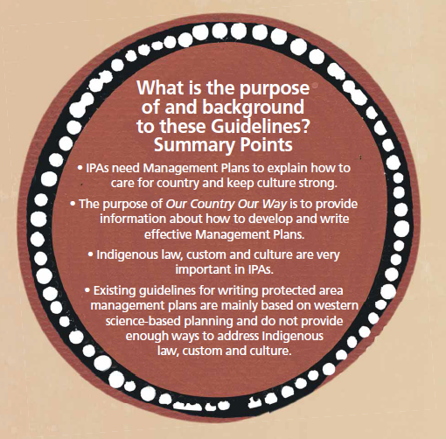
Figure 6.2: Purpose and Background to Our Country Our Way Guidelines
Source: Hill et al 2011:4
Our Country Our Way (Hill et al, 2011) was developed to sit alongside the existing Guidelines listed above. The purpose of the Our Country Our Way guidelines is to assist IPA owners, custodians and managers, including those involved in co-management projects, to produce Management Plans that ensure outcomes of value to both Indigenous peoples and the Australian nation (Hill et al, 2011).
IPA Management Plans therefore bring together management based on connections between Indigenous people, Country, traditional law, custom and culture with the Australian and international systems for protected area management. IPA Management Plans are most effective if they ensure Indigenous peoples drive and determine how these requirements will be met.
With the assistance of the Department of Agriculture, Water and the Environment, SGS Economics and Planning was able to locate Management Plans for 49 of the current 76 declared IPAs. SGS Economics and Planning subsequently examined each of those Management Plans plus seven (7) other Management Plans prepared for specific places by TOs/Custodians, to ascertain the extent to which they identify environmental and climate science research priorities.

Analysis of IPA Management Plans
To better inform our understanding of what Indigenous environmental and climate science research themes and questions might be, we turned to the IPA Management Plans and developed a spreadsheet with the following analysis:
- IPA No.
- IPA Name
- State/Territory
- BioRegion
- NRM Region
- Source Agency
- Management Plan and Date
- Plan Type
- Timespan of Management Plan
- Threats
- Research Priorities
- NESP 2 Research Hubs (Marine & Coastal; Resilient Landscapes; Climate Systems; Sustainable Communities and Waste), and
- Website addresses where available.
The Spreadsheet shows that 46 IPA’s have publicly available Management Plans, 38 of which include some identified Indigenous specific research methods and/or priorities. There are 30 IPAs where there is no publicly available Management Plan for that IPA.
Table 6.1 shows that the bulk of the Management Plans were prepared between 2011-15 and then between 2016-20.
Some of the Management Plans are in their third or fourth iteration, however the bulk of them are still on their first iteration and have expired or are about to expire and are therefore somewhat dated. Nevertheless, they still provide a valuable source of information.
Table 6.1: IPA and Other Management Plans and timeframes of when they were prepared
Period Management Plan prepared | IPA | Other Management Plans
1996-2000 | 0 | 0
2001-2005 | 4 | 1
2006-2010 | 2 | 1
2011-2015 | 30 | 3
2016-2020 | 7 | 2
Not identified | 3
TOTAL | 46 | 7
Source: IPA Management Plans 1996- 2020

The spreadsheet also identifies which Interim Biodiversity Regions and NRM regions the IPA is situated, in addition to other relevant details, including the nature of the threats identified in the Plan.
The primary purpose of this analysis is to ascertain whether the IPA Management Plans identify Indigenous specific environmental and climate science research priorities. SGSEP’s analysis found that:
- Of the 46 IPA Management Plans that SGSEP and DAWE were able to locate on the public record, 38 (79%) of them identified discernible/specific Indigenous research priorities.
- Of the seven (7) other non-IPA Management Plans on the public record, five of them identified discernible Indigenous research priorities.
By ‘discernible/specific Indigenous research priorities’ we mean that the priorities can be regarded as ‘Indigenous specific’ because they are identified in the Management Plan and the Management Plan has been prepared by the relevant TOs or Indigenous organisation that is responsible for the management of the IPA.
Two things are very clear from this analysis:
- Firstly, many of the IPA Management Plans raise issues around the use of Indigenous ecological or traditional knowledge and require the development of formal agreements or protocols for undertaking scientific research on the IPA.
- Secondly, many of the IPA Management Plans identify a wide range of threats and specific matters that the TOs or management body consider require further research.
The details are presented in the Excel Spreadsheet, and are discussed in more detail below.
Table 6.2 is a list of the relevant 38 IPA Management Plans and shows in tabular form in which IPA Management Plan these specific issues are raised. The analysis of the specific research priorities has been aligned with the four thematic Hubs that are to be established under the next iteration of the NESP (discussed further below).
Table 6.3 is a list of the Other Non-IPA Management Plans and shows in tabular form in which Other Non-IPA Management Plan these specific issues have been identified and how they align with the with the four thematic Hubs that are to be established under the next iteration of the NESP (discussed further below).

Table 6.2: IPA Management Plans, Indigenous specific research priorities and alignment with NESP2 Hubs
IPAs by number and jurisdiction |  |  | Indigenous specific research methods / approaches | NESP2 Hubs and Indigenous specific priorities
IPA No. | IPA Name | Jurisdiction | Indigenous specific research methods / approaches | Marine & Coastal Hub | Resilient Landscapes Hub | Climate Systems Hub | Sustainable Communities and Waste Management Hub
5 | Deen Maar | VIC | Y | Y | Y
12 | Warul Kawa Island | QLD | Y | Y
13 | Dhimurru | NT | Y |  | Y | Y
15 | Mount Willoughby | SA |  |  | Y
17 | Ngaanyatjarra | WA |  |  | Y
18 | Tyrendarra | VIC |  | Y | Y
20 | Anindilyakwa | NT | Y |  | Y | Y
21 | Laynhapuy | NT | Y | Y | Y
23 | Northern Tanami | NT |  |  | Y | Y
24 | Warlu Jilapaa Jumu | WA |  |  | Y
25 | Kaanju Ngaachi Wenlock & Pascoe Rivers | QLD | Y
32 | Warddeken | NT |  |  | Y
33 | Djelk | NT |  |  | Y
35 | Kurtonitj | VIC |  |  | Y
39 | Lake Condah | VIC |  | Y | Y
42 | Uunguu | WA | Y | Y | Y
50 | Mandingalbay Yidinji | QLD | Y | Y
Y51 | Southern Tanami | NT |  |  | Y | Y
53 | Ngunya Jargoon | NSW |  |  | Y
55 | Eastern Kuku Yalanji | QLD | Y
56 | Bardi Jawi | WA |  |  | Y
57 | Girrigun | QLD | Y |  | Y
59 | Dambimangari | WA | Y |  | Y
60 | Balangarra | WA |  |  | Y
61 | Thuwathu/Bujimulla | QLD |  |  | Y
63 | Wardaman | NT |  |  |  | Y
64 | Karajarri | WA |  |  |  | Y
65 | Nijinda Durlga | QLD |  | Y
67 | Kiwirrkurra | WA |  | Y
68 | Nyangumarta Warrarn | WA |  | Y
69 | Matuwa Kurrara-Kurrara | NT | Y |  | Y
70 | Katiti Petermann | NT |  |  | Y | Y
71 | Ganalanga-Mindibirrina | NT |  |  | Y
72 | Wardang Island | SA |  |  | Y
73 | Marthakal | NT |  |  | Y
74 | South-East Arnhem Land | NT |  |  | Y
75 | Yawuru | WA |  | Y
76 | Mawonga | NSW |  |  | Y
TOTAL | 38 |  | 12 | 11 | 28 | 7 | 0

Table 6.3: Non-IPA Management Plans, Indigenous specific research priorities and alignment with NESP2 Hubs
Other Management Plans |  | Indigenous specific research methods / approaches | NESP2 Hubs and Indigenous specific priorities
Location Name | Jurisdiction | Indigenous specific research methods / approaches | Marine & Coastal Hub | Resilient Landscapes Hub | Climate Systems Hub | Sustainable Communities and Waste Management Hub
Nyul Nyul | WA | Y |  | Y
Myala | WA | Y
Walalakoo | WA | Y |  | Y
Yirralka Rangers | NT |  |  | Y
Pormpuraaw Rangers (Land in Trust) | Qld | Y |  |  | Y
Gunggandii Land and Sea Rangers | Qld
Eastern Kuku Yalanji, Mandingalbay and GirringunI | Qld
TOTAL | 7 | 4 |  | 3 | 1

Indigenous Ecological Knowledge (IEK) and research methods
As shown in Table 6.2 and Table 6.3 respectively, 12 of the IPA Management Plans and 4 of the Other Non-IPA Management Plans identified several issues relating to accessing and making use of Indigenous ecological or traditional ecological knowledge (IEK, TEK), or more simply referred to as Indigenous Knowledge (IK). The issues relate primarily to methods or approaches to undertaking scientific or other research with Indigenous peoples about their ancestral lands and waters. As the extracts in the Spreadsheet show, Indigenous peoples are not always happy with the way their ecological or traditional knowledge has been used by researchers or end-users of the research. Hence, issues of process and approaches to working with Indigenous peoples and accessing their ecological or traditional knowledge are identified in the management plans as a matter of priority. The concerns relate mainly to a lack of understanding by researchers and end-users about the two-way nature of relationships between Indigenous and non-Indigenous knowledge systems.
For TOs, getting the relationships right is often a higher priority than deciding what the research question(s) may be. Experience has shown that the best outcomes arise when the methodologies and protocols are agreed upon before getting to the topics to be researched – rather than the other way around.
The majority of the IPA Management Plans state that any research conducted on Country can only be undertaken with the free, prior and informed consent of, and in partnership with, the relevant TOs or custodians of the area, and that there is an understanding and acceptance of the need for two-way knowledge exchange and learning before research can begin on Country.
What follows is a rich tapestry of advice about research methodologies in an intercultural context where two-way learning and knowledge exchange is such an important element of the partnerships between Indigenous and non-Indigenous interests.
Where relevant, this information has been classified into the five priority research topics and questions identified by Hill et al in their 2016 report ‘Country: multiple values, multiple benefits into the future; Research priorities for Indigenous Protected Areas across northern Australia’.
- Knowledge brokering for Indigenous land management (this is a Hill et al, 2016 category):
  - TEK must be regarded as specialist, technical expertise by researchers.
  - IPA management activities must be respected.
  - The rating for the health of each target area is based on TO knowledge, the knowledge of TO partners and some surveys from scientists.
  - Sustained involvement of TOs in on-ground land and sea assessments and formal research is essential.
  - TO Rangers partner with research institutions and government agencies to improve knowledge of the natural resources in the IPAs.
  - TOs’ traditional knowledge of the tides, currents and seas helps when looking for jigeedany (Dolphins).
  - TOs must talk to the scientists to make sure TOs are getting things right. Many parts of TO’s traditional Country hasn’t been researched in great detail, so TOs rely a lot on traditional knowledge.
  - So far only small parts of TO Country have been properly surveyed and TOs need to make sure that research is done jointly with scientists to get a better understanding of the health of traditional Country.
- Frameworks responsive to new impacts enabling Indigenous land managers (this is a Hill et al, 2016 category):
  - A balance must be maintained between TO and mainstream worlds and the active practice of two-way natural and cultural resource management is an important key guiding principle.
  - Some Indigenous knowledge is being eroded by the loss of older generations and the difficulty of transferring cultural and ecological knowledge when away from Country. These negative impacts can be mitigated by undertaking good “two-way” research projects using both western and traditional knowledge, and building the skills and methods of both knowledge systems.
  - Integrate Indigenous Knowledge with scientific research to increase understanding of biodiversity values and natural systems.
  - Engage TOs, local Rangers and researchers in “two-way” research in pest animal and plant species and removal or reduction actions.
  - Engage researchers in collaborative research projects in order to further the recognition of Indigenous governance and land and resource management practices.
  - TOs continue to seek and develop research collaborations and partnerships in order to prioritise areas of management concern and TO input into the process. The objectives are to promote and develop research projects and partnerships of equal benefit to the TO community and to others, and to promote and support two-way learning opportunities and further development of contemporary skills for the TOs that can be applied at a regional scale.
  - Some TO groups have actively brokered and facilitated equitable relationships between TOs and external researchers to promote and support culturally assured and ecologically sustainable research on Country.
  - In the past, TO Rangers worked with western scientists who were studying dolphins, and TOs would like to be more involved with researchers in joint projects that are meaningful to the TOs as well.
Other matters can be aligned under the following headings:
- IPA specific environments:
  - Species on IPA lands must be respected and valued.
  - Raise awareness of the IPA’s regional significance.
- Intellectual property issues:
  - Scientific research findings from TO’s Country are rarely made available to TOs.
  - TO’s intellectual property has been taken without permission, and without payment.
  - TOs have shown researchers where to find what they are looking for, but TOs have not been acknowledged as the knowledge holders or given in return the results of the scientists’ studies (which have helped their academic careers).
  - In some cases, TOs have given researchers and film crews information (such as stories), which the researchers have changed and published with wrong information
  - There is a strong moral and ethical position about the right to be consulted about marine research on Traditional Country (land and marine).
  - Surveying and mapping of Aboriginal cultural sites and stories; consider and use information from cultural mapping projects initiated by TOs to protect Aboriginal and cultural and heritage values.
- Obligations to County:
  - It is a cultural obligation to ensure that wetlands on traditional Country remain healthy into the future.
  - TOs want to look after the native animals and plants on land and in the sea according to their own traditional knowledge and western scientific research.
  - We want to work on our Country. Rangers can work on looking after Country and learning both ways. We want to learn from each other, and from scientists and researchers. We have lots of knowledge to share with them and they have lots to share with us.
  - IPA Rangers want to be trained up as scientists so that they can monitor water quality. TOs want to learn more about how to protect wetlands and undertake research together with scientists.
- Research policies:
  - Traditional laws dictate appropriate activities and locations for research projects;
  - TOs must make sure that any research on Country helps TOs to achieve everything in their IPA management plan;
  - Undertake research through partnerships that respect cultural protocols and use two-way learning and research; and
  - Research policies promote collaborative research that responds to questions of the wider Australian community as much as to research priorities of the TO community.
Many of the issues raised above about the use of Indigenous knowledge in scientific research and caring for Country are also discussed in the ‘Our Knowledge Our Way in Caring for Country’ report (NAER Project 5.4) (Woodward et al 2020). The preparation of the Our Knowledge Our Way in Caring for Country Guidelines was led by an Indigenous-majority Project Steering Group to ensure Indigenous leadership of the project. The Project Steering Group asked “who decides what is best practice and how?” and provided the critical direction that: Indigenous people must decide what is best practice in working with our knowledge. (Woodward et al, 2020).
With respect to protocols, the Guidelines state:
Our knowledge protocols are vital to positive experiences in sharing knowledge. It is our business to know and follow our own cultural protocols when sharing knowledge within and outside of different Traditional Owner groups.
Other protocols can be negotiated between Indigenous and non-Indigenous partners to facilitate sharing of knowledge the right way, and these can operate at many scales. Protocols can include: agreement on the activities, responsibilities and contributions of each partner; acknowledgement and consideration of background Intellectual property (IP); and how the research IP will be shared. Formalised research agreements between institutions offer a higher level of protection to IP because they are binding. (Woodward et al, 2020:xxi)
With respect to consent for sharing knowledge, the Guidelines state:
Free, prior and informed consent (FPIC) is critical to the sharing of knowledge. The UN Declaration on the Rights of Indigenous Peoples, and many other international and national laws and policies, recognise FPIC as the best practice approach to engaging with Indigenous knowledge.
FPIC requires that individuals and groups are provided with sufficient accessible information to enable full consideration of the risks and benefits of a proposed project, prior to them making a decision about whether or not to consent to that proposal. Partners should ensure that their project budgets accommodate payment of interpreters where appropriate, to ensure Indigenous partners are adequately informed before giving consent. The requirement for consent entitles Indigenous Peoples to determine the outcome of decision-making that affects them. (Woodward, et al, 2020:xxii)
As the Guidelines also state, Indigenous knowledge is current, relevant, dynamic and adaptable, and Indigenous knowledge is used today as it was in the past ‘to look after Country our way’ and ‘Improved environmental conditions and multiple social, cultural and economic benefits come from effective Indigenous adaptive management of Country’ (Woodward et al, 2020:2).
The issues associated with Indigenous cultural and intellectual property (ICIP) rights and protocols for engaging with Indigenous peoples about environmental and climate science research are discussed in more detail in Chapter 7.

Indigenous research themes and questions arising from IPA Management Plans
Table 6.2 and Table 6.3 also show the Indigenous specific research subjects and priorities from the IPA and Other Non-IPA Management Plans. These subjects and or priorities have been aligned with the new thematic Hubs and relevant Missions as identified in the material released by the Minister for the Environment on 27 March 2020 on NESP 2 (DAWE, 2020a).
Table 6.2 shows that:
- 28 out of the 38 IPAs have research subjects or priorities that can be aligned with the Resilient Landscapes Research Hub with lead responsibility for the threatened / migratory species and threatened ecological communities’ mission;
- 11 out of the 38 IPAs have research subjects or priorities that can be aligned with the Marine and Coastal Research Hub with lead responsibility for the Protected places management mission;
- 6 out of the 38 IPAs have research subjects or priorities that can be aligned with the Climate Systems Research Hub with lead responsibility for the Climate adaptation mission;
- None of the IPAs have identified research themes or questions that can be aligned with the Sustainable Communities and Waste Research Hub with lead responsibility for the Waste impact management mission).
Table 6.3 shows that:
- The research priorities of three (3) of the Management plans can be aligned with the Resilient Landscapes Research Hub with lead responsibility for the threatened / migratory species and threatened ecological communities’ mission;
- The research priorities of one (1) of the Management Plans can be aligned with the Climate Systems Research Hub with lead responsibility for the Climate adaptation mission.
Table 6.4, Table 6.5 and Table 6.6 lists the subjects relevant to three of the four new NESP2 research Hubs.
Table 6.4: Subjects relevant to NESP2 Resilient Landscapes Research
Improving baseline biodiversity data; better understanding of the health of our Country
Understanding biodiversity, ecology of landscapes, ecosystem health; sustainable use of natural resources, identify external or environmental contributors to weed and feral animal populations
Wildlife and habitat monitoring, monitoring of current management practices, address gaps in knowledge for threatened species and species of special conservation significance
Breeding cycles of threatened species, arrest the potential extinction of threatened species, protection of vulnerable species, optimal habitats for threatened species;
Impacts on threatened species (several species of plants, animals, birds and insects specifically mentioned)
Long term health of water resources, the effects of reductions in water quality and availability on biota, ground water flows, habitat mapping, fill knowledge gaps about water places of cultural significance
Trends in old growth forests
Impacts of over grazing on native species, impact of introduced animals (pigs, buffalo, deer, camels)
The impact of commercial activity such as fishing
The development of wildlife ranching and harvesting
Impact of invasive weeds
Understanding different fire regimes, impact or effect of wildfires, appropriate ecological burning regimes, long-term biological impacts of changed fire regimes on different land types including a lack of data on optimal fire mosaic scales for the enhancement of biodiversity values
The impact of natural disasters and the integration of traditional knowledge into accepted management practices
Establish a database to store scientific baseline data and Ecological Knowledge and monitoring activities, expand and manage database with natural and cultural traditional knowledge about plants, animals, Country and culture
Impacts of new land uses in or near IPAs
Extent and detail of Aboriginal heritage, engineering and archaeological channels and villages relating to eel aquaculture in South-west Victoria.
Table 6.5: Subjects Relevant to NESP2 Marine and Coastal Research Hub
Indigenous archaeological values of marine areas, better understanding of cultural and ecological values of sea Country; specific research strategies for the cultural, ecological and social values in marine parks
Strategies for monitoring turtle populations in key locations; marine environment surveys, and detailed beach cay, reef platform mapping to better understand sea level rises and tidal surges and to detect and monitor cay migration
Mapping sea currents, temperature, and oceanography
Impacts of key threatening processes (including seabed mining, visitor access and climate change); Threat monitoring in protected areas, strategies for managing weeds, pest species and marine debris
Health of our marine turtles, dugongs nesting turtles, and benthic habitats and other food species and culturally important species
Improve knowledge and understanding of humpback whales, other important ecological values, cultural heritage and human use in the marine park
Defining condition, pressure and response indicators and metrics (i.e. performance measures) to support the monitoring program, establishing baselines for marine park values, addressing knowledge gaps for values identified as key performance indicators, integrating traditional knowledge with contemporary science programs, where appropriate, examining how tidal amplitude influences the distribution and movement patterns of marine species
Establish a database to store all monitoring activities.
Table 6.6: Subjects Relevant to NESP2 Climate Systems Research Hub
Better understand the likely impact of climate change
Better manage the impacts of climate change
investigating potential impacts of climate change on terrestrial biodiversity
improving knowledge about potential impacts of climate change on wetland communities in the IPA and about future management actions that might be required
Feasibility studies exploring the science and viability of carbon abatement programs and methodologies
Action‐based research and analysis relating to Indigenous knowledge transmission to expected environmental degradation and other effects due to climatic changes

No IPA Management Plans identified research subjects or priorities that could potentially fall within the new NESP2 Sustainable Communities and Waste Research Hub, apart from the issue of marine debris impacting on coastal waters and marine reserves.

Findings and Conclusions
This Chapter examined the Management Plans for most of the 76 declared IPAs around Australia and the Healthy Country Management Plans for seven other non-IPA locations to ascertain what Indigenous environmental and climate science research themes and questions could be gleaned from them.
The recognition of an IPA by the Australian Government is a response to a declaration process initiated by the Traditional Owners (TOs) and/or custodians and depends on assurances that the ‘right people for Country’ can speak for that Country and have been consulted and give their free, prior and informed consent for the dedication to be made. However, it is noted that while IPAs are recognised by the Australian Government, there is no legislative framework for IPAs, and as Grace (2018:2) notes, their treatment by State and Territory governments varies both within and between jurisdictions depending on the underlying land tenure and/or classification as Crown land or as part of the conservation estate. This means that despite the Commonwealth’s dedication of an area as an IPA, they remain extremely vulnerable to external pressures and changes in land use and access that are well beyond the control of the management body for the IPA.
Most IPA Management Plans are based on a management approach consistent with the relevant IUCN Protected Area Management Category. The TOs invest considerable time and effort in preparing their IPA management plans because they will be responsible for the management of the IPA once the declaration is made. IPA Management Plans therefore carry considerable authenticity from the Traditional Owners when it comes to identifying how an IPA place is to be managed, what the threats are, what management approaches and techniques will be applied and what the research priorities might be for that area. They are therefore a very rich source of information.
This kind of analysis of the IPA and other Healthy Country management plans has never been done before. As a result, the analysis reveals some interesting insights, not only about environmental and climate science research themes and questions of concern to the TOs and /or managers, but also about the state of the management plans and the management of the areas they are intended to protect for present and future generations for the benefit of all Australians.
SGSEP found that 46 IPA management plans were publicly available. SGESP is also aware of management plans for two other IPAs, but as these are not publicly available, they are not included in this analysis. This means there are 18 IPAs that do not have management plans. The bulk of the 46 management plans were prepared before 2015 and most of them have about a five-yearly review cycle embedded in them. This means that many of them are due for renewal, but without an active program of renewal this is unlikely to happen in the foreseeable future.
A significant challenge for IPAs is the very limited financial resources available to support their management activities in order to achieve their conservation outcomes. IPA’s currently receive core funding from the Australian Government under the IPA Program, but this is insufficient to meet the conservation objectives in their management plans, and there is little or no funding to renew their management plans at regular intervals. The pressure to deliver multipurpose outcomes through existing financial resources or through other funding sources, such as juvenile justice programs, creates a situation whereby existing resources are stretched to the limit and the core conservation purpose of IPAs risks being undermined (Grace, 2018).
The analysis of the IPA and other Healthy Country management plans for environmental and climate science research themes or questions can be categorised into two broad matters.
- Firstly, many of the management plans express major concerns about access to IK or ICIP and the necessity for formal agreements or protocols for scientific researchers undertaking research on IPAs to protect indigenous knowledges from misuse.
- Secondly, several of the management plans identify a wide range of threats and other management issues that require further research.
In relation to the first matter, SGSEP finds that Indigenous peoples are expressing serious concerns about the ways in which their IK and ICIP are being used by researchers. The concerns are twofold. Firstly, getting the relationships right and agreeing on the protocols for engagement are necessary before getting to the topics that need to be researched. Secondly, there is an apparent lack of understanding by researchers and end-users about the two-way nature of relationships between Indigenous and non-Indigenous knowledge systems. That is not to say that these concerns relate directly to research undertaken by the NESP Hubs per se, because many of these management plans were written about five or more years ago. But the small number of Aboriginal and Torres Strait Islander stakeholders that SGSEP was able to consult or meet with via electronic means, also strongly reflected these concerns. The issues associated with better protection of IK and ICIP and the two-way nature of relationships between Indigenous and non-Indigenous knowledge systems in environmental and climate science research are discussed in Chapter 7.
On the second matter in relation to specific Indigenous research themes and questions, many of them fall within three of the four new Hubs to be established under NESP2: Resilient Landscapes, Marine and Coastal and Climate Systems. While none of the management plans identified research priorities or subjects that could potentially fall within the new NESP2 Sustainable Communities and Waste Research Hub, that may just be a product of the fact that there are no significant IPAs in close proximity to any of our major urban centres or inner regional areas. It certainly does not mean that there are no localities closer to our major cities or inner regional areas that cannot be considered worthy of IPA status.
However, the outcomes of our examination of research themes and questions in the IPA and other management plans has a high level of cross-over with the findings on research priorities for IPAs across northern Australia identified by the NAER Hub in their research project (Hill et al 2016). We agree with the participants in the NAER Hub research project, that the outcomes about research priorities and the economic values of IPAs apply to broader Indigenous land management activities across northern Australia (and possibly elsewhere in Australia also), and not just to the IPAs (NAER Hub, 2016). SGSEP therefore concludes that there is considerable merit in undertaking a meta-analysis of the IPA’s and their management plans to ascertain a better understanding of their value to the IBRA and IMCRA, the management threats the managers have to grapple with and to elicit their research themes, questions and priorities.
SGSEP also concludes that almost 25 years on from the first IPA, it may be time to revisit key aspects of the program with a view to scaling up the management support to review their management plans on a cyclical basis with clear links to Australia’s biodiversity conservation strategy and international obligations to the Convention on Biological Diversity, and commensurate with the significant conservation, cultural, social and health and wellbeing benefits delivered by IPAs. SGSEP also agrees with Grace (2018) that where requested by Indigenous peoples, better policy and legal mechanisms need to be developed that would enable the conservation purposes of the dedications to be protected for their long term future, and that means be found to confirm and strengthen the ability of native title holders to leverage their native title rights and interests to undertake land management activities.

Resources Supporting Indigenous Engagement

Introduction
This Chapter examines the existing resources to support Indigenous engagement in the NESP. This examination was carried out by reviewing over 50 agreements, guidelines, protocols and other resources from international and domestic sources. This is followed by a discussion of the definitions of ‘engagement’ and ‘effective engagement’ and the notion of co-design and co-production of research projects as a form of deeper engagement. The Chapter also explores the opportunities for integration of Indigenous knowledge and Western science that arise from collaborative engagement in environmental and climate science research between Indigenous peoples and western science researchers and a brief retrospect on the origins of the Department’s expectations for Indigenous engagement in environmental and climate science research at the conclusion of NERP and the commencement of NESP.
The NESP Hubs were also asked to provide copies of agreements or protocols they use for Indigenous engagement, and these are discussed. The role of the AIATSIS Guidelines for Ethical Research in Australian Indigenous Studies (AITSIS, 2012) and its continuing relevance as a key resource is discussed, as it is in the process of being upgraded to a Code of Ethics. Our consultations with various stakeholders also cast a spotlight on issues around protection of Indigenous cultural and intellectual property rights and Indigenous data sovereignty.

Indigenous Engagement Resources
The brief required SGSEP to review the various engagement resources that are of relevance to environmental and climate science research activities. SGSEP was able to locate over 55 Indigenous engagement resources from International and Australian sources. We narrowed that list to 44 resources that we believe have relevance to the NESP Hubs undertaking environmental and climate science research in Australia, as follows:
- International (10 Resources);
- Australian Research Institutions (7 Resources);
- Australian Government (13 Resources);
- Aboriginal and Torres Strait Islander Organisations (7 Resources); and
- NESP Hubs (7 Resources).
SGSEP ranked the resources using the following criteria:
- Must Conform – meaning ‘to act in accord or harmony with…’ the principles or protocols in relation to Indigenous engagement.
- Highly Applicable – meaning the resource represents best practice and therefore should be taken into consideration in the development of policy and practice or guidance documentation in relation to Indigenous engagement.
- Moderately Applicable – meaning the resource has some sound advice that is worth considering in the development of policy or guidance documentation and practice in relation to Indigenous engagement.
- General Relevance – meaning the resource may provide some useful tips, information or advice about engagement generally and may be of relevance to Indigenous engagement.
The results are presented in Table 7.1. The full analysis is presented in Appendix M.
Table 7.1: Resources supporting Indigenous engagement and their applicability to NESP research activities
Agency | Short Title and Year of Publication | A.  Must Conform | B.  Highly Applicable | C.  Moderately Applicable | D.  General relevance
International Indigenous Engagement Resources
CBD | Convention on Biological Diversity Voluntary Guidelines – 2016 | A
CBD | The Nagoya Protocol and Bonn Guidelines relating to access, benefit-sharing and compliance of genetic resources – 2011 and 2002 | A
FAO | Free, Prior and Informed Consent – Guide to good practice – 2016 |  | B
GIDA | CARE Principles for Indigenous data Governance – 2019 |  | B
ICEC | Brisbane Declaration on Core Principles in Community Engagement – 2005 |  |  |  | D
IUCN | ESMS Standard on Indigenous People – 2016 |  |  | C
UN HBRA | Applying HRBA to Development Cooperation and Capacity – 2006 |  |  | C
UN DRIP | Declaration on the Rights of Indigenous Peoples – 2007 | A
UNDG | Guidelines on Indigenous Peoples Issues – 2009 |  |  |  | D
WIPO | Protection of Traditional Cultural Expressions, Traditional Knowledge and Intellectual property and Genetic Resources – 2019 |  | B
Australian Research Institutions Indigenous Engagement Resources
AIATSIS | Guidelines for Ethical Research in Australian Indigenous Studies – 2011 | A
AIATSIS | Revision of the AIATSIS Guidelines for Ethical Research in Australian Indigenous Studies - Consultation Draft – 2019 | A
ARC, NHMRC, UA | National Statement on Ethical Conduct in Human Research – 2007 (updated 2018) | A
ARC, NHMRC, UA | Australian Code for the Responsible Conduct of Research – 2018 | A
NHMRC | Ethical conduct in research with Aboriginal and Torres Strait Islander Peoples and communities: Guidelines for researchers and stakeholders – 2018 | A
NHMRC | Keeping research on track II: A companion document to Ethical conduct in research with Aboriginal and Torres Strait Islander Peoples and communities: Guidelines for researchers and stakeholders – 2018 |  | B
Lowitja Institute | Engaging First Peoples: A Review of Methods. Discussion Paper – 2016  And  Researching Indigenous Health: Practical Guides for Researchers and Supervisors – 2011 and 2009. |  |  | C
Australian Government Indigenous Engagement Resources
AG | Engaging: A Guide to Interacting Respectfully and Reciprocally with Indigenous Peoples – 2015 |  |  |  | D
ACA | Protocols for producing Indigenous Australian Music, Writing, Visual Arts, Media Arts, Performing Arts – 2007. | A
AHRC | Aboriginal and Torres Strait Islander Engagement Toolkit – 2012 |  |  | C
AIHW & AIFS | Engaging with Indigenous Australia – 2013 |  | B
AIHW & AIFS | Engagement with Indigenous communities in key sectors – 2013 |  | B
DoE | Principles of Engagement with Indigenous Peoples – 2015 |  | B
DoE | Engage Early. Guidance under for assessments under the EPBC Act – 2016 |  |  | C
DEE | Guidance on Partnering with Indigenous organisations for a sustainable environment – 2019. |  | B
PM&C | Communicating with Aboriginal and Torres Strait Islander Audiences – 2017 |  |  | C
TSRA | Guidelines for ethical and effective communication for researchers working in the Torres Strait – 2006 |  | B
TSRA | Cultural Protocols for TSRA Staff – 2011 |  | B
WTMA | Scientific Research Protocol for working with Aboriginal Rainforest People in the WTWHA– 2018 | A
Aboriginal and Torres Strait Islander Organisations Indigenous Engagement Resources
APY lands | Permits | A
CLC | Permits – 2020 | A
CLC | CLC Protocols for research in CLC Region – 2005 |  | B
KLC | Intellectual Property and Traditional Knowledge Policy – 2011 | A
KLC | KLC Research Protocol – 2011 | A
Kimberley Saltwater Country | Collaborative Science on Kimberley Saltwater Country – A Guide for Researchers – 2017 | A
MAC | Murujuga Research Protocol – 2015 | A
NESP Hub Indigenous Engagement Resources
CAUL Hub | Three Category Workbook and Workshops – 2019 |  | B
ESCC Hub | Co-design, cross-cultural communication and climate change: considerations for engaging with First Nations peoples. Workshop Summary – 2020 |  | B
MB Hub | Template Agreement |  |  | C
NAER Hub | Our Knowledge, Our Way in Caring for Country. Best Practice Guidelines – 2020 | A
NAER Hub | Cooperative Research Agreement – 2018 |  |  | C
TSR Hub | Indigenous Engagement Protocols for Threatened Species Researchers – 2020 |  | B
TWQ Hub | The Three Category Approach |  | B
Totals per Category |  | 17 | 15 | 9 | 3

Table 7.1 shows that there are:
- 17 Must Conform resources;
- 15 Highly Applicable resources
- 9 Moderately Applicable resources; and
- 3 Resources of General Relevance.
The ‘Must Conform’ Indigenous engagement resources include several codes, protocols or guidelines that researchers engaging in research either with Indigenous Australians or more generally, must conform with.
Any research involving humans is governed by a set of ethical principles to ensure research is safe, respectful, responsible, high quality, and of benefit to research. All Aboriginal and Torres Strait Islander research in Australia must therefore conform with the ethical research framework comprising the following three documents:
- The National Statement on Ethical Conduct in Human Research (the National Statement) (NHMRC et al, 2018a) and
- The Australian Code for the Responsible Conduct of Research (the Code of Conduct) (NHMRC et al, 2018b); and
- The AIATSIS Guidelines for Ethical Research in Australian Indigenous Studies (GERAIS) (AIATSIS, 2012).
The National Statement, the Code of Conduct and the AIATSIS GERAIS (Code of Ethics – see discussion below) should be seen in the broader context of the overall governance of research. The three documents not only provide guidelines for researchers, Human Research Ethics Committees (HRECs) and others conducting ethical review of research, they also emphasise institutions’ responsibilities for the quality, safety and ethical acceptability of research that they sponsor or permit to be carried out under their auspices. It is important to note however, that AIATSIS has instigated a review of GERAIS with a view of upgrading the guidelines to a code. This is discussed in more detail later in this Chapter. This framework generally requires all research institutions to have human research ethics committees in place to assess research projects for their compliance with the framework as outlined in the three key documents. Hence, these three resources are categorised by SGSEP as ‘Must Conform’ for NESP Hubs undertaking research involving Aboriginal and Torres Strait Islander peoples or on matters that may affect them.
While the NHMRC’s Ethical conduct in research with Aboriginal and Torres Strait Islander Peoples and communities: Guidelines for researchers and stakeholders (NHMRC, 2018) applies to researchers undertaking research in health matters, the NHMRC’s Guidelines are intended to ensure that research is of benefit to Aboriginal and Torres Strait Islander people and communities. The Guidelines define six core values — spirit and integrity, cultural continuity, equity, reciprocity, respect, and responsibility. Applying these values and other ethical principles will ensure that research conducted with or for Aboriginal and Torres Strait Islander people and communities, or their data or biological samples, is ethically conducted. The Guidelines apply to all health researchers, whether they are Aboriginal or Torres Strait Islander people, other Australians or international researchers. Hence, they are categorised in this assessment as Must Conform.
The ‘Must Conform’ Indigenous engagement resources also include three international documents. The Voluntary Guidelines for complying with Article 8j of the Convention on Biological Diversity (the CBD) (Secretariat of the Convention on Biological Diversity, 1992), the Bonn Guidelines on Access to Genetic Resources and Fair and Equitable Sharing of the Benefits Arising out of their Utilization (the Bonn Guidelines) (Secretariat of the Convention on Biological Diversity, 2002) and the UN Declaration on the Rights of Indigenous Peoples (UNDRIP) (UN, 2007). The first and third of these international instruments are cited in the Department’s IEPS for the NESP and by the NESP Hubs in their documentation about Indigenous Engagement. If not the Declaration itself, the NESP Hubs refer to the principle of free, prior and informed consent which appears in several Articles of the Declaration. As a signatory to the CBD and having endorsed the UNDRIP, there is an expectation both internationally and domestically, that Australia will conform with their provisions.
The UNDRIP carries considerable normative weight and legitimacy for several reasons: It was adopted by the UN General Assembly, it was compiled in consultations with, and the support of, Indigenous peoples worldwide, and it reflects ‘an important level of consensus at the global level about the content of Indigenous peoples’ rights’ (UN, 2013:16). It also reflects the needs and aspirations of Indigenous peoples (Eide, 2006:157) as well as the concerns of states. The UNDRIP does not create any new or special human rights, but rather it elaborates general principles and human rights as they relate to ‘the specific historical, cultural and social circumstances of indigenous peoples’ (UNHRC, 2008:24). (Wensing, 2019:263). As argued earlier, the UNDRIP expresses rights and by doing so, explains how Indigenous peoples want nation states (and others) to conduct themselves about matters that may affect their rights and interests (Wensing, 2019:266).
The CBD is an international legally-binding treaty with three objectives: the conservation of biodiversity; the sustainable use of its components; and the fair and equitable sharing of the benefits arising from the use of genetic resources. Australia has been a Party to the CBD since 1993 and the Department’s website notes the Australian Government’s commitment to implementing its obligations in accordance with its national priorities. Article 8j of the CBD states that each contracting Party shall, as far as possible and as appropriate:
‘Subject to its national legislation, respect, preserve and maintain knowledge, innovations and practices of indigenous and local communities embodying traditional lifestyles relevant for the conservation and sustainable use of biological diversity and promote their wider application with the approval and involvement of the holders of such knowledge, innovations and practices and encourage the equitable sharing of the benefits arising from the utilization of such knowledge innovations and practices (Secretariat of the Convention on Biological Diversity, 1992),
The Bonn Guidelines serve as inputs when developing and drafting legislative, administrative or policy measures on access and benefit-sharing with particular reference to provisions under Article 8(j) of the CBD. The Nagoya Protocol on Access to Genetic Resources and the Fair and Equitable Sharing of Benefits Arising from their Utilization (ABS) to the Convention on Biological Diversity (Secretariat of the Convention on Biological Diversity, 2011) is a supplementary agreement to the Convention on Biological Diversity and sets out core obligations for its contracting Parties to take measures in relation to access, benefit-sharing and compliance of genetic resources. To the extent that NESP Hubs engage in research that involves access, benefit-sharing and compliance of genetic resources, the Hubs must conform with Nagoya Protocol and the Bonn Guidelines will apply.
Several documents generated by Aboriginal and Torres Strait Islander organisations are also included in the ‘Must Conform’ category because the organisations have their own protocols and require researchers to apply for permits to access Aboriginal or Torres Strait Islander lands and/or communities and to obtain the prior consent of the relevant people before undertaking research that will involve them or accessing their IK.
However, there is one resource that has been developed within the Kimberley Indigenous Saltwater Science Project (KISSP) that stands out for particular mention (see Case Study 9).
The Kimberley Indigenous Saltwater Science Project (KISSP) was a collaboration funded by the Western Australian Marine Science Institution (WAMSI) as part of their Kimberley Marine Research Program (KMRP). The KISSP was developed to improve the way natural and cultural resource management and research, involving TOs and the science community, is planned, assessed and undertaken on Kimberley Saltwater Country. The KISSP was guided by a Working Group comprised of representatives from seven Kimberley saltwater groups (Balanggarra, Wunambal-Gaambera, Dambimangari, Bardi-Jawi, Nyul Nyul, Yawuru and Karajarri) and a project team, comprised of the University of Western Australia (UWA), Charles Darwin University (CDU), Kimberley Land Council (KLC) and Mosaic Environmental.
The Working Group was concerned about the challenges between researchers and TOs and the mismatch between western science research and Indigenous ecological and traditional knowledge and the need for better integration of Indigenous ecological knowledge into marine conservation and management in the Kimberley region. The Working Group found that achieving good collaborative research has not always been easy for Kimberley researchers, particularly those new to working with Indigenous land and sea managers and while there have been some success stories, there have also been significant challenges to overcome (Lincoln et al 2017:5).
The Collaborative Science on Kimberley Saltwater Country – A Guide for Researchers (Lincoln et al 2017) was developed to address shortfalls in existing research processes and to provide some consistency to researchers embarking on Kimberley coastal or marine research projects. The Guide steps land and sea researchers through the process of doing research projects with Indigenous Kimberley saltwater people, providing access to an established network of Indigenous land and sea management processionals, deeply knowledgeable elders and Indigenous Rangers with research and monitoring experience (Case Study 9).
While the Guide applies only to natural and cultural resource management research proposed in land or waters belonging to the following Kimberley Indigenous saltwater peoples: Balanggarra; Wunambal Gaambera; Dambimangari; Bardi Jawi; Nyul Nyul; Yawuru; and Karajarri Aboriginal Corporations, The organisations involved in its development believe that it has the potential to include a larger number of TO groups and more inland areas as the processes are tested and refined (Lincoln et al 2017:7).

Case Study 9: Collaborative Science on Kimberley Saltwater Country – A Guide for Researchers

Kimberley Indigenous Saltwater Science Project (KISSP): Collaborative Science on Kimberley Saltwater Country – A Guide for Researchers
Indigenous Kimberley land & sea managers value the contribution of western science to management of their saltwater County in contemporary Australia, just as researchers with Kimberley experience value the contributions of Indigenous knowledge to scientific research.
Over time researchers have found that the western science they bring to their research projects is only one side of the equation, with Indigenous knowledge providing the balance. Experienced researchers place high value the input of Traditional Owners, Indigenous Rangers and other traditional knowledge holders to research projects. They also make good use of the network of Indigenous people with skills, knowledge, expertise, resources and interest in land and sea management and research. In essence, they do collaborative research on Kimberley Country.
Collaborative research (working ‘two-ways’) is the best-practice approach supported by Indigenous people in this region. It works because it respects both types of knowledge and culture, meets the research needs of all research partners and makes best use of available resources.
The Collaborative Science on Kimberley Saltwater Country – A Guide for Researchers has been developed to address shortfalls in the existing processes and to provide some consistency to researchers embarking on Kimberley coastal or marine research projects.
This Guide steps land and sea researchers through the process of doing research projects with Indigenous Kimberley saltwater people, providing access to an established network of Indigenous land & sea management processionals, deeply knowledgeable elders and Indigenous Rangers with research & monitoring experience.
It explains the requirements of researchers planning natural & cultural resource management on Kimberley traditional land and is linked to a new online research proposal form. It also acts a database of information, helping researchers to learn about Indigenous people and Country and supporting them as they plan for remote research.
Source: Lincoln et al, 2017.

The KISSP has produced a range of complementary products that seek to build capacity for collaborative management of Kimberley Saltwater Country. The key products include:
- Mobilising Indigenous Knowledges for Collaborative Management of Kimberley Saltwater Country (Austin et al, 2018);
- Guidelines for Collaborative Knowledge Work in Kimberley Saltwater Country (Austin et al, 2017);
- Collaborative Science on Kimberley Saltwater Country, A Guide for Researchers (includes links to Kimberley Saltwater Country Research Proposal (Natural & Cultural Resource Management)) (Lincoln et al, 2017);
- A Regional Framework for Saltwater Monitoring in the Kimberley (Dobbs et al, 2017a);
- A Toolbox for Saltwater Monitoring in the Kimberley (Dobbs et al, 2017b);
- Pilot training package: Monitoring for Management – A Learning Package for Kimberley Indigenous Rangers.
The relationship between the various products is show in Figure 7.1. Each of these products has been developed in a manner that creates space for multiple knowledges to be mobilised to support decision-making, management, monitoring and research, and contributes directly to building the collaborative capacity of Indigenous people and their partners to look after Kimberley Saltwater Country. The partner organisations maintain that by adopting this approach and implementing these tools, the natural and cultural assets of Kimberley Saltwater Country can be protected and/or leveraged to produce social, economic, cultural and environmental benefits for all (Lincoln et al 2017)

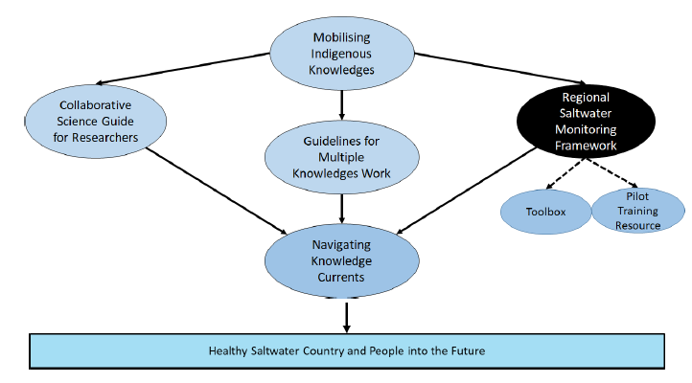
Figure 7.1: How the complementary products of the Kimberley Indigenous Saltwater Science Project relate to one another
Source: Austin et al, 2018.
The KISSP amply demonstrates what is possible when collaboration is placed at the forefront of engagement between two distinctly different cultures. While these resources apply to a particular group of TOs in a particular geographic area, the creators also note that the principles embedded in the Guide and in the project as a whole are worth considering elsewhere in the Kimberley. SGSEP believes the framework could also be applied in other parts of Australia with the cooperation of neighbouring TO groups with similar interests, and is something that NESP2 should explore.
The other document that SGSEP has also categorised as ‘Must Conform’ is the ‘Our Knowledge Our Way in Caring for Country Best Practice Guidelines’ produced under the auspices of the NAER Hub (see Case Study 10).
The Guidelines were developed by an Indigenous-led Project Steering Committee that sought to document Indigenous peoples approaches to land and sea Country management. The Guidelines incorporate IUCN approaches to best practice and include references to the UN Declaration on Rights of Indigenous Peoples, the Nagoya Protocol under the Convention on Biological Diversity, and the Intergovernmental Science-Policy Platform on Biodiversity and Ecosystem Services (IPBES).

Case Study 10: OUR KNOWLEDGE OUR WAY in caring for Country Best Practice Guidelines

Indigenous-led approaches to strengthening and sharing our knowledge for land and sea management
An Indigenous-majority Project Steering Group was established by the project co-leaders – the North Australian Indigenous Land and Sea Management Alliance and CSIRO – to lead the development of the guidelines. The Project Steering Group asked “who decides what is best practice and how?” and provided the critical direction that: Indigenous people must decide what is best practice in working with our knowledge.
The Project Steering Group decided to adopt the International Union for Conservation of Nature (IUCN) approach to best practice guidelines and therefore invited the Australian Committee for IUCN to partner in their development. NAILSMA led the call for case studies, seeking feedback from Indigenous groups and their partners involved in land and sea management and related enterprise development across the country. Indigenous authors of these case studies, together with other Indigenous experts invited as highlight chapter co-authors, are the foundation of the Indigenous voice throughout the Guidelines. Our and we in these Guidelines refer to Australian Aboriginal and Torres Strait Islander people.
Several non-Indigenous staff from NAILSMA and CSIRO provided significant support to the Indigenous case study authors and drafted much of the text for subsequent checking and summarising by Indigenous lead co-authors. The non-Indigenous staff position themselves in this role as allies working for and with Indigenous people: diligent, conscientious, skilful and respectful followers of Indigenous leadership. They have written what they have heard Indigenous people saying, and carefully checked with Indigenous people to make sure that what is written is correct.
Each chapter was independently checked by expert Indigenous highlight co-authors, who provided critical reflections distilled as highlights at the beginning of each chapter. In the attributions, highlight co-authors then became lead author of each chapter, followed by case study co-authors in the order the case studies appear in the chapter, and the NAILSMA and CSIRO staff co-authors. Case study co-authors gave permission for both co-authorship of their case study, and the chapter. Face-to-face discussions were held with Indigenous land and sea rangers through five workshops at the Northern Territory Indigenous Ranger Forum held at Charles Point near Darwin in August 2019. Some 60 individual Indigenous rangers provided high level input, identifying critical considerations about forming new partnerships or engagements involving Indigenous knowledge. The draft document was further reviewed by eight expert reviewers invited by the Australian Committee of the IUCN and a further two Indigenous expert reviewers invited by CSIRO.
The content of the Guidelines is based on principles of respecting Indigenous ownership of Indigenous knowledge and ensuring free, prior and informed consent (FPIC) for its publication. The case study co-authors provided FPIC to CSIRO and NAILSMA for release of their material as part of this document, while retaining the intellectual property in the copyright of their original production of the case studies, as well as ownership of their Indigenous cultural and intellectual property (ICIP). CSIRO and NAILSMA hold the copyright of other material and the rights to release the case study material within this report. The Guidelines are publicly released under a Creative Commons Attribution-Non-Commercial-No Derivatives Licence 4.0 Australia (CC BY-NC-ND 4.0), which means [you] can share the share the document provided [you] do not use it commercially, and [you] acknowledge the source. If [you] mix, transform or change the material, it cannot be shared with others without further permission.
Source: Woodward et al, 2020.

As Peter Cochrane, the IUCN Councillor, Australian Committee for IUCN notes, the Our Knowledge Our Way Guidelines are a vitally important document because the they distil the knowledge, lessons and understandings of Indigenous land and sea managers from across Australia through diverse case studies to present a set of guidelines for current and future managers and policy-makers (Woodward et al, 2020:x).
And as the Traditional Owner members of our Project Steering Group state, the Guidelines are a good way of getting concepts across to people:
It’s good for non-Indigenous people to see what we’re doing and how we do it. We’re not one mob, we are all from different areas, with different languages, and different views. The Guidelines bring that all together in one place, so people can learn about that … and understand that we all have different ways, and we have different knowledge. (Woodward et al, 2020:xi).
The Project Steering Group also note that the case studies in the Guidelines demonstrate that partnerships founded on trust between partners and mutual respect for Indigenous knowledge and country can work very well, but researchers need to be aware of the cultural protocols that govern who can access and share Indigenous knowledge, including the unique governance arrangements that exist for each different language group, community, and family group (Woodward et al, 2020:xi).
The engagement resources referred to in Case Studies 9 and 10 are vitally important for developing partnerships based on trust and mutual respect and therefore provide key resources for the next iteration of NESP. While both resources relate to particular geographic locations, the principles and frameworks embodied within them have much wider applicability, and there is an opportunity for NESP2 to build on these resources with other groups of TOs around Australia.
The ‘Highly Applicable’ resources include several International and Australian Government resources, while not mandatory or obligatory on researchers or their institutions, the resources nevertheless provide helpful information or practical advice about engagement practices in relation to Engagement with Indigenous peoples. SGSEP culled several documents from this category because they were not particularly relevant to the field of environmental or climate science research and Indigenous peoples per se. However, we have retained 15 documents in this category for their usefulness in raising awareness about Indigenous engagement techniques or practices that work. For example, the Department’s own resource documents and those prepared by the TSRA in relation to engagement with Torres Strait Islander people and communities.
The ‘Moderately Applicable’ resources includes several resources contain useful information or resources that may be of assistance with Indigenous Engagement and further advice or experience is necessary.
There are only three resources in the ‘General Relevance’ category that SGSEP thought be of general interest. There are many more resources we could have included on community engagement generally, but we saw little value in extending this list beyond the three that are included in Appendix M.
What this analysis demonstrates is that there are numerous international and domestic resources readily available for understanding the ethical requirements for engaging with Indigenous peoples in Australia in any context.
As stated above, there are three resources that form the framework for ethical research in Australia, and all researchers must conform to these documents when conducting research with Aboriginal and Torres Strait Islander peoples (The National Statement, the Code of Conduct and the GERAIS). The three documents not only provide guidelines for researchers, Human Research Ethics Committees (HRECs) and others conducting ethical review of research, they also emphasise institutions’ responsibilities for the quality, safety and ethical acceptability of research that they sponsor or permit to be carried out under their auspices. And the third element of that framework is in the process of becoming a mandatory Code of Ethics (discussed in part 7.6 below).
With respect to Indigenous peoples and their ICIP (including IK in all its forms), there are two international documents that researchers must also conform to when conducting research that involves Indigenous peoples’ ecological knowledge, traditional knowledge and/or genetic resources. These are the Guidelines under the Convention on Biological Diversity and the Declaration on the Rights of Indigenous Peoples. While these documents are not binding in Australian law, they are binding in international law, so they must be taken into account by researchers when undertaking environmental and climate science research on matters that may affect or involve Aboriginal and Torres Strait Islander peoples.
The analysis also shows there are a suite of other documents that researchers can use to guide their research and/or to develop localised protocols in collaboration with Aboriginal and Torres Strait Islander peoples to ensure the research is safe, respectful, responsible, high quality, protects their knowledge and will be of benefit to them. These matters are explored in more detail in the remainder of this Chapter.

Defining ‘engagement’ and ‘effective engagement’
Engagement between individuals and governments can be viewed as occurring on a spectrum from tokenism to control (Arnstein, 1969), with policy makers having to select the point along the spectrum at which they need to engage (Hunt, 2013a). The high end of the spectrum is seen as being particularly relevant to ‘wicked’ or complex and difficult problems where collaboration between the people and their governments are seen as essential to finding workable solutions (Hunt, 2013a).
A significant consideration for governments is that our modern democratic states are highly complex and our societies are increasingly pluralistic in terms of race, religion, ethnicity and cultures, and which makes the design of citizen involvement in the development of policies and programs complex and challenging (Holmes 2011:4). Hunt (2013:5) maintains that engagement can be seen as ‘an interaction between groups of people working towards shared goals’ (Hunt, 2013). Holmes concludes that engagement is not a single event or set of activities, but is rather a ‘relatively sustained and systematic interaction’ (Holmes, 2011:13) and ‘an ongoing process or conversation that builds trust and relationships’ (FaHCSIA, 2012:1).
At a major international conference on community engagement in Brisbane in 2005, the participants issued a Declaration that endorsed the following four core principles for community engagement:
- Integrity – when there is openness and honesty about the scope and purpose of engagement;
- Inclusion - when there is an opportunity for a diverse range of values and perspectives to be freely and fairly expressed and heard;
- Deliberation – when there is sufficient and credible information for dialogue, choice and decisions, and when there is space to weigh options, develop common understandings and to appreciate respective roles and responsibilities;
- Influence – when people have input in designing how they participate, when policies and services reflect their involvement and when their impact is apparent (ICEC, 2005).
Research in Australia has found that Indigenous engagement works best in a framework that respects Indigenous control and decision making and supports development towards Indigenous aspirations, early engagement to enable deliberation about shared goals, and supports the development of Indigenous governance development and capacity to engage (Hunt, 2013a:33). The development of respectful and trusting relationships is key to success. ‘This takes time, people with the right skills and approaches, good communication and leadership by all parties. Clarity about processes, roles and responsibilities, mutually agreed outcomes and the steps to achieve them and a willingness to share responsibility for progress are essential.’ (Hunt, 2013a:33). The research evidence shows that engaging successfully with Indigenous communities requires:
- An appreciation of the historical, social, cultural and political complexity of specific Indigenous contexts;
- Active Indigenous participation from the earliest stage of defining the problem to be solved and defining aspirations, through to implementing the program and evaluating the results;
- Long term relationships of trust, respect and honesty, as well as accessible and ongoing communication and clarity about roles and responsibilities;
- Genuine efforts to share power, including through negotiated agreements;
- Clarity about the purpose of and scale for engagement and appropriate timeframes;
- Attention to strengthening governance and capacity within both the Indigenous community and governments themselves, and good leadership; and
- Negotiation of clear and agreed outcomes and indicators of success with monitoring and evaluation processes that meet each parties' needs (Hunt, 2013a).
‘Effective engagement’ is therefore seen as ‘a sustained process that provides Indigenous people with the opportunity to actively participate in decision making from the earliest stage of defining the problem to be solved … continues during the development of policies/programs/projects … and the evaluation of outcomes’ (Hunt, 2013a:3).
Our discussions with the Knowledge Brokers in the NESP Hubs emphasised the notion of co-design and co-production of research projects as a form of deeper engagement. As reported in Part 3.4 of Chapter 3, our review of over 100 nominated NESP Hub research projects could only identify less than 30 projects that were genuinely co-designed and co-produced from start to finish. This is not a criticism of the Hubs’ performance, but rather an acknowledgement that co-design or co-production takes time and effort. Holmes (2011:21) notes that ‘co-production’ or ‘co-creation’ expresses ‘a distinctive commitment to collaboration in policy and services [research] design, with public servants, citizens and relevant stakeholder groups [researchers] working as partners across the spectrum of activity—from diagnosis and analysis of issues through to tactical and strategic considerations in pursuit of jointly devised outcomes.’
Although well-intentioned, researchers in the past have not always recognised the importance of consulting TOs when working on country, collaborating to deliver mutual benefits, and acknowledging the value of traditional knowledge and its ownership. There are many benefits for western science by incorporating traditional knowledge in efforts to understand the past and current changes. At the same time, First Nations peoples can benefit from incorporating the understanding of climate change from western science in planning for the future and while the benefits of bringing these two knowledge systems together are obvious, the steps for doing so are not always clearly laid out.
Co-design of research – that is, including Traditional Owners in research inception, development and delivery with a view to mutually useful and useable research outputs – offers a framework for ensuring that the oversights of the past are not repeated in the future. However, co-design and co-production approaches to engagement are not without their challenges. Including:
- the need for leadership and trusting relationships and willingness to share power;
- the requirement to reshape accountabilities and align organisational structures;
- the need for an organisational culture that supports such ways of working; and
- better evaluation of what works (Holmes, 2011:22-26; Hunt, 2013a:6).
From the outset of NESP, the Department’s IEPS required the NESP hubs to develop their own IEPS’s (Reviewed in Part 3.3 of Chapter 3 above). The Department’s IEPS (DoE, 2015a) included guidance on a number of matters to assist the NESP Hubs with the development of their IEPS, including:
- Information about performance indicators (which at that time were yet to be developed);
- Advice about the need for effective and respectful relationships and cultural sensitivity;
- Advice about the need for consultation, negotiation and consent with Indigenous people and that there must be understanding and mutual agreement to the research that is to be undertaken (including ensuring that free, prior and informed consent is obtained in a culturally appropriate manner from all research participants and stakeholders before the research can be undertaken with and about Indigenous peoples and to refer to the AIATSIS Guidelines (AIATSIS, 2012) for further information);
- Advice about engagement and participation not stopping at consultation, but also including opportunities for engagement at deeper levels through membership of the Hub’s steering committee, membership of projects steering committees or reference groups, and direct participation in research projects to help embed cultural perspectives, build Indigenous capacity and establish partnerships between researchers and Indigenous communities;
- Advice about ensuring appropriate acknowledgement of the contribution of resources, knowledge and access to other information made by Indigenous peoples, that research outcomes are made available to them in a form that is useful and understandable, that Indigenous co-researchers are recognised in publications to which their knowledge and endeavours have contributed and that researchers commit to the equitable sharing of benefits derived from the utilisation of Indigenous knowledge.
The Department’s IEPS also advised that Indigenous people have a reasonable expectation that research involving them or their traditional land and sea Country will be of benefit to Indigenous people, for example through payment for research work, capacity building, knowledge sharing, training, and the development of livelihoods, opportunities and joint publications, as well as real, on-ground outcomes (DoE, 2015a).
The Department’s IEPS came off the back of significant lessons learnt from the approaches to Indigenous engagement adopted by the TRaCK program (Jackson and Douglas, 2015). The TRaCK (Tropical Rivers and Coastal Knowledge) research program was established to provide the science and knowledge needed by governments, industries, and communities to sustainably manage northern Australia’s rivers and estuaries. The TRaCK program placed a strong emphasis on ethics in relation to the involvement of Indigenous peoples, especially on participatory methods and respecting Indigenous cultural and intellectual property rights. In order to ensure the needs of Indigenous peoples were addressed and to enhance the benefits they might derive from participating in the research, TRaCK developed an Indigenous engagement strategy to provide guidance on matters relating to the protection of intellectual property, negotiation of research agreements, remuneration for Indigenous expertise, and communications standards. At the conclusion of the TRaCK program, its Indigenous engagement strategy was evaluated, and in the interests on building on its success, it is worth reflecting on the key recommendations made by Jackson et al (2013:) at that time. Their recommendations were:
- Provide more support for Indigenous leadership of research projects;
- Explore ways of retaining flexibility to respond to Indigenous research priorities that may emerge during the course of the research;
- Allow plenty of time for research protocols to be negotiated and finalised with potential Indigenous partners;
- Ensure ethics approval is granted before the research starts and allow time and funds for communities to influence research design;
- Investigate and support opportunities for longer term employment and skills development; and
- Insist that cultural training for researchers is an essential part of future research programs and where possible, be delivered by local Indigenous groups involved in the research.

Opportunities for integrating IK and Western Science
Research in environmental and climate science with Indigenous peoples also involves opportunities for integrating IK and western science ‘to promote cultural diversity in the management of social-ecological system sustainability’ (Hill et al, 2012:23). Hill et al, (2012) undertook a study of the types of engagement in environmental management and differentiated the following four types of collaborations:
- Indigenous-governed collaborations (IG). IGs are formulated through Indigenous initiatives, and bring Indigenous peoples together to focus on common environmental issues, actions, and policy agendas.
- Indigenous-driven co-governance (ICoG). ICoG approaches are frequently formulated in response to government initiatives. The authors of the study identify IPAs as an example of how the power sharing, participation, and intercultural purposes have respected and empowered Indigenous interests and authority and not undermined them (see Bauman and Smyth, 2007).
- Agency driven co-governance (ACoG). ACoG approaches usually arise from formal processes to recognize and define Indigenous rights, such as through native title determinations or recognition of Aboriginal joint management of protected areas. Agency-driven models require the power to sit within the organisation, through mechanisms such as boards or committees of management. In the ACoG types, the agency seeks to meet the expectations of a wide array of stakeholders, and the complexity and competition within such arrangements risk crowding out Indigenous perspectives.
- Agency governance (AyG) AyG approaches regard Indigenous people as a stakeholder sector, similar to farmers or industry actors, rather than as a group requiring a different approach associated with their claims to a distinct political status within the nation-state (Hill et al, 2012:27-28).
The analytical framework was based on three axes:
- Power sharing (incorporating decision making, rules definition, resource values and property rights;
- Participation (incorporating participatory processes, organizations engaged, and coordination approaches);
- Intercultural purpose (incorporating purposes of environmental management, Indigenous engagement, Indigenous development and capacity building).
The researchers found that in the IG and AyG types, Indigenous peoples and agencies retain power respectively, whereas the ICoG type promotes Indigenous governance, and the ACoG type promotes negotiated agreement. The researchers also found differences between the types of governance and the extent of cross-cultural integration between IK and Western science, as follows:
- methods for integration between IK and western science;
- appearance of amalgams representing new, converged forms of IK and Western science knowledge;
- means for managing the integrity of IK; and
- means for integration of IK and Western science into environmental management (Hill et al, 2012:32).
The results are shown in Table 7.2 (reproduced from Hill et al, 2012:32).
The study’s results are worth dwelling on:
‘IG and ICoG pay great attention to Indigenous methods for ensuring the integrity of IEK. For example, NAILSMA is engaged in advocacy for Indigenous rights and titles over IEK. Yolngu specify in the Dhimurru IPA that all decisions must be made by those who own knowledge under customary law. This concern for integrity is reflected in recognition that both knowledge systems need to be applied to environmental management. MLDRIN, for example, expresses a specific principle: “that Indigenous science and Western science each have their own value and role in caring for country” (Weir, 2009:116).
‘ACoG and AyG types typically maintain the distinction between IEK and western science, through separate documentation initiatives, and clearly specified interactions, such as “validation” of IEK by science (Evans et al 2009). New amalgams, where they do appear, are more clearly in the western science domain, for example jointly authored papers or reports written to target both technical and Indigenous audiences. The AyG and ACoG types do not focus as strongly on ensuring the integrity of IEK; where respect for Indigenous law is articulated, practical means of enabling this are often unclear. The emphasis is on agreements about IEK utilization, rather than customary law maintenance and enhancement. The collection of IEK often does not feed into the agency environmental management strategies.’ (Hill et al, 2012:32-33).

Table 7.2: Analysis of manifestations of IEK and Western science integration according to governance types
 | Dimensions of knowledge integration
Governance type | Means of integration between IEK and science | Appearance of amalgams representing new, converged forms of IEK and science knowledge | Means of managing the integrity of IEK | Means of integration of IEK and science into environmental management
Indigenous-governed collaborations  (IG) | Collaboration between IEK and science; distinction between the two blurred. | Amalgams emphasized, e.g., ethno-ecology, ethnoscience; digital data-bases with both IEK and science. | Indigenous law and custom; exercise of traditional authority; tight contemporary governance structures specified. | Combination of western science and Indigenous knowledge tools, principles of application specified.
Indigenous-driven co-governance  (ICoG) | Collaboration between IEK and science; joint projects as means of integration. | Amalgams utilized, e.g., maps that amalgamate painting of Indigenous knowledge with western scientific data. | Same as above. | Simultaneous application of both into environmental management; principles sometimes specified.
Agency-driven co-governance  (ACoG) | “Validation” of IEK by science; separate documentation of IEK and science. | Jointly authored scientific papers; reports targeting both scientific and Indigenous audiences. | Protocols; agreements; respect for Indigenous law; informed consent. | Negotiated approaches; Indigenous emphasis on preventing cultural appropriation.
Agency governance  (AyG) | Separation of IEK and science; little or no documentation of IEK. | No amalgams identified. | Loose, not specified; e.g., involvement of elders in on-country knowledge transfer. | Management based on western science; IEK present but its utilization kept separate
Source: Hill et al, 2012:32.
Hill et al’s (2012) study shows that the processes of combining IK with Western science are diverse and are affected by numerous factors, including the adaptive co-management context, the intrinsic characteristics of the natural resources, and the many different governance systems for different components. The study also demonstrates that the general characteristics of ‘public’ engagement do not apply and that different approaches to Indigenous engagement are required depending on the particular circumstances of a research project, its proposed scope, the locality or localities involved, and the levels of engagement required in order to satisfactorily achieve the multiple outcomes anticipated by seeking to integrate IK and western science objectives and realities (Hill et al, 2012:23).
More significantly, the researchers concluded that ‘Indigenous governance and Indigenous-driven co-governance provides better prospects for integration of IK and western science for sustainability of social-ecological systems’ (Hill et al, 2012:23).

NESP Hub Research Agreements and/or Protocols
The purpose of a research agreement is to have a negotiated agreement with Aboriginal and Torres Strait Islander peoples and/or organisations so that each party fully understands what is expected from them and each other. Research agreements are important because they provide protection for the people and organisations involved in the research and for researchers and research institutions. Agreements should be a collaborative and co-designed process with all parties working together in the development of the agreement. Agreements should include how researchers, organisations and Aboriginal and Torres Strait Islander peoples will work together respectfully, define roles and responsibilities throughout the research process, identify conflict resolution and complaint processes, outline communication and dissemination strategies and provide adequate protection for any intellectual property (NHMRC, 2018d).
Such agreements will vary in format, formality and complexity, depending on the characteristics of each research project. However, the agreement should be comprehensive and cover all aspects of the research, incorporating ethical standards appropriate when working with Aboriginal and Torres Strait Islander Peoples, including free, prior and informed consent. In some cases (such as research resulting in commercial products), legal documents will likely be required. When more than one research institution is involved, then multi-institutional agreements may be necessary (NHMRC, 2018d).
Therefore, formal agreements are generally the mechanism through which the parties negotiate the terms of the arrangements between them. It was assumed that all of the NESP Hubs used formal agreements as a basis for embarking on a research project and that these were negotiated in good faith.
SGSEP therefore invited the NESP Hubs to provide copies of research agreements or protocols they use to secure Indigenous engagement in their research projects, either as templates or examples of the instruments they use. Only two of the Hubs provided examples of formal agreements they had signed with Aboriginal or Torres Strait Islander organisations, and these are identified in Table 7.1.
SGSEP was advised by three of the NESP Hubs that formal written agreements are not used for every research project involving Indigenous people, but only where it was felt necessary to enter into such formal contractual arrangements as a basis for governance of the arrangements for the duration of the research project. SGSEP was told by another NESP Hub that such formal contractual arrangements are rarely necessary, and the parties may settle the arrangements through an exchange of letters or an MoU. But no copies of such arrangements were provided by the NESP Hubs. We were not provided with a sufficient quantity of formal agreements from the NESP Hubs to draw any particular observations or conclusions, suffice to say that we requested such information several times.
Protocols are seen by the World Intellectual Property Organisation (WIPO, 2019a:37) as legal agreements, codes of conduct, guidelines or sets of manners that explain how people should behave in certain circumstances. Anderson (2010:28) views protocols as being context-driven, because they can be developed to address specific problems and provide guidance in relation to appropriate behaviour when it is required. They can be used to set community standards around knowledge circulation and use for outsiders, as well as help change attitudes and set new standards, incorporate community perspectives and be targeted to particular issues (WIPO, 2019a:37; Anderson, 2010:28). Protocols are not necessarily dependent upon governments – they are not a ‘top-down’ approach – as they can be developed locally and can be tailored to respond to community or local needs. Protocols are also flexible and can change over time and they can be used as tools to help achieve certain goals that other areas of law have been unable to fulfill (Anderson, 2010:28). As such, protocols can help build relationships and make new ones possible (WIPO, 2019a:37).
Anderson (2010:29) also notes that they are more suitable in situations where there may not be a real need for more formal and conventional legal mechanisms. For example, where Indigenous people might feel more comfortable articulating customary law or local laws specific to the context. ‘Protocols provide conditions for indigenous peoples’ agency in the sense that they can embolden already existing practices rather than imposing new ones’ – one of the reasons why they are increasingly found across all areas involving negotiations around indigenous knowledge use (Anderson, 2010:29).
Two of the NESP Hubs provided copies of protocols they had developed.
To support TSR Hub researchers to have more effective working relationships with Indigenous research partners, the TSR Hub has developed Indigenous Engagement Protocols for Threatened Species Researchers and should be read in conjunction with the TSR Hub’s IEPS. While the TSR Hub’s IEPS sets out high level aims and vision, these protocols are designed to be a more practical guide to Hub researchers seeking to collaborate with Indigenous partners. These Protocols have been endorsed by the TSR Hub’s Indigenous Reference Group (IRG). (See Appendix M for more details).
The ESCC Hub has produced key resources for the co-design of research projects from inception through to development and delivery with a view to mutually useful and useable research outputs. The ESCC Hub has found that important considerations for co-design include:
- Understanding that there are many peoples and many cultures;
- Including Traditional Owners from the start (and all the way through);
- Building (and being prepared to maintain) trusted relationships;
- Appreciating different timelines;
- Ensuring free, prior and informed consent;
- Respecting the provision and ownership of traditional knowledge;
- Identifying benefits to country and community;
- Ensuring you are giving as well as taking; and
- Remembering that connection to country is forever.
In our discussions with various stakeholders outside of the NESP Hubs, three issues emerged in relation to the informality or even the formality of research agreements.
- Firstly, the lack of clear dispute resolution processes in the event of a breakdown in relationships between the parties. The non-existence of an agreed dispute resolution process can lead to further barriers between the parties to arrive at a solution early enough to prevent yet further escalation of difference (Bauman, 2019);
- Secondly, the lack of clear agreement about protection of IK or ITK (Janke and Sentina, 2018); and
- Thirdly, lack of clear guidelines around benefit sharing of the outcomes of the research (Jackson, 2018).
While no specific NESP Hub examples were raised with SGSEP in those discussions, SGSEP is nevertheless concerned that the lack of formal written agreements or protocols setting out the arrangements agreed between the parties creates the potential for disputes to arise, and therefore issues around dispute resolution and protection of IK warrant further attention. Among the 108 NESP Hub projects that SGSEP examined, we found plenty of evidence of return of findings and research outcomes and outputs back to the Indigenous peoples/communities that were involved in the research, including training and ongoing monitoring practices, and a high level of acknowledgement of Indigenous input and co-authorship of reports and/or journal articles.
All of the NESP Hubs however, invariably referred to the AIATSIS GERAIS (AIATSIS, 2012) as the key resource they relied upon for guidance in their engagement with Aboriginal and Torres Strait Islander people. How well the NESP Hubs perform against the GERAIS is not systematically recorded or reported.

The AIATSIS GERAIS is to become a Code of Ethics
AIATSIS created the Guidelines for Ethical Research in Australian Indigenous Studies (GERAIS) to ensure that research with and about Aboriginal and Torres Strait Islander peoples follows a process of meaningful engagement and reciprocity between the researcher and the individuals and/or communities involved in the research (AIATSIS 2012).
The GERAIS was primarily intended for research sponsored by AIATSIS. However, AIATSIS recognised its responsibility as a leading institution in Australian Indigenous studies and that its ethics guidelines inform all research in this area. Hence, the GERAIS has become the expected standard when research involves Aboriginal and Torres Strait Islander peoples or on matters that may affect them.
The guidelines were revised in 2011 to reflect developments in critical areas that have emerged since the previous edition in 2000. The current edition embodied the best available standards of ethical research and human rights at the time they were published in 2012. The revisions included changes to intellectual property laws, rights in traditional knowledge and traditional cultural expressions, and the establishment of agreements and protocols between Indigenous people and researchers as well as emerging developments in digitisation, data and information management, and the very significant impacts this has on research and other aspects of Indigenous studies.
The GERAIS comprises 14 principles grouped under the following six categories:
- Rights, respect and recognition;
- Negotiation, consultation, agreement and mutual understanding;
- Participation, collaboration and partnership;
- Benefits, outcomes and giving back;
- Managing research: use, storage and access; and
- Reporting and compliance.
The GERAIS is accompanied by support materials, including a guide to informed consent, a letter of support, a sample survey form, and a distress protocol.
While the NESP Hubs claim that GERAIS is applied to all of their research activities, the extent to which the GERAIS is applied is unknown because no specific records are generated by the NESP Hubs to actively demonstrate how the guidelines have been applied. And, as stated above, the GERAIS has also become one of the three central documents that comprise the ethical research framework that researchers working with Indigenous peoples in Australia must comply with. But without a reporting requirement, it is not clear how well the GERAIS has in fact been applied and with the desired outcomes.
As a reflection of AIATSIS’s commitment to improving the standards of engagement and the benefits that research can offer Aboriginal and Torres Strait Islander peoples, in 2019 AIATSIS instigated a review of GERAIS and released a Consultation Draft of the AIATSIS Code of Ethics for Aboriginal and Torres Strait Islander Research (AIATSIS Code of Ethics) (AIATSIS, 2019a).
The consultation draft of the Code was structured in two parts:
- Part A constitutes the AIATSIS Code and outlines the four principles that underpin ethical Australian Indigenous research (Indigenous self-determination; Indigenous leadership; Impact and value; and Sustainability and accountability). Each principle includes a set of responsibilities when conducting Aboriginal and Torres Strait Islander research.
- Part B is a practice guide to implementing the Code and includes advice for applying the principles discussed in Part A and is structured by research practice stages (Getting started; Project implementation; Communicating research results; Post-project).
The consultation draft was supported by online case studies, guides, tools and templates that will be available on the AIATSIS ethics website once the Code is finalised.
AIATSIS states in the Draft that the Code of Ethics, when finalised, will become a formal part of the Australian framework for ethical and responsible conduct of research, and that the Code of Ethics should be read in conjunction with the National Statement on Ethical Conduct in Human Research (NHMRC 2018a), the Australian Code for Responsible Conduct of Research (NHMRC et al 2018b) and the United Nations Declaration on the Rights of Indigenous Peoples 2007 (the Declaration). It is also anticipated that when the Code of Ethics is finalised, it will supersede and replace the GERAIS and that all references to GERAIS in Australian research codes and guidance will be taken to refer to the new AIATSIS Code (AIATSIS, 2019a).
AIATSIS advises that it has received around 70 submissions from Indigenous organisations, national and international Universities, research organisations, government departments, HRECs; and individuals. The responses generally supported the following key points:
- The draft Code retains a clear link to UNDRIP.
- The change from guidelines to a code demonstrates the authority of the document and the importance of the standards it contains.
- The draft Code reflects the perspectives and expectations of Indigenous communities engaging with research.
- The changes address the major issues that organisations, researchers and HRECs have experienced (AIATSIS, 2019a).
While feedback on the guidelines has generally been positive, there were a number of suggestions for improvements or concerns over the implementation of the Code that AIATSIS is considering, including such matters as compliance and enforceability; institutional responsibilities; the relationship with other codes and guides and some issues in relation to specific applications in fields such as native title.
The intention is that once the Code is finalised, AIATSIS will continue working closely with the NHMRC, the ARC and Universities Australia (UA) to ensure that the Code is successfully integrated with the broader framework for ethical and responsible conduct of research in Australia. AIATSIS has announced that it will be releasing the Code of Ethics in September 2020, which will be followed by a 12-month implementation period, including the release of supporting resource material across the length of the implementation period.
While the GERAIS has come in for some criticism as not providing sufficient protections for ICIP, the new Code of Ethics will be a significant improvement and its effectiveness will need to pass the test of time. Indeed, the design of NESP2 should include compliance with the Code as a mandatory requirement, and regular monitoring and reporting of its application should become a key KPI for the new Hubs.

Protecting Indigenous Knowledge and Data Sovereignty
SGSEP found that a recurring issue was the protection of Indigenous knowledge (IK) and data sovereignty accessed/obtained or generated by the NESP Hubs.
There are two broad approaches to protecting Indigenous Knowledge (IK): legally enforceable instruments; and voluntary arrangements. In Australia, legally enforceable instruments include:
- Recognition of IK as intellectual property (IP), including certification and collective trade-marks and geographical indications (GIs);
- Sui generis laws for particular contexts;
- Enforceable private agreements; and
- Actions against the misuse of IK under the Australian Consumer Law (ACL), in tort or in equity. (Stratton et al, 2019).
Stratton et al (2019:17) have found that legally enforceable instruments grant holders of Indigenous Knowledge rights to use or control that knowledge or to undertake action against inappropriate use of that knowledge.
Voluntary arrangements include voluntary protocols, codes of conduct and certification schemes, which ‘encourage, but typically do not mandate, appropriate treatment of and compensation for the use of IK.’ (Stratton et al, 2019:27). These include for example, the GERAIS (AIATSIS 2012), the NHMRC Guidelines for Ethical Conduct in research with Aboriginal and Torres Strait Islander Peoples and Communities (NHMRC, 2018), and the Desert Knowledge CRC’s Protocol for Aboriginal Knowledge and Intellectual Property (DKCRC, 2007). The discussion below focuses on the voluntary arrangements.
Indigenous Ecological Knowledge (IEK), Indigenous Traditional Knowledge (ITK) and Traditional Ecological Knowledge (TEK) are referred to in several places in this report recognising that Indigenous societies are the holders of that knowledge. And indeed, all of the Hubs have in their engagement with Indigenous peoples, been in receipt of Indigenous Knowledge in one form or another through their research activities.
The term Indigenous Cultural and Intellectual Property or ‘ICIP’ is also widely used in Australia, including by the Productivity Commission (2016:58) in the context of its Inquiry into Intellectual Property Arrangements. The Productivity Commission (2016:58) Inquiry Report identified that ICIP has a very different set of economic characteristics compared with standard IP, particularly where it is created from community traditional knowledge or cultural expressions:
The Indigenous people would like to see a stronger regime that actually protects their traditional cultural expressions and their traditional knowledge, which are embodied in work that they create. … it comes at intellectual property from sort of a different perspective [which is] very communal in its nature and it has been passed down from generation to generations over thousands of years. So, it’s not all about individual rights for individual rights holders or creators. (Citing the Arts Law Centre of Australia, transcript of public hearing, Sydney 21 June 2016, p. 137)
The World Intellectual Property Organization (WIPO) has been working since 2001 to develop a global system to protect Indigenous knowledge around the world. WIPO’s Intergovernmental Committee on Intellectual Property and Genetic Resources, Traditional Knowledge and Folklore (IGC) has been undertaking text-based negotiations with the objective of reaching agreement on the texts of three international legal instruments which will ensure the effective protection of traditional knowledge, traditional cultural expressions and genetic resources, which the ICG considered at its Fortieth Meeting in Geneva in June 2019 (WIPO, 2019b, 2019c, 2019d). Due to COVID-19, the Forty-First meeting of the IGC which was planned to take place in March 2020, has been postponed. The Australian Government and Australian Indigenous representatives are active in this process, and the outcomes are keenly awaited.
In 2017, IP Australia and the Department of Industry, Innovation and Science commissioned a discussion paper, Indigenous Knowledge: Issues for protection and management, from Terri Janke and Company (Janke and Sentina, 2018). The Discussion Paper was aimed at building a nationally coordinated approach by focussing on six key areas to identify clear gaps and suggest strategies for addressing them. The Discussion Paper provided a comprehensive examination of the issues affecting protection and management of ICIP and identified the following six key issues:
- The misappropriation of Indigenous arts and crafts.
- The misuse of Indigenous languages and clan names, commercially, without the consent of the traditional custodians.
- Recording and digitisation of Indigenous Knowledge. Once Indigenous Knowledge is recorded, controlling access, use and interpretation of underlying Indigenous Knowledge contained in those works is often beyond the control of the Indigenous Knowledge rights owners.
- The use of Indigenous Knowledge without benefits flowing to communities. Not sharing the benefits of a community’s Indigenous Knowledge with that community can be offensive and propagates dispossession.
- The use of Indigenous Knowledge relating to genetic resources. Indigenous skills, techniques and other knowledge relating to bush foods, medicinal plants and other genetic resources remain largely unprotected. More and more, this knowledge is used and commercialised for scientific research and development, and much still needs to be done to safeguard Indigenous knowledge in research and from unauthorised use and commercialisation.
- The misuse of particularly sensitive sacred secret knowledge. Indigenous communities have customary laws that dictate whether Indigenous Knowledge is considered sacred or secret. Such laws restrict, for spiritual reasons, the use and availability of that knowledge. This knowledge needs to be protected from harm, and while there are no special laws for protecting sacred secret knowledge specifically, already some protections are available for example through the laws of confidential information. Sacred secret knowledge is also recognised in heritage and environmental legislation, which have special provisions to allow sensitive information or sacred sites to be protected (Janke and Sentina, 2018:7-8).
The IP Australia Discussion Paper noted there is no single solution to solve the issues raised, and it suggests a package of options in order to recognise Indigenous Knowledge rights, including many measures that can be practically achieved with ease, as well as others that require deeper consultation and legislative change (Janke and Sentina, 2018:117).
While the brief for this review did not include an examination of ICIP issues per se, several questions were raised by various stakeholders, suggesting there is room for improvement in the protection of ICIP by the NESP Hubs. The one formal agreement SGSEP did see, included the usual provisions for protection of background IP, Indigenous intellectual property, research project intellectual property and third-party intellectual property. While the provisions of this agreement may suffice for some research projects, at face value, the provisions may not be strong enough with respect to the use of other forms of communication such as video or audio recordings, and how that information is stored and accessed over time. There are also no provisions in the agreement for benefit sharing, if they were to arise from the research. SGSEP reiterates that we did not examine this issue to a level of detail where we can draw firm conclusions, but we believe the issues raised in discussions with various Indigenous stakeholders warrant closer attention.
SGSEP also notes that the Our Knowledge Our Way in Caring for Country Best Practice Guidelines also raises Indigenous peoples’ concerns about the wider use and application of traditional knowledge, innovations and practices (Woodward et al, 2017:15). Woodward et al, 2017:15) state that Indigenous cultural and intellectual property (ICIP) rights are based in customary laws which are not properly recognised by the Australian nation-state or international legal systems, and that once IK leaves Aboriginal and Torres Strait Islander customary territories, control over its future use is lost. Similar to SGSEP, Woodward et al (2017:15) found that ICIP law focusses on protecting ‘new’ information that has been ‘discovered’, it does not provide protection for Indigenous law and custom that has been passed on through generations. Woodward et al (2017:15) argue that any legal regime that affords reasonable protection for Indigenous knowledge must also provide security for:
- Sacred property (images, sounds, knowledge, material, culture or anything that is deemed sacred and, thereby not commodifiable);
- Knowledge of current use, previous use, and/or potential use of plant and animal species, as well as soils and minerals;
- Knowledge of preparation, processing, or storage of useful species;
- Knowledge of formulations involving more than one ingredient;
- Knowledge of individual species (planting methods, care for, selection criteria, etc.);
- Knowledge of ecosystem conservation (methods of protecting or preserving a resource that may be found to have commercial value, although not specifically used for that purpose or other practical purposes by the local community or the culture);
- Biogenetic resources that originate (or originated) on Indigenous lands and territories j Cultural property (images, sounds, crafts, arts and performances); and
- Classificatory systems of knowledge, such as traditional plant taxonomies (Posey, 1999).
The Productivity Commission (2016:58) noted that ICIP, ‘because of its communal nature and its connection to the cosmos (not just country but everything; land and water, stars and space)’, is affected by many factors, and not just the IP laws (Figure 7.2). The Productivity Commission therefore recommended improved governance arrangements to apply to the IP system as a whole arguing that this ‘would further ensure a broad-based examination of IP issues confronting Aboriginal and Torres Strait Islander Australians in the future’ (Productivity Commission, 2016:59).
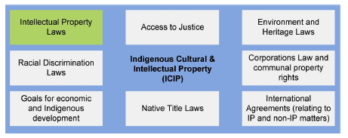
Figure 7.2: How ICIP is affected by more than IP laws
Source: Productivity Commission, 2016:59.
Janke’s research over two decades ago recommended a sui generis approach to ICIP law reform (Janke 1999). However, given such an approach has not eventuated, Janke (2019) believes that protocols still have a serious role to play in protecting ICIP. Janke’s (2019:328) research highlights that in an intercultural context, protocols may be defined as ‘the set of ethics, guidelines, rules or standards of behaviour when interacting with peoples and parties from another culture’. Janke stresses that:
‘From an Indigenous perspective, protocols may imply preferred ways of interacting with Indigenous people that respect their cultural ownership, values and practices. As primary guardians, reproducers and interpreters of their cultures, Indigenous people have their own well-established protocols for dealing with cultural knowledge and material; protocols that are based on an ancient jurisdiction of laws and governance.’ (Janke, 2019:328).
Janke (2019:328) argues that protocols:
‘can constitute agreed procedures for appropriate interactions; a basis for the way dealings should occur within a situation, community, culture or industry’ and that ‘Complying with the accepted protocols of other cultural groups arguably promoted ethical conduct, and interaction based on good faith and mutual respect. To achieve that standard of conduct and interaction, protocols need not only be well informed by culturally credible processes, the processes must also be workable and acceptable to all the stakeholders involved.’
Janke’s PhD research (2019) has examined how Indigenous people are operating at the legal and cultural interface between Indigenous cultural expression and knowledge and the Australian legal system. Drawing on 25 years of working with Indigenous people, organisations, companies and government in the context of intellectual property rights, Janke has developed a framework for dealing with Indigenous cultural assets and heritage in a way that promotes the intent of Article 31 of the UN Declaration on the Rights of Indigenous Peoples’ (Janke, 2019:9).
The framework comprises a set of 10 overarching True Tracks ICIP Principles (Figure 7.3) and a True Tracks Framework (Figure 7.4) which have been used across various sectors with practical applications in the arts, museums, archives and business.
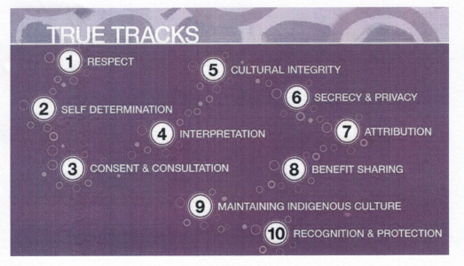
Figure 7.3: True Tracks Principles Diagram
Source: Janke, 2019:340.
The Principles were developed though an applied research methodology of continual action inquiry involving consultation and communication in a wide range of contexts, leading to a deepening understanding of the needs and desires of Indigenous people to protect their ICIP. The Framework was developed through culturally informed practice and ‘in response to the cultural values and feedback of Aboriginal and Torres Strait Islander clients during workshops and international panels’ (Janke, 2019:12).
While the actual content of protocols for research will need to differ depending on the nature of the research task(s) and between different communities and research institutions, the True Tracks principles and Framework developed by Terri Janke and Company present an overarching conceptual and good practice model to provide flexible arrangements within which to design relevant provisions (Janke 2019:328). The True Tracks Framework is able to be adapted to suit different industries or sectors and provides a basis to negotiate, plan and manage the ICIP in research activities. It also assists Indigenous people with protecting their ICIP with the necessary supporting infrastructure and governance (Janke, 2019:vi).
The Productivity Commission (2016:59) also believes protocols have a role to play as a flexible alternative to a legislated solution, but the Commission also points out they are inherently voluntary and there is a high risk they may not be followed. IP Australia notes that even when protocols are followed, they ‘may be invisible to detection because people are simply seen as collaborating or that people may not engage because of a misunderstanding of protocols’ (Blackwell et al, 2019:15).
Hence, SGSEP finds there is a strong case for including more specific performance indicators and reporting requirements of the new NESP Hubs under NESP2 on matters relating to the protection of IK and ICIP.
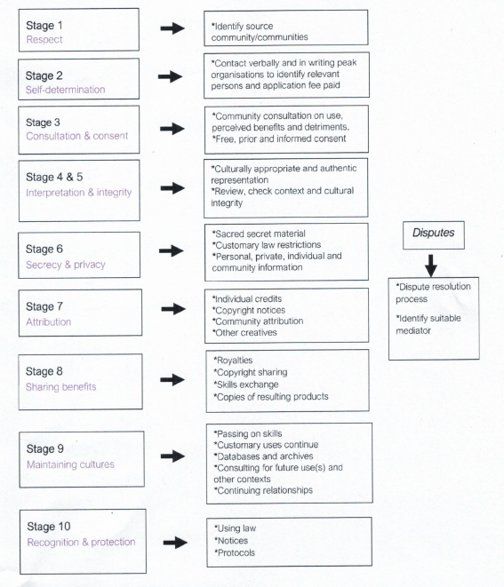
Figure 7.4: True Tracks Principles and Framework
Source: Janke, 2019:341.
A further issue that emerged from some of the consultations that SGSEP conducted with various stakeholders is Indigenous data sovereignty. As stated earlier in this report, Aboriginal and Torres Strait Islander peoples have expressed the need for better data collection, particularly in relation to Indigenous use and rights, non-commercial activities and other social and economic attributes, but they are very concerned about how this information may be utilised without their prior knowledge and consent. This is a consistent theme across many environmental and climate science research themes, not just coastal and marine matters. Indigenous Peoples have always been data collectors and knowledge holders and there is growing concern among Indigenous peoples world-wide about the need to protect against the misuse of Indigenous data and to ensure Indigenous Peoples are the primary beneficiaries of their data (Research Data Alliance International Indigenous Data Sovereignty Interest Group, 2019).
The concept of data sovereignty is ‘linked with Indigenous Peoples’ right to maintain, control, protect and develop their culture, heritage, traditional knowledge and traditional cultural expressions, as well as their right to maintain, control, protect and develop their intellectual property over these.’ (Tauli-Corpuz, 2016:xxii). The topic of Indigenous data sovereignty is multifaceted and wide-ranging from legal and ethical dimensions around data storage, ownership, access and consent to intellectual property rights and practical considerations how data is used in the context of research, policy and practice. The scope also includes data generated by Indigenous communities and organisations, governments, research institutions, non-government organisations and commercial entities (Kukutai and Taylor, 2016:2).
The impetus for the formation of the Global Indigenous Data Alliance (GIDA) commenced with a forum that was held in Canberra in July 2015, sponsored by the Academy of the Social Sciences (ASSA) and the Centre for Aboriginal Economic Policy Research (CAEPR). The forum was attended by an international group of scholars, representatives of Indigenous organisations and government personnel from the CANZUS group of Anglo-settler democracies – Canada, Australia, New Zealand and the United States of America. The purpose of the forum was to identify and develop an Indigenous data sovereignty agenda, to stimulate new thinking and to uncover emergent practices regarding the generation of demographic, wellbeing and community information and data on Indigenous peoples, and what this might mean for Indigenous peoples’ sovereignty over data about the, their territories, resources and ways of life (Kukutai and Taylor, 2016:1-2).
Since that time, the Global Indigenous Data Alliance has been established (GIDA), a network of Indigenous researchers, data practitioners, and policy activists advocating for Indigenous Data Sovereignty within their nation-states and at an international level. The aim of GIDA is to progress International Indigenous Data Sovereignty and Indigenous Data Governance in order to advance Indigenous control of Indigenous Data. GIDA’s objectives include:
- Advancing Indigenous Data Sovereignty and Governance;
- Asserting Indigenous Peoples rights and interests in data;
- Advocating for data for the self-determined well-being of Indigenous Peoples; and
- Reinforcing the rights to engage in decision-making in accordance with Indigenous values and collective interests.
The CARE Principles for Indigenous Data Governance are people and purpose-oriented, reflecting the crucial role of data in advancing Indigenous innovation and self-determination. CARE stands for Collective benefit, Authority to control, Responsibility and Ethics. These principles complement the existing FAIR principles encouraging open and other data movements to consider both people and purpose in their advocacy and pursuits. FAIR stands for Findable, Accessible, Interoperable, and Reusable. GIDA’s motto is “Be FAIR and CARE”.
The CARE Principles for Indigenous Data Governance were drafted at the International Data Week and Research Data Alliance Plenary co-hosted event “Indigenous Data Sovereignty Principles for the Governance of Indigenous Data Workshop,” 8 November 2018, Gaborone, Botswana. Australia was represented at this conference by Ray Lovett from the ANU.
To ensure governance of Indigenous data in health and research environments, GIDA advocates for mechanisms that facilitate Indigenous data governance. For example, better publication practices and metadata tagging. Provenance and disclosure statements detailing the origin of data, collective consent and data availability. The implementation of TK and Biocultural labels are a way to raise awareness of the cultural significance in data (and other content) and express restrictions and expectations around the access and use of the data by non-community users.
The NESP Hubs have been and will continue to be involved in the collection and collation of Indigenous data, and these Principles provide sound advice on how to protect the integrity of such data.

Reflections on Indigenous peoples’ experiences in Land and Water Research
During this Review, SGSEP was granted access to an Honours research project undertaken by Hmalan Hunter-Xenie, an Aboriginal woman from Larrakia Country in Darwin in the NT. Hunter-Xenie’s research was on Aboriginal peoples’ participation in land and water research. Hunter-Xenie interviewed over 50 people, 18 of whom were from Aboriginal research teams based in Darwin, 16 of whom were Aboriginal academics who are employed by research institutions, and 18 of whom were non-Aboriginal scholars undertaking research in the NT with Aboriginal peoples, many of them employed by universities, and some of them working as consultants.
To analyse the interviews Hunter-Xenie conducted, she used a software program that creates word clouds to show which words get the highest mentions. The following three Figures show the word clouds for each of the three different groups of people she interviewed. For those not familiar with reading Word Clouds, the most frequently used words in the interviews are those that appear the largest and darkest in the cloud.
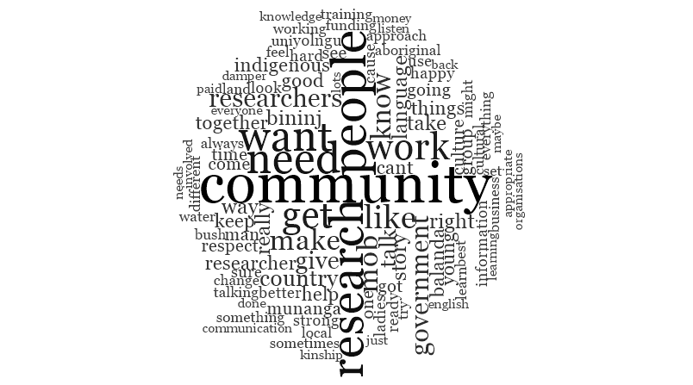
Figure 7.5: Word Cloud for Aboriginal Research Teams On-Country
Source: Hunter-Xenie, 2020:3
In relation to Figure 7.5, Hunter-Xenie (2020:3) found that for Aboriginal research teams on Country, the focus is on research jobs for locals, that research work on Country should include local Indigenous knowledges ‘to make sure researchers know and follow those kinship rules.’ Hunter-Xenie (2020:3) also found that Aboriginal people ‘also want to be recognised for what they know without having a university certificate.’

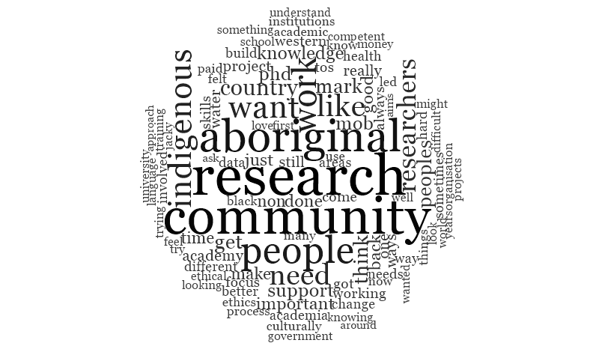
Figure 7.6: Word Cloud for Aboriginal Academics
Source: Hunter-Xenie, 2020:4
In relation to Figure 7.6, Hunter-Xenie (2020:4) found that for Aboriginal academics ‘want to do research differently to non-Aboriginal researchers’ and that ‘Aboriginal academics want universities to know local Indigenous knowledges and make sure research follows Aboriginal protocols.’ Hunter-Xenie found that Aboriginal academics want more Aboriginal researchers to do work with Aboriginal mobs, they are happy for non-Aboriginal people to work with them too, but only if they are helping as allies, but they do not want ‘non-Aboriginal people thinking they are the bosses.’

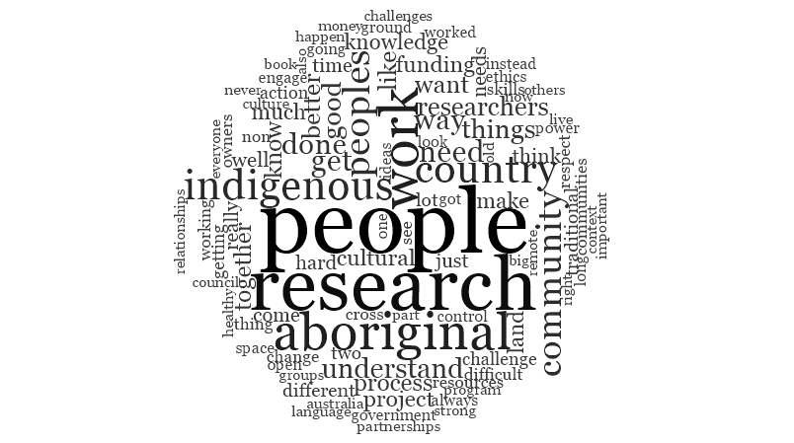
Figure 7.7: Word Cloud for Non-Aboriginal Scholars
Source: Hunter-Xenie, 2020:5
In relation to Figure 7.7, Hunter-Xenie (2020:4-5) found that for non-Aboriginal scholars are worried that not all researchers know how to undertake research with Aboriginal peoples, and they want to make sure that researchers are culturally competent, are taught how to behave with Aboriginal people and communities, and that universities are not teaching students enough about Aboriginal cultures and Aboriginal peoples. Hunter-Xenie also found that non-Aboriginal scholars ‘want universities to know what is needed to do research the way Aboriginal people want it done’, and ‘want emerging researchers to work with Aboriginal people to do research that Aboriginal people want.’ And that non-Aboriginal scholars want research organisations and researchers to show more respect for Aboriginal people’s ways of valuing, knowing, being and doing, and that this takes time (Hunter-Xenie, 2020:5).
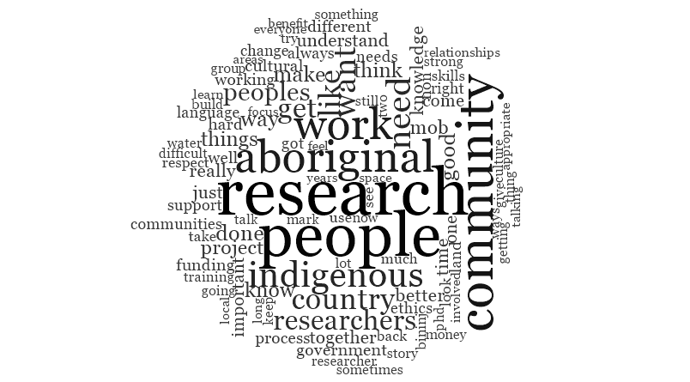
Figure 7.8: Word Cloud for all Participants Combined
Source: Hunter-Xenie, 2020
Figure 7.8 shows the Word Cloud for all Participants combined. What Figure 7.4 reveals is that words like ‘research’, ‘people’, ‘community’ and ‘work’ are getting the highest mentions. Other words such as ‘Indigenous’, ‘knowledge’, ‘researchers’ and ‘government’ are among the next most frequently used words in the interviews that Hunter-Xenie conducted.
What this research reveals are that Aboriginal people are deeply interested in conducting research on their Country, that kinship rules are applicable and must be followed when undertaking research on Country, and they want their knowledge of Country recognised in ways that don’t involve having to obtain formal university qualifications.
The research also reveals that Aboriginal academics want universities to know and understand Aboriginal knowledges and to adhere to Aboriginal protocols. They also want more Aboriginal researchers to work with Aboriginal people and for non-Aboriginal researchers to work with them, so long as they are willing to work with them as allies and not as their noses.
The research also reveals that non-Aboriginal scholars have several concerns about how universities are handling research with Aboriginal peoples and on Country. While the sample is obviously very small, it nevertheless reflects some of the concerns that SGSEP also found in conducting this review. Including for example, that some researchers are not adequately skilled in undertaking research in cross-cultural contexts where a fair two-way exchange of information and knowledge is regarded as the norm, and that more respect is needed for understanding Aboriginal people’s ways of valuing, knowing, being and doing when it comes to land and sea management and looking after Country.
Hunter-Xenie’s research is also consistent with other research currently being undertaken by three Aboriginal women from large regional centres in Queensland undertaking higher degree research programs at Central Queensland University – Melinda Mann, Samantha Cooms and Joann Schmider (Mann, Cooms and Schmider 2019). The three scholars gave a presentation on their reflections and insights at the AIATSIS Studies Conference in 2019 on their particular geo-cultural research relationships (Darumbal, Noonukul – Quandamooka, and Mamu – tropical rainforest peoples.
Mann, Cooms and Schmider (2019) highlight research design considerations to meet the University PhD requirements alongside cultural responsibilities and imperatives. The presenters assert that Traditional Custodians are well-positioned on their Homelands as researchers because of their access and knowledge of local land and people. Mann, Cooms and Schmider (2019) also assert that their cultural imperative for protecting, maintaining and creating knowledge as Traditional Custodians posits them as critical contributors in the future research agenda.
Mann, Cooms and Schmider have developed the following diagram (Figure 7.9) to depict the uniqueness of traditional custodian research and the link to traditional custodial identity. Mann (2019: audio recording) maintains that all research is about being immersed in the local place, and the closer you are to your apical family, the closer you are to your traditional custodial knowledge and responsibilities, and conducting research on one’s own country carries with it responsibility to ensure the elders are involved and that their knowledge and culture is strengthened.

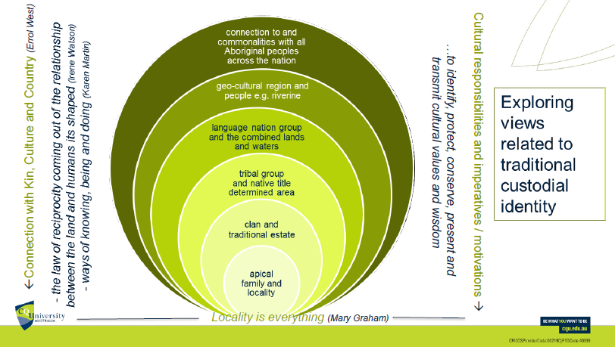
Figure 7.9: Exploring views related to traditional custodial identity
Source: Mann et al 2019.
Mann, Cooms and Schmider (2019) outline several benefits of working with Traditional Custodians, including transparency of motivation because the Traditional Custodians are involved; established knowledge and connection because the Traditional Custodians are enmeshed in culture and place; awareness of diversity and history and using the skills and knowledge for the Traditional Custodians’ benefit; familiarity with custodial and kinship responsibilities brings about accountability and transparency; and the relationships with Country and elders rests on connection and trust. Mann, Cooms and Schmider (2019) also acknowledge that research is not without its challenges, including ensuring the grounded-ness of the research aims, objectives and research questions; developing the contribution to the field of research; dealing with definitional issues; and managing budget limitations and time constraints.
As AIATSIS (2019a) notes in its introductory remarks about the research by these three Aboriginal scholars, it is increasingly accepted that Indigenous researchers are best placed to conduct Indigenous research. The clear benefit is that Indigenous researchers possess the intimate understanding of cultural, historical, social and political contexts affecting Indigenous peoples and their ancestral Country.

Findings and Conclusions
This Chapter examined the resources supporting Indigenous engagement in environmental and climate science research and found that there are several international and domestic resources available to the NESP Hubs to develop appropriate guidance materials, whether they be engagement policies or strategies, formal agreements or protocols.
There are three resources that form the framework for ethical research in Australia (The National Statement, the Code of Conduct and the GERAIS), and all researchers must conform to these documents when conducting research with Aboriginal and Torres Strait Islander peoples. While the third element of this framework is still a guideline, it is in the process of being elevated to a mandatory Code of Ethics. While the GERAIS has come in for some criticism from Indigenous people as being too weak, especially with respect to protection of ICIP, the new Code of Ethics will need to stand the test of time to measure its effectiveness in this regard, when combined with the National Statement and the Code of Conduct.
It was reported in Part 3.2 of Chapter 3, that Indigenous engagement in environmental and climate science research has also given increased access to IK and observance of Indigenous cultural practices and as a consequence significant contributions have been made to, or enhanced existing scientific knowledge of, environmental issues (including but not limited to, threatened species, land and water management, fire management, climate change) and contributed to the development of practical environmental solutions. In part, this can be attributed to the co-design and co-production of research projects by Indigenous people. However, as Holmes (2011:22-26) and Hunt (2013a:6) note, co-design and co=production of research projects are not without their challenges, including the need for leadership, trusting relationships and willingness to share power; the requirement to reshape accountabilities and align organisational structures; the need for an organisational culture that supports such ways of working; and better evaluation of what works.
Recent research found that combining IK with Western science are affected by numerous factors, including the adaptive co-management context, the intrinsic characteristics of the natural resources, and the many different governance systems for different components. The research projects with a high level of co-governance arrangements provides better prospects for integration of IK and western science, for the sustainability of social-ecological systems (Hill et al, 2012:23) and ultimately for the benefit of all Australians.
Several questions were raised by various stakeholders, suggesting there is room for improvement in the protection of ICIP in the context of research being undertaken by the NESP Hubs. While several reviews have recommended Australia’s intellectual property laws be amended to provide better protection (i.e. Janke 1999), it remains an area of considerable discussion (Productivity Commission 2016; Janke and Sentina 2018; IP Australia 2019). This leaves voluntary arrangements as the only available mechanism for developing locally appropriate solutions for providing adequate protections on a case by case basis.
Recent research by Janke (2019:328) has found that protocols enable the parties to arrive at an arrangement that respects Indigenous cultural ownership, values and practices as the primary holders, guardians, reproducers and interpreters of the cultures and interactions based on good faith and mutual understanding. Based on many years of experience working in intellectual property protection, Janke has developed a True Tracks Principles and Framework which is able to be to adapted to suit particular circumstances or fields of research.
While protocols are a flexible alternative to a legislated solution, they are inherently voluntary and there is a risk that they may not be followed in all circumstances. SGSEP therefore finds there is a case for including more specific performance indicators and reporting requirements on matters relating to the protection of ICIP in environmental and climate science research in the Funding Agreements for the new NESP Hubs being established under NESP2.
The other issue that emerged from consultations with stakeholders is Indigenous data sovereignty. The NESP Hubs have been and will continue to be involved in the collection and collation of Indigenous data and information, and SGSEP finds the principles being developed by GIDA provide a sound basis for protecting the integrity of such data. Especially if GIDA is successful with the implementation of ITK and Biocultural labels as a way of raising awareness of the cultural significance in data (and other content) and the express restrictions and expectations that may apply to the access and use of Indigenous data by non-community users.
Recent research by Indigenous scholars is finding that several factors are crucial to engaging meaningfully and effectively with Indigenous peoples in research on matters pertaining to their land and sea Country. Factors such as transparency of motivation, established knowledge and connection, awareness of history and diversity, custodial and kinship responsibilities, relationships with Country and elders, the grounded-ness of the research proposal’s aims and objectives, the contribution the research will make, and managing budget and time limitations. As AIATSIS (2019b) concludes these factors present multiple opportunities and challenges for Indigenous researchers, particularly where research focuses on Indigenous peoples’ lands and waters. The reality is that Traditional Owners or Custodians cannot ignore their custodial responsibilities. As Mann, Cooms and Schmider (2019) assert, their cultural imperative for protecting, maintaining and creating knowledge as Traditional Custodians, posits them as critical contributors in the future research agenda.
SGSEP therefore concludes that Indigenous engagement resources of the kind produced by the KISSP under the auspices of WAMSI (the Collaborative Science on Kimberley Saltwater Country – A Guide for Researchers, Lincoln et al 2017) and by the NAER Hub (Our Knowledge Our Way in Caring for Country Best Practice Guidelines, Woodward et al, 2020), are invaluable because they have been prepared by Indigenous peoples and are specifically about how they want others to work with them in respectfully accessing and sharing their unique knowledges. While these two resources have particular relevance to specific TO groups and their land and sea Country, the authors of the two resources have said that the principles and frameworks embedded in them are replicable by other TO groups and custodians subject to the free, prior and informed consent of the TOs and Custodians that prepared them.

Conclusions and Recommendations

Introduction
The brief for this review required SGSEP to:
- Scope Indigenous environmental and climate science research themes and questions through a desktop review, collating and synthesizing existing work on identifying themes/questions, and provide guidance on how to interpret the material provided. Sources should include but not be limited to existing NESP research hubs, Caring for Country/Working on Country/Healthy Country Plans, Indigenous Land Councils, Prescribed Body Corporates and Native Title Representative Bodies, CSIRO Indigenous Futures, and the PM&C Regional Network.
- In regions where documented research themes have not been found online, consult with relevant representative and peak bodies to ascertain whether they are aware of any documented sources and how to access them. (Following discussions with the Department, SGSEP interpreted this to be a spatial gap analysis.)
- Collate existing resources to support Indigenous collaboration in environmental research, for example template agreements, engagement protocols/principles and case studies. These resources should be drawn from but not be limited to existing NESP research hubs, Departmental line areas and other relevant organisations (e.g. AIATSIS).
- Liaise with NESP Indigenous stakeholders about the draft findings using desktop methods, including 3-4 virtual meetings, emails and phone calls to seek feedback and comments. Prepare a consultation summary and list of parties who were consulted for inclusion in the Final Report.
The remainder of this Chapter is structured around those tasks, and includes our recommendations.

Task 1: Scoping Indigenous environmental and climate science research themes and questions
One of the tasks of this desk-top review was to scope Indigenous environmental and climate science research themes and questions by reviewing the work of the NESP Hubs and various other sources.
The Department’s expectations with respect to ensuring effective integration of Indigenous aspirations and outcomes in the NESP were set out in the NESP IEPS Guidelines which acknowledge that all research undertaken, irrespective of its nature, will have some sort of impact on Indigenous Australians (DoE 2015a). The Department identified Indigenous engagement and participation in the NESP as a cross-cutting theme for all the Hubs in the development of their research priorities. Our analysis therefore examined the full scope of NESP Hub activities, including their Indigenous governance and engagement arrangements, their annual plans and annual reports, selected research projects that involved Indigenous people and Country, and engagement practices across the board.
However, our conclusions are subject to the following limitations and caveats:
- It was not a requirement of the NESP that the Hubs specifically identify Indigenous environmental or climate science research priorities. Our observations about what these research priorities may be, has been drawn from our analysis of the research projects that involved Indigenous people and Country, other activities undertaken by the NESP Hubs and from various other sources, including selected Commonwealth agencies and departments and IPA management plans. (See Chapters 3, 4 and 5 and Appendices C to G and I.)
- Most of the NESP Hub research projects that involved Indigenous peoples and their Country were not necessarily initiated by Indigenous peoples as a reflection of their priorities per se, but rather were initiated by other end-users or the research project arose from Hub or end-user priorities.
- The research for this brief was largely desk-top based and therefore cannot reflect Aboriginal and Torres Strait Islander peoples’ voices about their environmental and climate science research themes and questions. Some feedback from Indigenous research stakeholders was elicited through the virtual consultation (see Appendix A) and this has been built into the analysis and conclusions that follow.
- NESP research in environmental and climate science with Indigenous peoples has provided many opportunities for cross-cultural integration of IK and western science, which aligns closely with Indigenous peoples’ philosophy of ‘two-way’ learning between different cultures. ‘Two-way’ dialogues between researchers and TOs take time and effort to establish and requires an ongoing commitment based on mutual respect and trust. As Martin Parkinson (2017), the former Secretary of the Department of the Prime Minister and Cabinet observes, relationships of trust and good faith with the Indigenous peoples of Australia can take years to build and are often anchored in the commitment of a particular community and particular public servants. Parkinson goes on to note that the constant churn in public policy and programs presents opportunity costs impacting on the transfer of knowledge and capability from one generation of public servants to the next and that relationships risk becoming the collateral damage in a culture of constant change. In the case of the NESP Hubs, read ‘researchers’ instead of public servants. A process for recognising and maintaining the long established and trusted relationships between researchers and Indigenous peoples in the transition to NESP2 will avoid the loss of trust and good faith that have been established between Aboriginal and Torres Strait Islander peoples and NESP Hub research scientists.
As stated in the Executive Summary, our most significant finding is that Aboriginal and Torres Strait Islander peoples are more concerned about getting the processes for research right, rather than agreeing on a list of topics and priorities. Good engagement has to be built on the premise of mutual respect, cultural understanding, continuing trust and honest dialogue and that everyone has a mutual responsibility to engage, consult, achieve and communicate shared outcomes. Hence, issues of research process and approaches to working with Indigenous peoples and accessing their ecological or traditional knowledge are identified as matters of priority when working with Aboriginal and Torres Strait Islander peoples. The research shows that where the process is driven by genuine co-governance arrangements there are better prospects for integration of Indigenous Knowledge (IK) with Western science and better outcomes for the sustainability of social and ecological systems.
SGSEP recommends that:
- As part of the first phase of research planning for NESP2, a gathering of the proposed Indigenous Facilitation Network for NESP 2 be convened to assist in the identification of Indigenous research needs and interests within and across hubs and their missions, drawing on this report and the engagement resources (see Chapter 7 and Appendix M) as a starting point for meaningful conversations with Aboriginal and Torres Strait Islander peoples and communities across Australia.

- The proposed Indigenous Facilitation Network to be established under NESP2 commence a series of conversations with Aboriginal and Torres Strait Islander peoples around Australia, and that the ESCC Hub’s planned national gathering on climate change, delayed because of COVID-19 in the current NESP, be explored as one important opportunity to commence those conversations.

- Care be taken in the transition to NESP2 to ensure that the long-term relationships and trust that have been established between Aboriginal and Torres Strait Islander peoples and NESP Hub research scientists, are not lost. SGSEP further recommends therefore that opportunities for maintaining long-established regional relationships with Aboriginal and Torres Strait Islander peoples and communities should be documented and valued in the assessment process for the new Hubs.
SGSEP found that the Indigenous peoples of Australia value land and water and all the life systems associated with them as integral to their life and well-being. Indigenous knowledge (IK) views life holistically and is applied to land management so all life is sustained for present and future generations. Western science tends to compartmentalise knowledge into separate components. Hence, Indigenous peoples’ research priorities may or may not always align with those of Western science, and these differences should not be seen as conflicting priorities, but rather as different world-views worthy of equivalent respect, consistent with Article 8j of the Convention on Biological Diversity and Articles 3, 4, 5, 10, 11, 19, 25, 26, 27 of the UN Declaration on the Rights of Indigenous Peoples. The Caring for Country concept embodies a stewardship approach to land and sea management which is deeply embedded in Aboriginal and Torres Strait Islander culture.
SGSEP recommends that:
- A significant proportion of the funds within each NESP Hub be quarantined for Indigenous conceived environmental and climate science research projects, to be designed, led, implemented and outputs communicated by Indigenous researchers. SGSEP suggests a minimum of 10 to 15 per cent of NESP funds over the life of NESP2, that the outcomes of the research assist Indigenous peoples to conserve and sustainably manage areas of high biodiversity and conservation value. SGSEP also suggests that the research from this pool of resources be oversighted by the proposed Indigenous Facilitation Network to be established under NESP2 and be guided and assisted by the relevant NESP Hub.
SGSEP found that significant resources for Indigenous engagement in environmental and climate science research have been developed in close partnership with Aboriginal and Torres Strait Islander peoples by the Western Australian Marine Science Institution (WAMSI) as part of their Kimberley Marine Research Program (KMRP) (the Collaborative Science on Kimberley Saltwater – A Guide for Researchers, Lincoln et al 2017) and the NAER Hub (the Our Knowledge Our Way in Caring for Country Best Practice Guidelines, Woodward et al, 2020). These resources demonstrate that collaborative research (working ‘two-ways’) works best when both types of knowledge and culture are respected equally by each of the partners to the research task. These resources are invaluable because they have been prepared by Indigenous peoples and are specifically about how they want others to work with them in respectfully accessing and sharing their unique knowledges. While these two resources have particular relevance to specific TO groups and their land and sea Country, the authors of the two resources have said that the principles and frameworks embedded in them are replicable by other TO groups and custodians, subject to the free, prior and informed consent of the TOs and Custodians that prepared them.
SGSEP recommends that:
- NESP2 encourage other TO organisations to develop similar engagement resources for research praxis in their regions, based on the principles and frameworks developed by KISSP/WAMSI for the Collaborative Science on Kimberley Saltwater – A Guide for Researchers and the NAER Hub for the Our Knowledge Our Way in Caring for Country Best Practice Guidelines (see Case Studies 9 and 10).
In relation to the scope of Indigenous environmental and climate science research themes and questions, SGSEP has attempted to draw some broad conclusions about Indigenous environmental and climate science research themes and questions. These have been grouped to align with the four thematic hubs of NESP2. The following conclusions are subject to the caveat that these matters need to be discussed with Aboriginal and Torres Strait Islander peoples from around Australia in the very early stages of NESP2, as recommended above.

Resilient Landscapes
The Resilient Landscapes Hub will have discrete responsibility for applied research to support management of Australia’s terrestrial and freshwater habitats, including bushfire recovery, feral animals and invasive species impacts, accessible science to assist land managers to create and maintain resilient, sustainable and productive landscapes, targeted biodiversity and taxonomy products to support efficient system monitoring, and environmental monitoring systems and decision support tools. The Resilient Landscapes Hub will also have responsibility for cross-hub coordination for the ‘threatened and migratory species and ecological communities’ functional mission to support policy development, program management and regulatory processes to protect Australia’s environmental assets in terrestrial, Ramsar and marine environments (DAWE 2020a).
As discussed in Part 3.9.4 in Chapter 3, the NAER Hub has a long track record of engaging with Indigenous peoples in large research programs in northern Australia and has built on those long-term relationships. It has done so very effectively, culminating in the production of several valuable resources in collaboration with many TO groups across northern Australia, including for example, the Our Knowledge. Our Way in Caring for Country best practice guidelines, the Country: multiple values, multiple benefits into the future research priorities for IPAs across northern Australia, and the Economic values of Indigenous Protected Areas across Northern Australia, and the Report on the National Indigenous Fire Knowledge and Fire Management Forum – Building Protocols from Practical Experiences.
The Research Priorities for Indigenous Protected Areas project identifies five critical Indigenous research topics and questions that fit within the theme of understanding how to manage Country for multiple values and multiple benefits while supporting today’s youth into the future:
- New research models: What innovations and adaptations to environmental research models can enable Indigenous people to be central and gain greater benefit from current and new research?
- Economic dimensions: What does Indigenous land management contribute when valued through economic approaches?
- Knowledge brokering: How can both science and Indigenous knowledge be made more accessible and useful to Indigenous decision makers?
- Sustainable enterprise: How can Indigenous caring for Country be made sustainable through models of planning, innovation, governance, and business that can be tailored to diverse contexts?
- Frameworks responsive to new impacts: What participatory monitoring, participatory impact assessment methods, and institutional or tenure responses, enable protection of Country in response to new impacts e.g. new conservation and development proposals? (Hill et al, 2016:10; NAER, 2016b).
The greatest priority of Indigenous land managers is the development of new research models in which they are central, tailored to their diverse environmental, economic and social information needs with peer to peer Indigenous networking (NAER, 2016b).
Given the geospatial scope of the NAER Hub, it has been able to successfully collaborate with Indigenous peoples across northern Australia on a very diverse range of matters, including environmental and Indigenous cultural water needs for culturally important River systems; environmental and economic accounting for river waters, the links between Gulf rivers, coastal environments and food for migratory birds; managing savanna riparian zones; tools for assessing mangrove die-back in the Gulf; fish movement and sensitivity to contaminated mine water; waste and marine debris management in remote communities; lessons from Top-End fire management; defining metrics for feral animal management; invasive weed management; prioritising threatened species management; monitoring, mapping and safeguarding culturally important threatened species; developing eDNA methods for detecting Top-End animals; and the development of Healthy Country indicators for adaptive co-management. Most of these matters are of ongoing research interest for Indigenous people in the north, particularly access to tools to help them apply their knowledge to manage Country and building understanding of their customary uses of water and biological resources, both to maintain Country and culture and support social and economic well-being, and to enable better integration of Indigenous knowledge and laws with Australian laws and Western science as the basis for making informed land and water management decisions.
Rather than establishing an overarching Indigenous Reference Group, the NAER Hub appointed three Regional Coordinators to enable partnerships with regional communities on research planning, on-Country field activity and engagement (see Case Study 5 in Part 3.8.4 of Chapter 3). This grounded approach enabled important two-way knowledge sharing and field training and partnerships with Indigenous land managers on Country.
Also as discussed in Part 3.9.4 in Chapter 3, the TSR Hub has collaborated with Indigenous peoples across Australia on a wide range of matters, including mitigating feral animal impacts on native animals; saving endangered species; contrasting outcomes of contemporary and traditional fire management approaches in different environments; improving conservation measures for threatened species; long-term monitoring of threatened species to try and unravel causes of decline and extinctions of threatened species; developing coordinated monitoring programs; optimising the design of a network of havens for vulnerable species; key factors for effective partner integration and governance for threatened species and developing national monitoring priorities for threatened species. Researchers from the TSR Hub have also played a key role in advising the Minister on threatened ecological communities and threatened species recovery following the 2019-20 bushfire season through membership of the Minister’s Wildlife and threatened species bushfire recovery Expert Panel. The TSR Hub was also one of two Hubs to appoint an Indigenous Reference Group (IRG) to assist the Hub with better aligning its research with Indigenous Australians’ strategic needs, identifying activities within the Hub which could advance Indigenous Australians’ involvement in threatened species recovery and management, advice on how to value-add to projects by addressing Indigenous research needs, and advice on culturally appropriate formats for research outputs for Indigenous end-users and stakeholders.
SGSEP’s review of selected Commonwealth agencies in Chapter 4 and Appendix H, allowed for several recurring themes to be distilled from a review of the agencies and departments’ activities. For the Resilient Landscapes Hub, these include:
- Collecting and collating baseline level of ecological data.
- Governance of social-ecological systems for sustainable ecosystem stewardship.
- Data and technology for monitoring of ecosystems and threatened species.
- Improving the recording and application of IK for land and sea management.
- Fire management: cultural landscape fire management versus adverse fire events.
- Managing threatened species and their habitats.
- Managing feral animals to reduce impacts in protected areas and to protect important cultural sites.
- Water resource planning and cultural flows.
- Documenting and quantifying Indigenous social and economic values of aquatic resources.
Consultations with Indigenous research stakeholders revealed that ongoing concerns about the lack of adequate protections around accessing and sharing of IK. In the absence of adequate legislative protections, there is a strong case for the adoption of protocols, such as the True Tracks principles and Framework developed by Janke (2019), as a minimum standard for the protection of IK in all its forms and for adopting the FAIR and CARE principles developed by GIDA as the basis for protecting the integrity of Indigenous data (discussed below). Stakeholders also pointed to the engagement expectations being placed on communities suggesting the level and nature of that engagement needs to be carefully monitored across Commonwealth agencies (and related programs) so as not to exhaust the capacity and goodwill of the Aboriginal and Torres Strait Islander peoples to continue sharing their IK for the benefit of all Australians.
The following Indigenous research themes and questions were aggregated from our analysis of the IPA (and other non-IPA) Management Plans relevant to the Resilient Landscapes Hub:
- Improving baseline biodiversity data; better understanding of the health of our Country.
- Understanding biodiversity, ecology of landscapes, ecosystem health; sustainable use of natural resources, identify external or environmental contributors to weed and feral animal populations.
- Wildlife and habitat monitoring, monitoring of current management practices, address gaps in knowledge for threatened species and species of special conservation significance.
- Breeding cycles of threatened species, arrest the potential extinction of threatened species, protection of vulnerable species, optimal habitats for threatened species.
- Impacts on threatened species (several species of plants, animals, birds and insects specifically mentioned).
- Long term health of water resources, the effects of reductions in water quality and availability on biota, ground water flows, habitat mapping, fill knowledge gaps about water places of cultural significance.
- Trends in old growth forests.
- Impacts of over grazing on native species, impact of introduced animals (pigs, buffalo, deer, camels).
- The impact of commercial activity such as fishing.
- The development of wildlife ranching and harvesting.
- Impact of invasive weeds.
- Understanding different fire regimes, impact or effect of wildfires, appropriate ecological burning regimes, long-term biological impacts of changed fire regimes on different land types including a lack of data on optimal fire mosaic scales for the enhancement of biodiversity values.

Marine and Coastal
The Marine and Coastal Hub will have discrete responsibility for delivering applied research to support management of Australia’s marine and coastal environments including estuaries, coast, reefs, shelf and deep-water; targeted biodiversity and taxonomy products to support efficient system monitoring; and environmental monitoring systems and decision support tools. The Marine and Coastal Hub will also have responsibility for cross-hub coordination for the ‘protected place management’ functional mission to support the management of Australia’s protected places and heritage including the national park estate and Ramsar sites in both marine and terrestrial environments (DAWE 2020a).
The MB Hub came from a position of minimal direct engagement with Indigenous peoples when it was first established. The MB Hub therefore sought to promote Indigenous engagement and participation in marine science research by convening a series of Indigenous engagement workshops at the Australian Marine Sciences Association’s (AMSA) annual conferences over the last four years, as discussed in Part 3.6 above. This series of workshops resulted in an increased and increasing level of awareness about engagement with Indigenous people in marine science research and resulted in genuine engagement. The MB Hub also focussed its efforts on Matters of National Environmental Significance under the EPBC Act (i.e. listed species, communities and world heritage areas) and protected places (Australian Marine Parks), finding that many of the listed species and communities accorded this formal significance are also of great importance to Indigenous peoples. The marine research interests identified by Indigenous people reflect the powerful obligations they accept as custodians of sea Country and the lifeforms and ancestors depending on their management of sea Country. Research is continuing with a number of specific species and communities of interest to Indigenous peoples, including ongoing research with Indigenous knowledge of culturally important marine species (and habitat) shark species, Indigenous knowledge for culturally important habitat recovery and the cultural Importance and use of sea snakes.
In relation to the GBR, one of the seven natural wonders of the World, the TOs aspirations and expectations about the management of the Reef and its environs and their research themes and questions could not be clearer. The report titled ‘Traditional Owners of the Great Barrier Reef: The Next Generation of Reef 2050 Actions’ (The Report) (CofA, 2018) makes the following points very clear. While significant progress has been made with respect to some matters (catchment and marine land and sea rights and some outstanding examples of productive partnerships) there is no lasting, continuously improving GBR-wide approach to empowering TOs in the governance of the GBR. With the future health of the GBR under serious threat from climate change and other stresses, it is now critical to harness the capacity of TOs and their Sea Country institutions for a new generation of reef protection and management into the future (CofA, 2018).
The Report makes clear that the TOs want to be more actively involved in research partnerships to address key Indigenous knowledge gaps, but the varying levels of capacity among TO Groups along the GBR is hampering their ability to be more involved than they already are and their ability to deliver on all of the TO and other actions in the Reef 2050 Plan. The Report also notes that Traditional knowledge capture and sharing will facilitate partnerships with Western science, increase traditional knowledge involvement in planning and policies and most importantly protect and retain the knowledge for future generations. To this end, the TOs have indicated their support for the development of a safe and secure information storage and retrieval system relating to their cultural heritage and traditional knowledge, with the relevant controls regarding access and use of that knowledge.
SGSEP reiterates that TOs on the GBR want a lasting, continuously improving GBR-wide approach to governance of the GBR. Establishing a coalition of TO groups along the entire length of the Reef similar to that of NAILSMA across northern Australia, would be a step in the right direction. Such an entity would foster better collaboration and capacity amongst TO groups and the integration of IK with western science in the overall management of the Reef. It would also provide a place where IK can be collected, collated and accessed with the free, prior and informed consent of the people that hold that knowledge as part of their cultural law and practice.
As discussed in Part 3.4.9 in Chapter 3, the TWQ Hub has also been able to build on long-standing collaborations with Indigenous peoples, particularly in Queensland along the Great Barrier Reef and other parts of Northern Australia, with the TWQ Hub playing a significant role in developing and applying the Three Category Approach to Indigenous Engagement. Thematically, the research priorities that the TWQ Hub has been able to collaborate with Indigenous peoples on, includes further research on the crown of thorns invasive species; best practice approaches to restoration of the GBR; improving coral conditions in the GBR through better resilience-based management practices; better management of estuarine environments flowing into the GBR; assessment of key Turtle and Dugong seagrass resources in the northern Torres Strait; water quality and ecosystem health threats in the Torres Strait; and capacity building and increased participation in sea Country management. The TWQ’s research on TOs and Sea Country in the Southern Great Barrier Reef was used to further define Indigenous aspirations in the Reef 2050 Plan, and the research on Ecosystem Services in the Eastern cape York Peninsula has proved invaluable in terms of holistic approaches to environmental management in tropical waters.
The following Indigenous research themes and questions were aggregated from our analysis of the IPA (and other non-IPA) Management Plans relevant to the Marine and Coastal Hub:
- Indigenous archaeological values of marine areas, better understanding of cultural and ecological values of sea Country; specific research strategies for the cultural, ecological and social values in marine parks.
- Strategies for monitoring turtle populations in key locations; marine environment surveys, and detailed beach cay, reef platform mapping to better understand sea level rises and tidal surges and to detect and monitor cay migration.
- Mapping sea currents, temperature, and oceanography.
- Impacts of key threatening processes (including seabed mining, visitor access and climate change), threat monitoring in protected areas, strategies for managing weeds, pest species and marine debris.
- Health of our marine turtles, dugongs nesting turtles, and benthic habitats and other food species and culturally important species.
- Improve knowledge and understanding of humpback whales, other important ecological values, cultural heritage and human use in the marine park.
- Defining condition, pressure and response indicators and metrics (i.e. performance measures) to support the monitoring program, establishing baselines for marine park values, addressing knowledge gaps for values identified as key performance indicators, integrating traditional knowledge with contemporary science programs, where appropriate, examining how tidal amplitude influences the distribution and movement patterns of marine species.
- Establish a database to store all monitoring activities.
SGSEP’s review of selected Commonwealth agencies in Chapter 4 and Appendix H, reveals that while agencies have supported Indigenous involvement in coastal and marine management activities, Aboriginal and Torres Strait Islander peoples want to be acknowledged as custodians and marine managers of coastal and marine resources and they want to increase the level of their involvement in coastal and marine research. Aboriginal and Torres Strait Islander people have an in-depth knowledge and understanding of coastal and marine systems that stretches back at least 60,000 years and while there is growing recognition of the value of this knowledge base and its integration with western science, they are concerned about how their IK is being applied without their free, prior and informed consent.
Aboriginal and Torres Strait Islander peoples have expressed the need for better data collection, particularly in relation to Indigenous use and rights, non-commercial activities and other social and economic attributes, but they are very concerned about how this information may be utilised without their prior knowledge and consent. This is a consistent theme across many environmental and climate science research themes, not just coastal and marine matters. The review allowed for several recurring Indigenous research themes and questions to be distilled from a review of the agencies and departments’ activities. For the Marine and Coastal Hub, these include:
- Water quality and ecosystem health threats to the Torres Strait from Fly River runoff.
- Research about species vulnerable to climate change (e.g. corals, fishes, crayfish, marine turtles, dugongs, seagrasses, pelagic foragers) to optimise the effectiveness of resilience-based management.
- Improving estimates of abundance and distribution of turtle and dugong in the Torres Strait.
- Cumulative impacts on marine and coastal ecosystems and their resilience to recovery under climate change.
- Improving the recording and application of TEK for land and sea management.
- Collecting and collating baseline level of ecological data.
- Data and technology for monitoring of ecosystems and threatened species.

Sustainable Communities and Waste
The Sustainable Communities and Waste Hub will have discrete responsibility for delivering research that supports targeted information and management tools to reduce the impact of plastic and other material on the environment; applied scenario modelling to support sustainable people-environment interactions in communities including urban heat island impacts and liveability analysis; effective and efficient management options for hazardous waste, substances and pollutants throughout their lifecycle to minimise environmental and human health impacts; and maintained and improved air quality. The Sustainable Communities and Waste Hub will also have responsibility for cross-hub coordination for the ‘waste impact management’ functional mission to support decision maker policy development, program management and regulatory processes in both marine and terrestrial environments (DAWE 2020a).
As discussed in Chapter 3, the CAUL Hub is one of two Hubs that established an Indigenous Advisory Group, whose role is to oversight the CAUL Hub’s Indigenous engagement, collaboration and participation practices, especially in relation to urban locations. Under the guidance of its Indigenous Advisory Group, the CAUL Hub has worked hard to develop a cross-cultural and cross discipline approach to Caring for Country in cities, by posing the question: ‘Given thousands of years of Caring for Country in places we now call cities, how can city decisions better include Traditional Custodians, Indigenous knowledge and cultures in future city planning?’
The CAUL Hub’s research reinforces the fact that Australia has been slow to recognise the history and continuity of Aboriginal and Torres Strait Islander peoples’ custodial responsibilities as custodians or rights holders under State/Territory statutory land rights and/or cultural heritage schemes (Wensing, 2016). The CAUL Hub’s research also highlights the disconnect between urban researchers, urban land managers and Indigenous Australians, and the need to make space for Indigenous-led research on biodiversity in urban environments. The most significant knowledge gaps are the need for mechanisms to improve Indigenous participation in urban decision-making processes, particularly in relation to publicly owned lands where Indigenous rights and interests and cultural heritage are more likely to exist and building the cultural competency of urban researchers and practitioners to work with Aboriginal and Torres Strait Islander peoples.
The CAUL Hub’s research has focussed on how Indigenous values, perspectives and methodologies are able to drive environmental and climate science research in both urban and non-urban settings. The CAUL Hub found that urban practitioners and researchers need to better understand and engage in meaningful dialogue on the expectations, rights and aspirations of Indigenous communities in urban areas. Moving beyond a model of ‘inclusion’ of Indigenous people in research and teaching, especially within an urban context, toward genuine involvement in decision making about urban environments. The research has also identified that further work is required on developing better models for enabling Indigenous communities to define and direct research that is of importance and value to them in urban areas.
The CAUL Hub has applied the concept of Caring for Country in an urban context in both Melbourne and Perth as a new and innovative way of interacting with nature and managing its resources for economic, social and cultural prosperity. The CAUL Hub’s research has resulted in a synthesis of Indigenous perspectives about urban planning and urban greening. In particular, introducing greater levels of Indigenous input and active engagement in managing urban public green and blue spaces in urban environments, reversing the trend of species loss, restoring ecological function and ecosystem services and reconnecting people with traditional Aboriginal knowledge in urban environments. And for the Noongar people in WA, increased understanding of Indigenous values and perspectives in urban planning and urban greening in the Perth Area.
The NAER and TWQ Hubs have undertaken targeted research on specific management issues related to waste and debris in remote locations. This includes the issue of ocean rubbish and debris washing up on Australia’s northern coastline and the management of hard waste in remote locations such as Cape York and the Gulf of Carpentaria. These impacts are likely to affect remote Aboriginal communities around Australia (and not only coastal locations) who, because of distance, have limited access to infrastructure and resources to manage the waste stream and implement recycling in their communities. This is an issue of ongoing concern for Indigenous people in remote communities and for future research in this Hub.
No IPA Management Plans identified research subjects or priorities that could potentially fall within the new Sustainable Communities and Waste Research Hub.
SGSEP’s review of selected Commonwealth agencies in Chapter 4 and Appendix H, highlighted the special needs of Indigenous communities for remote waste solutions and suggests that the cultural knowledge of Aboriginal and Torres Strait Islander peoples living in cities and towns need to be recognised in liveability and place management policy in both urban and regional environments. For the Sustainable Communities and Waste Hub, a stronger relationship with the Department of Infrastructure, Transport, Regional Development and Communications will be necessary for Indigenous peoples’ environmental and climate science research needs to be integrated into the Commonwealth’s Cities and regional development agendas.
SGSEP’s review allowed for the following Indigenous Research themes and questions to be distilled from a review of DAWE's policy activities. For the Sustainable Communities and Waste Hub, these include:
- Improving regional, remote and Indigenous communities’ ability to access, influence and participate in a circular economy.
- Reducing the impacts of plastic and packaging on the environment and oceans, reducing plastic pollution, and maximising benefits to the local economy and to society.

Climate Systems
The Climate Systems Hub will have discrete responsibility for Earth system science and modelling; advancing Australia’s understanding of climate variability, extremes and associated drivers (including of events such as bushfires, droughts and high rainfall events); and for developing tools and information to manage Australia’s emerging risks and opportunities. The Climate Systems Hub will also have responsibility for cross-hub coordination for the ‘climate adaptation’ functional mission to support climate information to program hubs to drive integrated adaptation research across the program to support evidence-based decision-making and improve Australia’s climate resilience (DAWE 2020a).
One of the recurring topics to emerge from this review of NESP research projects and conversations with stakeholders, especially Indigenous stakeholders, is the impacts of changes to Australia’s climate systems on the environment.
As discussed in Chapter 3, the ESCC Hub held the second national Indigenous Dialogue on climate change on Yorta Yorta Country in 2018. Attended by more than 50 Traditional Owners from across Australia they conversed on climate change, sharing their observations, talking about their priorities and exploring opportunities to improve knowledge of climate change and its risks for people and Country. The event was a two-way dialogue between researchers and Traditional Owners working on climate change. Significantly, the key outcome from the Dialogue was a statement from Traditional Owners (see Figure 3.2) stating that they have always understood and adapted with Country, and through their cultural practices, interpreted the change. The Yorta Yorta People agreed to host the second summit because they wanted mainstream Australia to understand what is happening and that all Australians must work together ‘as we only share one planet one life’ (Morgan et al, 2019:8).
The report of the Dialogue makes the point that Western science has only been able to monitor weather and climate systems for a few hundred years, whereas Indigenous peoples all over the World, but especially in Australia, have been monitoring climate systems for tens of thousands of years, including changes due to ice ages. ‘First Nations peoples are the only continuous civilisation that has lived through the ice ages, and the stories of this lived experience can contribute critically important information to Western science’ and ‘In partnering with First Nations people we can better understand how climate has influenced their nations and country and how it is likely to be affected in the future.’ (David Karoly, in Morgan et al, 2019:18)
The 2018 National Dialogue was one of the most significant national gatherings of Indigenous peoples on climate science research priorities and which also highlighted the importance of an ongoing dialogue and made clear that First Peoples want to set their own agenda on climate knowledge and action. Several research priorities were identified, including bio cultural renewal; monitoring of seasonal indicators; impact on water cycles/flows; water rights and access; impacts of resource extraction; governance and institutional responses; cumulative impacts and many others; the need to weave Indigenous climate knowledge into climate science modelling across Australia.
The 2018 National Dialogue generated a strong response among Aboriginal people and communities from across Australia and a growing interest in being involved in the next national dialogue and translating the outcomes into policies and actions, especially in relation to managing their ancestral Country. As recommended above, ESCC hub’s planned national gathering on climate change provides a unique and important opportunity to commence conversations with Aboriginal and Torres Strait Islander people about their environmental and climate science research themes and questions. Planning has commenced for the next national dialogue which will likely be held in early 2021, given the impact of the COVID-19 pandemic.
The ESCC Hub also facilitated the first ever Indigenous session at the annual Australian Meteorological and Oceanographic Society (AMOS) conference in Darwin in 2019, where TOs were invited to present on their perspective of climate change and risks to their country, as well as community led solutions contributing to climate change mitigation while generating income for communities. This event prompted a follow-up workshop at the AMOS Conference in Freemantle in March 2020, where TOs and researchers were able to share experiences and advice for successful collaboration on climate-change-related projects. Several important considerations were identified, including:
- Understanding that there are many peoples and many cultures;
- Including Traditional Owners from the start (and all the way through);
- Building (and being prepared to maintain) trusted relationships;
- Appreciating different timelines;
- Ensuring free, prior and informed consent;
- Respecting the provision and ownership of traditional knowledge;
- Identifying benefits to country and community;
- Ensuring you are giving as well as taking; and
- Remembering that connection to country is forever.
The following Indigenous research themes and questions were aggregated from our analysis of the IPA (and other non-IPA) Management Plans, relevant to the Climate Change Hub:
- Better understand the likely impact of climate change.
- Better manage the impacts of climate change.
- Investigating potential impacts of climate change on terrestrial biodiversity.
- Improving knowledge about potential impacts of climate change on wetland communities in the IPA and about future management actions that might be required.
- Feasibility studies exploring the science and viability of carbon abatement programs and methodologies.
- Action‐based research and analysis relating to Indigenous knowledge transmission to expected environmental degradation and other effects due to climatic changes.
Also arising from our analysis, the accumulating impacts of climate change was identified as a key threat and many IPA managers identified the need for more research in this area.
SGSEP’s review of selected Commonwealth agencies in Chapter 4 and Appendix H, allowed for several recurring themes to be distilled from a review of the agencies and departments’ activities. For the Climate Systems Hub, these include:
- Impacts of climate systems/change on the environment, industries and communities in the Murray Darling Basin with a focus on four key actions to respond to the risks and prepare for impacts.
- Mapping of Indigenous weather, season and related biological knowledge.
- Knowledge brokering for managing landscapes in a time of climate change, including the need for interdisciplinary science to address the extreme events, such as severe cyclones and harsh heat-waves.

Task 2: Indigenous Research gap analysis
In order to ascertain where Indigenous environmental and climate science research themes and questions have not been documented (and not found online or by other means), it was first necessary to identify where Indigenous environmental and climate science research projects have taken place. It is important to understand, as we articulate in Part 5.3 of Chapter 5, that it was not possible, given time and budget constraints, to examine the hundreds of research projects that the NESP Hubs have undertaken over the life of NESP, nor was it possible to geographically map them all. We therefore focussed on 108 projects that we selected or were guided to by the NESP Hubs on the basis of having a high level of Indigenous involvement and engagement. The following conclusions are drawn from our analysis in Chapters 3, 5 and 6 and Appendices D, F, G, I and J.
From the spatial analysis in Chapter 5 and Appendix J, SGSEP draws the following broad conclusions:
- There has been more research conducted in the north of Australia, and considerable gaps in the southern parts of Australia. This is due in part to the fact that two of the NESP Hubs are specifically focussed on Northern Australia where explicit research priorities about Indigenous engagement and partnership have driven this focus. Notwithstanding, there are considerable gaps in several jurisdictions (i.e. SA, Tas, Vic, ACT) where research with Indigenous peoples has not been undertaken. The environmental and climate science research needs of the Indigenous peoples in the southern portions of Australia requires further investigation, both terrestrial and marine.
- SGSEP found that there are very few NESP Hub research projects with high levels of Indigenous engagement in many of the bioregions that are under-represented in the NRS. While there is some correlation between the NESP Hubs’ research projects and the IMCRA and IBRA regions, it would be helpful to have a better understanding of Indigenous peoples’ environmental and climate science research needs and particularly how their cultural knowledge may add value to the IMCRA, the IBRA and the NRS, especially in areas that are not able to be dedicated as IPAs.
- The Indigenous estate is broadly defined to include land owned, managed or controlled by Aboriginal and Torres Strait Islander peoples and to which they have use and rights that protect their special values. It covers about 33 per cent of the land mass of Australia and is continuing to increase in size, and much of it with high biodiversity conservation values. While there is some correlation between NESP Hub research projects and the Indigenous estate, there is considerable scope for improving the alignment between the Indigenous estate and the environmental and climate science research needs of the Indigenous land owners and/or managers. SGSEP hastens to add that this is an area where further investigation is required in consultation with the Indigenous people and entities that have interests in land to ascertain with greater clarity what their environmental and climate science research themes and questions may be.
- There is also scope for better alignment between NRM activities involving regional Indigenous communities funded under the NLP and Aboriginal and Torres Strait Islander peoples land owners and/or managers in the Indigenous estate as that may assist with yielding more information about Indigenous environmental and climate science research needs, especially with respect to biodiversity threats, ecological systems and land management practices.
On the basis of this spatial analysis therefore, some states that have no or very few research projects with an Indigenous focus, some marine parks in the southern and eastern parts of Australia have very few or no research projects with an Indigenous focus, and many bioregions (particularly those that are under-represented in the NRS) have no research projects with an Indigenous focus. More detailed regional gap analysis should be progressed in consultation with Aboriginal and Torres Strait Islander people and communities about their research needs and priorities across Australia.
SGSEP recommends that:
- Stronger correlations be made between the various geo-spatial thematic layers of information about Australia’s terrestrial and marine environments held by DAWE (such as the IMCRA, the IBRA, the NRS, the IPAs, and the Indigenous estate) with the identification of Indigenous environmental and climate science research needs, as such correlations will provide useful guidance on setting research priorities for NESP2 and beyond.
As discussed in Chapter 6, SGSEP also undertook an analysis of the IPA Management Plans across Australia to see whether they identify any environmental and climate science research themes and questions. While considerable research has been undertaken by the NESP Hubs and others on matters pertaining to the management of IPAs and their underlying values, this kind of analysis of the full suite of IPA Management Plans has never been undertaken before. SGSEP found that many of the management plans raise issues around the protection of IK and many of them identify broad and specific environmental and climate science research themes and questions.
SGSEP also found that many of the management plans are out of date and due for renewal. While SGSEP supports the findings of the NAER Hub’s work on identifying the research priorities of the IPAs across northern Australia (Hill et al, 2016), we also conclude that 25 years on from the first IPA, it is time to revisit key aspects of the program with a view to scaling up the management support, scaling up the level of protection and that, where requested by TOs, better policy and legal options be explored for enabling native title holders to leverage their native title rights and interests over IPAs to undertake their management activities consistent with or as part of their native title rights and interests. Furthermore, we note that the current management arrangements for the of the IPA Program and Indigenous Ranger Program away from the Australian Government’s environment functions are a detraction from the wider intent and benefits of the programs as being integral to Australia achieving its biodiversity conservation and environmental management outcomes. Australia’s 76 IPAs comprise over 44 per cent of the NRS and once the 12 IPA Consultation Sites are dedicated, they will add over 30 million hectares to the NRS and increase the size of the NRS by almost 20 per cent.
SGSEP recommends that:
- Building on Recommendation 6. A meta-analysis of IPAs and their management plans be undertaken to ascertain a better understanding of their value to the IBRA and IMCRA, the threats they face with the identification of Indigenous environmental and climate science research needs of the IPA managers and/or TOs. As part of this analysis, SGSEP also recommends that:
- Efforts to scale up management support be explored, including to undertake regular updates or reviews of IPA management plans;
- Options for scaling up the level of protection for IPAS from external threats be explored;
- Better policy and legal options be explored for enabling native title holders to leverage their native title rights and interests over IPAs to undertake their management activities consistent with, or as part of, their native title rights and interests; and that
- Functional and administrative responsibility for the IPA Program and Indigenous Ranger Program should be returned to DAWE so the Programs can be re-integrated into the Department’s biodiversity conservation and environmental policy and management responsibilities and to improve alignment between NESP research and IPA management.

Task 3: Resources supporting Indigenous engagement
SGSEP located and examined several international and domestic Indigenous engagement resources and categorised them on the basis of whether the NESP Hubs and their researchers ‘Must Conform’ with them, whether they are ‘Highly Applicable’, ‘Moderately Applicable’ or of ‘General Relevance’ in relation to Indigenous engagement in environmental and climate science research. SGSEP categorised 17 resources as ‘Must Conform’, and a further 15 resources as ‘Highly Applicable’ to environmental and climate science research involving Indigenous peoples. (See Chapter 7 and Appendix M)
In Australia, any research involving humans is governed by a set of ethical principles to ensure research is safe, respectful, responsible, high quality, and of benefit to research. All research involving Aboriginal and Torres Strait Islander peoples must conform with the ethical research framework comprising the:
- National Statement on Ethical Conduct in Human Research (the National Statement) (NHMRC et al, 2018a);
- Australian Code for the Responsible Conduct of Research (the Code of Conduct) (NHMRC et al, 2018b); and the
- AIATSIS Guidelines for Ethical Research in Australian Indigenous Studies (GERAIS) (AIATSIS, 2012).
The AIATSIS GERAIS is currently being reviewed with a view to it being upgraded to a Code of Ethics (AIATSIS, 2019a). These three documents form the broader context of the overall governance of human research ethics in Australia and there is no question therefore that the new Hubs under NESP2 must conform with them.
At the international level, there are three resources that SGSEP also categorised as ‘Must Conform’. Australia is a signatory to the Convention on Biological Diversity and has also endorsed the United Nations Declaration on the Rights of Indigenous Peoples (UNDRIP). Article 8(j) of the CBD commits Convention Parties to respect, preserve, maintain and promote the wider use of traditional knowledge with the approval and involvement of the users of such knowledge, and Australia’s Biodiversity Conservation Strategy 2010-2030 (NRMMC, 2010) arises from Australia being a signatory to the CBD and commits Australia to increased Indigenous engagement in biodiversity conservation and respecting the culture, values, innovations, practices and knowledge of Indigenous peoples. As discussed in Chapter 7, the Convention’s guidelines with respect to genetic resources must be adhered to if environmental or climate science research involves the utilisation of genetic resources. There is no question as to the requirement to conform with the Bonn Guidelines and the Nagoya Protocol in such circumstances.
While the UNDRIP is not binding in Australian law, Australia has endorsed it and as a Declaration of the General Assembly of the United Nations it is considered to be universally applicable (Amnesty International Canada, 2012). The UNDRIP also reflects the needs and aspirations of Indigenous peoples and expresses rights, and by doing so, explains how Indigenous peoples want nation states (and others) to conduct themselves about matters that may affect their rights and interests (Wensing, 2019). As stated elsewhere in this report, the NESP Hubs and various Commonwealth agencies and departments make frequent references to the UNDRIP, especially in relation to their engagement activities with Indigenous peoples, and especially the principle of free, prior and informed consent. However, our consultations with various stakeholders revealed concerns about the lack of application of the principle or misunderstanding of how it should be applied.
The Australian Human Rights Commission has issued a community guide to UNDRIP, which sets out how the principle of free, prior and informed consent applies in practice (AHRC, 2010:25) (Figure 8.1).
The four elements of the principle are interlinked and should not be treated separately (FAO, 2016:5). The FAO’s good practice guide on the concept of free, prior and informed consent states that:
‘…consent should be sought before any project, plan or action takes place (prior), it should be independently decided upon (free) and based on accurate, timely and sufficient information provided in a culturally appropriate way (informed) for it to be considered a valid result or outcome of a collective decision making process’ (FAO, 2016:15).
The principle applies to research activities, as much as it applies to the formation of public policy and legislation. The principle raises the level of engagement with Aboriginal and Torres Strait Islander people by switching the relationship from consultation to consent and provides a safeguard to Aboriginal peoples’ full participation in decisions affecting their rights and interests (Nosek, 2017:119, 124). Applying these principles consistently creates a process whereby research institutions and researchers and Aboriginal and Torres Strait Islander peoples can talk to each other on an equal footing and come to a solution or agreement that all parties can accept (UNHRC, 2009: Paras 36-57).
SGSEP concludes therefore that it is in Australia’s wider and long-term interests to make better use of Indigenous knowledge about Australia’s environment with the free, prior and informed consent of the knowledge holders, if we as a nation are to prosper, not only environmentally, but also socially, culturally and economically.
What does free, prior and informed consent mean?
When making policies, laws or undertaking activities that affect our peoples, governments and others should negotiate with us with the aim of obtaining our consent.
This is much stronger than an obligation to just provide information or ‘consult’. Governments and companies should not impose their position onto our peoples, without first taking our rights into consideration.
The following outlines free, prior and informed consent:
Free means no force, bullying or pressure.
Prior means that Indigenous peoples have been consulted before the activity begins.
Informed means Indigenous peoples are given all of the available information and informed when that information changes or when there is new information. If Indigenous peoples don’t understand this information then they have not been informed. An interpreter or other person might need to be provided to assist.
Consent means Indigenous peoples must be consulted and participate in an honest and open process of negotiation that ensures:
- all parties are equal, neither having more power or strength;
- Indigenous peoples’ group decision-making processes are allowed to operate; and
- Indigenous peoples’ right to choose how they want to live and their world views are respected
This creates a process where governments or companies and our peoples can talk to each other on an equal footing and come to a solution or agreement that all parties can accept. This also means that Aboriginal and Torres Strait Islander peoples re to be involved in the design, development, implementation, monitoring and evaluation of all programs, policies and legislation that affects us.
The greater the impact and damage that a decision or project will have on our peoples’ lives, cultural integrity and country, the greater the need to reach an outcome that we can agree to. If an action is a direct threat to our survival or cultural integrity then we should be entitled to say ‘no’ to that action.
Source: AHRC, 2010:25.
Figure 8.1: The principle of Free, Prior and Informed Consent
Sources: AHRC, 2010:25; WGIP, 2005, para 56.
SGSEP recommends that:
- The principle of free, prior and informed consent be applied to all research activities by the NESP Hubs that involve Aboriginal and Torres Strait Islander peoples, without exception, and that relevant KPIs be developed that require the NESP Hubs to report regularly on their performance with its application.
SGSEP also found that research in environmental and climate science with Indigenous peoples provides significant opportunities for cross-cultural integration of IK and western science, which aligns closely with Indigenous peoples’ philosophy of ‘two-way’ learning between different cultures. The research concluded that where the process is driven by Indigenous governance or co-governance arrangements, there are better prospects for integration of IK and Western science and better outcomes for the sustainability of social-ecological systems (Hill et al, 2012:23). The key to success with co-design and co-production of environmental and climate science research is paying greater attention to Indigenous methods for ensuring the integrity of IK and respecting the fact that IK and Western science each have their own value to contribute to caring for Country and the environment (Hill et al 2012:32; Weir, 2009:116).
In our assessment of the selected 108 NESP Hub projects, we found that not many of them were initiated by Indigenous people, but were rather initiated by the NESP Hub or other end users. We also found that the projects initiated, designed, led and executed by Indigenous people were very successful, not only because the research benefited the Indigenous people concerned, but because the research also successfully integrated IK and Western science.
SGSEP sought to examine written agreements that the NESP Hubs used to formalise the arrangements between them and the Indigenous peoples they engaged with in their research activities, but we were not provided with sufficient quantity of such agreements to come to any definitive conclusions about their merits or otherwise. Two of the NESP Hubs have developed specific protocols for engagement in their respective research fields (the TSR and ESCC hubs). SGSEP found that the World Intellectual Property Organisation and IP Australia regard protocols as being more suitable in situations where there may not be a need for more formal agreements because they can be more context driven. However, our consultations with stakeholders revealed significant concerns about lack of clear dispute resolution processes in the event of a breakdown in relationships between the parties, and lack of clear protection for IK.
And as the CSIRO’s Chief Executive, Larry Marshall, notes:
The [Our Knowledge Our Way caring for Country] Guidelines critically remind us that in order to achieve best practice in land and sea management, partners must work together across diverse knowledge systems in the right way: with understanding and respect for local values and governance, cultural protocols and Indigenous cultural and intellectual property. (Woodward et al, 2017:ix).
SGSEP recommends that:
- Formal protocols be negotiated between the NESP Hubs, researchers and the Indigenous peoples and communities from the very outset of research engagements involving Indigenous peoples, and that such protocols include sufficient provisions for dispute resolution and alternative dispute resolution, and sufficient provision for the ongoing protection of IK (as discussed below).
SGSEP also reviewed the levels of protection available to IK (in all its forms). While several reviews over recent years have recommended a sui generis approach to ICIP law reform to better protect ICIP generally, there are no such plans on the horizon. Indeed, a recent Discussion Paper issued by IP Australia noted there is no single solution to solve the issues raised, and suggests a package of options in order to recognise Indigenous Knowledge rights, including many measures that can be practically achieved with ease, as well as others that require deeper consultation and legislative change (Janke and Sentina, 2018:117).
While SGSEP did not examine the issues of lack of protection for IK with the NESP Hubs per se, on the basis of the literature and recent reports we examined, SGSEP concludes there is a case for including better protections for IK in all its forms in the next iteration of the NESP. This can be achieved very simply by requiring the NESP hubs to apply the True Tracks Principles and Framework developed by Terri Janke and Company to develop individually tailored protocols for each research project, where appropriate, and by including specific performance indicators and regular reporting requirements in the NESP Hubs annual plans and reports on matters relating to the protection of IK.
SGSEP recommends that:
- Building on Recommendation 9. The True Tracks Principles and Framework developed by Terri Janke and Company be adopted as the minimum standard for protocols between the NESP Hubs and Indigenous peoples for the protection of IK in all their forms. The protocols must also include dispute resolution processes, including provisions for the appointment of an independent mediator.

- Key performance indictors be developed (in consultation with Terri Janke and Company) for the NESP Hubs on the measures put in place for the ongoing protection and integrity of IK, including the application of the True Tracks Principles and Framework, as part of their annual plan and reporting requirements.
SGSEP also found a new global network has been established to progress International Indigenous data sovereignty and Indigenous data governance. The Global Indigenous Data Alliance (GIDA) has been established between researchers, data practitioners and policy activists. GIDA has developed a motto of ‘be FAIR and CARE’ about Indigenous data, and are advocating for metadata tagging, provenance and disclosure statements detailing the origin of data, collective consent and data availability, and TK and Biocultural labels as a way of raising awareness of the cultural significance of data, and express restrictions and expectations around the access and use of data by non-community users. SGSEP anticipates the work of GIDA will gain momentum over time.
SGSEP recommends that:
- The NESP Hubs be made aware of Global Indigenous Data Alliance (GIDA) and its objectives with respect to Indigenous data, and the NESP Hubs take account of GIDA’s FAIR and CARE principles relating to Indigenous data, especially in relation to access and use of Indigenous data by non-Indigenous users.

Task 4: NESP Hub Performance and Consultation Outcomes
SGSEP was able to undertake a small number of consultations with key stakeholders, including some members of the Minister’s IAC, on our preliminary findings. Throughout the course of the review, SGSEP held several consultation meetings with NESP Hub Knowledge brokers, researchers, Commonwealth agency staff and various stakeholders, and these consultations yielded valuable information and views about how the NESP Hubs performed with respect to Indigenous engagement across the board. The outcomes of those consultations are summarised below.
- There is scope for greater engagement between the NESP Hubs and the Minister’s IAC on broader matters such as: identifying Indigenous research themes and priorities; the development of KPIs around engagement, monitoring and year-on-year reporting on improvements with Indigenous engagement practices (especially in relation to the application of the principle of free, prior and informed consent); communication and dissemination of research outcomes; and integration of research outcomes into recovery plans, management plans and environmental impact assessments under the EPBC Act. KPI’s should include both qualitative and quantitative indicators or measures.
- The Department’s IEPS Guidelines and directives about Indigenous engagement were not made available at the start of the NESP. The timing of the guidance and establishment arrangements meant it was difficult to achieve meaningful Indigenous partnerships from the outset which impacted on how some of the Hubs progressed their Indigenous engagement strategies. There is room for improvement in terms of providing more information and guidance to the NESP Hubs about Indigenous Engagement from the outset of NESP2.
- Several Indigenous stakeholders commented that the Department’s IEPS (DoE, 2015a) did not include a set of consistent objectives for Indigenous engagement in the NESP. It would have helped if the NESP Hubs had been given a clear set of objectives they could add to, but not divert from, in developing their own IEPS. Stakeholders also commented that Aboriginal and Torres Strait Islander people should be consulted on the development of the engagement objectives and their agreement sought before the objectives are adopted by the Department. If engagement and participation strategies are to be seen as living documents, then the annual research plans and reports need to show how the strategies are being applied and reviewed annually.
- Questions were also raised by several stakeholders about KPIs that the NESP Hubs are expected to report on in their annual reports and whether they are sufficiently appropriate as measures of Indigenous engagement across the full suite of NESP governance and research activities. It was suggested that there needs to be stronger benchmarking of performance on a much wider range of indicators if the intent is to monitor and keep improving the level and quality of Indigenous engagement by the NESP Hubs. While reporting against the current set of KPIs shows some remarkable and worthy achievements by the NESP Hubs compared the Program’s predecessors, there is no evaluation of improvements made year-on-year. There are other practical measures that could also be designed into the program to improve the level of accountability and improving performance in relation to Indigenous engagement. For example, it was suggested that targets be negotiated with the Hubs from the outset of NESP2 and that additional incentives be offered for reaching the agreed targets to ensure they can go further the following year.
- In some respects, the NESP has benefited from researchers with considerable experience working with TOs and researchers who have begun to develop cultural capacity. In selecting the new Hubs, it is important to be mindful of not losing the trusted relationships that have been developed over the life of NESP and its predecessors. SGSEP found there is a strong commitment to two-way knowledge exchange and learning in several projects. It is a sign of significant progress in building relationships between Indigenous Australians and the environmental and climate science fraternity when there is a clear commitment to two-way learning and knowledge exchange on matters relating to the management of land and sea Country and generally on equal terms. This knowledge exchange and Country partnerships in NESP is enabling the production of practical management and training tools for Indigenous land and sea Country managers and their communities. And this is what Indigenous people are finding most valuable.
- Some projects have suffered in the past from inadequate resourcing and planning for Indigenous inclusion from the outset of a research project. Careful pre-planning and allocation of resources for Indigenous inclusion in environmental and climate science research is a pre-requisite to success.
- While the numbers of Indigenous researchers involved in environmental and climate science research are slowly growing, there is still a need to build the capacity of Indigenous researchers by providing support at all levels from high school through to university, by investing in skills transfer and by supporting early career researchers.
- All NESP research should include explicit ethical requirements for the ongoing protection of Indigenous cultural and intellectual property. While the legal framework for protection of ICIP remains unclear, researchers still have a responsibility to ensure adequate protections are put in place from the very outset of a research project to provide long term protection for any IK acquired or accessed during the research.
- The National Indigenous Gathering in Canberra in 2018 resonated with Indigenous people involved in environmental and climate science research because it provided a rare opportunity for them to discuss a broad range of issues, to share experiences and to develop ideas for actions. Events such as these are what can be termed ‘milestone events’ because they provide important opportunities for fostering respect and understanding about Indigenous peoples environmental and climate science research themes and questions at key points in the life of NESP.
- Similarly, the Canberra briefings resonate with the Aboriginal and Torres Strait Islander people involved in research on their land and/or sea Country. The opportunity to come to Canberra to brief Departmental and agency officials and politicians on the outcomes of their research was mentioned by several stakeholders as very valuable. Such events enable them to share their knowledge and understanding about their Country directly with decision makers and how the investment in environmental and climate science research is beneficial, not only to them but also for all Australians. The quality and value-add of these kinds of events should not be under-estimated.
- In the course of conducting this research, SGSEP encountered several difficulties in accessing basic information and resources, especially the paucity of adequately linking research outcomes to the research project information. SGSEP was also unable to readily access several key documents that were supposed to be publicly available online from NESP Hub websites. There were several frustrating moments when documents were not provided within a reasonable timeframe or when we were unable to connect documents to research projects for lack of consistent details like project numbers or name changes that were not properly documented. There is scope therefore under NESP2 for improvement in making final research results readily available online and that are easily searchable and connected to the original research proposal.
SGSEP therefore recommends that:
- NESP2 include the following elements as a matter of good practice:
- Greater opportunities for engagement between the NESP Hubs and the Minister’s IAC on identifying Indigenous research themes and priorities; KPIs for monitoring and reporting on Indigenous co-governance, engagement practices, communication and dissemination of research outcomes, and integration of Indigenous knowledge and research outcomes into recovery plans, management plans and environmental impact assessments under the EPBC Act.
- All research involving Aboriginal and Torres Strait Islander peoples must conform with the ethical research framework (The NHMRC National Statement, the ARC Code of Conduct and the AIATSIS Code of Ethics [when finalised]).
- The Department review its IEPS for the NESP to reflect the recommendations arising from this review, and the Indigenous Engagement resources (see Chapter 7 and Appendix M).
- A clear set of consistent objectives for Indigenous engagement to be developed in consultation with Aboriginal and Torres Strait Islander people. The Hubs be allowed to build on these objectives relevant to their particular field of research, but not detract from the core objectives.
- The KPIs for Indigenous engagement be developed in consultation with Aboriginal and Torres Strait Islander peoples. KPI’s should include both qualitative and quantitative indicators or measures. The Hubs be required to report against the KPIs, year-on-year and to show improvement in performance.
- Allow the Hubs to provide support for Indigenous leadership of research projects, including flexibility to respond to Indigenous research priorities that may emerge during the course of research;
- Allow sufficient time and funds for Indigenous peoples to have input into the research design and the development of appropriate research protocols for each project. The research protocols must include sufficient protections for ICIP and provisions for dispute resolution.
- Include capacity to support the development of Indigenous researchers from high school through to university, in skills transfer and as early career researchers.
- Ensure that cultural capability training for researchers is an essential part of future research programs and where possible, be delivered by local Indigenous groups involved in the research.
- National Indigenous Gatherings be planned early in the life of NESP2, at midterm and again toward the end of NESP2 as a way of enabling information gathering and sharing between Aboriginal and Torres Strait Islander peoples and other stakeholders, including the NESP Hubs and the Department and relevant Commonwealth agencies.
- Canberra briefings be held in line with significant research project outcomes to enable Aboriginal and Torres Strait Islander and other researchers to present and share their findings with key decision-makers.
- The NESP Hub websites include up to date information and better links between research projects and their outputs to make them more accessible.

References
All Web links current as at May/June 2020, unless otherwise stated.

Legal Authorities
Western Australia v Ward (2002) 213 CLR 1

Legislation
Aboriginal and Torres Strait Islander Commission Act 1989 (Cth)
Aboriginal and Torres Strait Islander (ATSI) Act 2005 (Cth)
Aboriginal and Torres Strait Islander Heritage Protection Act 1984 (Cth)
Aboriginal Land Rights Act (Northern Territory) Act 1976 (Cth)
Australian Institute of Marine Science Act 1972 (Cth)
Commonwealth Regional Forest Agreements Act 2002 (Cth)
Environment Protection and Biodiversity Conservation Act 1999 (Cth)
Great Barrier Reef Marine Park Act 1975 (Cth)
Meteorology Act 1955 (Cth)
Native Title Act 1993 (Cth)
Protection of Movable Cultural Heritage Act 1986 (Cth)
Public Governance, Performance and Accountability Act 2013 (Cth) (PGPA Act)
Science and Industry Research Act 1949 (Cth)
Water Act 2007 (Cth)

Books, Book Chapters, Journal Articles, Reports, etc.
ABARES (2018) Australia’s State of the Forests Report 2018, Department of Agriculture, Canberra. https://www.agriculture.gov.au/sites/default/files/abares/forestsaustralia/documents/sofr_2018/web%20accessible%20pdfs/SOFR_2018_web.pdf
AG (1992a) Intergovernmental Agreement on the Environment. https://www.environment.gov.au/about-us/esd/publications/intergovernmental-agreement
AG (1992b) National Strategy on Ecological Sustainable Development. http://www.environment.gov.au/about-us/esd/publications/national-esd-strategy
AG (2012) Basin Plan 2012, made under subparagraph 44(3)(b)(i) of the Water Act 2007 (Cth). https://www.legislation.gov.au/Details/F2012L02240
AG (2014) National Environmental Science Program Guidelines 2014.
AG (2017) Australia’s 7th National Communication on Climate Change. A report under the United Nations Framework Convention on Climate Change, December 2017. https://unfccc.int/files/national_reports/national_communications_and_biennial_reports/application/pdf/024851_australia-nc7-br3-1-aus_natcom_7_br_3_final.pdf
AG (2018a) Reef 2050 Long-Term Sustainability Plan, July 2018. http://www.environment.gov.au/system/files/resources/35e55187-b76e-4aaf-a2fa-376a65c89810/files/reef-2050-long-term-sustainability-plan-2018.pdf
AG (2018b) National Waste Policy, Less Waste, More Resources. Prepared by the Australian Government, state and territory governments and the Australian Local Government Association. https://www.environment.gov.au/system/files/resources/d523f4e9-d958-466b-9fd1-3b7d6283f006/files/national-waste-policy-2018.pdf
AG (2019) Indigenous Collaboration for Australia’s environmental science (brochure), http://www.environment.gov.au/science/nesp
AIATSIS (2012) Guidelines for Ethical Research in Australian Studies. Revised Second Edition. AIATSIS, Canberra. https://aiatsis.gov.au/sites/default/files/docs/research-and-guides/ethics/gerais.pdf
AIATSIS (2019a) 2019 Revision of the AIATSIS Guidelines for Ethical Research in Australian Indigenous Studies - Consultation Draft. AIATSIS, Canberra. https://aiatsis.gov.au/sites/default/files/docs/research-and-guides/ethics/consult/consultation_draft_guidelines_for_ethical_research_in_australian_indigenous_studies.pdf
AIATSIS (2019b) Introductory remarks to ‘Traditional Custodians as researchers: Experiences of researching with our Mob on our Country’ Tuesday, 2 July 2019, by Melinda Mann, Samantha Cooms, and Joann Schmider. https://aiatsis.gov.au/publications/presentations/traditional-custodians-researchers-experiences-researching-our-mob-our-country
AIATSIS (2020) AIATSIS Code of Ethics for Aboriginal and Torres Strait Islander Research, https://aiatsis.gov.au/research/ethical-research/aiatsis-code-ethics?utm_medium=email&utm_campaign=AIATSIS%20News%20July%202020&utm_content=AIATSIS%20News%20July%202020+CID_a316994b584e505636ac9907de2edb48&utm_source=Email%20marketing%20Campaign%20Monitor&utm_term=Find%20out%20more
AHRC (2010) The Community Guide to the UN Declaration on the Rights of Indigenous Peoples, AHRC, Sydney. Accessed 9 June 2016. http://www.humanrights.gov.au/declaration_indigenous/index.html
AHRC (2016) Indigenous Property Rights, AHRC, Sydney.Accessed 3 May 2016. https://www.humanrights.gov.au/our-work/aboriginal-and-torres-strait-islander-social-justice/projects/indigenous-property-rights and https://www.humanrights.gov.au/sites/default/files/Indigenous%20Property%20Rights%20Guiding%20Principles%20-%20FINAL%202016.pdf
AIMS (2015) National Marine Science Plan 2015-2025. Driving the development of Australia’s blue economy. https://www.marinescience.net.au/wp-content/uploads/2018/06/National-Marine-Science-Plan.pdf
AIMS (2018) Australian Institute of Marine Science Strategy 2025. https://www.aims.gov.au/sites/default/files/AIMS_Strategy-2025-Web.pdf
ALRC (2015) Connection to Country: Review of the Native Title Act 1993 (Cth), Final Report. ALRC Report 126.Sydney. https://www.alrc.gov.au/wp-content/uploads/2019/08/alrc_126_final_report.pdf
Altman, J. (2014) ‘The political ecology and political economy of the Indigenous titling “revolution” in Australia’, Maori Law Review – 2014 Indigenous Law Speaker Series.
Altman, J., Buchanan, G.L., and Larsen, L. (2007) The environmental significance of the Indigenous estate: Natural resource management as economic development in remote Australia. CAEPR Discussion Paper No. 286/2007. https://caepr.cass.anu.edu.au/sites/default/files/docs/2007_DP286_0.pdf
Altman, J. and Kerins, S. (eds) (2012) People on Country: Vital Landscape: Indigenous Futures, Federation Press, Sydney.
Amnesty International Canada (2012) United Nations Declaration on the Rights of Indigenous Peoples, Fact Sheet. http://www.amnesty.ca/sites/amnesty/files/undeclarationfactsheetsept2012.pdf
ANAO (Australian National Audit Office (2007) Whole of Government Indigenous Service Delivery Arrangements, Audit Report No.10 2007–08 Performance Audit. https://www.anao.gov.au/sites/default/files/ANAO_Report_2007-2008_10.pdf
ANAO (2020) Referrals, Assessments and Approvals of Controlled Actions under the Environment Protection and Biodiversity Conservation Act 1999, Department of Agriculture, Water and the Environment. Performance Audit, Auditor-General Report No.47 2019–20. https://www.anao.gov.au/sites/default/files/Auditor-General_Report_2019-2020_47.pdf
Anaya, J. (2009) The Right of Indigenous Peoples to Self-Determination in the Post-Declaration Era, in C. Charters and R. Stavenhagen (eds), Making the Declaration Work: The United Nations Declaration on the Rights of Indigenous Peoples, International Working Group for Indigenous Affairs, Document No. 127. Copenhagen, pp.184-198.
Anderson, J. (2010) Indigenous Knowledge/Traditional Knowledge and Intellectual Property, Issues Paper, Centre for the Public Domain, Duke University. http://www.law.duke.edu/cspd/itkpaper
ANU (2020) Australia’s Environment Summary Report 2019. The Centre for Water and Landscape Dynamics (WALD). https://www.wenfo.org/aer/
Arnstein, S.R. (1969) ‘A Ladder of Citizen Participation’, Journal of the American Institute of Planners, Vol. 35, No. 4, pp. 216-224.
Austin, B.J., Robinson, .C, Lincoln, G., Mathews, D., Oades, D., Wiggins, A., Bayley, S., Edgar, J., King, T., George, K., Mansfield, J., Melbourne, J., Vigilante, T., with the Balanggarra, Bardi Jawi, Dambimangari, Karajarri, Nyul Nyul, Wunambal Gaambera & Yawuru Traditional Owners (2017) Guidelines for Collaborative Knowledge Work in Kimberley Saltwater Country. Final Report of project 1.5.2, the Kimberley Indigenous Saltwater Science Project (KISSP). Prepared for the Kimberley Marine Research Program, Western Australian Marine Science Institution, Perth, Western Australia, 23pp. https://www.wamsi.org.au/sites/wamsi.org.au/files/files/Indigenous%20Knowledge_Guidelines%20for%20working%20with%20multiple%20knowledges%20report_%20WAMSI%20KMRP%20Project%201_5_2_Austin%20et%20al%202017%20FINAL.pdf
Austin, B.J., Robinson, C., Lincoln, G. Dobbs, R., Tingle, F. Mathews, D., Oades, D., Wiggan, A., Bayley, S., Edgar, J., King, T., George, K. Mansfield, Melbourne, J., Vigilante, T., with Balangarra Bardi Jawi, Dambimangari, Karajarri, Nyul Nyul, Wunambal Gaambera and Yawuru Traditional Owners (2018) Mobilising Indigenous Knowledge for the Colllaborative Management of Kimberley Saltwater Country. Final Report of project 1.5.1 the Kimberley Indigenous Saltwater Science Project (KISSP). Prepared for the Kimberley Marine Research Program, Western Australian Marine Science Institution, Perth, Western Australia, 49pp. https://www.wamsi.org.au/sites/wamsi.org.au/files/files/Indigenous%20Knowledge_Mobilising%20Indigenous%20Knowledge%20Report_WAMSI%20KMRP%20Project%201_5_1%20_Austin%20et%20al%202018_FINAL.pdf
Bauman, T. (2019) The missing piece of infrastructure – The case for Indigenous dispute resolution, decision making and engagement services in Closing the Gap. Presentation to NIAA 8 November. (copy provided by the author).
Bauman, T., and D. M. Smyth. (2007) Indigenous partnerships in protected area management in Australia: three case studies. Australian Institute of Aboriginal and Torres Strait Islander Studies, Canberra, Australia.
Berkes, F., Colding, J. & Folke, C. (2000) ‘Rediscovery of traditional ecological knowledge as adaptive management’, Ecological Applications, 10, 1251-1261.
Blackwell, B.D., Bodle, K., Hunt, J., Hunter, B., Stratton, J., and Woods, K. (2019). Methods for Estimating the Market Value of Indigenous Knowledge, report commissioned by IP Australia, Canberra.
Brundtland, G.H. (1987) Our Common Future, From One Earth to One World. An Overview by the World Commission on Environment and Development, Transmitted to the General Assembly of the United Nations as an Annex to document A/42/427 - Development and International Economic Co-operation: Environment, 4 August 1987. http://www.un-documents.net/our-common-future.pdf
BoM (2016) Reconciliation Action Plan 2016–2019. http://www.bom.gov.au/inside/rap/
Burgess, C.P., Johnston, F.H., Berry, H.L., McDonnell, J. Yibarbuk, D., Gunabarra, C. Mileran, A., and Bailie, R.S. (2009) Healthy country, healthy people: the relationship between Indigenous health status and “caring for country”. The Medical Journal of Australia, Vol. 190, No. 10, pp. 567-572.
Butler, C. (2006). Historicizing Indigenous knowledge: Practical and political issues. In C. R. Menzies (Ed.), Traditional ecological knowledge and natural resource management (pp. 107-126). Lincoln: University of Nebraska Press.
CAUL Hub (2015) Indigenous Engagement and Participation Strategy, Version 1. https://nespurban.edu.au/wp-content/uploads/2019/03/CAUL_Hub_IndigenousEngagementParticipationStrategy_May2015.pdf
Charterpoint (2018) National Environmental Science Program Mid-Term Evaluation Final Report, 27 February.
CMP (2013) Open Standards for the Practice of Conservation, (Originally produced in 2004, updated in 2007 and 2013). https://sites.google.com/a/fosonline.org/cmp-workspace/initiatives/os-4-0-revisions
COAG (2008) Meeting Communique 3 July. http://archive.coag.gov.au/coag_meeting_outcomes/2008-07-03/index.cfm
COAG (2019) Partnership Agreement on Closing the Gap 2019-2029. https://www.coag.gov.au/sites/default/files/agreements/partnership-agreement-on-closing-the-gap_0.pdf
CofA (1999) Australian Guidelines for Establishing the National Reserve System. Environment Australia, Canberra.
CofA (2018) Traditional Owners of the Great Barrier Reef: The Next Generation of Reef 2050 Actions.
CofA (2019) Administrative Arrangements Order made on 5 December 2019 with effect from 1 February 2020. https://www.pmc.gov.au/sites/default/files/publications/aao-5-December-2019-effect-1-February-2020.pdf
Convention of the World Meteorological Organization (WMO) https://public.wmo.int/en/about-us
CSIRO (2007) Indigenous Engagement Strategy (supplied by CSIRO).
CSIRO (2018) Reconciliation Action Plan November 2018 – November 2020. file:///C:/Users/edwen/Downloads/18-00246_OIE_BROCHURE_ReconciliationActionPlan2018-20_WEB_FINAL%20(1).pdf
Daes, E.I. (1993) Study on the Protection of the Cultural and Intellectual Property of Indigenous Peoples, Special Rapporteur of the Sub-Commission on Prevention of Discrimination and Protection of Minorities, and Chairperson of the Working Group of Indigenous Populations, E/CN.4/Sub.2/1993/28, 28 July.
Daes, E.I. (2008) ‘An overview of the history of Indigenous peoples: self-determination and the United Nations’, Cambridge Review of International Affairs, Volume 21, Number 1, pp. 7-26.
Dale, A. George, M., Hill, R. and Fraser, D. (2016) Traditional Owners and Sea Country in the Southern Great Barrier Reef – Which Way Forward? Report to the National Environmental Science Program. Reef and Rainforest Research Centre Limited, Cairns (50pp.). http://nesptropical.edu.au/wp-content/uploads/2016/05/NESP-TWQ-3.9-FINAL-REPORT.pdf
DAWE (2020a) National Environmental Science Program (NESP) 2 Grant Opportunity Guidelines. https://www.communitygrants.gov.au/sites/default/files/documents/03_2020/national-environment-science-program-2-grant-opportunity-guidelines_0.pdf
See also:
NESP 2 hub research scope overview: Resilient Landscapes Hub
https://www.communitygrants.gov.au/sites/default/files/documents/04_2020/national-environment-science-program-resilient-landscapes-hub-research-scope_0.pdf
NESP 2 hub research scope overview: Marine and Coastal Hub
https://www.communitygrants.gov.au/sites/default/files/documents/04_2020/national-environment-science-program-marine-coastal-hub-research-scope_0.pdf
NESP 2 hub research scope overview: Sustainable Communities and Waste Hub
https://www.communitygrants.gov.au/sites/default/files/documents/04_2020/national-environment-science-program-sustainable-communities-waste-hub-research-scope.pdf
NESP 2 hub research scope overview: Climate Systems Hub
https://www.communitygrants.gov.au/sites/default/files/documents/04_2020/national-environment-science-program-climate-systems-hub-research-scope.pdf
DAWE (2020b) Indigenous Protected Areas. Accessed 23 March 2020. https://www.environment.gov.au/land/indigenous-protected-areas
Dawson, T., Rounsevell, M., Kluvánková-Oravská, T., Chobotová, V., and Stirling, A. (2010) ‘Dynamic properties of complex adaptive ecosystems: implications for the sustainability of service provision.’ Biodiversity and Conservation Vol. 19:2843-2853. http://dx.doi.org/10.1007/s10531-010-9892-z
DEE (2017) NESP Research Priorities for 2017, and Explanation Table (copy provided by the Department).
DEE (2018) A shared vision for successful collaboration, NESP Indigenous Gathering, ANU, Canberra 21-22 February. Draft Report – Unpublished. Cited with permission.
DEE (2019) The National Heritage List and the Commonwealth Heritage List: 1 July 2013 – 30 June 2018. (Copy provided by DAWE.)
Dillon, R., Jeyasingham, J., Eades, S. and Read, S. (2015). Development of the Australia’s Indigenous forest estate (2013) dataset. ABARES Research Report 15.6, Canberra.
DKCRC (2007) Protocol for Aboriginal Knowledge and Intellectual Property. http://nintione.com/resource/NintiOneProtocolAboriginalTorresStraitIslanderKnowledgeIntellectualProperty_2015.pdf
Dobbs, R.J., Close, P.C., Austin, B.J., Tingle, F., Lincoln, G., Mathews, D., Oades, D., Wiggins, A., Bayley, S., Edgar, J., King, T., George, K., Mansfield, J., Melbourne, J., Vigilante, T. with the Balanggarra, Bardi Jawi, Dambimangari, Karajarri, Nyul Nyul, Wunambal Gaambera & Yawuru Traditional Owners (2017a) A Regional Framework for Saltwater Monitoring. Final Report of project 1.5.4. the Kimberley Indigenous Saltwater Science Project (KISSP). Prepared for the Kimberley Marine Research Program, Western Australian Marine Science Institution, Perth, Western Australia, 33pp. https://www.wamsi.org.au/sites/wamsi.org.au/files/files/Indigenous%20Knowledge_Regional%20Framework%20Report_WAMSI%20KMRP%20Project%201_5_4%20Dobbs%20et%20al%202017_FINAL.pdf
Dobbs, R.J., Austin, B.J., Close, P.C., Tingle, F., Lincoln, G., Mathews, D., Oades, D., Wiggins, A., Bayley, S., Edgar, J., King, T., George, K., Mansfield, J., Melbourne, J., Vigilante, T., with the Balanggarra, Bardi Jawi, Dambimangari, Karajarri, Nyul Nyul, Wunambal Gaambera & Yawuru Traditional Owners (2017b) Kimberley Saltwater Monitoring Toolbox. Final Report of project 1.5.5, the Kimberley Indigenous Saltwater Science Project (KISSP). Prepared for the Kimberley Marine Research Program, Western Australian Marine Science Institution, Perth, Western Australia, 58pp. https://www.wamsi.org.au/sites/wamsi.org.au/files/files/Indigenous%20Knowledge_Kimberley%20Toolbox%20for%20Saltwater%20Monitoring%20Report_WAMSI%20KMRP%20Project%201_5_Dobbs%20et%20al%202017%20FINAL.pdf
DoE (2015a) Indigenous Engagement Strategy Guidelines, V1.0.
DoE (2015b) Monitoring and Evaluation Plan for the National Environmental Science Program (NESP). Prepared by Vista Advisory (Caroline Spencer, John Hawley and Hayley Shone) with the assistance of Waratah Partners (Norman Laing and Kellyanne Stanford).
DoE (2015c) Fact Sheet: Principles of Engagement with Indigenous Peoples.
DoE (2016) Engage Early. Guidance for proponents on best practice Indigenous engagement for environmental assessments under the Environment Protection and Biodiversity Conservation Act 1999 (EPBC Act). (February) https://www.environment.gov.au/system/files/resources/3201a986-88e8-40f3-8c15-6e659ed04006/files/engage-early-indigenous-engagement-guidelines.pdf
Eide, A. (2006) ‘Rights of indigenous peoples – achievements in international law during the last quarter of a century’. Netherlands Yearbook of International Law. Volume 37, December, pp 155-212.
Engle, K. (2011) ‘On Fragile Architecture: The UN Declaration on the Rights of Indigenous Peoples in the Context of Human Rights’, The European Journal of International Law, Volume 22, No. 1, pp. 141-163.
ESCC Hub (2017) Indigenous Engagement and Collaboration Strategy, Version 3, February. http://nespclimate.com.au/wp-content/uploads/2018/07/ESCC-Indigenous-Engagement-Strategy_2017.pdf
Evans, L., H. Scott, K. Muir, and J. Briscoe. 2009. Effective intellectual property protection of traditional knowledge of plants and their uses: an example from Australia. GeoJournal Vol. 74:391-401. http://dx.doi.org/10.1007/s10708-008-9229-6
FaHCSIA (2012) Engaging today, building tomorrow: the engagement spectrum. Canberra: FaHCSIA. (Cited in Hunt 2013:5).
FAO (2016) Free, Prior and Informed Consent. An Indigenous peoples’ right and a good practice guide for local communities. Manual for project Practitioners. http://www.fao.org/3/a-i6190e.pdf
Farr, M., Stoeckl, N., Esparon, M., Grainger, D., and Larson, S. (2016) Economic values and Indigenous Protected Areas across northern Australia. Final Report. Accessed 14 April 2020. https://www.nespnorthern.edu.au/wp-content/uploads/2017/04/Economic_Values_and_IPAs_final_web.pdf
Fordham, A., Fogarty, W., Corey, B. and Fordham, D. (2010) Knowledge Foundations for the Development of Sustainable Wildlife Enterprises in Remote Indigenous Communities of Australia, CAEPR Working Paper No. 62. ANU, Canberra. https://caepr.cass.anu.edu.au/sites/default/files/docs/CAEPRWP62_0.pdf
GA (2019) Geoscience Australia Strategy 2028. Applying Geoscience to Australia’s most important challenges. https://www.ga.gov.au/__data/assets/pdf_file/0005/85595/Strategic-Plan-2028-v2.pdf
GA (2020) Land and Marine Access (LAMA) Strategy 2020 (copy provided by GA).
Gammage, B. (2011) The Biggest Estate on Earth. How Aborigines made Australia, Allen & Unwin, Sydney.
Ganesharajah, C. (2009) Indigenous Health and Wellbeing: The Importance of Country, Native Title Research Report No, 1/2009. AIATSIS, Canberra. https://aiatsis.gov.au/sites/default/files/products/report_research_outputs/ganesharajah-2009-indigenous-health-wellbeing-importance-country.pdf
Garnett, S. and Sithole, B. (2007) Sustainable Northern Landscapes and the Nexus with Indigenous Health: Healthy Country, Healthy People, Research Project NTU7 of the Social and Institutional Research Program of Land & Water Australia.
Garnett, S., Latch, P., Lindenmyer, D., and Woinarski, J (eds) (2018) ‘Recovering Australian Threatened Species: A Book of Hope. CSIRO Publishing, Canberra.
GBRMPA (2017) Reef Blueprint: Great Barrier Reef Blueprint for Resilience, GBRMPA, Townsville.
GBRMPA (2019) Great Barrier Reef Outlook Report 2019, GBRMPA, Townsville.
Gidarjil Development Corporation (2016) Reef 2050 Indigenous Implementation Plan. https://www.environment.gov.au/system/files/resources/2e4fa6bc-9fba-40b4-be64-cc701c78dea3/files/reef-2050-indigenous-implementation-plan.pdf
Gilligan, B. (2006) The National Reserve System Programme 2006 Evaluation, Department of the Environment and Heritage, Canberra
Griggs, D. Joachim, L. and Kestin, T. (2013) National Workshop on Indigenous Knowledge for Climate Change Adaptation, 14–15 November 2012, Echuca Workshop Report. MSI Report 13/02, Monash Sustainability Institute, Monash University, Victoria.
Grace, P. (2018) ‘Indigenous-Led Conservation: experiences from the Kimberley’, Australian Environmental Law Digest. V1 2018.
Hedge, P. (ed.) (2017) AMSA Indigenous Engagement Workshop Summary. Report to the National Environmental Science Program, Marine Biodiversity Hub. 2017 AMSA Indigenous Engagement Workshop Working Group. https://www.nespmarine.edu.au/system/files/Summary%202017%20AMSA%20Indig%20Engt%20Wshop_Final_10Nov17.pdf
Hedge, P. and Bax, N. (2019) 2019 Hub Workshop Hobart, Tasmania 29-31 October 2019 Summary Report. Marine Biodiversity Hub, Hobart. https://www.nespmarine.edu.au/system/files/2019%20Hub%20Workshop%20Summary%20report_FINAL_1.pdf
Hill, R., Walsh F., Davies, J. and Sandford, M. (2011) Our Country Our Way: Guidelines for Australian Indigenous Protected Area Management Plans. CSIRO Ecosystem Sciences and the Australian Government Department of Sustainability, Water, Environment, Population and Communities. Accessed 12 January 2020. https://www.environment.gov.au/land/nrs/science/maps-and-data
Hill, R., Grant, C., George, M., Robinson, C.J., Jackson, S., & Abel, N. (2012). ‘A typology of Indigenous engagement in Australian environmental management: Implications for knowledge integration.’ Ecology and Society, 17 (1), 23.
Hill, R., Pert, P.L., Davies, J., Robinson, C.J., Walsh, F., Falco-Mammone, F. (2013) Indigenous Land Management in Australia. Diversity, scope, extent, success factors and barriers. CSIRO Ecosystem Sciences, Cairns.
Hill, R., Lyons, I., George, M., Biggs, K., (2016) Country: multiple values, multiple benefits into the future. Research priorities for Indigenous Protected Areas across northern Australia. Cairns, Australia: CSIRO Land and Water. https://www.nespnorthern.edu.au/wp-content/uploads/2016/08/Web-Final-Report-1.pdf
Holmes, B. (2011) Citizens’ engagement in policymaking and the design of public services. Parliament of Australia Research Paper No. 1, 2011–12. Canberra: Parliament of Australia. https://parlinfo.aph.gov.au/parlInfo/download/library/prspub/942018/upload_binary/942018.pdf;fileType=application/pdf#search=%222010s%22
Hunt, J. (2013a) Engaging with Indigenous Australia – Exploring the conditions for effective relationships with Aboriginal and Torres Strait Islander communities. Issues paper No. 5, produced for the Closing the Gap Clearinghouse, AIHW and AIFS, Canberra. https://www.aihw.gov.au/getmedia/7d54eac8-4c95-4de1-91bb-0d6b1cf348e2/ctgc-ip05.pdf.aspx?inline=true
Hunt, J. (2013b) Engagement with Indigenous communities in key sectors, Resource Sheet No. 23, produced for the Closing the Gap Clearinghouse, AIHW and AIFS, Canberra. https://www.aihw.gov.au/getmedia/c3d74d39-0ded-4196-b221-cc4240d8ec90/ctgc-rs23.pdf.aspx?inline=true
Hunter-Xenie, H. (2020) ‘More Than a Human GPS? Opportunities for Aboriginal Peoples to Lead and Manage Land and Water Research On-Country in the Northern Territory, Australia’ Precis of ANU Honours Thesis. Cited with permission of the author.
ICEC (International Conference on Engaging Communities) (2005) Brisbane Declaration on Community Engagement. Declaration to the General Assembly of the United Nations. Inaugural ICEC, Brisbane 15–17 August. Brisbane: Government of Queensland. https://www.lcsansw.org.au/documents/item/330
IP Australia (2019) Protection of Indigenous Knowledge in the Intellectual Property System, Consultation Report. IP Australia, Canberra. https://www.ipaustralia.gov.au/sites/default/files/reports_publications/indigenous_knowledge_consultation_report.pdf
IPBES (2019) Summary for policymakers of the global assessment report on biodiversity and ecosystem services of the Intergovernmental Science-Policy Platform on Biodiversity and Ecosystem Services. S. Díaz, J. Settele, E. S. Brondízio E.S., H. T. Ngo, M. Guèze, J. Agard, A. Arneth, P. Balvanera, K. A. Brauman, S. H. M. Butchart, K. M. A. Chan, L. A. Garibaldi, K. Ichii, J. Liu, S. M. Subramanian, G. F. Midgley, P. Miloslavich, Z. Molnár, D. Obura, A. Pfaff, S. Polasky, A. Purvis, J. Razzaque, B. Reyers, R. Roy Chowdhury, Y. J. Shin, I. J. Visseren-Hamakers, K. J. Willis, and C. N. Zayas (eds.). IPBES secretariat, Bonn, Germany. 56 pages. https://ipbes.net/global-assessment
IUCN (2003) Guidelines for Management Planning of Protected Areas, World Commission on Protected Areas (WCPA) Best Practice Protected Area Guidelines Series No. 10. IUCN – The World Conservation Union 2003. https://portals.iucn.org/library/sites/library/files/documents/PAG-010.pdf
IUCN (2013) Guidelines for Applying Protected Area Management Categories, Edited by Nigel Dudley. (Complete Title: Guidelines for applying protected area management categories including IUCN WCPA best practice guidance on recognising protected areas and assigning management categories and governance types.) https://portals.iucn.org/library/sites/library/files/documents/PAG-021.pdf
Jackson S.E. (2018) ‘Building trust and establishing legitimacy across scientific, water management and Indigenous cultures’, Australian Journal of Water Resources, DOI: 10.1080/13241583.2018.1505994
Jackson, S.E. and Douglas, M. (2015) ‘Indigenous Engagement in Tropical River Research in Australia: The TRaCK Program’, The International Indigenous Policy Journal, Volume 6, Issue 2, pp. 1-23.
Jackson, S., Golson, K., Douglas M. and Morrison, J. (2013) Indigenous engagement in the Tropical Rivers and Coastal Knowledge program: A review of policies, strategies and research activities, TRaCK, Darwin. https://www.nespnorthern.edu.au/wp-content/uploads/2016/02/TRaCK-Indigenous-Engagement-Review_June-2013.pdf
Jackson, W.J., Argent, R.M., Bax, N.J., Clark, G.F., Coleman, S., Cresswell, I.D., Emmerson, K.M., Evans, K., Hibberd, M.F., Johnston, E.L., Keywood, M.D., Klekociuk, A., Mackay, R., Metcalfe, D., Murphy, H., Rankin, A., Smith, D.C. & Wienecke, B. (2017). Australia state of the environment 2016: overview, Independent report to the Australian Government Minister for the Environment and Energy, Australian Government Department of the Environment and Energy, Canberra. https://library.dbca.wa.gov.au/static/FullTextFiles/070234.pdf
Janke, T. (1999) Our Culture: Our Future – Report on Australian Indigenous Cultural and Intellectual Property Rights. Final Report, Michael Frankel and Company.
Janke, T. (2019). Indigenous governance and cultural property: towards a framework for national guidelines and beneficiary arrangements. PhD Thesis, The Australian National University.
Janke, T. and Sentina, M. (2018) Indigenous Knowledge: Issues for Protection and Management, Discussion Paper, IP Australia, Commonwealth of Australia, 2018
Kukutai, T and Taylor, J. (2016) Data sovereignty for Indigenous peoples: Current practice and future needs, Chapter 1 in Kukutai, T. and Taylor, J. (eds) (2016) Indigenous Data Sovereignty. Toward an Agenda. CAEPR Research Monograph No. 38, CAEPR, ANU, Canberra. https://caepr.cass.anu.edu.au/research/publications/indigenous-data-sovereignty-toward-agenda
Langton, M. (2010) ‘The Estate as Duration: “Being in Place” and Aboriginal Property Relations in Areas of Cape York Peninsula in North Australia’ Chapter 4 in Lee Godden and Maureen Tehan (eds.) Comparative Perspectives on Communal Lands and Individual Ownership: Sustainable Futures, Routledge, Oxon.
Larson S., Stoeckl, N. Jarvis, D., Addison, J. Grainger, D., Lui, F.W. Walalakoo Aboriginal Corporation, Bunuba Dawangarri Aboriginal Corporation RNTBC, Ewamian Aboriginal Corporation RNTBC and Yanunijarra Aboriginal Corporation RNTBC (2020) ‘Indigenous Land and Sea Management Programs (ILSMPs) Enhance Wellbeing of Indigenous Australians’, International Journal of Environmental Research and Public Health, Vol. 17 125; doi:10.3390/ijerph17010125.
Ley, The Hon Sussan (2020) National Environmental Science Program – A Message from the Minister. https://www.communitygrants.gov.au/grants/national-environmental-science-program-nesp-2
Lincoln, G., B.J. Austin, R.J. Dobbs, D. Mathews, D. Oades, A. Wiggan, S. Bayley, J. Edgar, T. King, K. George, J. Mansfield, J. Melbourne, T. Vigilante with the Balanggarra, Bardi Jawi, Dambimangari, Karajarri, Nyul Nyul, Wunambal Gaambera & Yawuru Traditional Owners (2017) Collaborative Science on Kimberley Saltwater Country - A Guide for Researchers V17.03. Prepared by the Kimberley Land Council for the Kimberley Indigenous Saltwater Science Project (KISSP), Western Australian Marine Science Institute (WAMSI). Broome July 2017. https://www.wamsi.org.au/sites/wamsi.org.au/files/files/Guide%20to%20Collaborative%20Science%20on%20Kimberley%20Saltwater%20Country%20V17_3_2.pdf
Lincoln, G. and Hedge, P. (2019) Promoting partnerships for Sea Country Research and Monitoring in Western Australia: A snapshot of Indigenous, science and management agency partners. https://www.nespmarine.edu.au/document/promoting-partnerships-sea-country-research-and-monitoring-western-australia-snapshot
Mann, M., Cooms, S. and Schmider, J. (2019) Traditional Custodians as Researchers: Experiences of researching with our Mob on our Country, Presentation to the Australian Institute of Aboriginal and Torres Strait Islander Studies conference July 2019. https://aiatsis.gov.au/publications/presentations/traditional-custodians-researchers-experiences-researching-our-mob-our-country and https://aiatsis.gov.au/sites/default/files/docs/presentations/traditional_custodians_as_researchers_experiences_of_researching_with_our_mob_on_our_country.pdf
MB Hub (2015) Indigenous Engagement and Participation Strategy, Version 1.1, November. https://www.nespmarine.edu.au/document/indigenous-engagement-and-participation-strategy
MDBA (Murray Darling Basin Authority (2019) General overview – update of the Basin-wide environmental watering strategy, August 2019. https://www.mdba.gov.au/sites/default/files/pubs/general-overview-update-of-the-basin-wide-environmental-watering-strategy-august-2019.pdf
Mora, C., Tittensor, D.P., Adl, S., Simpson, A.G.B., Worm, B. (2011) How many species are there on earth and in the ocean? PLoS Biol 9, e1001127. doi:10.1371/journal. pbio.100112.
Morgan M, Morgan-Bulled D, Hopkins M, Hill R, Talbot L, Lyons P, Sheppard M, Gorring A, Johnston S, Baldwin L, Karoly D, Bullio R, Bolzenius J, Brady L, Bux J, Clubb K, Clubb R, Clubb Z, Cooper S, Cushion A, Neal DP, Flugge K, Fourmile J, Gilbert J, Gilbert R, Gilbert Z, Gudju Gudju, Jakobi C, James L, Joseph J, Kerr B, Kulka A, Lawerence M, Liezenga K, Locke J, McNeair B, Martin J, Morgan G, Mumbulla M, Pattison A, Pattison M, Power A, Romagnoli Z, Steffensen K, Stuart H, Thompson S, Turpin G, Walker C, Wason S, Watkins S, Willis K, Wilson J, Whyman D, Chung C, Dobrohotoff P, Marsland S, Moise A, Ramsay H, Trenham C, Wilson B. (2019) National Indigenous Dialogue on Climate Change. Earth Systems and Climate Change Hub Report No. 11, NESP Earth Systems and Climate Change Hub, Australia.
Mouthaan, R., Buchanan, S., Sweeney, M. 2020. Land access and Indigenous engagement for Australian geoscience. Geoscience Australia, Canberra. http://dx.doi.org/10.11636/132981.
NAER Hub (2016a) NAER Indigenous Research Collaboration Strategy, NAER Hub, August, (Copy provided by NAER Hub).
NAER Hub (2016b) Research priorities for Indigenous Protected Areas across northern Australia. Project Summary. https://nespnort.wpengine.com/wp-content/uploads/2016/08/Research-priorities-for-IPAs-across-northern-Australia-4-page-project-summary-14Oct2016-WEB-1.pdf
NHMRC, ARC and UA (2018a) National Statement on Ethical Conduct in Human Research 2007 (Updated 2018) (the National Statement) (The. Commonwealth of Australia, Canberra. https://www.nhmrc.gov.au/about-us/publications/national-statement-ethical-conduct-human-research-2007-updated-2018
NHMRC, ARC, and UA (2018b) Australian Code for the Responsible Conduct of Research (the Code of Conduct) Commonwealth of Australia, Canberra. https://www.nhmrc.gov.au/about-us/publications/australian-code-responsible-conduct-research-2018#block-views-block-file-attachments-content-block-1
NHMRC (2014) Ethical considerations in quality assurance and evaluation activities, Commonwealth of Australia, Canberra. https://www.nhmrc.gov.au/about-us/resources/ethical-considerations-quality-assurance-and-evaluation-activities
NHMRC (2018a) Ethical conduct in research with Aboriginal and Torres Strait Islander Peoples and communities: Guidelines for researchers and stakeholders, Commonwealth of Australia, Canberra. https://www.nhmrc.gov.au/about-us/resources/ethical-conduct-research-aboriginal-and-torres-strait-islander-peoples-and-communities
NHMRC (2018b) Keeping research on track II: A companion document to Ethical conduct in research with Aboriginal and Torres Strait Islander Peoples and communities: Guidelines for researchers and stakeholders (2018), Commonwealth of Australia: Canberra. https://www.nhmrc.gov.au/about-us/resources/keeping-research-track-ii
Nosek, G. (2017) ‘Re-Imagining Indigenous Peoples’ Role in Natural Resource Development Decision Making: Implementing free, prior and informed consent in Canada through Indigenous legal traditions’, University of British Columbia Law Review, Volume 50, pp. 95-160.
NRMMC (2010) Australia’s Biodiversity Conservation Strategy 2010–2030, Prepared by the National Biodiversity Strategy Review Task Group convened under the Natural Resource Management Ministerial Council. https://www.environment.gov.au/system/files/resources/643fb071-77c0-49e4-ab2f-220733beb30d/files/nrsstrat.pdf
Palmer, L. (2001) Kakadu as an Aboriginal place: tourism and the construction of Kakadu National Park, unpublished PhD Thesis, Aboriginal and Torres Strait Islander Studies, Northern Territory University, Darwin.
Parkinson, M. (2017) The promise of 1967: Commonwealth Public Administration of Indigenous Affairs 50 years on, Wentworth Public Lecture, b28 September. https://www.pmc.gov.au/news-centre/pmc/wentworth-lecture-full-transcript-promise-1967-commonwealth-public-administration-indigenous-affairs-50-years
Pascoe, B. (2014) Dark Emu. Black Seeds: agriculture or accident? Magabala Books, Broome.
Porter, L. and Arabena, L. (2018) Flipping the Table. Toward an Indigenous-led urban research agenda. Clean Air and Urban landscapes Hub for the National Environmental Research Program, University of Melbourne.
Posey, D.A. (1999) Safeguarding Traditional Resource Rights of Indigenous Peoples, Chapter 12 in Nazarea, V.D. (1999) Ethnoecology: Situated Knowledge/Located Lives, pp. 217-299. The University of Arizona Press, Tucson AZ.
Productivity Commission (2016) Intellectual Property Arrangements, Productivity Commission Inquiry Report No. 78, 23 September 2016. https://www.pc.gov.au/inquiries/completed/intellectual-property/report/intellectual-property.pdf
Reinhold, SL., Hemming, S., Holland, S., Nursey-Bray, M., Rogers, P., Sutherland, L., Hedge, P., Duncan, P., Marshall, C., Lee, E., Goldsmith, G., Rose, D., Collard, D., Reynolds, D., Rigney, D., Evans-Illidge, L., Forster, T and O’Brien, R. (2019) AMSA Marine Sciences and Meeting Indigenous Research Priorities 2018 Workshop Summary. Australian Marine Sciences Association Publication No. 978-0-646-80061-5. https://www.amsa.asn.au/sites/default/files/2018%20Marine%20Science%20Meeting%20Indigenous%20Research%20Priorities.pdf
Research Data Alliance International Indigenous Data Sovereignty Interest Group (2019) “CARE Principles for Indigenous Data Governance.” The Global Indigenous Data Alliance. https://static1.squarespace.com/static/5d3799de845604000199cd24/t/5da9f4479ecab221ce848fb2/1571419335217/CARE+Principles_One+Pagers+FINAL_Oct_17_2019.pdf
Rose, D.B. (1996) Nourishing Terrains. Australian Aboriginal Views of Landscape and Wilderness. Australian Heritage Commission. https://www.environment.gov.au/system/files/resources/62db1069-b7ec-4d63-b9a9-991f4b931a60/files/nourishing-terrains.pdf
RRRC (2013) Indigenous Engagement Strategy and Implementation Plan for January 2013 – December 2014. Final. http://www.nerptropical.edu.au/sites/default/files/publications/files/NERP%20TE%20HUb%20Indigenous%20Engagment%20Strategy%20FINAL_150513.pdf
Samuel, G. (2019) Independent Review of the EPBC Act, Discussion Paper, November. https://epbcactreview.environment.gov.au/
SCFFR (2008) National Indigenous Reform Agreement (NIRA). http://www.federalfinancialrelations.gov.au/content/national_agreements.aspx
Secretariat of the Convention on Biological Diversity (1992) Convention on Biological Diversity, signed at the Earth Summit in Rio de Janeiro, Brazil in 1992 and entered into force on 29 December 1993. Accessed 16 May 2016. https://www.cbd.int/convention/text/default.shtml
Secretariat of the Convention on Biological Diversity (2002). Bonn Guidelines on Access to Genetic Resources and Fair and Equitable Sharing of the Benefits Arising out of their Utilization. Montreal: Secretariat of the Convention on Biological Diversity, Canada. file:///I:/Authors%20by%20International/UN%20-%20United%20Nations/Convention%20on%20Biological%20Diversity/cbd-bonn-gdls-english.pdf
Secretariat of the Convention on Biological Diversity (2011) Nagoya Protocol on Access to Genetic Resources and the Fair and Equitable Sharing of Benefits Arising from their Utilization (ABS) to the Convention on Biological Diversity. Montreal: Secretariat of the Convention on Biological Diversity, Canada. file:///I:/Authors%20by%20International/UN%20-%20United%20Nations/Convention%20on%20Biological%20Diversity/nagoya-protocol-english.pdf
Simons, M. (2020) ‘Cry me a River: The tragedy of the Murray Darling Basin’, Quarterly Essay, Issue 77, pp. 1-144.
Smyth, D. (1994) Understanding Country: The Importance of Land and Sea in Aboriginal and Torres Strait Islander Societies, Council for Aboriginal Reconciliation, Canberra.
Spratt, D. and Dunlop, I. (2018) What Lies beneath: The Understatement of Existential Climate Risk, Breakthrough – The National Centre for Climate Restoration, Melbourne. First published 2017, Revised and Updated August 2019. https://climateextremes.org.au/wp-content/uploads/2018/08/What-Lies-Beneath-V3-LR-Blank5b15d.pdf
Steffensen, V. (2020) Fire Country. How Indigenous fire management could help save Australia. Hardie Grant Travel, Melbourne.
Stratton, J., Blackwell, B., Bodle, K., and Hunter B. (2019) An overview of legal instruments and other measures to aid in the protection and valuation of Indigenous knowledge. Chapter 2 in Blackwell et al 2019.
Suppiah, R., Bathols, J. Collier, M., Kent, D., and O’Grady, J. (2010) Observed and Future Climates of the Torres Strait Region, TSRA and CSIRO.
SVA Consulting (2016) Consolidated report on Indigenous Protected Areas following Social Return on Investment analyses, Department of the Prime Minister and Cabinet, Canberra. https://www.niaa.gov.au/sites/default/files/publications/SROI-Consolidated-Report-IPA_1.pdf
Tauli-Corpuz, V. (2016) Preface, Special Rapporteur on the Rights of Indigenous Peoples, in Kukutai, T. and Taylor, J. (eds) (2016) Indigenous Data Sovereignty. Toward an Agenda. CAEPR Research Monograph No. 38, CAEPR, ANU, Canberra. https://caepr.cass.anu.edu.au/research/publications/indigenous-data-sovereignty-toward-agenda
Terri Janke and Company (2018) Indigenous Knowledge: Issues for protection and management. Discussion Paper. Commissioned by IP Australia and the Department of Industry, Innovation and Science, Canberra. https://www.ipaustralia.gov.au/sites/default/files/ipaust_ikdiscussionpaper_28march2018.pdf
Trevorrow, T. (2010) Murrundi Ruwe Pangari Ringbalin "River Country Spirit Ceremony: Aboriginal Perspectives on River Country", Produced by Talkinjeri Dance Group, goodmorningbeautifulfilms and Enlightening Productions. 3rd April – 10 April. http://www.mdba.gov.au/bpkid/bpkid-view.php?key=tsP33vmN57iXdN/QuW0blhF582yNb7lP4JUFIoRgkIc=
TSRA (2014) Torres Strait Climate Change Strategy 2014–2018. Building Community Adaptive Capacity and Resilience. Report prepared by the Land and Sea Management Unit, Torres Strait Regional Authority, July, 36p. http://www.tsra.gov.au/__data/assets/pdf_file/0003/7419/TSRA-Climate-Change-Strategy-2014-2018-Upload4.pdf
TSRA (2016) Traditional Ecological Knowledge (TEK) Review, Community Summary, TSRA, Thursday Island.
TSR Hub (2016) Indigenous Engagement and Participation Strategy, TSR Hub, September. file:///C:/Users/edwen/Downloads/160430_TSR+Hub+Indigenous+Engagement+and+Participation+Strategy.pdf
TSR Hub (2020) Indigenous Engagement Protocols for Threatened Species Researchers, TSR Hub, National Environmental Science Program.
TWQ Hub (2015) TWQ Hub Indigenous Engagement and Participation Strategy, Version 1 – Final. July. http://nesptropical.edu.au/wp-content/uploads/2015/09/NESP-TWQ-Hub-Indigenous-Engagment-Strategy-FINAL-COMPLETE.pdf
TWQ Hub (2016) NESP TWQ Hub Indigenous Engagement Categories Research Plan Version Two (copy provided by DAWE).
UN (2007) Declaration on the Rights of Indigenous Peoples (DRIP), General Assembly Resolution 61/295. http://legal.un.org/avl/pdf/ha/ga_61-295/ga_61-295_ph_e.pdf
UN (2013) Report of the Special Rapporteur on the rights of Indigenous Peoples, General Assembly Sixty-eighth session, A/68/317. Accessed 9 November 2017. http://unsr.jamesanaya.org/docs/annual/2013-ga-annual-report-en.pdf
UN (2015) Transforming our world: the 2030 Agenda for Sustainable Development. General Assembly Resolution A/70/L.1. https://www.unfpa.org/resources/transforming-our-world-2030-agenda-sustainable-development
UNHRC (2008) Report of the Special Rapporteur on the situation of human rights and fundamental freedoms of indigenous people, S. James Anaya, A/HRC/9/9, ninth session, Agenda item 3, 11 August. Accessed 13 November 2017. http://unsr.jamesanaya.org/docs/annual/2008_hrc_annual_report_en.pdf
UNHRC (2009) Report of the Special Rapporteur on the situation of human rights and fundamental freedoms of indigenous people, S. James Anaya, A/HRC/12/34, twelfth session, Agenda item 3. http://unsr.jamesanaya.org/docs/annual/2009_hrc_annual_report_en.pdf
UNPFII (2004) The Concept of Local Communities, Background paper prepared by the Secretariat of the Permanent Forum on Indigenous Issues for the Expert Workshop on the Disaggregation of Data. PFII/2004/WS.1/3/Add.1.
Wallace-Bruce, N.L. (1987) ‘Two Hundred Years On: A Re-Examination of the Acquisition of Australia’, Georgia Journal of International and Comparative Law, Volume 19, pp. 87-116.
Weir, J.K. (2009) Murray River Country: an ecological dialogue with traditional owners. Aboriginal Studies Press, Canberra, Australia.
Wensing, E. (2016) The Commonwealth’s Indigenous land tenure reform agenda: Whose aspirations, and for what outcomes?) Australian Institute of Aboriginal and Torres Strait Islander Studies Research Publications, Canberra. http://aiatsis.gov.au/sites/default/files/products/report_research_report/the-commonwealths-indigenous-land-tenure-reform.pdf
Wensing, E. (2019) Land Justice for Indigenous Australians: Can the two systems of land ownership and tenure co-exist with each other? PhD Thesis, National Centre for Indigenous Studies, ANU.
WGIP (2005) Standard-setting: Legal commentary on the concept of free, prior and informed consent. Expanded working paper submitted by Mrs. Antoanella-Iulia Motoc and the Tebtebba Foundation offering guidelines to govern the practice of Implementation of the principle of free, prior and informed consent of indigenous peoples in relation to development affecting their lands and natural resources, UN Doc E/CN.4/Sub.2/AC.4/2005/WP.1.
White Face, C. and Wobaga, Z. (2013) Indigenous Nations’ Rights in the Balance: An Analysis of the Declaration on the Rights of Indigenous Peoples. Living Justice Press, St. Paul, Minnesota, USA.
WIPO (2019a) Glossary of Terms related to Intellectual Property and Genetic Resources, Traditional Knowledge and Traditional Cultural Expressions, Intergovernmental Committee on Intellectual Property and Genetic Resources, Traditional Knowledge and Folklore, Fortieth Session, Geneva, June 17 to 21, 2019, WIPO/GRTKF/IC/40/INF/7. https://www.wipo.int/edocs/mdocs/tk/en/wipo_grtkf_ic_40/wipo_grtkf_ic_40_inf_7.pdf
WIPO (2019b), The Protection of Traditional Knowledge, Draft Text, Intergovernmental Committee on Intellectual Property and Genetic Resources, Traditional Knowledge and Folklore, Fortieth Session, Geneva, June 17 to 21, 2019, WIPO/GRTKF/IC/40/4. https://www.wipo.int/meetings/en/details.jsp?meeting_id=50424
WIPO (2019c) The Protection of Traditional Cultural Expressions, Draft Articles, Intergovernmental Committee on Intellectual Property and Genetic Resources, Traditional Knowledge and Folklore, Fortieth Session, Geneva, June 17 to 21, 2019, WIPO/GRTKF/IC/40/5. https://www.wipo.int/meetings/en/details.jsp?meeting_id=50424
WIPO (2019d) Consolidated Document Relating to Intellectual Property and Genetic Resources, Draft Articles, Intergovernmental Committee on Intellectual Property and Genetic Resources, Traditional Knowledge and Folklore, Fortieth Session, Geneva, June 17 to 21, 2019, WIPO/GRTKF/IC/40/6. https://www.wipo.int/meetings/en/details.jsp?meeting_id=50424
Woodard, E., Hill, R., Harkness, P., and Archer, R. (eds.) (2020) Our Knowledge Our Way in Caring for Country. Indigenous-led approaches to strengthening and sharing our knowledge for land and sea management. Best Practice Guidelines from Australian Experiences, NAILSMA and CSIRO. https://www.csiro.au/en/Research/LWF/Areas/Pathways/Sustainable-Indigenous/Our-Knowledge-Our-Way
https://www.csiro.au/en/Research/LWF/Areas/Pathways/Sustainable-Indigenous/Our-Knowledge-Our-Way/OKOW-resources
Woons, M. (2014) Introduction: On the Meaning of Restoring Indigenous Self-Determination, in M. Woons (ed) Restoring Indigenous Self-Determination. Theoretical and Practical Approaches, E-International Relations, Bristol, UK.
Zander, K. and Garnett, S. (2011) ‘The Economic Value of Environmental Services on Indigenous-Held Lands in Australia’, Plos ONE 6(8): e23154. Doi:10.1371/journal.pone.0023154.

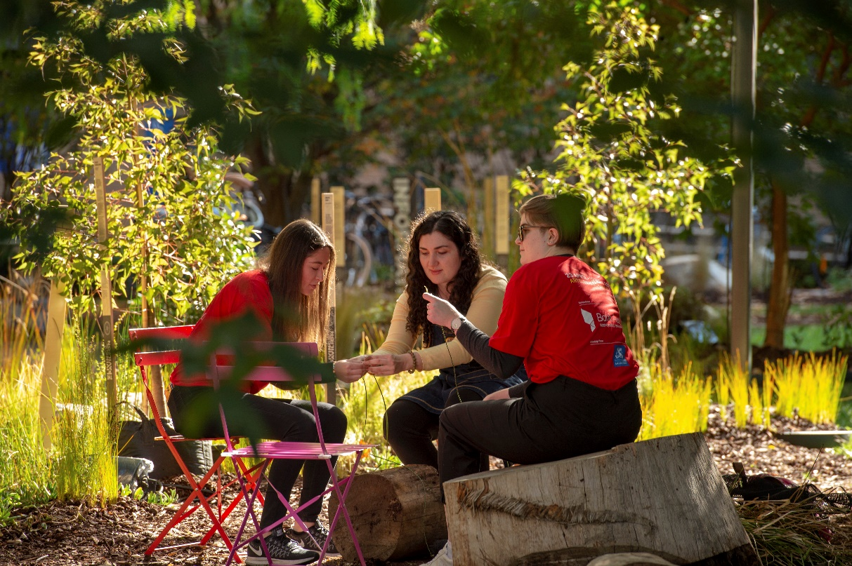
Stephanie Beaupark, Ngugi woman teaching Indigenous weaving techniques using Spiny-headed Mat-rush (Lomandra longifolia). Stephanie completed research for the CAUL Hub on air quality and Indigenous seasons and engaged with attendees through her practice.
Photo by Sarah Fisher.


By this turn of phrase, we mean NESP Hub projects with a high level of Indigenous engagement.
AIATSIS is planning to release a new Code of Ethics in September 2020 with a 12-month implementation period. Other supporting resource material will be developed and released across the length of the implementation period. https://aiatsis.gov.au/research/ethical-research/aiatsis-code-ethics?utm_medium=email&utm_campaign=AIATSIS%20News%20July%202020&utm_content=AIATSIS%20News%20July%202020+CID_a316994b584e505636ac9907de2edb48&utm_source=Email%20marketing%20Campaign%20Monitor&utm_term=Find%20out%20more
Western Australia v Ward (2002) 213 CLR 1 [58, 468].
https://www.environment.gov.au/science/nesp
See for the IAC’s Meeting Bulletins - https://www.environment.gov.au/epbc/advisory-committees/iac
The CAUL Hub’s priorities were not amended at this time. See Table 2.1 later in this Chapter.
The Outcomes of the Gathering were provided by the Scientific Partnerships Section of the Department of Agriculture, Water and the Environment.
https://www.environment.gov.au/node/13277
https://www.nespnorthern.edu.au/track/ and https://www.environment.gov.au/system/files/pages/56c08f6f-7bf7-4594-8175-b4c143110156/files/hub-track.pdf
https://www.environment.gov.au/science/nerp
The process of compiling the NERP Indigenous Engagement Strategy and identifying Indigenous engagement opportunities within the NERP Tropical Ecosystems Hub projects involved three workshops from November 2012 – January 2013. The Working Group consisted of Indigenous representatives, Hub Administration staff and identified project leaders.
https://nespurban.edu.au/3-category-workbook/
https://www.nespnorthern.edu.au/projects/nesp/knowledge-brokering-indigenous-land-management/
https://www.nespmarine.edu.au/system/files/Lincoln_Hedge%20Promoting%20partnerships%20for%20Sea%20Country_FINAL%2001Nov19.pdf
http://nespclimate.com.au/wp-content/uploads/2020/03/A4-2p-AMOS-TO-workshop-summary.pdf
The additional details in the summaries prepared by the Department of Agriculture, Water and the Environment used Endnote, which cannot be easily transposed into this report. See Appendix F and the original Tables prepared and held by the Department of Agriculture, Water and the Environment for more details.
https://www.environment.gov.au/node/13277
https://www.nespnorthern.edu.au/track/ and https://www.environment.gov.au/system/files/pages/56c08f6f-7bf7-4594-8175-b4c143110156/files/hub-track.pdf
https://www.environment.gov.au/science/nerp
https://www.nespnorthern.edu.au/achievements/bringing-northern-australia-science-to-canberra/ and https://www.nespnorthern.edu.au/2019/02/26/follow-up-resources-from-canberra-research-forum/
https://nespurban.edu.au/people/indigenous-advisory-group/
http://www.environment.gov.au/biodiversity/bushfire-recovery/expert-panel
https://www.nespnorthern.edu.au/2016/10/11/developing-protocols-indigenous-fire-management-partnerships/
http://www.nespthreatenedspecies.edu.au/projects/collaborations-with-indigenous-people-in-threatened-species-research-and-management
https://www.nespnorthern.edu.au/projects/nesp/research-priorities-for-ipas-across-northern-australia/
https://www.nespnorthern.edu.au/projects/nesp/guided-resource-investment/
Free, prior and informed consent is a specific right that pertains to Indigenous peoples and is recognised in several articles in the United Nations Declaration on the Rights of Indigenous Peoples (UN 2007). See discussion in Chapter 8.
An ILUAs is a voluntary agreement made under the Native Title Act 1993 (Cth) between people who hold, or claim to hold, native title rights and interests in an area and other people who have, or wish to gain, an interest in that area. ILUAs are negotiated agreements, and when registered they are binding on all persons who hold or may hold native title for the area covered by the agreement.
The Great Barrier Reef marine park is managed by the Great Barrier Reef Marine Park Authority and the Heard Island and McDonald Islands marine park is managed by the Australian Antarctic Division.
http://www.environment.gov.au/system/files/resources/94665a8c-2e41-4aa3-915f-77a1a6af0199/files/darwin-statement-hcoanz.pdf
http://www.nrm.gov.au/indigenous-nrm/telling-the-story
https://www.communitygrants.gov.au/grants/national-environmental-science-program-nesp-2
The overall research ethics framework also includes the following elements, but these are not considered within the scope of this assessment: - The Ethical conduct in research with Aboriginal and Torres Strait Islander Peoples and communities: Guidelines for researchers and stakeholders (NHMRC, 2018) for researchers undertaking research in health matters; - The Ethical considerations in quality assurance and evaluation activities (NHMRC, 2014) for researchers undertaking evaluation and quality assurance; and - Other specific codes and guidelines apply to research involving animals, and certain biomedical and clinical research, See https://www.nhmrc.gov.au/research-policy/ethics-and-integrity.
The current NESP Hubs have been hosted by universities or research institutions, all of which have such committees in place. Any new consortiums for NESP2 will have to have human research ethics committee in place if it is to conform with Australia’s human ethics research framework.
In particular, Articles 10 (relocation), 11 (cultural property), 19 (regulatory measures), 28 (land and territories), 29 (environment) and 32 (development and use of land/territories).
The UN General Assembly has a long history of adopting declarations on various human rights issues including the Universal Declaration of Human Rights in 1948. Such declarations are adopted under Article 13(1)(b) of the UN Charter and are generally reserved by the UN ‘for standard-setting resolutions of profound significance’ (UN, 2013:16).
Erica-Irene Daes was the Chairperson of the Working Group on Indigenous Populations (WGIP) and Special Rapporteur of the UN Sub-Commission on Human Rights from 1984 to 2001 and was instrumental in the preparation of the UNDRIP. Daes (2008:24) maintains that ‘no other UN instrument has been elaborated with such an active participation of all parties concerned’.
Article 46 has been interpreted by Engle (2011: 147) as sealing the deal that ‘external forms of self-determination are off the table for Indigenous peoples’ and by Woons (2014:10) as ‘the ability of Indigenous nations to use UNDRIP to challenge the power imbalance they are locked into with states has been truncated’ with the territorial integrity of the former being maintained at the expense of the latter (White Face and Wobaga, 2013). Furthermore, the then UN Special Rapporteur on the Rights of Indigenous Peoples, James S. Anaya, also disagrees that any imputation that the right to self-determination sets Indigenous peoples apart from the right to self-determination that peoples generally enjoy under international law (UN, 2013:19; see also Daes, 2008:22-24; Anaya, 2009:184-198).
https://www.environment.gov.au/biodiversity/international/un-convention-biological-diversity
https://www.wamsi.org.au/research-site/indigenous-knowledge and https://www.klc.org.au/the-kimberley-indigenous-saltwater-science-project
Despite the passage of time, Arnstein’s ladder of citizen participation still stands as a benchmark in planning and citizen participation theory.
See also: https://www.aihw.gov.au/news-media/media-releases/2013/october/trust-integrity-and-respect-confirmed-as-cornerst
Adopting Dawson et al’s (2010:2845) definition of definition that ‘a sustainable social-ecological system is one that, over the normal cycle of pressures and disturbance events, maintains its characteristic diversity of major functional groups, processes, services and utility thereby ensuring its capacity to endure’.
http://nespclimate.com.au/co-design-cross-cultural-communication-and-climate-change/
AIATSIS is planning to release a new Code of Ethics in September 2020 with a 12-month implementation period. Other supporting resource material will be developed and released across the length of the implementation period. https://aiatsis.gov.au/research/ethical-research/aiatsis-code-ethics?utm_medium=email&utm_campaign=AIATSIS%20News%20July%202020&utm_content=AIATSIS%20News%20July%202020+CID_a316994b584e505636ac9907de2edb48&utm_source=Email%20marketing%20Campaign%20Monitor&utm_term=Find%20out%20more
These abbreviations are used interchangeably in this report.
For a further summation of Indigenous Knowledge issues in Australia, see IP Australia 2019:6-7, and on Traditional Knowledge and Genetic Resources in particular, see IP Australia, 2019:8-13.
See Chapter 17 of the Productivity Commission, 2016:485-525.
For an overview of legal instruments and other measures to aid in the protection and valuation of Indigenous knowledge, see Chapter 2 of Blackwell et al 2019, pp.16-31.
https://www.communitygrants.gov.au/sites/default/files/documents/04_2020/national-environment-science-program-resilient-landscapes-hub-research-scope_0.pdf
http://www.environment.gov.au/biodiversity/bushfire-recovery/expert-panel
https://www.communitygrants.gov.au/sites/default/files/documents/04_2020/national-environment-science-program-marine-coastal-hub-research-scope_0.pdf
https://www.communitygrants.gov.au/sites/default/files/documents/04_2020/national-environment-science-program-sustainable-communities-waste-hub-research-scope.pdf
https://www.communitygrants.gov.au/sites/default/files/documents/04_2020/national-environment-science-program-climate-systems-hub-research-scope.pdf
http://nespclimate.com.au/co-design-cross-cultural-communication-and-climate-change/

